Client/Server Architecture With MySQL

1. The basic idea
Client–server architecture is a model where one side, the client, sends requests, and the other side, the server, listens, processes those requests, and returns responses. This pattern is common in web applications, APIs, and database systems because it separates the requester from the service provider.

2. Simple illustration
Think of the model as a request–response exchange across a network.
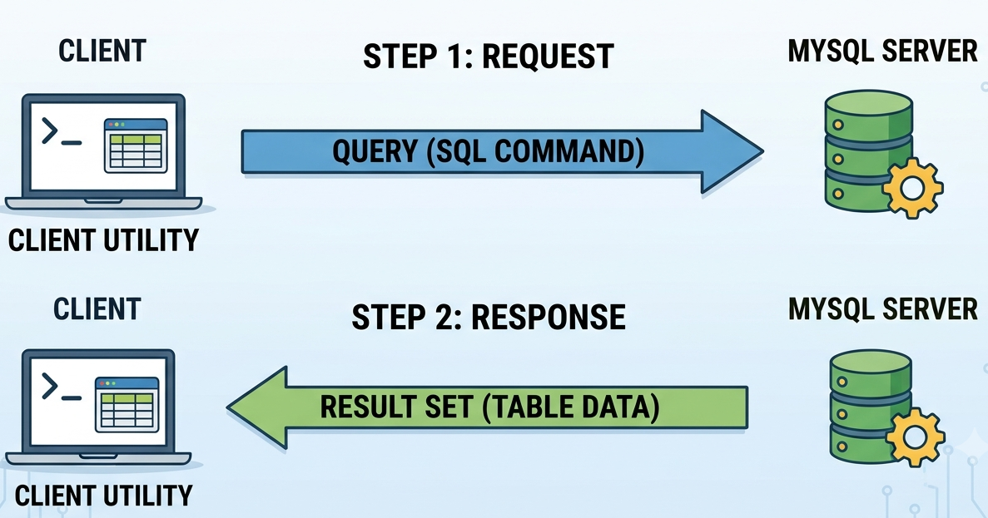
The client can be a browser, terminal command, or database client utility, while the server can be a web server, API, or database engine. The network carries the request to the server and carries the response back to the client.

3. Using curl -lv
curl is a command-line client that sends requests to a server and displays the response, which makes it useful for seeing client–server communication directly. In verbose mode, it shows request and response details, including headers and connection information.
Example:
bash
curl -lv https://example.com
Here, your machine is the client, example.com is the server, and HTTP/HTTPS is the protocol used between them. In the verbose output, lines beginning with > are sent by the client, while lines beginning with < are returned by the server.

4. MySQL as a client–server application
MySQL is also a client–server system: the MySQL client sends SQL queries to the MySQL server, and the server processes them and returns results. In a common setup, one machine runs the MySQL server process, while another machine or terminal uses the MySQL client to connect remotely over TCP port 3306.
A typical remote connection looks like this:
bash
mysql -u username -h server_ip -p
In this interaction, the mysql command is the client, the MySQL daemon is the server, and SQL is the language used to communicate with the database service.

5. Mini SQL cheatsheet
Once connected to MySQL, you can test the client–server interaction with a few basic SQL commands.
sql
SHOW DATABASES;
CREATE DATABASE bookstore;
USE bookstore;

CREATE TABLE books (
id INT AUTO_INCREMENT PRIMARY KEY,
title VARCHAR(100),
author VARCHAR(100)
);

SHOW CREATE TABLE books;

INSERT INTO books (title, author)
VALUES ('Clean Code', 'Robert C. Martin');

SELECT * FROM books;

DROP TABLE books;
DROP DATABASE bookstore;
SHOW CREATE TABLE displays the SQL statement used to create a table. INSERT adds data, SELECT reads data, and DROP removes tables or databases, so together they form a simple cheat sheet for basic MySQL operations.

6. Troubleshooting tools
When client–server communication fails, it helps to diagnose the problem from the network layer up to the application layer.
- ping checks whether a host is reachable and gives simple latency and packet-loss information.
- traceroute shows the path packets take through the network and helps locate where delays or failures happen.
- curl -lv checks whether an HTTP service is reachable and responding correctly.
Examples:
bash
ping example.com
traceroute example.com
curl -lv https://example.com
These tools answer different questions: whether the host is reachable, where network traffic is getting delayed, and whether the server application itself is responding.

7. Troubleshooting MySQL latency
If MySQL requests are slow, the latency may come from the network, the server load, or the SQL queries themselves. A practical troubleshooting flow is:
- Check network reachability and latency
bash
ping mysql-server-ip
traceroute mysql-server-ip
This shows whether the client can reach the MySQL server and whether the network path is introducing noticeable delay.
- Check whether the MySQL service is responding
bash
mysql -u username -h mysql-server-ip -p
If the connection is slow even before running queries, look at network latency, firewall rules, or server resource pressure.
- Look for slow queries
sql
SHOW VARIABLES LIKE 'slow_query%';
SHOW VARIABLES LIKE 'long_query_time';
MySQL performance troubleshooting often starts with the slow query log, which helps identify statements taking too long to execute.
- Inspect query execution
sql
EXPLAIN SELECT * FROM books WHERE author = 'Robert C. Martin';
EXPLAIN helps show whether MySQL is scanning too many rows or missing useful indexes, which is a common cause of latency.
- Check connections and load
sql
SHOW STATUS LIKE 'Threads_connected';
SHOW STATUS LIKE 'Aborted_connects';
Too many active connections or connection errors can increase response time and reduce database performance.

8. Practical summary
Client–server architecture becomes straightforward when you think of it as a request sent by a client and a response returned by a server. Tools such as ping, traceroute, curl -lv, and the MySQL client make that exchange visible and help you diagnose where communication or performance problems occur.

