HTML-CSS-JS Self Study Guide

Understand the three layers
Before coding, remember what each technology does:
- HTML: the structure of the page (elements like headings, paragraphs, forms, buttons).
- CSS: the design (colors, spacing, layout, fonts).
- JavaScript: the behavior (interactivity, events, validation, dynamic changes).

Step 1 – Create a basic HTML page
Create a file named index.html. This will be the main entry point for your site.
Minimal template:
<!DOCTYPE html>
<html lang="en">
<head>
<meta charset="UTF-8">
<title>My First Web Page</title>
<link rel="stylesheet" href="style.css">
</head>
<body>
<h1>Welcome to my page</h1>
<p>This is my first HTML + CSS + JS project.</p>

<button id="clickMe">Click me</button>
<p id="message"></p>

<script src="script.js"></script>
</body>
</html>

Step 2 – Add CSS styling

Create a file named style.css in the same folder:
body {
font-family: Arial, sans-serif;
background-color: #f5f5f5;
padding: 2rem;
}

h1 {
color: #333;
}

button {
padding: 0.5rem 1rem;
background-color: #007acc;
color: #fff;
border: none;
border-radius: 4px;
cursor: pointer;
}

button:hover {
background-color: #005f99;
}

#message {
margin-top: 1rem;
color: #007acc;
}

This makes the page cleaner and shows how CSS changes appearance without touching HTML structure.

Step 3 – Add JavaScript behavior
Create a file named script.js
const button = document.getElementById('clickMe');
const message = document.getElementById('message');

button.addEventListener('click', () => {
message.textContent = 'Hello from JavaScript!';
});
What happens:
- JavaScript finds elements by ID (clickMe, message).
- It listens for a click event.
- When clicked, it updates the text on the page.
This simple interaction is enough to test that HTML + CSS + JS are linked correctly.

Step 4 – Test locally or in an online editor
- Put index.html, style.css, script.js in the same folder.
- Double-click index.html to open it in your browser.
- Check:
  - Page layout looks correct.
  - Button styles appear.
  - Clicking button shows the message.
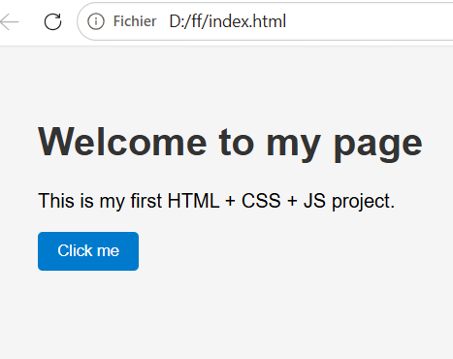
After clicking on “Click me” Button
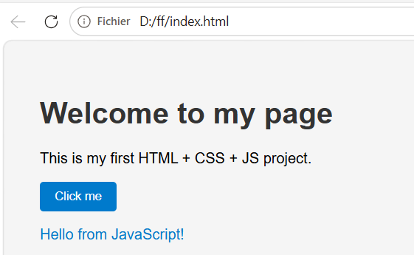
To start your journey in learning HTML, CSS, and JavaScript through hands-on practice, the following URL is recommended.
HTML CSS JavaScript - Free Online Editors and Tools

