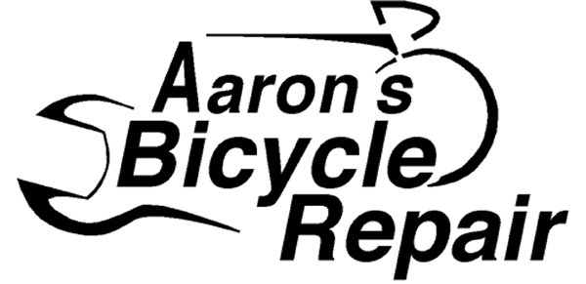
and
Dead Baby Bikes
Present:

A Ride and Concert with
Kipchoge Spencer
co-owner of Xtracycle and lead singer of the
Ginger Ningas

Meet at Aaron's Bicycle Repair, 6521 California AVE SW in West Seattle at 6 PM and ride downtown to Westlake Center. We will meet more people there at 7 PM and ride 'round [baby] for an hour or two. The group will determine the route. After the ride we will ride to Dead Baby Bikes' Bat Cave (club house) at the southwest corner of First and Marion under the the east end of the pedestrian overpass. (same block as the Owl and Thistle).

Heavy rain plan is to just meet at the Bat Cave around 7 PM.
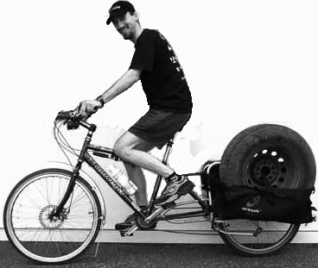

www.deadbabybikes.org
www.gingerninjas.com
www.rideyourbike.com/xtracycleride6.html
THIS IS A FREE EVENT!
and
Dead Baby Bikes
Present:

A Ride and Concert with
Kipchoge Spencer
co-owner of Xtracycle and lead singer of the
Ginger Ningas

Meet at Aaron's Bicycle Repair, 6521 California AVE SW in West Seattle at 6 PM and ride downtown to Westlake Center. We will meet more people there at 7 PM and ride 'round [baby] for an hour or two. The group will determine the route. After the ride we will ride to Dead Baby Bikes' Bat Cave (club house) at the southwest corner of First and Marion under the the east end of the pedestrian overpass. (same block as the Owl and Thistle).

Heavy rain plan is to just meet at the Bat Cave around 7 PM.

www.deadbabybikes.org
www.gingerninjas.com
www.rideyourbike.com/xtracycleride6.html

THIS IS A FREE EVENT!

