1. **Write a C++ program to find the sum of two numbers entered by the user.**

#include<iostream>

using namespace std;

class sum{

int n1, n2, add;

public:

void in(){

cout<<"Enter first number:";

cin>>n1;

cout<<"Enter second number:";

cin>>n2;

}

void calSum(){

add=n1+n2;

cout<<n1<<"+"<<n2<<"="<<add;

}

};

int main(){

sum s1;

s1.in();

s1.calSum();

}

**Output:**

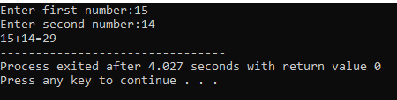

1. **Write a C++ program that calculates the factorial of a given positive integer.**

#include<iostream>

using namespace std;

class factorial{

private:

int n;

long fact=1;

public:

void calFactorial(){

cout<<"Enter a number=";

cin>>n;

if(n==0 ||n==1){

fact=1;

}

else{

for(int i=1; i<=n; i++){

fact= fact*i;

}

}

}

void out(){

cout<<"Factorial= "<<fact;

}

};

main(){

factorial f1;

f1.calFactorial();

f1.out();

}

**Output:**

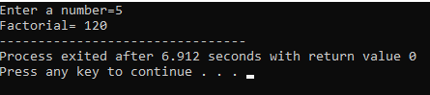

1. **Write a C++ program to check if a number is even or odd.**

#include<iostream>

using namespace std;

class num{

int n;

public:

void enterNum(){

cout<<"Enter an integer:";

cin>>n;

}

void check(){

if(n %2==0){

cout<<n<<" is even.";

}

else{

cout<<n<<" is odd.";

}

}

};

main(){

num N;

N.enterNum();

N.check();

}

**Output:**

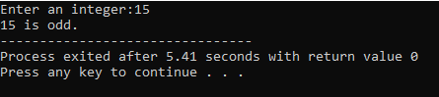

1. **Write a C++ program to find the largest among three numbers entered by the user.**

#include<iostream>

using namespace std;

class largest{

public:

int n1, n2, n3;

void numbers(){

cout<<"Enter numbers:"<<endl;

cin>>n1>>n2>>n3;

}

void check(){

if(n1>n2 && n1>n3){

cout<<n1<<" is the largest number."<<endl;

}

else if(n2>n3 && n2>n1){

cout<<n2<<" is the largest number."<<endl;

}

else{

cout<<n3<<" is the largest number."<<endl;

}

}

};

main(){

largest num;

num.numbers();

num.check();

}

**Output:**

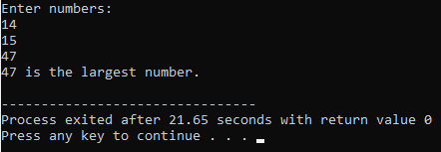

1. **Write a C++ program to reverse a string entered by the user.**

#include <iostream>

#include <string>

using namespace std;

class Reverse {

public:

string reverseString(const string& input) {

string reversed;

for (int i = input.length() - 1; i >= 0; i--) {

reversed += input[i];

}

return reversed;

}

};

int main() {

Reverse rev;

string input;

cout << "Enter a string: ";

cin >> input;

string reversed = rev.reverseString(input);

cout << "Reversed string: " << reversed <<endl;

return 0;

}

**Output:**

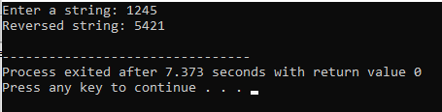

1. **Write a C++ program that converts temperature from Fahrenheit to Celsius.**

#include<iostream>

using namespace std;

class temp{

public:

float convert(float celsius) {

return (celsius * 9/5) + 32;

}

};

int main(){

temp t1;

float cel, fahren;

cout<<"Enter temperature in celsius:";

cin>>cel;

fahren= t1.convert(cel);

cout<<cel<<" degree celsius is equals to "<<fahren<<" degree Fahrenheit.";

}

**Output:**

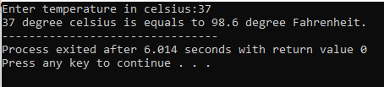

1. **Write a C++ program to implement a simple calculator with addition, subtraction, multiplication, and division operations.**

#include<iostream>

using namespace std;

class calculator{

float n1,n2;

int sum, sub, mul, div;

public:

void in(){

cout<<"Enter first integer:";

cin>>n1;

cout<<"Enter second integer:";

cin>>n2;

}

void operations(){

char op;

cout<<"Enter an operator:";

cin>>op;

switch (op){

case '+':

sum=n1+n2;

cout<<n1<<"+"<<n2<<"="<<sum;

break;

case '-':

sub=n1-n2;

cout<<"Subtraction="<<sub;

break;

case'*':

mul=n1*n2;

cout<<"Multiplication="<<mul;

break;

case '/':

div=n1/n2;

cout<<"Division="<<div;

break;

default:

cout<<"INVALID INPUT";

}

}

};

main(){

calculator c1;

c1.in();

c1.operations();

}

**Output:**

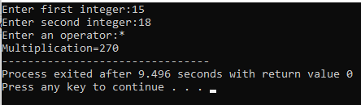

1. **Write a C++ program to generate a Fibonacci sequence of a given length.**

#include<iostream>

using namespace std;

class series{

public:

void fi(int length){

if(length <= 0){

cout<<"INVALID";

return;

}

int a=0, b=1, next;

cout<<"Fibonacci series:"<<endl;

if(length >=1){

cout<<a;

}

for(int i=2; i<=length ; i++){

cout<<endl<<b;

next=a+b;

a=b;

b=next;

}

cout<<endl;

}

};

int main(){

series f1;

int length;

cout<<"Enter length:";

cin>>length;

f1.fi(length);

}

**Output:**

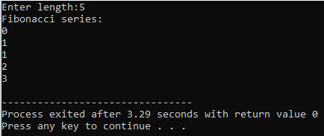

1. **Write a C++ program to find the prime factors of a number.**

#include <bits/stdc++.h>

using namespace std;

void primeFactors(int n)

{

while (n % 2 == 0)

{

cout << 2 << " ";

n = n/2;

}

for (int i = 3; i <= sqrt(n); i = i + 2)

{

while (n % i == 0)

{

cout << i << " ";

n = n/i;

}

}

if (n > 2)

cout << n << " ";

}

int main()

{

int n;

cout<<"Enter a number:";

cin>>n;

primeFactors(n);

return 0;

}

**Output:**

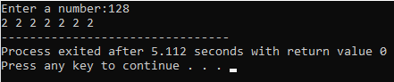

1. **Write a C++ program to determine whether a given year is a leap year or not.**

#include<iostream>

using namespace std;

class leap{

int year;

public:

void in(){

cout<<"Enter year:";

cin>>year;

}

void check(){

if(year % 4==0){

cout<<"It's a leap year";

}

else{

cout<<"It's not a leap year";

}

}

};

main(){

leap y;

y.in();

y.check();

}

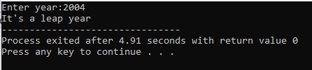**Output:**