SLE-3: Architectural Design (Full C4 Model)

Course : 02AML204 – Introduction to Artificial Intelligence
PRN: 26UAM306
Name: Aishwarya Sanjay Vibhute
Division: A
Date: 01- 10-2026
GitHub Link: https://github.com/im-aishwarya-vibhute/IAI_SLE-3_26UAM306_Aishwarya_Vibhute

1. System Title & Short Description
Graph Search System using BFS and DFS
The Graph Search System is a simple Artificial Intelligence search system that finds a path between a starting node and a goal node in a graph. The system uses two search algorithms: Breadth First Search (BFS) and Depth First Search (DFS). BFS searches the graph level by level, while DFS explores a path deeply before backtracking. The system accepts a graph, starting node and goal node and produces the search path and result. This system is continued from the BFS and DFS work completed in SLE-1 and SLE-2.

2. Context Diagram — Level 1
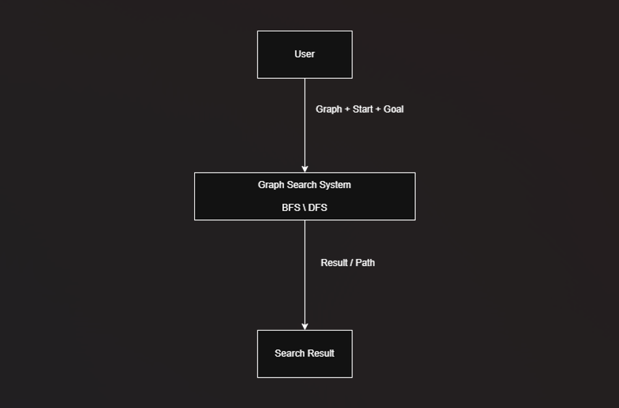
Explanation
The user provides the graph, starting node and goal node to the Graph Search System. The system uses BFS or DFS to search for the goal node. After completing the search, the system provides the search result and path to the user.

3. Container Diagram — Level 2
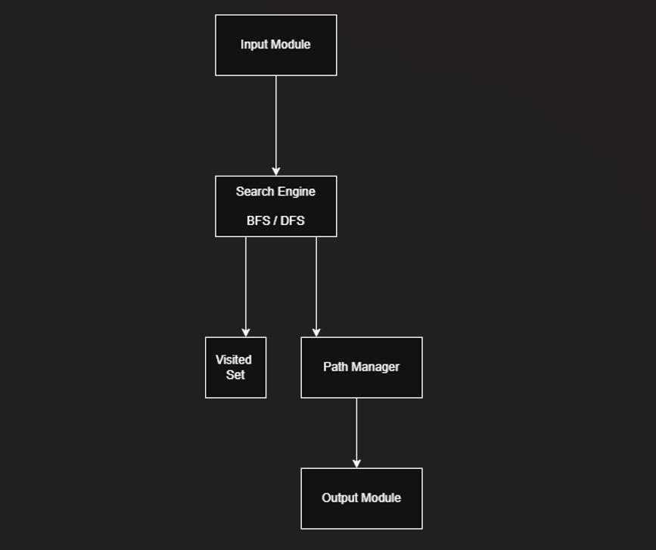Containers
1. Input Module:
Takes the graph, starting node and goal node as input.
2. Search Engine:
Runs the selected BFS or DFS search algorithm.
3. Visited Set:
Stores the nodes that have already been visited to avoid repeated processing.
4. Path Manager:
Maintains and reconstructs the path from the starting node to the goal node.
5. Output Module:
Displays the search path, result and performance information.

4. Component Diagram — Level 3
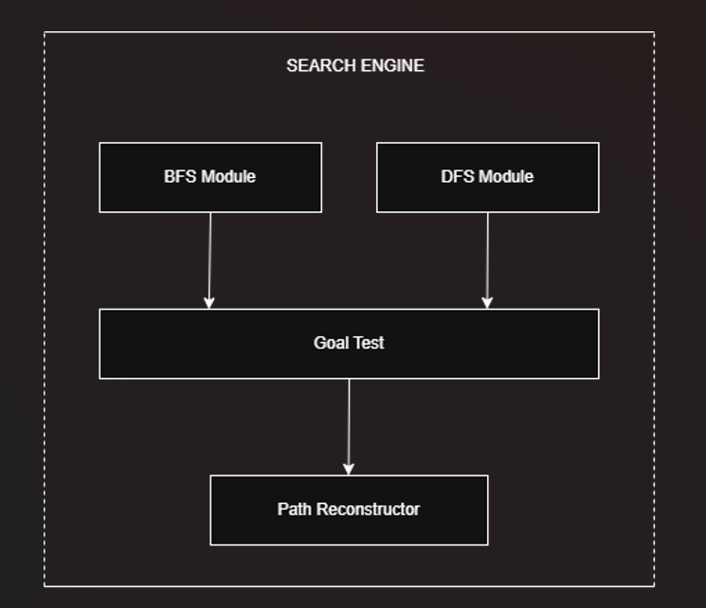
Explanation
The Search Engine is the main container selected for the component-level design. It contains the BFS Module and DFS Module for performing the two search strategies. The Goal Test checks whether the current node is the required goal node. The Path Reconstructor prepares the final path from the starting node to the goal node.

5. Code Level Overview — Level 4
Main Functions
graph: Stores the graph structure.
bfs(graph, start, goal): Performs Breadth First Search using a queue.
dfs(graph, start, goal): Performs Depth First Search using a stack.
timeit: Measures the execution time of the search algorithms.
nodes_expanded: Counts the number of nodes expanded during the search.

6. Design Decisions
The system is divided into separate modules so that input, search processing, visited-node management, path handling and output can be understood easily. BFS and DFS are kept as separate search functions so their performance can be compared using the same graph. The design is kept simple because the project is a small graph search system.

7. AI Contribution Note
AI Tool Used: ChatGPT
AI was used for guidance in understanding the SLE-3 requirements, C4 model levels, BFS/DFS architecture, diagram structure and report organization. I created and organized the diagrams and connected the architecture with my BFS and DFS project. I reviewed the design and prepared the final report based on my understanding of the system.

8. Conclusion
The SLE-3 activity helped me understand how the BFS and DFS search system can be represented using the complete C4 model. The Context level shows the system and user, the Container level shows the main modules, the Component level shows the internal parts of the Search Engine, and the Code level shows the main functions. This activity helped me understand the architecture of my search system from a high-level view to the implementation level.

