**Glycemic Control of Male Professional Athletes With Type 1 Diabetes Over an Entire Competitive Season: A Retrospective Observational Study**

**Short title:** Glycemia of Athletes with Type 1 Diabetes

Eva van Weenen, MSc1; Nicolas Banholzer, PhD2; Simon Föll, MSc1; Thomas Züger, MD3,4; Federico Y. Fontana, PhD3,5; Kristina Skroce, MSc5; Charlotte Hayes, MMSc5; Mathias Kraus, PhD6; Stefan Feuerriegel, PhD7; Felix Wortmann, PhD8,* Sam N. Scott, PhD5,*; Christoph Stettler, MD3,*

*Joint last author

1 Department of Management, Technology and Economics, ETH Zurich, Zurich, Switzerland

2 Institute of Social and Preventive Medicine, University of Bern, Bern, Switzerland

3 Department of Diabetes, Endocrinology, Nutritional Medicine and Metabolism, Bern University Hospital, University of Bern, Bern, Switzerland

4 Department of Endocrinology and Metabolic Diseases, Kantonsspital Olten, Olten, Switzerland

5 Team Novo Nordisk Professional Cycling Team, Atlanta, USA

6 School of Business, Economics and Society, Friedrich-Alexander University Erlangen-Nürnberg, Germany

7 Institute of AI in Management, LMU Munich, Munich, Germany

8 Institute of Technology Management, University of St. Gallen, St. Gallen, Switzerland

**Corresponding author:**

Prof Christoph Stettler

Department of Diabetes, Endocrinology, Nutritional Medicine and Metabolism

Freiburgstrasse 15, CH-3010 Bern, Switzerland

christoph.stettler@insel.ch

Word count: 3879 / 4000

Number of tables: 2

Number of figures: 2

Word count abstract: 318 / 250

**ABSTRACT**

**Objective:** To analyze glycemic control of professional athletes with type 1 diabetes during a competitive season.

**Research Design and Methods:** In a retrospective observational study, the glycemic control of n=12 professional male cyclists with type 1 diabetes (HbA1c 6.6 [6.5–6.9]%, 49 [46–52] mmol/mol; and 288.5 [254.0–300.5] days of cycling) was analyzed. First, glycemia were summarized during exercise, recovery, and nocturnal phases on competitive and non-competitive days. Second, associations between dysglycemia and exercise were analyzed using multilevel logistic regressions.

**Results:** Glycemic outcomes, reported as median [interquartile range] over the participants, were overall 66.1 [62.4–82.2]% of time in range (70–180 mg/dL), 5.3 [2.6–9.2]% of time in hypoglycemia (<70 mg/dL), and 25.3 [14.1–33.8]% of time in hyperglycemia (>180 mg/dL). During non-competitive exercise, time in range was 74.0 [61.8–83.5]%, time in hypoglycemia was 4.1 [2.4–8.1]%, and time in hyperglycemia was 20.8 [9.3–30.5]%. Glucose concentrations were 24.4 [17.7–32.8]% (*p*<0.001) higher during competitive exercise than during non-competitive exercise, with 58.6 [56.4–68.9]% of time in range, 0.5 [0.1–1.7]% of time in hypoglycemia, and 38.5 [30.5–41.8]% of time spent in hyperglycemia during competition. Hyperglycemia during exercise was positively associated with duration, intensity factor, and variability index of exercise (all *p*<0.001). During recovery, 29.9 [21.6–34.4]% of time was spent in hyperglycemia, which was positively associated with exercise variability index (*p*=0.034) and negatively associated with duration of exercise (*p*=0.002). During nighttime, time in hypoglycemia was 10.5 [3.6–13.8]% after training days and 4.2 [0.8–12.6]% after competition days.

**Conclusions:** These results may guide supervision of athletes with type 1 diabetes, pointing towards periods where particular focus on glucose management is needed.

**INTRODUCTION**

Regular physical exercise is a key component in the management of type 1 diabetes (1-2), associated with increased longevity and improved cardio-metabolic health (3). Despite significant advances in supportive technology and guidance (1,4), exercise poses considerable challenges for people with type 1 diabetes, with fear of hypoglycemia and inadequate knowledge around exercise management being major barriers (5-6). Nevertheless, there are examples of people living with type 1 diabetes that undertake ultra-endurance exercise on a regular basis (7-12), where some are even competing at a professional level (e.g., 7-8).

Current guidelines to prevent exercise-induced hypoglycemia suggest insulin dose adaptation and ingestion of additional carbohydrates in the context of physical exercise (4, 13). These recommendations are largely based on findings from laboratory-based studies and clinical experience of moderately trained individuals undertaking less than 60 minutes of exercise. Yet, the applicability to prolonged endurance exercise is less well known. This is partly due to the fact that reports on ultra-endurance exercise in people with type 1 diabetes have only been provided over a short period of time, such as an individual race or training period (7-12), meaning that there is little research describing the associated glycemic control in endurance athletes living with type 1 diabetes beyond a single training camp or competitive event.

Developments in technology to monitor glucose (e.g., continuous glucose monitoring (CGM)) and physical exercise (e.g., power meters and heart rate monitors) enable non-invasive and comprehensive measurement of factors related to glycemic management and exercise behaviors, regardless of the training or competition setting and environment. Here, monitoring both glucose and exercise performance for a prolonged study period allows for unique insights into the effects of training and competition on glycemia and the various challenges athletes may face in combining high-performance exercise with type 1 diabetes.

In this retrospective observational study, we evaluated the glycemic control of professional athletes with type 1 diabetes from the Team Novo Nordisk cycling team over a competitive season (Oct 2018 – Oct 2019). The objective of this study is twofold: (i) to summarize glycemic control during competitive and non-competitive physical exercise, recovery, and nocturnal phases; and (ii) to analyze the association of exercise-related factors with the occurrence of hypo- and hyperglycemia during these phases.

**RESEARCH DESIGN AND METHODS**

**Participants**

This retrospective observational study included data from 12 male professional road cyclists with type 1 diabetes from Team Novo Nordisk over a competitive season (Oct 2018 – Oct 2019). The study was performed in accordance with the Declaration of Helsinki. Ethical approval was obtained from the Canton of Bern ethics committee (Project ID: 2019-01988). All participants provided both verbal and written informed consent. Participant eligibility and exclusion criteria are reported in Supplemental Figure 2.

**Data collection**

Data collection was carried out during the Team Novo Nordisk 2019 competitive season (Oct 2018 – Oct 2019). During cycling sessions, participants were equipped with a mobile power meter (SGYPM900H90, Pioneer, Aliso Viejo, CA), a cycling computer (Wahoo Fitness, Atlanta, GA), and a chest strap heart rate monitor (Wahoo Fitness, Atlanta, GA). The following data were monitored at a 1Hz frequency: power output [W], cadence [rpm], heart rate (HR) [bpm], temperature [°C], latitude [°N], longitude [°E], distance [km], and altitude [m]. Data collected from these sensors were exported daily to a central database (TrainingPeaks, Peaksware LLC, USA).

Data collected from cycling sessions were aggregated by day to capture causes of physiological effects of exercise: duration [min], intensity factor, and variability index, as well as time in heart rate- and power zones [min] based on individualized Coggan heart rate- and power zones (14) (see Supplemental Table 4 for further details). If more than one exercise session had taken place during a day, data from the exercise sessions were aggregated cumulatively (i.e., through concatenation). To obtain metabolic thresholds, incremental cardiopulmonary exercise (CPX) tests were performed biannually on the athlete’s personal bike (Colnago C60) attached to a cycle trainer (KICKR, Wahoo, Atlanta, GA). Together with collected anthropometric data, such as height [cm], body mass [kg], and fat mass [%], these tests yielded the maximum rate of oxygen consumption (V̇O2max) [mL/min/kg], maximum heart rate (HRmax) [bpm], lactate threshold heart rate (LTHR) [bpm], and functional threshold power (FTP) [W/kg].

Additionally, individual travel and competition calendars were collected. Data from continuous glucose monitoring (CGM) were collected using Dexcom G6 (Dexcom, San Diego, CA) throughout the study period. Blood analyses were performed quarterly to measure HbA1c. Further details on data collection are presented in Appendix A of the Supplemental Material.

**Analysis of glycemia**

Continuous glucose monitoring data were analyzed in accordance with the international consensus statement (15) to calculate for each participant the mean glucose [mg/dL], glycemic variability expressed as coefficient of variation (CV) [%], time in hypoglycemia (L1: 54–69 mg/dL, L2: <54 mg/dL), time in range (70–180 mg/dL), and time in hyperglycemia (L1: 181–250 mg/dL, L2: >250 mg/dL). These statistics were calculated for five phases of the day: (i) the entire day (06:00–06:00h); (ii) wake (06:00–00:00h); (iii) exercise (corresponding to the times of the day that participants recorded cycling exercise); (iv) recovery (corresponding to the 4 hours after exercise, excluding times during subsequent exercise); and (v) sleep (00:00–06:00h). Phases (i), (ii), and (v) correspond to the time frames defined in the international consensus statement (15). Statistics on glycemia were calculated for all days that met the inclusion criteria in Supplemental Figure 2, thus also comprising days without exercise. Moreover, the statistics were calculated separately for days with competitive- and non-competitive exercise.

Summary statistics of glycemic outcomes across patients were reported with median [interquartile range] and compared with clinical targets recommended by Battelino et al. (16) using one-sample *t*-tests. Glycemic outcomes were compared between competitive and non-competitive exercise using paired *t*-tests.

**Associations of exercise with dysglycemia**

Characteristics of exercise (i.e., duration, intensity factor, variability index, and time in heart rate- and power zones) were associated with the occurrence of hypoglycemia (<70 mg/dL) and hyperglycemia (>180 mg/dL) during exercise, subsequent recovery, and sleep. For this purpose, multilevel multivariate logistic regression models were used. To account for participant-specific variation in physiology and glycemia, random intercepts and random slopes were incorporated in the models. The models were fitted for each individual exercise variable separately, and adjusted for environmental variables. Environmental variables were average temperature [°C] during exercise, average altitude [m] during exercise, day in the competitive season (counting from the start of the competitive season), and whether travel was undertaken in the current or the previous two days.

Prior to analysis, we standardized independent variables. Variables with more than 30% missing values were excluded. Additionally, time in heart rate- and power zones were excluded if more than 80% of their values were zero. Missing values in all remaining variables were imputed with their mean. Estimated standardized associations are reported as the odds ratio (OR) [95% confidence interval (CI)].

Further details on this analysis are presented in Appendix B of the Supplemental Material. Specifically, details on the independent variables in this analysis are provided in Supplemental Table 4. Supplementary analyses are presented in Appendix C of the Supplemental Material.

**RESULTS**

**Participants**

Participant characteristics are summarized in Table 1. For the n=12 participants, median [interquartile range] age was 25.5 [22.0–27.8] years, duration of type 1 diabetes was 10.0 [7.0–14.2] years, and HbA1c was 6.6 [6.5–6.9]% (49 [46–52] mmol/mol). All participants were using a basal-bolus insulin regimen administered via multiple daily injections (MDI). The participants cycled on 288.5 [254.0–300.5] days during the study period, of which 36.0 [23.0–47.2] days were during a competitive event.

**Analysis of glycemia**

Continuous glucose monitoring was analyzed for a total of 2,115 days, where we distinguished between training (1,536 days) and competition (256 days). Time in glycemic ranges [%] for individual participants are shown in Figure 1. A summary of glycemia statistics from the participants is provided in Table 2. Additional figures are presented in Appendix B of the Supplemental Material. For instance, the comparison of glycemic outcomes with their clinical targets is shown in Supplemental Tables 1 and 2. The comparison of glycemic outcomes between training days and competition days is shown in Supplemental Table 3.

Overall, the percentage of time in range (70–180 mg/dL) was 66.1 [62.4–82.2]%, time in hypoglycemia (<70 mg/dL) was 5.3 [2.6–9.2]%, time in hyperglycemia (>180 mg/dL) was 25.3 [14.1–33.8]%, and glycemic variability expressed as coefficient of variation (CV) was 39.9 [34.0–41.7]%. On an individual level, the clinical target for time in range (i.e., >70% as recommended by Battelino et al. (16)) was met by 5 out of 12 participants, the clinical target for time in hypoglycemia (i.e., <4%) was met by 4 out of 12 participants, and the clinical target for time in hyperglycemia (i.e., <25%) was met by 6 out of 12 participants. A similar number of participants met these clinical targets on training days. However, on competition days, the clinical target for hypoglycemia was met by 7 out of 11 participants (i.e., one participant did not engage in any competitive exercise).

During non-competitive exercise sessions, time in range was 74.0 [61.8–83.5]%, time in hypoglycemia was 4.1 [2.4–8.1]%, time in hyperglycemia was 20.8 [9.3–30.5]%, and glycemic variability was 37.5 [35.0–44.3]%, with 7 out of 12 participants meeting the clinical target for time in range. Competitions were associated with an increase in mean glucose concentration of 34.1 [25.2–41.9] mg/dL (*p*<0.001, corresponding to 24.4 [17.7–32.8]%) and a decrease in glycemic variability of 4.2 [3.4–7.8] percentage points (*p*=0.005) compared to training sessions. Additionally, compared to non-competitive exercise sessions, time in range was 14.0 [5.1–17.4] percentage points lower (*p*=0.008), time in hypoglycemia was 6.9 [2.1–2.6] percentage points lower (*p*=0.017), and time in hyperglycemia was 16.4 [12.9–24.0] percentage points higher (*p*<0.001) during competition. Hence, during competition, the participants did not meet the clinical targets for time in range (*p*=0.035) and time in hyperglycemia (*p*=0.006). Nevertheless, time spent in hypoglycemia during competition was well within clinical targets (*p*<0.001).

During the 4-hour post-exercise recovery phase, time in range was 67.2 [59.1–72.6]%, time in hypoglycemia was 2.7 [1.6–6.1]%, time in hyperglycemia was 29.9 [21.6–34.4]%, and glycemic variability was 35.5 [32.7–41.9]%. Clinical targets for hypoglycemia were met by 8 out of 12 participants. However, the targets for time in range and hyperglycemia during this phase of the day were only met by 3 out of 12 participants. Additionally, the recovery phase following competitive exercise was associated with a slight increase in mean glucose concentrations of 9.6 [-1.7–23.5] mg/dL (*p*=0.041) compared to recovery following non-competitive exercise.

During the nocturnal phase, the percentage of time in range was 72.4 [62.4–80.7]%, time in hypoglycemia was 9.4 [3.5–15.1]%, time in hyperglycemia was 17.2 [12.3–23.1]%, and glycemic variability was 40.3 [36.0–46.8]%. Here, the clinical targets for time in range and time in L2 hyperglycemia (i.e., <5% for L2 hyperglycemia) were met by 7 out of 12 participants. Additionally, 10 participants met the target for time in L1 hyperglycemia (i.e., a target of <20%). However, the participants did not meet the target for time in nocturnal hypoglycemia after training days (*p*=0.016). Time in nocturnal hypoglycemia was 10.5 [3.6–13.8]% after training days and 4.2 [0.8–12.6]% after competition days.

**Associations of exercise with dysglycemia**

The associations of exercise-related factors with the occurrence of hypo- and hyperglycemia during exercise, recovery, and sleep are shown in Figure 2. There are several statistically significant associations of exercise variables with hyperglycemia during exercise. Exercise with longer duration, higher intensity factor, or higher variability index was associated with increased odds of hyperglycemia during exercise (*p*<0.001 each). In addition, higher heart rate- and higher power zones had stronger associations with hyperglycemia during exercise. Additionally, competitions were positively associated with hyperglycemia during exercise (*p*<0.001), and negatively associated with hypoglycemia during exercise (*p*<0.001).

During the recovery phase, the odds of hyperglycemia were significantly associated with duration (OR 0.81 [0.71–0.93]; *p*=0.002) and variability index (OR 1.16 [1.01–1.34]; *p*=0.034). Additionally, significant negative associations between hyperglycemia during recovery and time in endurance- and tempo heart rate- and power zones were found.

Finally, only few significant associations of exercise variables with dysglycemia during sleep were found. Significant positive associations with nocturnal hypoglycemia were found for time in endurance- and tempo heart rate- and power zones.

**CONCLUSIONS**

This is the first study to report on the glycemic control of professional athletes with type 1 diabetes over a prolonged study period of an entire competitive season. This allows for novel insight into the associations of training and competitive exercise with glycemia of high-performance endurance athletes with type 1 diabetes on MDI. The most important findings of this analysis are four-fold. First, despite the physical demands of high-performance endurance exercise, the overall percentage of time in range (70–180 mg/dL) was 66.1 [62.4–82.2]% with 5 out of 12 participants meeting the clinical recommendations for time in range. Second, during non-competitive training sessions, 7 out of 12 participants spent over 70% of time in range. Conversely, competitive exercise events were associated with a 24.4 [17.7–32.8]% (*p*<0.001) increase in glucose concentrations compared to non-competitive exercise, where participants did not meet clinical targets for time in range (*p*=0.035) and time in hyperglycemia (*p*=0.006), but time in hypoglycemia (>180 mg/dL) was well within clinical targets (*p*<0.001). Hyperglycemia during competitive- and non-competitive exercise was significantly associated with longer duration, higher intensity factor, and higher variability index, where higher heart rate- and power zones had stronger associations with hyperglycemia during exercise. Third, in the 4-hour post-exercise recovery period, there was a tendency towards hyperglycemia for both training and competition days, which was positively associated with variability index and negatively associated with duration and time in endurance- and tempo heart rate- and power zones. Fourth, participants did not meet the clinical target for time in hypoglycemia (<70 mg/dL) overnight after training days (*p*=0.016). Nocturnal hypoglycemia was positively associated with time in endurance- and tempo zones during the preceding exercise session.

Over the course of the year, the participants spent on average 66.1 [62.4–82.2]% of time in range (see Table 1), with a mean HbA1c of 6.6 [6.5–6.9]%. The values for time in target range over the 24-hour period fall just short of the clinical recommendations (i.e., >70% of daily values within 70–180 mg/dL [3.9–10.0 mmol/L]) (16). Although the median percentage of time in range was not above the 70% target, these findings suggest that the participants have developed sound strategies to manage glycemia during training and competition. Nevertheless, our findings provide further information on where particular attention on glucose control is needed.

During competitive exercise events, we observed significantly elevated glucose concentrations compared to non-competitive exercise events, with greater time in hyperglycemia. The elevated glucose concentrations may be attributed to three factors. First, during competitive events, strict avoidance of hypoglycemia is vital to avoid withdrawal from the competition; therefore, the athletes may deliberately aim for elevated glucose during competition. Second, during competition, the athletes are generally advised to follow a diet that is higher in carbohydrates than during training (17), because it is metabolically more efficient to compete with high carbohydrate availability to promote performance (18-20). Although nutrition and insulin data have been unavailable for this study, previous reports of the Team Novo Nordisk athletes have shown a consumption of 76 ± 23 g/h carbohydrates during the races of a single 7-day World Tour stage race (7). In a training camp condition, a group of athletes from the same team consumed on average 41.9 ± 6.8 g/h of carbohydrates (12), although this varied greatly, depending on the demands (i.e., time and intensity) of a given training session. Third, the competitive aspect of a race may cause stress-induced changes in glucose metabolism, mediated by an elevation in counter-regulatory hormones (e.g., 21), resulting in hyperglycemia.

Despite the common focus on the risk of dysglycemia during exercise, we observed that most challenges were to be found post-exercise (both short-term and overnight). During the 4-hour post-exercise recovery window, there was a distinct pattern of elevated glucose levels with 29.9 [21.6–34.4]% of time spent in hyperglycemia. The substantial time in hyperglycemia in the 4-hour post-exercise period may have been due to an increase in carbohydrate consumption during this period, as well as decreased insulin administration after high-intensity exercise. However, as we do not have access to nutrition or insulin data, we cannot verify this, and we acknowledge that we can only provide limited reflections on potential causes. These patterns of post-exercise hyperglycemia suggest that the athletes may benefit from implementing a structured post-exercise recovery routine to not only help manage glycemia but potentially maximize training adaptation and recovery (22).

During the overnight periods, our analysis shows that hypoglycemia presented challenges on training days but less so on competition days (Table 2). The amount of time spent in hypoglycemia during the nocturnal period is concerning, given the dangerous repercussions of hypoglycemia (23-25) and the increased risk of subsequent hypoglycemia due to blunted counterregulatory response the following day (26). In addition, sleep is critical for athletic performance to optimize the regenerative processes and adaptations that take place during training and competition (27-30). As sleep deficiency has been associated with a range of negative health outcomes (31-32) and impaired athletic performance (30), greater attention may be given to an improvement of overnight glycemic control (especially reducing hypoglycemia) to optimize sleep in athletes with type 1 diabetes.

The challenges highlighted by this analysis, particularly in the post-exercise period, raise the question as to whether changing insulin therapy from MDI to an automated insulin delivery (AID) system or other hybrid insulin regimen may optimize glycemic control in athletes with diabetes. Hybrid closed-loop systems are known to increase time in range (33-35) and quality of life (33, 35) of users. Exercise continues to be a challenge for hybrid closed-loop systems (37-39) due to the increase in insulin sensitivity and contraction-mediated glucose uptake into the skeletal muscles. There are studies that have assessed the efficacy of AID systems during and after exercise (37-39), some of which demonstrate benefits for improved time in range overnight and during exercise (39-40), even under demanding environmental and unplanned condi­tions (41-42). An alternative suggestion is an “untethered” approach with a hybrid regimen of injected insulin and continuous subcutaneous insulin infusion, and with pump removal during exercise (43). The outcomes of the study by Aronson et al. (43) suggested that the hybrid “untethered” approach may represent a safe and effective insulin delivery regimen, but is yet to be formally tested in athletes with type 1 diabetes in a competitive setting.

The key strength of this study is the fact that we report on a unique group of professional athletes with type 1 diabetes who engaged in highly competitive endurance exercise over an entire competitive season and thereby provide novel insights into the glucose control of professional cyclists with type 1 diabetes during a large number of competitive and non-competitive events. Moreover, we aimed to connect the physiological effects of exercise with dysglycemia during and after exercise for this specific group of athletes. In our analysis, we accounted for participant-specific variation in glycemia and physiological responses through multilevel modeling. Nevertheless, we acknowledge certain limitations. Our findings are based on observational data and are not interventional assessments. For this reason, we emphasize that we only report associations, and not causal effects, of individual exercise variables with dysglycemia. Second, the sample size was small and exclusively consisted of young males, thus limiting the generalizability of our findings. Furthermore, we did not have access to insulin and nutritional data in our study. Therefore, we cannot conclude whether the underlying causes of the observed associations of exercise variables with dysglycemia were insulin-, nutrition-, or exercise-related changes in metabolism, or other unknown factors. We therefore remain conservative in the interpretation of our results. Future research may also investigate other characteristics of dysglycemia, such as length or severity of dysglycemic episodes.

In conclusion, we provide insights into the glycemic control of a group of professional athletes with type 1 diabetes over an entire competitive season. These findings may guide supervision of athletes with type 1 diabetes, pointing towards periods where particular focus on glucose management is needed. Particular attention should be given to the post-exercise period, where we report a pattern of hyperglycemia during the 4-hour post exercise recovery window and hypoglycemia overnight, specifically on non-competitive training days. These findings will help researchers to develop hypothesis-driven questions around exercise and type 1 diabetes and demonstrate the possibility for remote data collection during endurance exercise events using the latest technology.

**ACKNOWLEDGEMENTS**

**Contributors**

EW, FW, SNS and CS contributed to the design of the study. EW, FF, KS, CH and SNS contributed to data collection. EW, NB, SFö, MK, FF, SFe and FW contributed to data analysis. EW, FF, TZ, SFe, FW, SNS, CS contributed to the interpretation of study results. EW and SNS prepared the first draft of the manuscript and all authors reviewed and approved the manuscript.

**Funding**

Portions of this work were supported by Team Novo Nordisk, Atlanta, GA. Dexcom supplies were provided by Dexcom, San Diego, CA. EvW and SFe acknowledge funding from the Swiss National Science Foundation (SNSF) as part of the Eccellenza grant 186932 on “Data-driven health management”.

**Competing interests**

None

**Patient consent for publication**

Yes

**Ethics approval**

The study was performed in accordance with the Declaration of Helsinki and ethical approval was obtained from the Canton of Bern ethics committee (Project ID: 2019-01988). All participants provided both verbal and written informed consent.

**Patient and Public Involvement Statement**

The cyclists participating in this study, and the rest of the Team Novo Nordisk staff, have been aware of our research team and its aims since January 2019. As the current study was an observation of current practices, every effort was made to avoid burdening the cyclists through researcher activity.

**REFERENCES**

1. Colberg SR, Sigal RJ, Yardley JE, Dunstan DW, Dempsey PC, Castorino K, Tate DF. Physical activity/exercise and diabetes: A position statement of the American diabetes association. Diabetes Care 2016; 39:2065-2079
2. Chetty T, Shetty V, Fournier PA, Jones TW, Davis EA. Exercise management for young people with type 1 diabetes: A structured approach to the exercise consultation. Front. Endocrinol. (Lausanne) 2019;10:326
3. Chimen M, Kennedy A, Nirantharakumar K, Pang TT, Narendran P. What are the health benefits of physical activity in type 1 diabetes mellitus? A literature review. Diabetologia 2012;55:542-551
4. Riddell MC, Gallen IW, Smart CE, Adolfsson P, Lumb AN, Rabasa-Lhoret R, McCrimmon RJ, Annan F, Fournier PA, Graham C, Bode B, Galassetti P, Jones TW, Millán IS, Heise T, Peters AL, Laffel LM. Exercise management in type 1 diabetes: a consensus statement. Lancet Diabetes Endocrinol. 2017;5:377-390
5. Lascar N, Kennedy A, Hancock BAJ, Andrews RC, Greenfield SAN. Attitudes and barriers to exercise in adults with type 1 diabetes (T1DM) and how best to address them: a qualitative study. PLoS One 2014;9:e108019
6. Brazeau AS, Rabasa-Lhoret R, Strychar I, Mircescu H. Barriers to physical activity among patients with type 1 diabetes. Diabetes Care 2008;31:2108-2109
7. Scott SN, Christiansen MP, Fontana FY, Bracken RM, Hayes CA, Fisher M, Bode B, Lagrou PH, Southerland P, Riddell MC. Evaluation of factors related to glycemic management in professional cyclists with type 1 diabetes over a 7-day stage race. Diabetes Care 2020;43:1142-1145
8. Gawrecki A, Zozulinska-Ziolkiewicz D, Matejko B, Hohendorff J, Malecki MT, Klupa T. Safe completion of a trail running ultramarathon by four men with type 1 diabetes. Diabetes Technol. Ther. 2018;20:147-152
9. Hill NE, Campbell C, Buchanan PAK, Godsland IF, Oliver NS. Biochemical, physiological and psychological changes during endurance exercise in people with type 1 diabetes. J. Diabetes Sci. Technol. 2017;11:529-536
10. Moser O, Dietrich M, McCarthy OAB, Eckstein ML. Bolus insulin dose depends on previous-day race intensity during 5 days of professional road-cycle racing in athletes with type 1 diabetes: A prospective observational study. Diabetes Obes. Metab. 2020;22:1714-1721
11. Lespagnol E, Bocock O, Heyman JAG, Berthoin S, Pereira B, Boissière J, Duclos M, Heyman E. In amateur athletes with type 1 diabetes, a 9-day period of cycling at moderate-to-vigorous intensity unexpectedly increased the time spent in hyperglycemia, which was associated with impairment in heart rate variability. Diabetes Care 2020;43:2564-2573
12. McCarthy O, Eckstein ML, Scott SN, Christiansen MP, Stettler C, Fisher M, Bode B, Riddell MC, Hayes C, Lagrou PL, Southerland PAM, Bracken RM. Glycemic responses to strenuous training in male professional cyclists with type 1 diabetes: a prospective observational study. BMJ Open Diabetes Res. Care. 2020;8:e001245
13. Adolfsson P, Riddell MC, Taplin CE, Davis EA, Fournier PA, Annan F, Scaramuzza AE, Hasnani D, Hofer SE. ISPAD Clinical Practice Consensus Guidelines 2018: Exercise in children and adolescents with diabetes. Pediatr. Diabetes 2018;19:205-226
14. Allen H, Coggan A. *Training and Racing with a Power Meter*, 2nd Ed. Boulder, CO, VeloPress, 2010
15. Danne T, Nimri R, Battelino TAB, Close KL, DeVries JH, Heinemann L, Hirsch I, Amiel SA, Beck R, Bosi E, Buckingham B, Cobelli C, Dassau E, Doyle FJ, Heller S, Hovorka R, Jia WAJ, Kordonouri O, Kovatchev BAK, Laffel L, Maahs D, Murphy HR, Nørgaard K, Parkin CG, Saboo B, Scharf M, Tamborlane WV, Weinzimer SA, Phillip M. International consensus on use of continuous glucose monitoring. Diabetes Care 2017;40:1631-1640
16. Battelino T, Danne T, Bergenstal RM, Beck R, Biester T, Bosi E, Buckingham BA, Cefalu WT, Cobelli C, Dassau EAD, Donaghue KC, Dovc K, Doyle FJ, Garg S, Grunberger GAH, Heinemann L, Hirsch IB, Hovorka R, Jia W, Kordonouri O, Kovatchev BAK, Laffel L, Levine BAM, Mathieu C, Murphy HR, Nørgaard K, Parkin CG, Renard E, Rodbard D, Saboo BAS, Stoner K, Urakami TAW, Phillip M. Clinical targets for continuous glucose monitoring data interpretation: Recommendations from the international consensus on time in range. Diabetes Care 2019;42:1593-1603
17. Impey SG, Hearris MA, Hammond KM, Louis J, Close GL. Fuel for the work required: A theoretical framework for carbohydrate periodization and the glycogen threshold hypothesis. Sports Med. 2018;48:1031-1048
18. Hawley JA, Morton JP. Ramping up the signal: promoting endurance training adaptation in skeletal muscle by nutritional manipulation. Clin. Exp. Pharmacol. Physiol. 2014;41:608-613
19. Bartlett JD, Hawley JA, Morton JP. Carbohydrate availability and exercise training adaptation: too much of a good thing? EJSS (Champaign) 2015;15:3-12
20. Burke LM, Hawley JA. Swifter, higher, stronger: What's on the menu? Science 2018;362:781-787
21. Shamoon H, Hendler R, Sherwin RS. Altered responsiveness to cortisol, epinephrine, and glucagon in insulin-infused juvenile-onset diabetics. A mechanism for diabetic instability. Diabetes 1980;29:284-291
22. Scott SN, Fontana FY, Cocks M, Morton JP, Jeukendrup A, Dragulin R, Wojtaszewski JFP, Jensen J, Castol R, Riddell MC, Stettler C. Post-exercise recovery for the endurance athlete with type 1 diabetes: a consensus statement. Lancet Diabetes Endocrinol. 2021;9:304-317
23. Gill GV, Woodward A, Casson IF, Weston PJ. Cardiac arrhythmia and nocturnal hypoglycaemia in type 1 diabetes-the 'dead in bed' syndrome revisited. Diabetologia 2009;52:42-45
24. Koivikko ML, Kenttä T, Salmela PI, Perkiömäki JS. Changes in cardiac repolarisation during spontaneous nocturnal hypoglycaemia in subjects with type 1 diabetes: a preliminary report. Acta Diabetol. 2017;54:251-256
25. Koivikko ML, Karsikas M, Salmela PI, Tapanainen JS, Ruokonen A, Seppänen T, Huikuri HV. Effects of controlled hypoglycaemia on cardiac repolarisation in patients with type 1 diabetes. Diabetologia 2008;51:426-435
26. Bao S, Briscoe VJ, Tate DB, Davis SN. Effects of differing antecedent increases of plasma cortisol on counterregulatory responses during subsequent exercise in type 1 diabetes. Diabetes 2009;58:2100-2108
27. Swanson CM, Kohrt WM, Buxton OM, Everson CA, Wright KP, Orwoll ES, Shea SA. The importance of the circadian system & sleep for bone health. Metabolism 2018;84:28-43
28. Beersma DG, Gordijn MC. Circadian control of the sleep-wake cycle. Physiol. Behav. 2007;90:190-195
29. Reilly T, Waterhouse J. Sports performance: is there evidence that the body clock plays a role? Eur. J. Appl. Physiol. 2009;106:321-332
30. Samuels C. Sleep, recovery, and performance: the new frontier in high-performance athletics. Phys. Med. Rehabil. Clin. N. Am. 2009;20:149-59ix
31. Borel AL, Pépin JL, Nasse LAB, Netter S, Benhamou PY. Short sleep duration measured by wrist actimetry is associated with deteriorated glycemic control in type 1 diabetes. Diabetes Care 2013;36:2902-2908
32. Matejko B, Kiec-Wilk B, Szopa MATM, Malecki MT, Klupa T. Are late-night eating habits and sleep duration associated with glycemic control in adult type 1 diabetes patients treated with insulin pumps? J. Diabetes Investig. 2015;6:460-464
33. Horowitz ME, Kaye WA, Pepper GM, Reynolds KE, Patel SR, Knudson KC, Kale GK, Gutierrez ME, Cotto LA, Horowitz BS. An analysis of Medtronic MiniMed 670G insulin pump use in clinical practice and the impact on glycemic control, quality of life, and compliance. Diabetes Res. Clin. Pract. 2021;177:108876
34. Da Silva J, Bosi E, Jendle J, Arrieta A, Castaneda J, Grossman B, Cordero TL, Shin J, Cohen O. Real-world performance of the MiniMed™ 670G system in Europe. Diabetes Obes. Metab. 2021;23:1942-1949
35. Messer LH, Berget C, Pyle L, Vigers T, Cobry E, Driscoll KA, Forlenza GP. Real-world use of a new hybrid closed loop improves glycemic control in youth with type 1 diabetes. Diabetes Technol. Ther. 2021;23:837-843
36. Pinsker JE, Müller L, Constantin A, Leas S, Manning M, McElwee Malloy M, Singh H, Habif S. Real-world patient-reported outcomes and glycemic results with initiation of control-IQ technology. Diabetes Technol. Ther. 2021;23:120-127
37. Dovc K, Macedoni M, Bratina N, Lepej D, Nimri R, Atlas E, Muller I, Kordonouri O, Biester T, Danne T, Phillip M, Battelino T. Closed-loop glucose control in young people with type 1 diabetes during and after unannounced physical activity: a randomised controlled crossover trial. Diabetologia 2017;60:2157-2167
38. Taleb N, Emami A, Suppere C, Messier V, Legault L, Ladouceur M, Chiasson JL, Haidar A, Rabasa-Lhoret R. Efficacy of single-hormone and dual-hormone artificial pancreas during continuous and interval exercise in adult patients with type 1 diabetes: randomised controlled crossover trial. Diabetologia 2016;59:2561-2571
39. Haidar A, Legault L, Messier VAM, Leroux C, Rabasa-Lhoret R. Comparison of dual-hormone artificial pancreas, single-hormone artificial pancreas, and conventional insulin pump therapy for glycaemic control in patients with type 1 diabetes: an open-label randomised controlled crossover trial. Lancet Diabetes Endocrinol. 2015;3:17-26
40. Breton MD, Cherñavvsky DR, Forlenza GP, DeBoer MD, Robic J, Wadwa RP, Kovatchev BP, Maahs DM. Closed-loop control during intense prolonged outdoor exercise in adolescents with type 1 diabetes: The artificial pancreas ski study. Diabetes Care 2017;40:1644-1650
41. Ekhlaspour L, Forlenza GP, Chernavvsky DAM, Wadwa RP, Deboer MD, Town M, Pinnata JAK, Kovatchev BP, Buckingham BA. Closed loop control in adolescents and children during winter sports: Use of the Tandem Control-IQ AP system. Pediatr. Diabetes 2019;20:759-768
42. Aronson R, Li A, Brown RE, McGaugh S, Riddell MC. Flexible insulin therapy with a hybrid regimen of insulin degludec and continuous subcutaneous insulin infusion with pump suspension before exercise in physically active adults with type 1 diabetes (FIT Untethered): a single-centre, open-label, proof-of-concept, randomised crossover trial. Lancet Diabetes Endocrinol. 2020;8:511-523
43. Tagougui S, Taleb N, Legault L, Suppère C, Messier V, Boukabous I, Shohoudi A, Ladouceur M, Rabasa-Lhoret R. A single-blind, randomised, crossover study to reduce hypoglycaemia risk during postprandial exercise with closed-loop insulin delivery in adults with type 1 diabetes: announced (with or without bolus reduction) vs unannounced exercise strategies. Diabetologia 2020;63:2282-2291

**FIGURE LEGENDS**

**TABLE 1. Participant Characteristics**

Demographic, anthropometric, diabetes and physical exercise characteristics of (n=12) professional cyclists. Data are median [interquartile range] or n [%] unless otherwise indicated. Abbreviations: MDI = multiple daily injections; CSII = continuous subcutaneous insulin infusion.

**TABLE 2. Summary Statistics of Glycemia**

Summary of outcomes from continuous glucose monitoring (CGM) of (n=12) professional cyclists over a competitive season. We distinguish between all days (2,115 observations), training days (1,536 observations), and competition days (256 observations). Statistics were calculated for five phases of the day: entire day (06:00–06:00h), wake (06:00–00:00h), exercise, recovery (4-hours post-exercise), and sleep (00:00–06:00h), as defined in Research Design and Methods. Data are median [interquartile range] calculated over all participants. Glycemic control is reported following the international consensus statement on CGM (15). Glycemic values are reported in bold if the majority (i.e., >50%) of individuals do not achieve the recommended clinical targets by Battelino et al. (16).

**FIGURE 1. Time in Glycemic Ranges by Participant**

Time in glycemic ranges [%] during (a) the entire day, (b) wake, (c) exercise, (d) recovery, and (e) sleep phases, for (n=12) individual male professional cyclists over the course of a competitive season. Duration of type 1 diabetes [yr] is displayed in the boxes below, where a darker shade indicates a longer duration of type 1 diabetes. Athletes are sorted by descending time in range during the entire day. As a reference, recommended clinical targets according to Battelino et al. (16) are displayed on the right-hand side.

**FIGURE 2. Associations of Exercise with Dysglycemia**

Estimated associations of the exercise variables (standardized) with the odds ratio of hypo- and hyperglycemia during (a) exercise, (b) recovery, and (c) sleep. Listed are odds ratio [95% CI] and *p*-value. Significance is indicated with *** (*p*<0.001), ** (*p*<0.01), and * (*p*<0.05). Associations are presented on a logarithmic scale and vary in color, where a darker blue/red color represents a stronger association. The colors blue and red demonstrate a decrease and increase in odds ratio, respectively. Note that “Time in HR zone 5 (Anaerobic Capacity)” is excluded from the analysis due to the large number of zero values (i.e., 82%). Abbreviations: CI = confidence interval.

**TABLE 1. Participant Characteristics**

| **Demography and anthropometry** | | |
| --- | --- | --- |
| Sex [male/female] | 12/0 | [100/0%] |
| Age [yr] | 25.5 | [22.0–27.8] |
| Weight [kg] | 68.2 | [60.5–74.1] |
| Fat mass [%] | 7.7 | [6.3–9.1] |
| Height [cm] | 178 | [173.2–180.0] |
| **Diabetes and glycemia** | | |
| Diabetes duration [yr] | 10.0 | [7.0–14.2] |
| HbA1c [%] | 6.6 | [6.5–6.9] |
| Days with CGM coverage ≥ 70 % | 161 | [109.2–223.8] |
| Insulin therapy [MDI/CSII] | 12/0 | [100/0%] |
| **Physical exercise** | | |
| Functional threshold power (FTP) [W/kg] | 5.0 | [4.6–5.3] |
| Maximum heart rate (HRmax) [bpm] | 188.4 | [182.2–193.1] |
| Lactate threshold heart rate (LTHR) [bpm] | 172.0 | [168.9–176.5] |
| Maximum rate of oxygen consumption (VO2max) [mL/min/kg] | 69.8 | [66.9–74.2] |
| *Competitive season* | | |
| Cycling [days/yr] | 288.5 | [254.0–300.5] |
| Competition [days/yr] | 36.0 | [23.0–47.2] |
| Distance cycled [km/yr] | 25,042.6 | [22,698.8–29,268.4] |
| *Cycling day* | | |
| Mean time cycled [h/day] | 3.1 | [3.0–3.3] |
| Mean distance cycled [km/day] | 97.1 | [89.3–103.2] |
| Mean elevation gain [m/day] | 1,229.9 | [1,123.2–1,317.5] |

Demographic, anthropometric, diabetes and physical exercise characteristics of (n=12) professional cyclists. Data are median [interquartile range] or n [%] unless otherwise indicated. Abbreviations: MDI = multiple daily injections; CSII = continuous subcutaneous insulin infusion.

**TABLE 2. Summary Statistics of Glycemia**

|  | **Entire day**  (06:00–06:00h) | | **Wake** (06:00–00:00h) | | **Exercise** | | **Recovery** (4h post-exercise) | | **Sleep**  (00:00–06:00h) | |
| --- | --- | --- | --- | --- | --- | --- | --- | --- | --- | --- |
| **All days (2,115 obs.)** | | | | | | | | | | |
| Mean glucose [mg/dL] | 145.3 | [135.3–157.0] | 150.4 | [138.3–160.7] | 143.6 | [130.4–163.0] | 157.3 | [141.8–165.1] | 134.9 | [126.1–143.5] |
| Coefficient of variation (CV) [%] | **39.9** | **[34.0–41.7]** | **38.9** | **[33.3–40.9]** | **36.9** | **[34.9–44.3]** | 35.5 | [32.7–41.9] | **40.3** | **[36.0–46.8]** |
| *CGM readings [%] in …* | | | | | | | | | | |
| … hypoglycemia (<70 mg/dL) | **5.3** | **[2.6–9.2]** | 4.6 | [2.3–7.2] | 4.0 | [2.2–6.0] | 2.7 | [1.6–6.1] | **9.4** | **[3.5–15.1]** |
| … hypoglycemia L2 (<54 mg/dL) | **1.3** | **[0.4–2.9]** | 0.8 | [0.3–1.9] | 0.5 | [0.2–1.1] | 0.5 | [0.2–1.5] | **2.3** | **[0.7–4.2]** |
| … hypoglycemia L1 (54–69 mg/dL) | **4.2** | **[2.2–6.4]** | **3.5** | **[1.9–5.2]** | **3.4** | **[2.0–4.9]** | 2.3 | [1.4–4.5] | **6.2** | **[2.1–8.8]** |
| … target range (70–180 mg/dL) | **66.1** | **[62.4–82.2]** | **66.6** | **[59.2–81.9]** | 71.0 | [58.7–83.0] | **67.2** | **[59.1–72.6]** | 72.4 | [62.4–80.7] |
| … hyperglycemia (>180 mg/dL) | 25.3 | [14.1–33.8] | **27.3** | **[14.9–35.8]** | 23.2 | [10.3–35.9] | **29.9** | **[21.6–34.4]** | 17.2 | [12.3–23.1] |
| … hyperglycemia L1 (181–250 mg/dL) | 17.9 | [12.6–22.2] | 18.7 | [13.4–23.7] | 14.5 | [9.4–26.8] | **21.9** | **[16.1–24.1]** | 13.6 | [9.2–16.5] |
| … hyperglycemia L2 (>250 mg/dL) | **7.0** | **[1.5–9.9]** | **6.9** | **[1.5–10.1]** | **8.0** | **[1.3–10.7]** | **6.5** | **[3.4–11.2]** | 3.7 | [1.5–8.2] |
| **Training days (1,536 obs.)** | | | | | | | | | | |
| Mean glucose [mg/dL] | 141.8 | [135.6–151.1] | 146.6 | [138.2–151.9] | 137.5 | [125.6–151.4] | 154.6 | [142.9–159.8] | 133.2 | [124.9–138.5] |
| Coefficient of variation (CV) [%] | **40.6** | **[33.4–42.3]** | **39.2** | **[32.8–41.0]** | **37.5** | **[35.0–44.3]** | 35.6 | [32.8–40.8] | **41.0** | **[34.9–47.1]** |
| *CGM readings [%] in …* | | | | | | | | | | |
| … hypoglycemia (<70 mg/dL) | **6.1** | **[2.6–9.7]** | **5.2** | **[2.3–6.8]** | 4.1 | [2.4–8.1] | 2.8 | [1.6–5.6] | **10.5** | **[3.6–13.8]** |
| … hypoglycemia L2 (<54 mg/dL) | **1.5** | **[0.4–2.7]** | 0.8 | [0.3–1.7] | 0.6 | [0.2–1.1] | 0.4 | [0.2–1.3] | **2.9** | **[0.6–4.3]** |
| … hypoglycemia L1 (54–69 mg/dL) | **4.8** | **[2.2–6.8]** | **4.3** | **[2.0–5.1]** | **3.4** | **[2.2–6.3]** | 2.3 | [1.4–4.2] | **6.3** | **[2.4–9.3]** |
| … target range (70–180 mg/dL) | **67.4** | **[64.6–82.4]** | **68.5** | **[63.2–82.6]** | 74.0 | [61.8–83.5] | **68.5** | **[59.5–72.6]** | 70.6 | [62.0–80.2] |
| … hyperglycemia (>180 mg/dL) | 23.1 | [13.0–30.7] | 25.1 | [13.8–31.7] | 20.8 | [9.3–30.5] | **28.8** | **[21.9–32.9]** | 16.7 | [12.4–21.4] |
| … hyperglycemia L1 (181–250 mg/dL) | 16.9 | [11.6–21.2] | 18.4 | [12.3–22.6] | 14.1 | [8.5–22.7] | **22.2** | **[16.4–23.2]** | 12.4 | [9.3–16.3] |
| … hyperglycemia L2 (>250 mg/dL) | **5.7** | **[1.4–8.7]** | **6.1** | **[1.5–8.6]** | **6.7** | **[0.9–8.7]** | **6.1** | **[3.5–9.7]** | 3.7 | [1.7–6.8] |
| **Competition days (256 obs.)** | | | | | | | | | | |
| Mean glucose [mg/dL] | 143.6 | [139.4–160.3] | 153.3 | [142.7–166.1] | 170.6 | [160.3–178.0] | 164.3 | [144.4–178.4] | 129.2 | [123.0–153.4] |
| Coefficient of variation (CV) [%] | **37.5** | **[29.4–39.8]** | **36.9** | **[30.2–38.0]** | 30.0 | [29.1–38.0] | 32.8 | [28.7–41.0] | 35.7 | [25.5–44.4] |
| *CGM readings [%] in …* | | | | | | | | | | |
| … hypoglycemia (<70 mg/dL) | 2.5 | [2.0–5.8] | 3.0 | [1.3–5.0] | 0.5 | [0.1–1.7] | 1.6 | [0.9–5.3] | **4.2** | **[0.8–12.6]** |
| … hypoglycemia L2 (<54 mg/dL) | 0.6 | [0.3–1.7] | 0.5 | [0.3–1.4] | 0.0 | [0.0–0.2] | 0.3 | [0.0–0.8] | 0.5 | [0.0–3.5] |
| … hypoglycemia L1 (54–69 mg/dL) | 2.4 | [1.4–4.1] | 2.2 | [0.9–3.9] | 0.5 | [0.1–1.5] | 1.6 | [0.8–3.8] | 2.9 | [0.8–8.5] |
| … target range (70–180 mg/dL) | **64.1** | **[60.3–84.7]** | **68.8** | **[58.2–81.5]** | **58.6** | **[56.4–68.9]** | **64.9** | **[58.2–75.7]** | 73.8 | [58.0–93.1] |
| … hyperglycemia (>180 mg/dL) | 24.7 | [13.9–33.6] | **28.0** | **[17.2–37.2]** | **38.5** | **[30.5–41.8]** | **31.1** | **[19.5–39.5]** | 12.6 | [4.3–32.7] |
| … hyperglycemia L1 (181–250 mg/dL) | 18.2 | [12.9–24.4] | 18.8 | [15.3–25.0] | **23.7** | **[20.4–31.5]** | **20.8** | **[15.3–25.3]** | 11.2 | [4.3–19.0] |
| … hyperglycemia L2 (>250 mg/dL) | **6.9** | **[1.2–12.1]** | **6.0** | **[1.7–12.0]** | **12.8** | **[7.0–18.2]** | **7.7** | **[2.1–14.4]** | 0.5 | [0.0–13.7] |

Summary of outcomes from continuous glucose monitoring (CGM) of (n=12) professional cyclists over a competitive season. We distinguish between all days (2,115 observations), training days (1,536 observations), and competition days (256 observations). Statistics were calculated for five phases of the day: entire day (06:00–06:00h), wake (06:00–00:00h), exercise, recovery (4-hours post-exercise), and sleep (00:00–06:00h), as defined in Research Design and Methods. Data are median [interquartile range] calculated over all participants. Glycemic control is reported following the international consensus statement on CGM (15). Glycemic values are reported in bold if the majority (i.e., >50%) of individuals do not achieve the recommended clinical targets by Battelino et al. (16).

**FIGURE 1. Time in Glycemic Ranges by Participant**

**(a)**

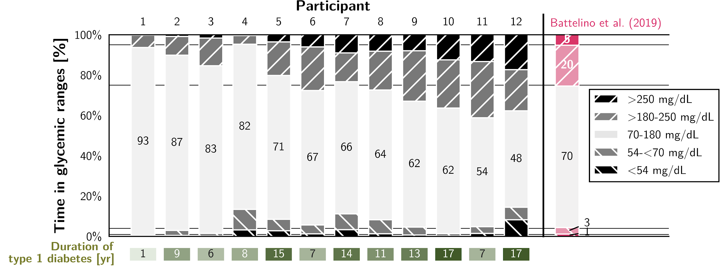

**(b)**

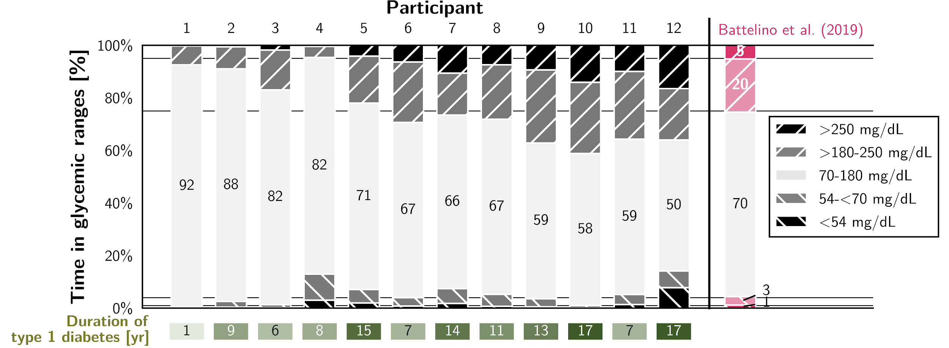

**(c)**

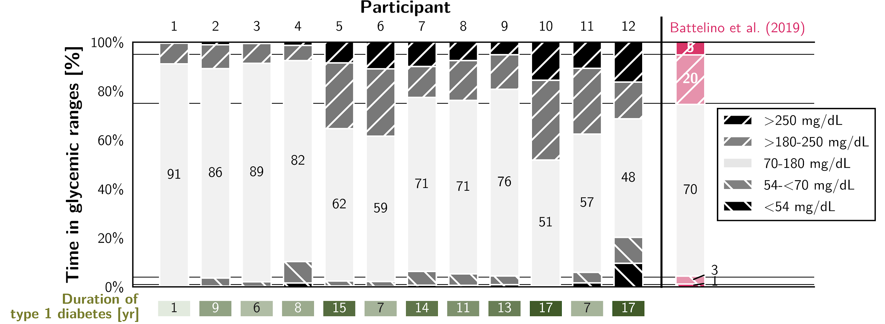

**(d)**

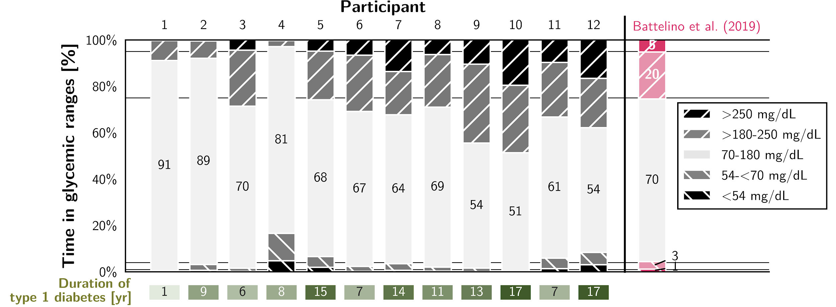

**(e)**

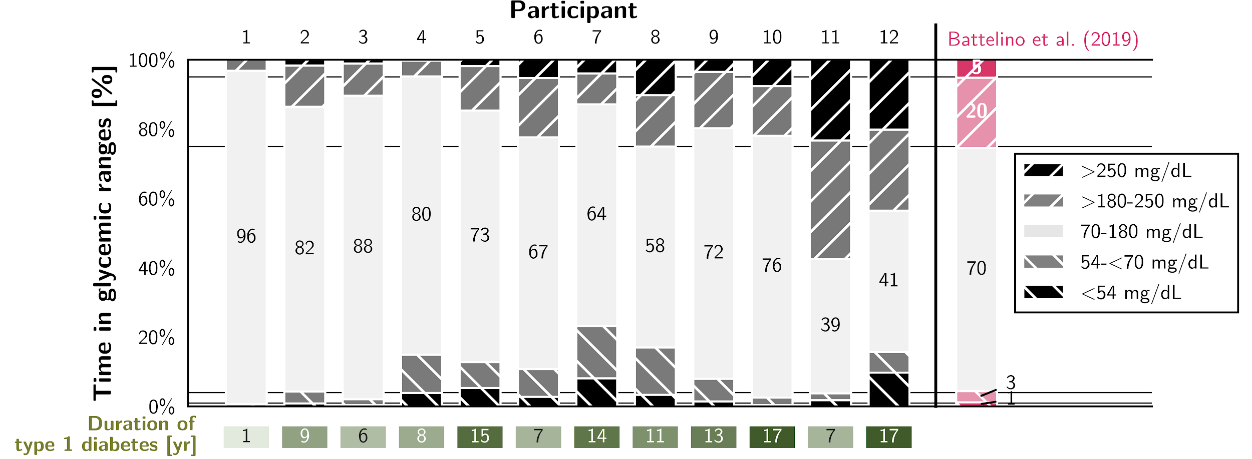

Time in glycemic ranges [%] during (a) the entire day, (b) wake, (c) exercise, (d) recovery, and (e) sleep phases, for (n=12) individual male professional cyclists over the course of a competitive season. Duration of type 1 diabetes [yr] is displayed in the boxes below, where a darker shade indicates a longer duration of type 1 diabetes. Athletes are sorted by descending time in range during the entire day. As a reference, recommended clinical targets according to Battelino et al. (16) are displayed on the right-hand side.

**FIGURE 2. Associations of Exercise with Dysglycemia**

**(a)**

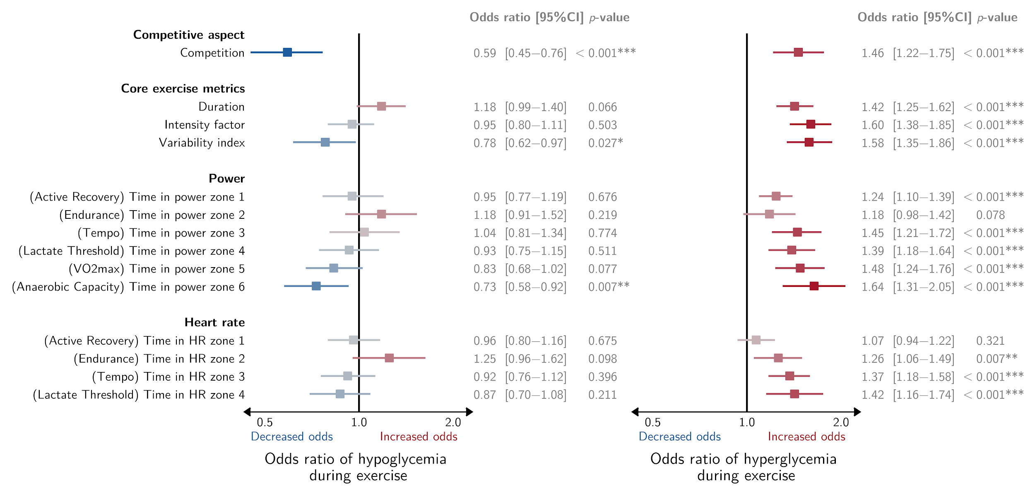

**(b)**

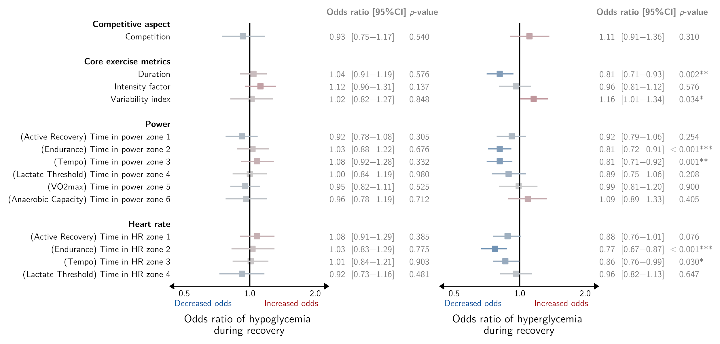

**(c)**

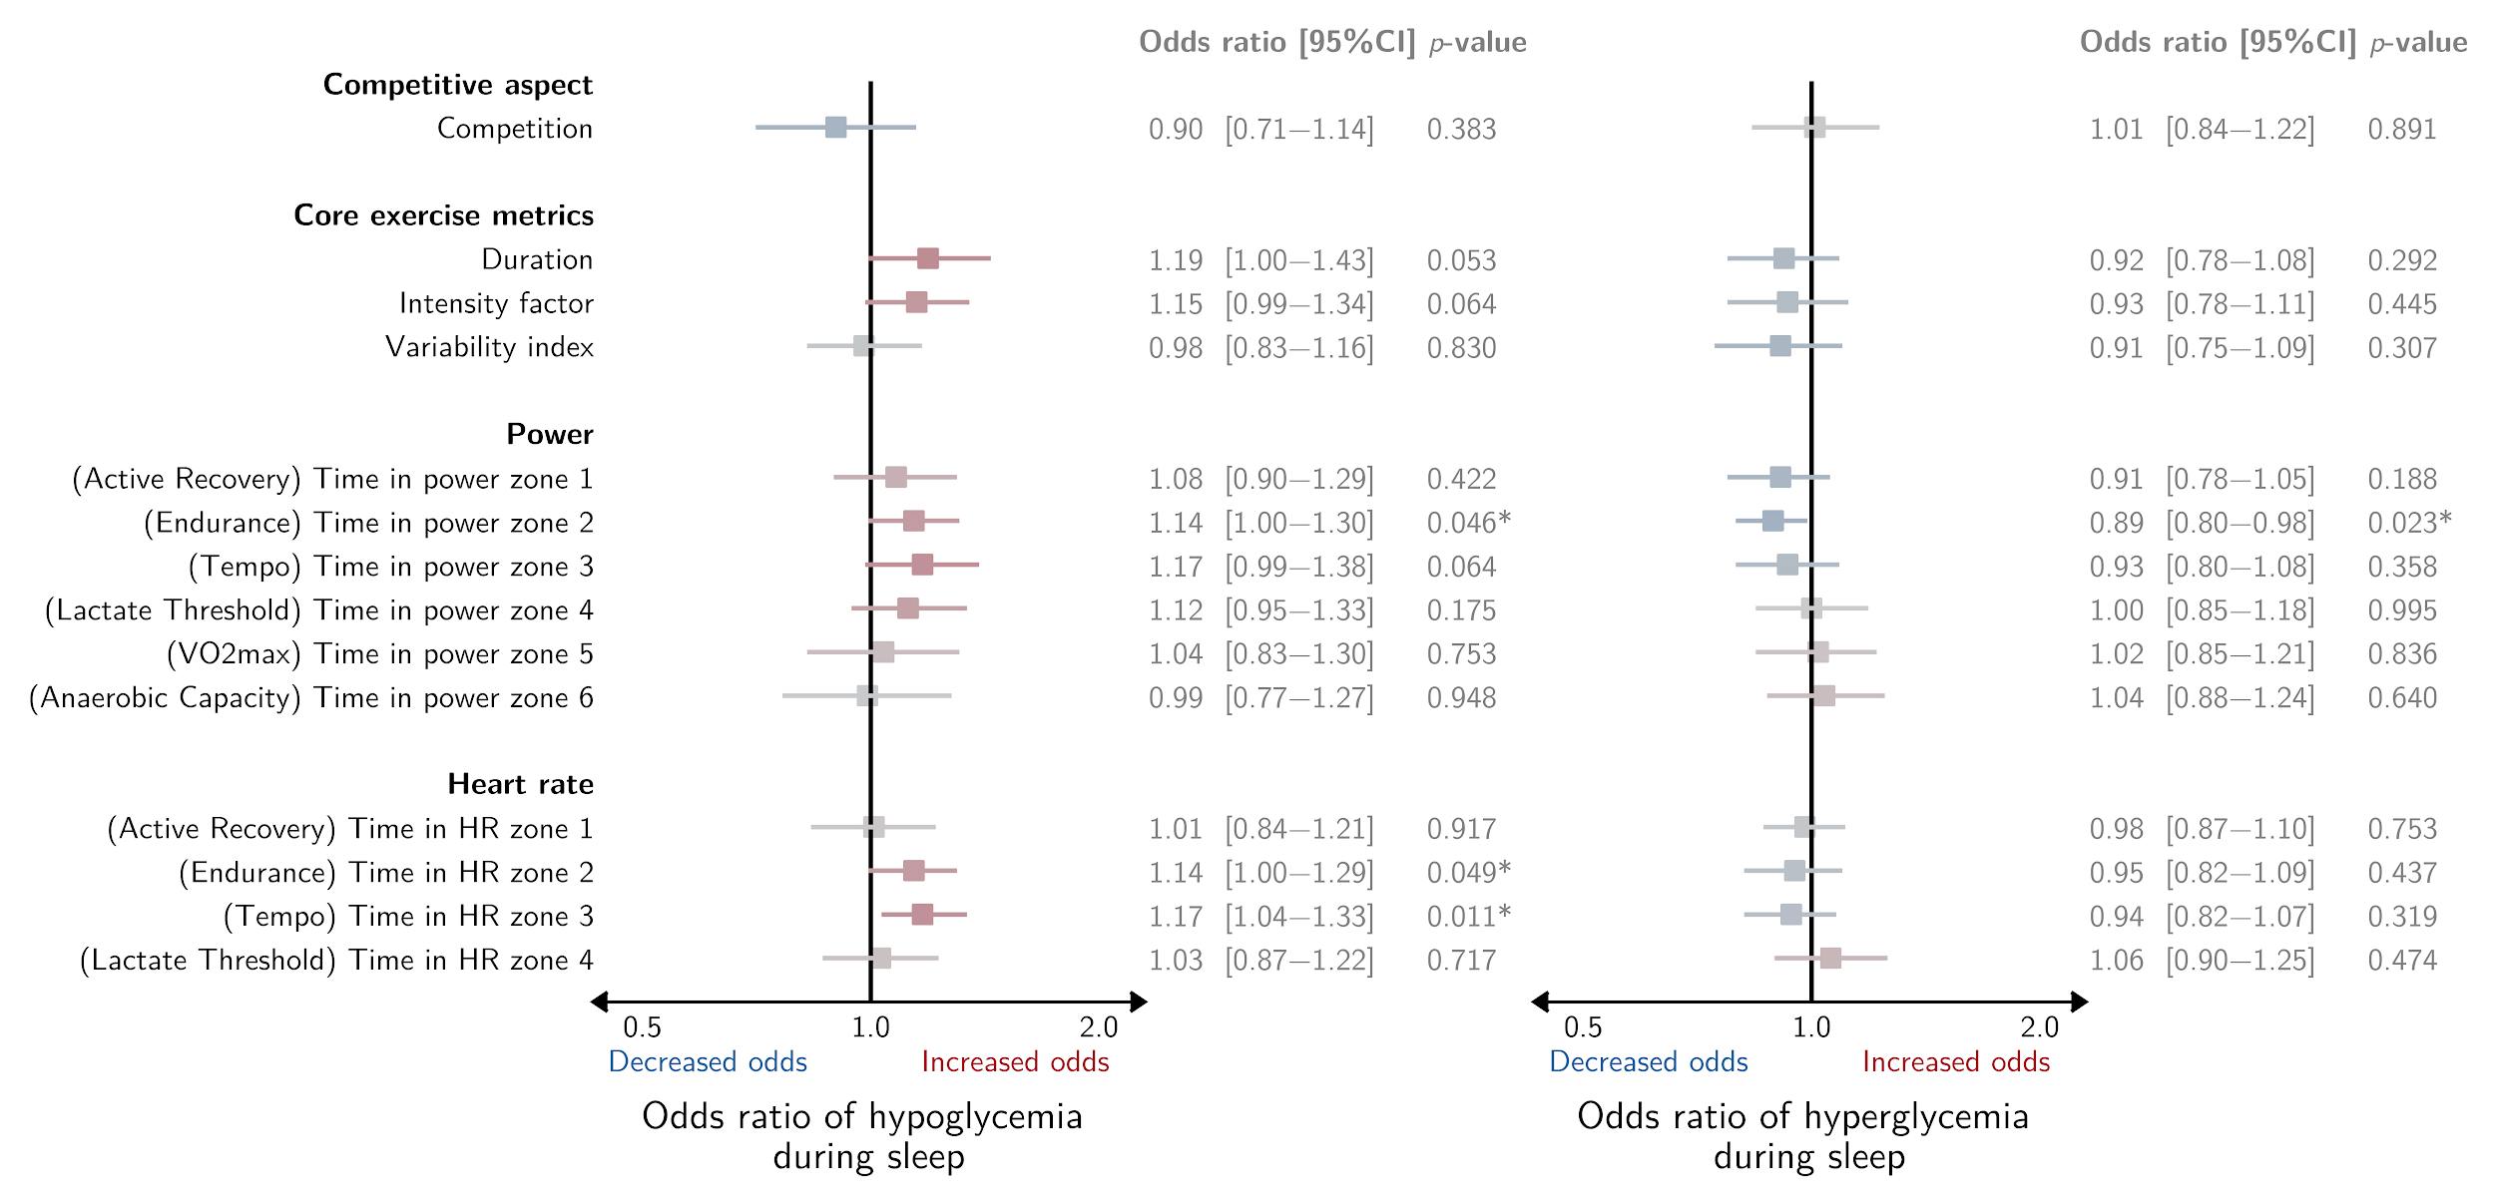

Estimated standardized associations of the exercise variables with the odds ratio of hypo- and hyperglycemia during (a) exercise, (b) recovery, and (c) sleep. Listed are odds ratio [95% CI] and *p-*value. Significance is indicated with *** (*p*<0.001), ** (*p*<0.01), and * (*p*<0.05). Associations are presented on a logarithmic scale and vary in color, where a darker blue/red color represents a stronger association. The colors blue and red demonstrate a decrease and increase in odds ratio, respectively. Note that “Time in HR zone 5 (Anaerobic Capacity)” is excluded from the analysis due to the large number of zero values (i.e., 82%). Abbreviations: CI = confidence interval.