StudyNest — Experimental Plan
Oct 25, 2026 · @FaZaSu
Interface Style and Trust in Deceptive Design · HCI research project, Phase 1
Fatima Irfan (29294) · Sumaiya Batool (29295) · Zainab Irfan Ansari (29091) · Slot 101623, 2:30 pm
We will run a between-subjects pilot experiment with 15–20 adults. Each participant uses one version of a fictional study-planner app, StudyNest, styled either like an iPhone app or like an Android app. Both versions show the same deceptive free-trial offer. We will measure trust, detection of the hidden renewal charge, and whether participants subscribe. The experiment runs entirely in a working web app that participants open on their own phone; it handles consent, random assignment, interaction logging, questionnaires and debriefing.

Background and research question
Li, Flatla and Arndt (2025) reviewed the same 143 apps on both platforms and found 1,477 deceptive-pattern instances on iOS and 1,398 on Android. iOS apps had significantly more confirmshaming and visual interference. The authors also note that iPhone users tend to see their platform as safer, which may make them less alert to these tricks. Their study compared interfaces only; it did not test how users respond.
We test that missing step. If the deceptive pattern is held identical and only the platform styling changes, does the styling alone change how people react?
Research question: How do iOS-style and Android-style interfaces affect perceived trustworthiness when presenting the same deceptive pattern?
Secondary questions: does styling change whether participants notice the hidden renewal charge, and whether they avoid the unwanted subscription?

Hypotheses
H1 is the primary hypothesis. H2–H5 are secondary and exploratory. All are two-sided: we do not predict which style will score higher.
ID | Hypothesis | Status
H1 | Trust ratings differ between the iOS-style and Android-style versions. | Primary
H2 | The proportion of participants who end up in a paid plan (susceptibility) differs between styles. | Secondary
H3 | Attention to the offer differs: time the disclosure text is on screen, time on the offer screen, decision speed, and "View details" taps. | Exploratory
H4 | Participants who believe iOS protects users better detect the hidden charge at a different rate from others. | Exploratory
H5 | Longer visibility of the disclosure text predicts detection, controlling for style and own platform. | Exploratory

Study design
A between-subjects experiment with one independent variable and two levels. Each participant sees only one version, so no one can compare the two.
Element | Definition
Independent variable | Interface style: iOS style (Apple Human Interface Guidelines) or Android style (Material Design 3)
Primary dependent variable | Trust: mean of five 7-point items
Secondary dependent variables | Susceptibility (outcome of the offer), detection of the renewal charge, attention measures from the interaction log
Held constant | All text, prices, dates, element order, app logic, and the size, colour and spacing of the three deceptive elements
Allowed to vary | Typeface, control shapes, navigation chrome (status bar, header, tab bar) and purchase-sheet layout
Covariates | Own phone platform, years of use, belief about which platform is safer, confidence with new apps
Randomisation. Stratified block randomisation with a block size of 2. Participants are grouped by the phone they use most (iPhone, Android, other). Within each group, every two participants are randomly given one of each style, so the styles stay balanced within each platform group. The app assigns styles automatically; researchers cannot choose who gets which.

Participants
Target: 15–20 adults, about 7–10 per style, plus 2–3 pilot participants kept outside the main sample.
- Eligibility: 18 or older, owns or regularly uses a smartphone. No other restrictions.
- Recruitment: all three team members recruit from fellow students and personal contacts. Each facilitator runs sessions in both styles, because the app assigns the style, not the facilitator.
- Exclusions (decided now, applied in analysis): demo and test sessions; sessions not completed; sessions where the app task took under 15 seconds; pilot sessions.
- Data removal: a participant can ask for their data to be removed by giving us the ID shown on their debrief screen.

Materials: the StudyNest app
StudyNest is a fictional study-planner web app built for this experiment (React and TypeScript, hosted online). Participants open one link on their phone. It has two onboarding screens, a home screen with study decks, and a locked "Practice tests" feature that opens a subscription offer (the paywall). No real payment, account or personal details are involved.
The offer. A Yearly plan with "7 DAYS FREE" (Rs 250/month, billed yearly) is preselected, and so is a box labelled "Continue with Plus after my free trial". The main button reads "Start my free trial". Tapping it opens a store-style purchase sheet. If the participant subscribes with the defaults, the free trial silently becomes a Rs 2,999 yearly plan.
The three deceptive patterns (types from Li et al. 2025 and Deceptive.design):
Pattern | How it appears | Fixed styling in both versions
Visual interference | The yearly charge is in small grey text under the large button | 11 px, colour #8E8E93, contrast 3.26:1
Preselection | The auto-renew box is ticked by default | 13 px label, colour #3C3C43
Confirmshaming | The decline link reads "No thanks, I'll keep studying the hard way" | 13 px, colour #8E8E93
One app, two styles. Both versions come from a single codebase, and the style is the only setting that changes. The same words appear in the same order with the same logic.
Equivalence checks. Before data collection we confirm the two versions present the deceptive elements equally:
- The researcher panel's Equivalence tab measures both offer screens live. Font size, contrast, area and spacing of the deceptive elements must all be within 10%; in current measurements they are identical.
- Automated tests confirm the visible offer text is word-for-word identical in both versions, and that the same taps produce the same sequence of logged events.
- A visual-saliency check estimates how much of each screen's visual attention falls on the disclosure text. The difference is 2.8% at our chosen image resolution, within the 10% tolerance, but varies with resolution (up to 17%), so we treat it as supporting evidence only.

Procedure
Each session takes about 20–25 minutes in person, of which about 8 minutes are in the app. The participant uses their own phone where possible.
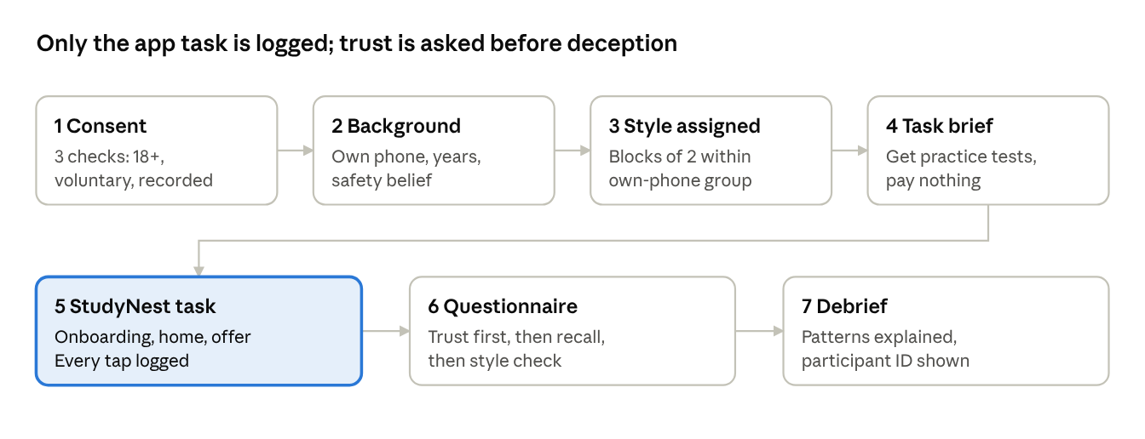
session flow · 7 steps, about 8 minutes in the app
The participant cannot go back between steps. Trust is rated before any question mentions anything misleading, so the later questions cannot bias it.
Facilitator script (same wording for all three facilitators):
- "We're testing a study-planner app. It takes about 20 minutes. Please open this link on your phone."
- Stay neutral during the task. Do not mention prices, trials or tricks. If asked for help, say: "Do whatever you would normally do."
- Record observations on the observation sheet: hesitations, comments, re-reading the offer.
- After the debrief, ask: "Did you notice anything about the offer while you were using it?" Note the answer.
- Ask the participant not to tell others about the study until data collection ends.

Measures
Trust (primary). Five items rated 1–7 (Strongly disagree to Strongly agree), averaged into one score. The items are adapted from common trust-in-website and app scales; the final wording must be agreed with the instructor before testing.
- StudyNest was honest about what I was agreeing to.
- I would trust StudyNest with my payment details.
- StudyNest seemed to act in my interest.
- The offer screen was clear and straightforward.
- I would feel comfortable using StudyNest.
Susceptibility (behaviour). Recorded automatically from the participant's final action on the offer:
Final action | Outcome | Susceptible
Subscribe, Yearly with auto-renew on | trial_autorenew | Yes
Subscribe, Monthly | paid_monthly | Yes
Subscribe, Yearly with auto-renew off | trial_no_renew | No
Tap the decline link | declined | No
Close the offer | closed | No
Attention (interaction log). The app logs every tap with its position and time. From this we derive time the disclosure text was at least 50% on screen, time on the offer screen, time from opening the offer to the first decision, "View details" taps, and toggles of plan and auto-renew.
Detection (coded). Two open questions, answered before any question about deception: "What happens when the free trial ends?" and "Will you be charged anything? If yes, how much and when?" Two team members code each answer independently as detected, partly or not, then resolve disagreements. The code is "detected" only if the answer names an automatic charge after the trial. Declining the offer alone is not counted as detection.
Other measures. Whether anything seemed misleading (yes, no, not sure, plus what); a manipulation check (which platform the app looked designed for); and familiarity of the look and feel (1–7).

Analysis plan
Data is exported from the researcher panel as CSV and JSON and analysed in Python (pandas, SciPy, statsmodels). The analysis scripts are already written and tested on a synthetic dataset, so the same code runs on the real data.
Hypothesis | Test | Reported
H1 trust | Mann–Whitney U on mean trust | Medians, rank-biserial r with bootstrap 95% CI
H2 susceptibility | Fisher's exact test, style × susceptible | Proportions with Wilson 95% CI, odds ratio
H3 attention | Mann–Whitney U on disclosure time, offer-screen time, decision time | Medians; counts of "View details" taps
H4 safety belief | Fisher's exact test, believes iOS safer × detected | Proportions, odds ratio
H5 visibility | Logistic regression: detected ~ disclosure time + style + own platform | Odds ratios; descriptive only if the model cannot be fitted
- Main analysis uses participants who passed the manipulation check (correctly identified the platform style). We then repeat every test on all complete sessions.
- Descriptives: results for participants whose own phone matches the style they saw versus those who don't; box plots per style; tap heatmaps on the offer screen.
- Coding reliability: percent agreement between the two coders.
- Small sample: with about 7–10 per style, estimates will be uncertain. We report effect sizes and confidence intervals, not only p-values. A non-significant result does not show that the styles are equivalent.

Pilot, timeline and responsibilities
Pilot. Before the main study we run 2–3 pilot sessions with people outside the main sample. We check that the task is clear, the questionnaire wording works, and the logs record correctly. After any revisions the app and materials are frozen. Pilot IDs are listed in a file and excluded from analysis.
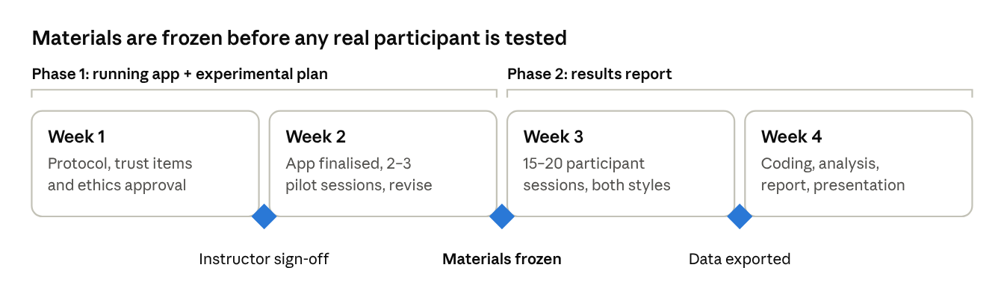
four-week schedule · 3 gates
No participant data is collected until the instructor has approved the trust items and the course ethics process is complete.
Member | Lead responsibility | Shared
Member 1 | Related work, study planning, measures, methodology writing | Recruitment, sessions in both styles, report
Member 2 | Building the app and documenting design decisions | Recruitment, sessions in both styles, report
Member 3 | Recruitment coordination, dataset management, analysis | Recruitment, sessions in both styles, report
Two members will code the recall answers independently; the team assigns who before coding starts.

Ethics
- Consent: participants confirm they are 18 or older, that taking part is voluntary, and that their anonymous answers and taps are recorded. They can stop at any time.
- Deception and debrief: the study withholds its real purpose until the end, so the deception does not change behaviour. The debrief explains all three patterns and the two styles, and the consent screen warns that some details come at the end.
- No harm: no real payment, account or payment details. Nobody is charged. No Apple or Google names or logos appear.
- Privacy: no names, emails, phone numbers or locations are collected. Each session has a random ID such as SN-4K7QX.
- Approval: the course's required ethics process is completed before recruitment.

Limitations
- With 7–10 participants per style, only large effects can be detected; inconclusive results will not show equivalence.
- Familiarity and visual appearance are mixed together: an effect could come from the style itself or from whether it matches the participant's own phone. We record own platform to explore this.
- A fictional app in a study setting is not the same as a real purchase, so susceptibility may be lower or higher than in real life.
- The results cannot speak to app-store reputation or show that one whole design system is more trustworthy.

References
Li, W., Flatla, D. R., & Arndt, F. (2025). Divergent deceptions: comparative analysis of Deceptive Patterns in iOS and Android apps. Behaviour & Information Technology, 44(16), 3879–3908. https://doi.org/10.1080/0144929X.2025.2452359
Brignull, H., Leiser, M., Santos, C., & Doshi, K. (2023). Deceptive Patterns. https://www.deceptive.design/

