CS 2050 Homework Assignment 3
Due date: TBD

Directions:
Complete the following homework assignment using the description given in each section.

Purpose:
- Understanding insertion and traversal of binary trees.
- Level by Level (Breadth First Search) searching in the binary tree.
Submission information:
Submit this assignment through Blackboard by the deadline – NO LATER! It must be submitted before the due date. Not doing so WILL result in a zero, no exceptions. If you are even one minute late in your submission, Blackboard will close down and your TA will not make an exception for you.

Description:
A template file has been provided to you that explain all of the functions that must be implemented in detail, along with a sample input files. There is no output file required.
Keep the following things in mind as you work:
- You must check for the proper number of command line arguments, as well as success when opening files. You should display an error message if any of these checks fail.
- You are responsible for closing any files that you open. Failure to do so will result in a loss of points.
- You ARE responsible for freeing memory that you allocate.
Sample output

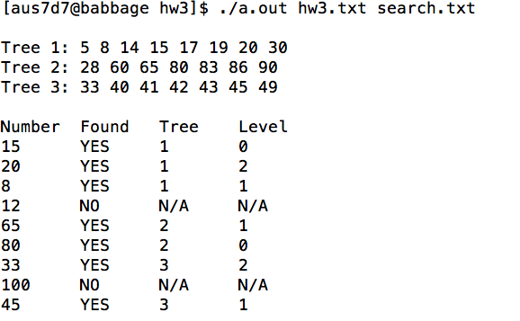
Guidelines for grading HW 1 - 50 points possible
If your program does not compile, does not link, or fails to produce any output, your homework will receive a grade of ZERO. If your program segfaults or infinitely loops you will receive a severely reduced grade. ALWAYS COMPILE IMMEDIATELY BEFORE SUBMITTING YOUR CODE. To be safe, you should download your submission from Blackboard and verify its contents. If your submission fails for any reason and you do not notify your TA in advance, before the due date, you will receive a grade of ZERO.
If your program uses global variables including global arrays/pointers, you will receive a grade of ZERO.
To receive partial credit, your program must correctly provide output that includes some results from your program.

15 points – BFS function
8 points – main function
8 points – insert_bTree function
8 points – free_bTree
6 points – print_bTree_inorder
3 points – free_list
2 points – printTrees

In Addition to the functions listed above there are other functions that are listed in the template file. Please make sure that you use them, as they will only help in reaching the solution easily.
In addition to these requirements, you can lose up to 10 points on the homework if your code is poorly formatted, poorly commented, or does not adhere to good code style. You should follow basic good practice: indent code within curly braces, give your variables meaningful names, and comment every block of code that is logically distinct from the block before it.

