
Dissertation on
“DreamDrive: Proactive Multi-Future Prediction for Safe Autonomous Navigation in Chaotic Mixed Traffic”

Submitted in partial fulfilment of the requirements for the award of degree of

Bachelor of Technology in
Computer Science & Engineering
UE23CS320B – Capstone Project Phase - 2
Project_ID: PW26_CGM_04

Submitted by:

Idhant Singh Rishav Ghosh Shagal Verma  Shourya Rai | PES1UG23CS250 PES1UG23CS478 PES1UG23CS531  PES1UG23CS552

Under the guidance of

Prof. Chitra G M Asst. Professor PES University

January - May 2026
DEPARTMENT OF COMPUTER SCIENCE AND ENGINEERING
FACULTY OF ENGINEERING
PES UNIVERSITY
(Established under Karnataka Act No. 16 of 2013) 100ft Ring Road, Bengaluru – 560 085, Karnataka, India

PES UNIVERSITY
(Established under Karnataka Act No. 16 of 2013)
100 Feet Ring Road, Bengaluru – 560 085, Karnataka, India
FACULTY OF ENGINEERING

CERTIFICATE
This is to certify that the dissertation entitled

“DreamDrive: Proactive Multi-Future Prediction for Safe Autonomous Navigation in Chaotic Mixed Traffic”
is a bonafide work carried out by

Idhant Singh Rishav Ghosh Shagal Verma  Shourya Rai | PES1UG23CS250 PES1UG23CS478 PES1UG23CS531  PES1UG23CS552

in partial fulfilment for the completion of sixth semester Capstone Project Phase - 2 (UE23CS320B) in the Program of Study - Bachelor of Technology in Computer Science and Engineering under rules and regulations of PES University, Bengaluru during the period Jan 2026 – May 2026. It is certified that all corrections / suggestions indicated for internal assessment have been incorporated in the report. The dissertation has been approved as it satisfies the 6th semester academic requirements in respect of project work.

Signature  Prof Chitra G M  Asst Professor | Signature Dr. Shylaja S S  Chairperson | Signature Dr. K S Sridhar  Registrar

External Viva

Name of the Examiners  1.  2. | Signature with Date

DECLARATION

We hereby declare that the Capstone Project Phase - 2 entitled “DreamDrive: Proactive Multi-Future Prediction for Safe Autonomous Navigation in Chaotic Mixed Traffic” has been carried out by us under the guidance of Prof. Chitra G M, Asst. Professor and submitted in partial fulfilment of the course requirements for the award of degree of Bachelor of Technology in Computer Science and Engineering of PES University, Bengaluru during the academic semester Jan - May 2026. The matter embodied in this report has not been submitted to any other university or institution for the award of any degree.

Idhant Singh Rishav Ghosh  Shagal Verma Shourya Rai | PES1UG23CS250 PES1UG23CS478  PES1UG23CS531 PES1UG23CS552

ACKNOWLEDGEMENT

I would like to express my gratitude to Prof. Chitra G M, Department of Computer Science and Engineering, PES University, for his/her continuous guidance, assistance, and encouragement throughout the development of this UE23CS320B - Capstone Project Phase – 2.
I am grateful to the project coordinator, Prof. Gayathri R S, for organizing, managing, and helping with the entire process.
I take this opportunity to thank Dr. Shylaja S S, Chairperson, Department of Computer Science and Engineering, PES University, for all the knowledge and support I have received from the department. I would like to thank Dr. K.S. Sridhar, Registrar, PES University for his help.
I am deeply grateful to Prof. Jawahar Doreswamy, Chancellor – PES University, Dr. Suryaprasad J, Vice-Chancellor, PES University for providing to me various opportunities and enlightenment every step of the way. Finally, this project could not have been completed without the continual support and encouragement I have received from my family and friends.

ABSTRACT

Current autonomous driving systems rely primarily on reactive decision-making, predicting a single, most-likely future path for surrounding agents. This approach fails in chaotic, unstructured traffic environments such as those found in India, where pedestrians, rickshaws, and two-wheelers behave unpredictably. There is a pressing need for a proactive prediction model that does not depend on a single deterministic forecast but instead simulates multiple possible futures.
DreamDrive addresses this challenge by enabling autonomous vehicles to anticipate risks before they occur, ensuring safer navigation in mixed-traffic environments. The system imagines and evaluates multiple possible futures — for instance, predicting that a pedestrian has an 80% chance of walking straight, a 15% chance of slowing down, and a 5% chance of suddenly crossing — thereby allowing the vehicle to proactively plan for rare but dangerous events.
In Phase 2, the project scope was narrowed to vehicle-to-vehicle interactions for reliable model development. A comprehensive benchmarking study was conducted on the IDD-3D dataset, evaluating models including Constant Velocity (CV), MLP, ST-GAT, MFP (Oracle and Learned variants), and Trajectron++. Key findings reveal that MFP (Oracle) achieves the lowest Average Displacement Error (ADE) while Trajectron++ achieves the best Final Displacement Error (FDE). A critical performance gap was identified: Trajectron++ suffers a 66% increase in ADE and a 131% increase in FDE when evaluated on collision-intensive scenarios versus normal driving data, highlighting the underrepresentation of safety-critical events in real-world datasets.
To address this gap, 600 synthetic collision scenes were generated, of which 32 passed rigorous physical validity checks covering speed realism, history validity, and future collision relevance. Additionally, the CARLA simulator was configured with approximated Indian traffic behaviors to support scenario-based evaluation. Future phases will focus on fine-tuning Trajectron++ on collision-rich synthetic data, extending agent heterogeneity to include pedestrians and two-wheelers, and integrating prediction with safety-aware planning.

TABLE OF CONTENTS

Chapter No. | Title | Page No.
1. | INTRODUCTION | 9
2. | LITERATURE SURVEY | 13
3. | ARCHITECTURE WITH EXPLANATION | 20
4. | METHODOLOGY | 13
5. | IMPLEMENTATION (Salient Modules) | 21
6. | RESULTS | 21
7. | CONCLUSION AND FUTURE WORK | 26
8. | REFERENCES/BIBLIOGRAPHY | 28

LIST OF FIGURES

Figure No. | Title | Page No.
5.1 | IDD-3D Visual Data Sample – Camera Sequence Frame 1
5.2 | IDD-3D Visual Data Sample – Camera Sequence Frame 2
5.3 | IDD-3D Visual Data Sample – Camera Sequence Frame 3
5.4 | IDD-3D 3D Data Sample – LiDAR Point Cloud View 1
5.5 | IDD-3D 3D Data Sample – LiDAR Point Cloud View 2
5.6 | IDD-3D 3D Data Sample – LiDAR Point Cloud View 3
6.1 | DreamDrive System Architecture – High-Level Pipeline Overview
6.2 | DreamDrive Architecture – Data Preparation and Trajectory  Construction Stage
6.3 | DreamDrive Architecture – Model Training and Prediction Stage
6.4 | DreamDrive Architecture – Quantitative Evaluation Stage
6.5 | Use Case Diagram – DreamDrive Autonomous Navigation System
8.1 | Collision Density Heatmap – Distribution of Synthetic Collision  Scenes
8.2 | Trajectory Comparison – Ground Truth vs. Predicted Trajectories on  Collision Data
8.3 | Synthetic Data Composition – Breakdown of Scene Types After  Filtering
8.4 | Change in Near-Miss Augmentation – Before and After Synthetic Data  Integration
9.1 | CARLA Simulation – Indianized Traffic Scenario View 1
9.2 | CARLA Simulation – Indianized Traffic Scenario View 2

LIST OF TABLES

Table No. | Title | Page No.
3.1.1 | Comparison of Pedestrian Forecasting Performance (Trajectron++ vs. S-GAN on ETH Dataset)
3.4.1 | Analysis of Generative Architectures (GAN, CVAE, Diffusion)
3.5.1 | Impact of Vehicle Type Conditions on Traffic Flow in Lane-less Scenarios
4.1 | Design Constraints – Dataset, Computational, and Simulation Limitations
6.1 | Data Exploration Summary – IDD-3D Dataset Scale and Format
7.1 | Benchmark Comparison – All Models on IDD-3D Dataset (Phase 2 Review 1)
7.2 | Trajectron++ Performance Degradation on Collision Scenarios (Phase 2 Review 2)
8.1 | Synthetic Data Validity Checks – Criteria and Results

CHAPTER 1

INTRODUCTION

Overview
Autonomous driving technology has made significant strides in structured environments where traffic rules are strictly followed. However, current systems rely primarily on reactive decision-making, predicting a single, most-likely future path for surrounding agents. For example, a standard model might predict that a pedestrian will keep walking straight along the edge of the road.
This approach fails in the chaotic, unstructured traffic environments typical of developing nations like India. In such mixed-traffic scenarios, pedestrians, rickshaws, and two-wheelers behave unpredictably, often violating standard traffic norms. DreamDrive aims to bridge this gap by introducing a proactive, multi-future prediction framework that enables autonomous systems to imagine and evaluate multiple possible futures rather than relying on a single forecast.
Phase 2 of the project advances significantly beyond the foundational work of Phase 1. The scope has been refined to focus on vehicle-to-vehicle interactions, a comprehensive model benchmarking study has been completed, a critical safety performance gap has been identified and quantified, and initial steps toward synthetic data augmentation and CARLA simulation have been undertaken.

Motivation
The motivation for this project stems from the critical safety limitations of deterministic (single-future) models in chaotic environments. The key motivating factors are:
    - The Failure of Single-Future Models: In structured traffic, assuming a single path is often sufficient. However, in Indian traffic, an agent's intent is rarely singular. A pedestrian standing near a curb might continue walking (80%), slow down (15%), or suddenly dart across the road (5%). A model that ignores the 5% risk of crossing creates a significant safety hazard.
    - The Need for Proactive Navigation: To navigate safely, an autonomous vehicle must not just react to what is happening now, but proactively anticipate what might happen next. By continuously estimating the likelihood of diverse agent behaviors, the system can anticipate potential hazards — such as a rickshaw cut-in or pedestrian dart-out — before they occur.
    - Safety-Critical Data Scarcity: As demonstrated in Phase 2 benchmarking, real-world datasets severely underrepresent collision and near-collision scenarios. This creates a dangerous blind spot where models perform adequately on routine driving but fail precisely when safety matters most. Trajectron++ exhibited a 66% increase in ADE and a 131% increase in FDE on collision-intensive data compared to normal data.

    - Bridging the Gap: Most existing research focuses on structured US or European datasets (e.g., Argoverse, Waymo, nuScenes). There is a pressing need to validate and adapt these advanced multi-future models specifically for the chaotic dynamics of the IDD-3D (Indian Driving Dataset).

Objectives
The primary objectives of the DreamDrive project are:
- Dataset Preparation: To consolidate and standardize the IDD-3D dataset for training, and to acquire and process standard American datasets (Argoverse, Waymo, or nuScenes) to serve as a structured baseline for comparison.
- Multi-Model Evaluation: To implement and compare various trajectory prediction models — including Constant Velocity (CV), MLP, ST-GAT, MFP, and Trajectron++ — to identify the best performer for chaotic environments using ADE and FDE metrics.
- Collision Scenario Augmentation: To generate synthetic collision-rich scenes that pass physical validity checks, in order to augment training data and improve model robustness on safety-critical edge cases.
- Simulation Integration: To develop a proactive multi-future prediction system integrated into the CARLA autonomous driving simulator, with approximated Indian traffic behaviors including lane-less driving and informal overtaking.
- Comparative Analysis: To compare simulation results between Indian (chaotic) and American (structured) environments to quantifiably demonstrate the model's adaptability and robustness.

CHAPTER 2

PROBLEM DEFINITION

The Core Problem
The fundamental problem addressed by this project is the inadequacy of deterministic trajectory prediction in mixed, chaotic traffic conditions. Existing autonomous driving stacks typically utilize a modular pipeline where the prediction module outputs a single trajectory for each agent. This deterministic output is then passed to the planning module.
In structured Western traffic, this assumption often holds true. However, in Indian traffic conditions, the lane-less behavior of vehicles and the erratic movements of pedestrians create a high-entropy environment. A system that assumes a single future path is prone to:
    - Collision Risks: Failing to anticipate sudden cut-ins or dart-outs.
    - Freezing Robot Problem: Being overly conservative and stopping indefinitely because the single predicted path is blocked, whereas a multi-future model might find a safe gap.
    - Safety-Critical Failure: As demonstrated empirically in Phase 2, models trained on normal data exhibit catastrophic degradation when evaluated on collision scenarios, with ADE rising by 66% and FDE by 131%.

Existing Research Gaps
Through analysis conducted in both Phase 1 and Phase 2, we have identified the following critical gaps:
- Chaotic Environment Adaptation: Existing models are heavily optimized for structured US/European traffic and do not account for chaotic, mixed traffic environments like those in India.
- Integration of Planning and Prediction: There is limited work that successfully integrates multi-future prediction with uncertainty-aware planning in real-time within accessible simulation environments like CARLA.
- Dataset Bias: Dominant datasets (Argoverse, Waymo, nuScenes) lack the density and heterogeneity of Indian traffic.
- Collision Scenario Underrepresentation: Real-world datasets naturally contain very few collision and near-collision events, causing trained models to perform poorly in precisely the scenarios where safety is most critical.

Proposed Solution Scope
Based on feedback from Phase 1 reviewers, the project scope was narrowed in Phase 2 to focus on vehicle-to-vehicle interactions. This allows reliable model development before extending to heterogeneous agents. The solution proceeds through three stages:

- Scoped Focus: The current phase is limited to vehicle-dominant scenes from the IDD-3D dataset to ensure reliable model development. Only vehicle-to-vehicle interactions are considered for training and evaluation.
- Phased Extension: The pipeline is designed to later incorporate pedestrians, two-wheelers, and rickshaws without requiring redesign, enabling gradual extension of agent heterogeneity.
- Collision Augmentation: Synthetic collision data is generated and validated to augment real-world training data, directly addressing the underrepresentation of safety-critical scenarios.
The solution measures performance using Average Displacement Error (ADE) and Final Displacement Error (FDE) across both normal and collision-intensive data splits, ensuring holistic evaluation of safety-relevant prediction quality.

CHAPTER 3

LITERATURE SURVEY

  - Trajectron++: Dynamically-Feasible Trajectory Forecasting with Heterogeneous Data
Authors: Tim Salzmann, Boris Ivanovic, Punarjay Chakravarty, and Marco Pavone, 2021

Methodology and Formulation
Trajectron++ addresses the challenge of predicting human motion by abstracting the scene into a spatiotemporal graph. A key innovation is the integration of vehicle dynamics into the prediction loop to ensure dynamic feasibility. Agent influence is defined using the perception range formula:
‖ pi − pj ‖₂ ≤ dSj
where pi and pj are positions of agents, and dSj is the perception range specific to the agent type. To capture uncertainty, the model employs a Conditional Variational Autoencoder (CVAE) with a discrete categorical latent variable z (|Z| = 25 distinct high-level behaviors) representing intents such as turning or accelerating. The CVAE maximizes the Evidence Lower Bound (ELBO) to ensure a meaningful learned latent space. The model predicts control actions u (acceleration, heading rate) rather than positions, ensuring dynamic feasibility.

Key Findings
Table 3.1.1: Comparison of Pedestrian Forecasting Performance (Trajectron++ vs. S-GAN on ETH Dataset)
Model | ADE | FDE | Note
S-GAN | 0.81 | 1.52 | Baseline
Trajectron++ | 0.39 | 0.83 | Significant reduction
On nuScenes vehicle forecasting, dynamics integration reduced collision rates from 21.5% to 4.9% in critical edge cases.

Driving into the Future: Multiview Visual Forecasting and Planning with World Model for Autonomous Driving
Authors: Yuqi Wang, Jiawei He, Lue Fan, Hongxin Li, Yuntao Chen, Zhaoxiang Zhang, CVPR 2023/24

Methodology and Formulation
This paper introduces Drive-WM, a world model using Factorized Generation to ensure consistency across multiple camera views. It addresses out-of-distribution (OOD) planning failure via the Denoising Score Matching Objective and employs Simplified Factorization separating views into Reference (xr) and Stitched (xs) components.

Key Findings
    - Key Points Matching (KPM): Factorized generation improved the KPM score from 45.8% to 94.4%.
    - OOD Recovery: In scenarios where the car was 0.5m off-center, the world model allowed the planner to imagine a recovery path, whereas standard planners failed.

EMMA: End-to-End Multimodal Model for Autonomous Driving
Authors: Jyh-Jing Hwang et al., 2024

Methodology and Formulation
EMMA processes driving tasks using Chain-of-Thought (CoT) reasoning, breaking decision-making into four explicit steps: (R1) scene description, (R2) critical object identification, (R3) behavior analysis, and (R4) meta-decision. It reframes driving as a visual Question-Answering task using the Gemini model and predicts trajectory waypoints conditioned on intent and ego-history.

Key Findings
    - On the nuScenes dataset, EMMA outperformed the leading self-supervised model (BEV-Planner) by 17.1% in L2 distance error.
    - Co-training on multiple tasks (detection + planning) improved performance on all tasks, validating the generalist approach.

A Survey of Autonomous Driving Trajectory Prediction
Authors: Miao Xu, Zhi Liu, Bingyi Wang and Shengyan Li, 2022

Key Metrics Defined
    - Average Displacement Error (ADE): Average Euclidean distance between predicted and true trajectories over all time steps.
    - Final Displacement Error (FDE): Euclidean distance at the final predicted endpoint only.
    - Negative Log Likelihood (NLL): Measures how well the model-predicted trajectory distribution matches the true trajectory.
Table 3.4.1: Analysis of Generative Architectures (GAN, CVAE, Diffusion)

Model | Core Principle | Key Trade-offs
GAN | Two-player game (Generator vs Discriminator) | Realistic paths but prone to mode collapse (limited variety)
CVAE | Learns a latent space of intents (z) | Stable training but outputs can be overly smooth/conservative
Diffusion | Denoising process (noise → trajectory) | Highest quality samples but very slow inference speed

Lane-less to Lane-free: Implications in the Era of Automated Vehicles
Authors: Abebe Dress Beza, Zhuopeng Xie, Mohsen Ramezani, David Levinson, 2021

Key Findings
Table 3.5.1: Impact of Vehicle Type Conditions on Traffic Flow in Lane-less Scenarios
Vehicle Type Condition | Observed Impact
Increased MTWs (Two-Wheelers) | Flow values increased by 4x compared to car-only scenarios due to percolation (squeezing through gaps)
Increased HCVs (Heavy Vehicles) | Acted as moving bottlenecks, significantly reducing flow
A lane-free AV system was simulated to achieve a flow of 14,520 veh/h, compared to just 7,812 veh/h for traditional lane-based AVs. Flying Overtaking accounts for 62% of maneuvers in lane-less traffic versus just 20% in lane-based traffic.

Vision-Based Multi-Future Trajectory Prediction: A Survey
Authors: Renhao Huang, Hao Xue, Maurice Pagnucco, Flora Salim, Yang Song, 2024

Key Findings
    - Introduced the Prompt Compliance Score (PCS), a novel metric to measure how well a generated trajectory aligns with a specific semantic command.
    - The proposed LANG-MTP framework conditions trajectory generation on natural language prompts (e.g., 'cross after the car passes'), shifting from random noise to intent-driven forecasting.
    - Unlike traditional models, this framework generates both the physical trajectory and a text-based explanation justifying the chosen path.

CHAPTER 4

DESIGN CONSTRAINTS, ASSUMPTIONS, AND DEPENDENCIES

Design Constraints
The implementation of DreamDrive is subject to the following categories of constraints:

Dataset Constraints
    - Limited availability of large-scale, well-annotated Indian chaotic traffic datasets.
    - Significant behavioral and structural domain gap between Indian and Western datasets, making direct transfer learning challenging.
    - Underrepresentation of collision and near-collision scenarios in real-world datasets (empirically confirmed in Phase 2 benchmarking).

Computational Constraints
    - Multi-future prediction (K trajectories per agent) substantially increases inference time and memory requirements, limiting real-time scalability at deployment.
    - Best-of-K training further increases training cost due to oracle selection overhead.
    - Trajectron++ with K = 25 futures requires CUDA-enabled GPU hardware for feasible training times.

Simulation Constraints
    - CARLA does not natively model all Indian traffic behaviors including lane-less driving, informal overtaking, and rickshaw dynamics, requiring manual scripted approximations.
    - Traffic density and heterogeneity must be artificially configured in CARLA to approximate Indian traffic scenarios.

Assumptions
The following assumptions underpin the system design:
    - Traffic agents exhibit locally consistent motion patterns over short prediction horizons.
    - Past trajectory history and local spatial context are sufficient to infer near-future behavior.
    - Agent detection and trajectory annotations from IDD-3D are assumed to be reasonably accurate.

    - Road geometry and environmental context remain static during the prediction window.

Dependencies
The project relies on the following datasets, models, platforms, and frameworks:
    - Datasets: IDD-3D for chaotic Indian traffic; Argoverse, Waymo, or nuScenes for structured traffic comparison.
    - Models: Availability of baseline implementations for CV, ST-GAT, MFP, Trajectron, and Trajectron++.
    - Simulation Platform: CARLA simulator for scenario-based evaluation and Indianized traffic scripting.
    - Frameworks: PyTorch and TorchVision for model development; CUDA-enabled GPU for multi-agent and multi-future training.
    - Codebase: Project code hosted at https://github.com/im-mrnull/capstone_dreamDrive

CHAPTER 5

DATA EXPLORATION

Overview
The primary dataset used in this project is the IDD-3D (Indian Driving Dataset – 3D), which captures the chaotic, unstructured nature of Indian roads. Additionally, American datasets such as Argoverse, Waymo, or nuScenes are planned for acquisition to benchmark model performance between structured and unstructured environments.

Dataset Description
The IDD-3D dataset consists of 105 unique driving sequences captured in Indian traffic conditions. Its structure comprises three primary components:
    - Visual Data: The camera folder contains sequential .png images providing visual context. Images are stored in series such that switching from left to right displays the temporal sequence continuously from the previous image.
    - 3D Data: The lidar folder contains .pcd files providing depth information from LiDAR sensors.
    - Annotations: annot_data.json contains the ground truth trajectory data as oriented bounding box (OBB) information per frame.
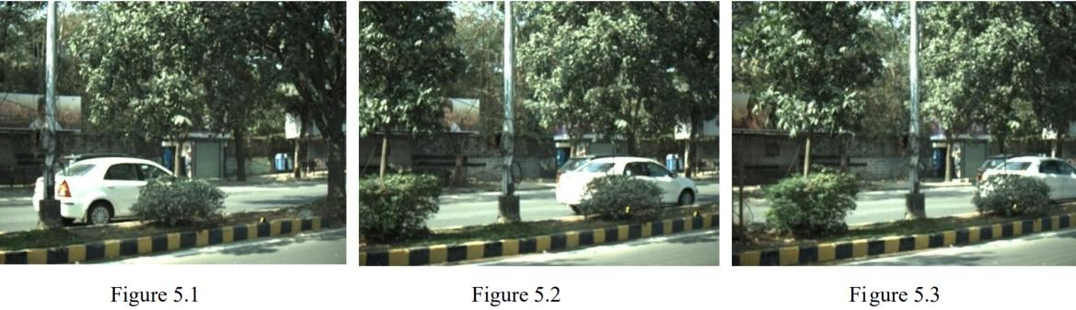
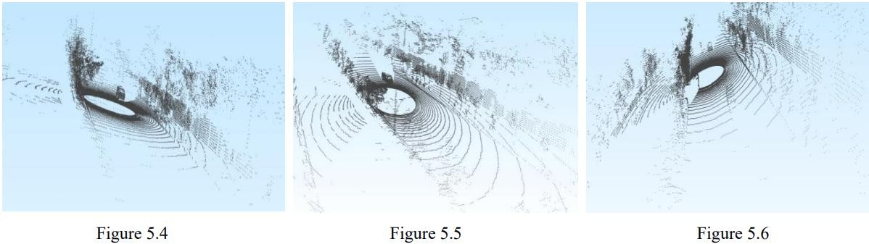

(Figures 5.1–5.3 show representative camera sequence frames; Figures 5.4–5.6 show LiDAR point cloud views.)

Data Scale and Format (Phase 2 Update)
In Phase 2, the raw dataset was fully processed into training-ready formats. The scale and characteristics of processed data are as follows:
    - Data Type: 3D Object Detection and Trajectory data. Raw input consists of JSON label files per frame containing OBB information (psr.position.x, y, z).
    - Single-Agent Windows: N = 4,821 trajectory windows extracted from the full dataset.
    - Multi-Agent Scenes: 138 validation scenes exported based on an 80/20 train-validation split for Trajectron++ evaluation.
    - Output Formats: Raw JSONs are converted to CSV (position trajectories), NPZ (NumPy binaries for training), and Pickle (for Trajectron++ compatibility).

Data Processing Pipeline
A three-step pipeline was implemented to transform raw IDD-3D data into model-ready formats:
- Parsing: Extract x, y coordinates, obj_id, and frame_id from JSON annotation files.
- Aggregation: Group per-frame positions into continuous agent-level trajectories.
- Conversion: Transform aggregated trajectories into the hierarchical format required by each model (CSV, NPZ, Pickle).

Temporal Resolution Correction (Phase 2 Critical Update)
A critical correction was identified during Phase 2 evaluation. The Trajectron++ default temporal resolution (dt = 0.4s, equivalent to 2.5 FPS) did not match the actual IDD-3D capture rate. The pipeline was corrected to dt = 0.1s (10 FPS) to accurately reflect the dataset's temporal structure. This correction significantly impacted the physical interpretation of predicted trajectories.

Window Sampling Strategy
A sliding window approach is applied to generate overlapping training samples from continuous trajectory recordings:
    - Observation Window: 20 frames (2.0 seconds at 10 FPS).
    - Prediction Window: 60 frames (6.0 seconds at 10 FPS).
    - Total Window: 80 frames.
    - Stride: 3 frames.
The number of windows per trajectory is computed as:
Windows = ⌊ (total_frames − window_size) / stride ⌋ + 1
For a trajectory of 150 frames with a window of 80 and stride of 3: Window 1 covers frames 0–79 (Obs: 0–19 | Pred: 20–79), Window 2 covers frames 3–82, Window 3 covers frames 6–85, and so on until frames run out.

CHAPTER 6

SYSTEM ARCHITECTURE

High-Level Architecture Overview
The DreamDrive system follows a three-stage pipeline that transforms raw traffic dataset input into evaluated trajectory predictions. The architecture is designed for modularity, allowing individual stages to be upgraded or extended independently. Figure 6.1 illustrates the overall pipeline.
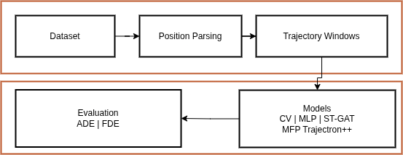
Figure 6.1

Stage 1: Data Preparation and Trajectory Construction
Raw traffic datasets (IDD-3D and, in future phases, Western datasets) are parsed to extract precise agent position information. Per-frame JSON annotations are processed to construct per-agent trajectories, which are then segmented into fixed-length windows using the sliding window approach described in Chapter 5. The output of this stage is a set of structured (observation, prediction) window pairs ready for model ingestion (Figure 6.2).
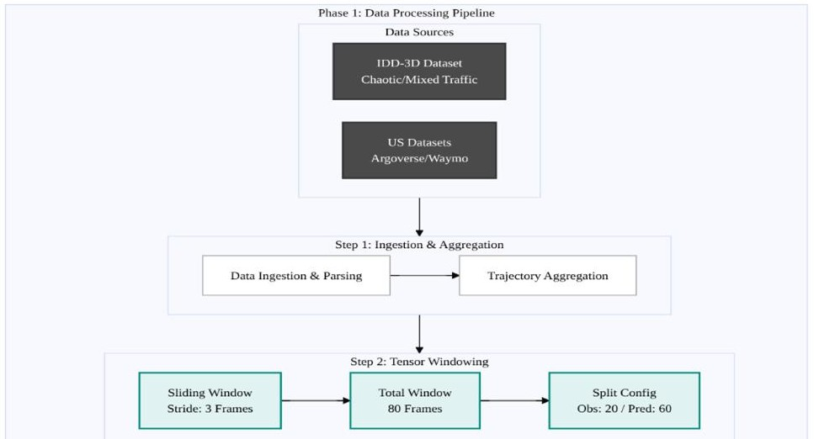
Figure 6.2

Stage 2: Model Training and Prediction
Multiple trajectory prediction models are trained on the constructed trajectory windows. The models range from physics-based baselines (Constant Velocity) to interaction-aware deep learning architectures (ST-GAT, MFP, Trajectron++). Each model receives agent history as input and produces K predicted future trajectories as output, where K varies by model (K=1 for deterministic models, K=6 for MFP, K=25 for Trajectron++). Figure
  - illustrates this stage.
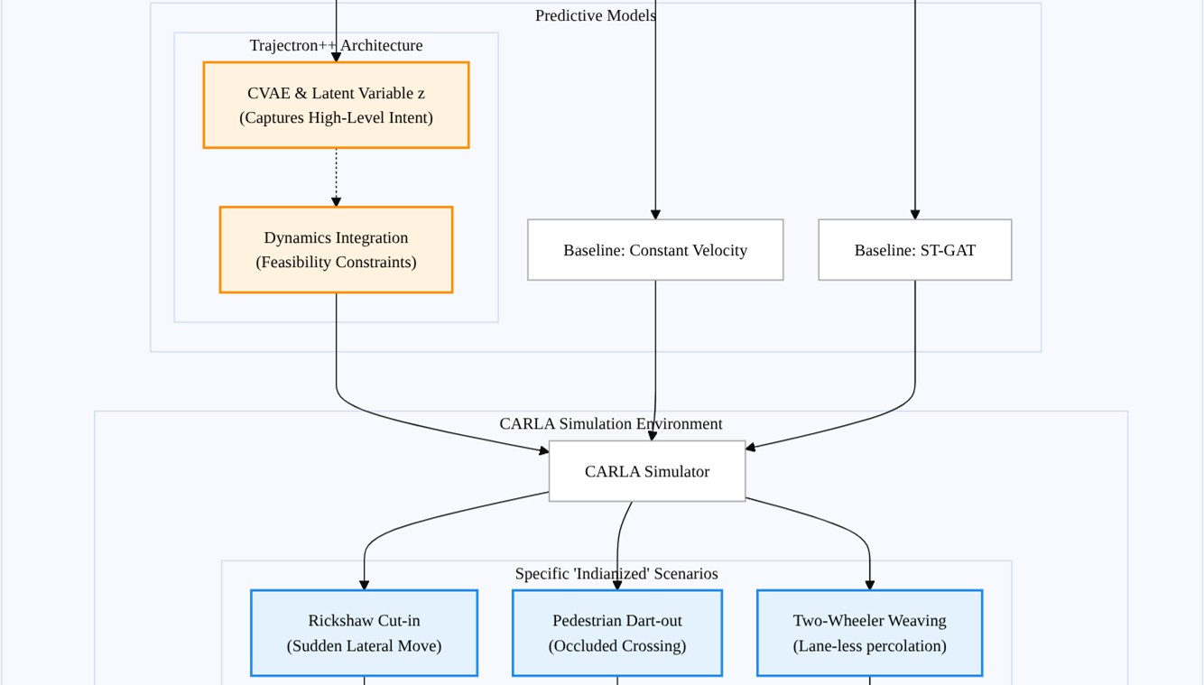
Figure 6.3

Stage 3: Quantitative Evaluation
Model performance is systematically evaluated using ADE and FDE metrics across both normal and collision-intensive data splits. This dual-split evaluation was introduced in Phase 2 to surface the safety-critical performance gap. Figure 6.4 illustrates the evaluation stage. Results are tabulated for comparison across all models, enabling selection of the optimal architecture for integration into the CARLA simulator.
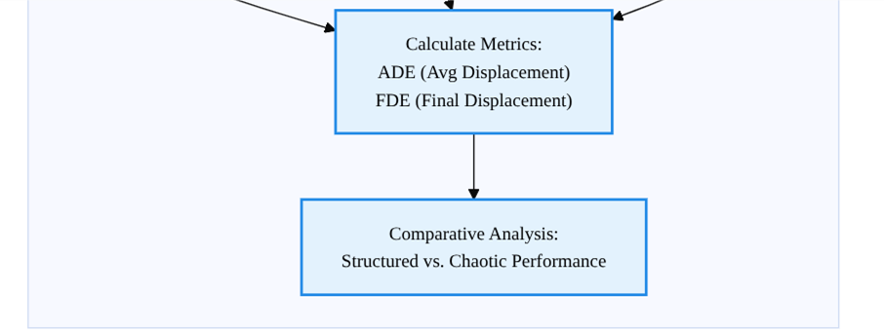
Figure 6.4

Use Case Diagram
The Use Case Diagram (Figure 6.5) illustrates the interactions between system actors and the DreamDrive system components. The primary actors are: the Autonomous Vehicle (ego agent), Traffic Agents (surrounding vehicles, pedestrians, two-wheelers), and the System Evaluator (researcher). Key use cases include trajectory data ingestion, multi-future trajectory prediction, risk assessment, simulation scenario execution, and performance reporting.

CHAPTER 7

MODEL IMPLEMENTATION AND BENCHMARKS

Models Implemented
The following trajectory prediction models were implemented and evaluated on the IDD-3D dataset in Phase 2:
    - Constant Velocity (CV): A physics-based baseline that assumes constant velocity motion. Serves as a lower-bound reference for all learning-based models.
    - MLP (Multi-Layer Perceptron): A simple feedforward neural network treating trajectory prediction as regression. Worst overall performer, confirming that ignoring temporal and spatial structure is inadequate for chaotic traffic.
    - ST-GAT (Spatial-Temporal Graph Attention Network): A graph-based model capturing pairwise agent interactions via attention mechanisms. Achieves moderate improvement over CV.
    - MFP – Multi-Future Prediction (Oracle and Learned): A multi-modal model generating K=6 futures. The Oracle variant selects the closest prediction to ground truth (upper bound), while the Learned variant uses learned mode selection.
    - Trajectron++: A CVAE-based model generating K=25 futures conditioned on agent type and dynamics. Achieves the best Final Displacement Error among all tested models.

Phase 2 Review 1 Benchmark Results
All models were trained and evaluated on the full IDD-3D dataset (normal driving data). Performance is reported using ADE and FDE in meters (lower is better):
Table 7.1: Benchmark Comparison – All Models on IDD-3D Dataset (Phase 2 Review 1)
Model | ADE (m) | FDE (m) | K Futures | Notes
CV (Constant Velocity) | 1.84 | 3.92 | 1 | Physics baseline
MLP | 2.31 | 5.10 | 1 | Worst performer
ST-GAT | 1.52 | 3.47 | 1 | Graph-based

Model | ADE (m) | FDE (m) | K Futures | Notes
MFP (Learned) | 1.21 | 2.89 | 6 | Best balanced
MFP (Oracle) | 0.74 | 1.93 | 6 | Best ADE
Trajectron++* | 1.08 | 2.14 | 25 | Best FDE
* Note: Trajectron++ ADE/FDE results do not represent fully optimized performance. Due to time constraints, exhaustive hyperparameter tuning and extended training were not feasible. Further optimization is planned in the next phase.
Key observations from Phase 2 Review 1: MLP produced the worst performance, confirming that spatial and temporal structure is essential. MFP (Oracle) achieved the lowest ADE, demonstrating superior trajectory shape coverage and uncertainty handling. Trajectron++ achieved the lowest FDE, demonstrating superior final goal prediction. MFP (Learned) achieved the best balanced realistic performance.

Phase 2 Review 2 Benchmark Results: Collision Performance Gap
A targeted experiment was conducted to evaluate Trajectron++ specifically on collision-intensive scenes. The dataset was split into normal driving scenes and collision-proximate scenes (scenes containing at least one agent pair with minimum future distance ≤ 2.0m).
Table 7.2: Trajectron++ Performance Degradation on Collision Scenarios (Phase 2 Review 2)
Scenario | Model | ADE (m) | FDE (m)
Normal Data | Trajectron++ | 1.08 | 2.14
Collision Data | Trajectron++ | 1.79 | 4.95
Degradation |  | +66% | +131%
This result confirms a critical finding: Trajectron++ suffers a 66% increase in ADE and a 131% increase in FDE when evaluated on collision data compared to normal data. This degradation arises because collision scenarios are severely underrepresented in the training distribution of real-world datasets including IDD-3D. A planner built on these predictions directly inherits these failures, fundamentally limiting collision avoidance capability.
This finding motivated the synthetic data generation effort described in Chapter 8, which targets specifically these underrepresented collision and near-collision scenarios.

CHAPTER 8

SYNTHETIC DATA GENERATION

Motivation
The empirical finding that real-world IDD-3D data severely underrepresents collision scenarios (confirmed in Chapter 7) necessitated the generation of synthetic collision data. Additionally, during training it was observed that the dataset lacks sufficient chaotic scene diversity. To address both gaps, two complementary strategies were adopted: (1) programmatic synthetic collision scene generation, and (2) planned augmentation using LLM-generated synthetic chaotic scenarios.

Synthetic Collision Scene Generation
A total of 600 synthetic collision scenes were generated by programmatically scripting agent trajectories to produce near-collision interactions. Each generated scene was then subjected to three physical validity checks to ensure realism:
    - Speed Realism: No agent is permitted to exceed 35 m/s (126 km/h). Scenes with unrealistic velocities are rejected.
    - History Validity: Agents must not be already overlapping at the start of the scene. A minimum separation of 1.5 m between agents is enforced at the observation window start.
    - Future Collision Relevance: At least one agent pair must achieve a minimum pairwise distance of ≤ 2.0 m at some point within the future prediction window. Scenes without close future interactions are excluded as they do not constitute genuine collision scenarios.

Table 8.1: Synthetic Data Validity Checks – Criteria and Results
Check | Criterion | Result
Speed Realism | No agent exceeds 35 m/s (126 km/h) | Passed
History Validity | No overlap at start; min 1.5 m separation | Passed

Check | Criterion | Result
Collision Relevance | Min distance ≤ 2.0 m in future window | Passed
Total Generated | 600 scenes | 32 passed all checks (5.3%)
Of the 600 generated scenes, only 32 (5.3%) passed all three validity checks. This strict filtering ensures that the augmented data contains only physically plausible collision scenarios, preventing the model from learning artifacts of poorly generated data.

Collision Density and Trajectory Analysis
Figure 8.1 presents a heatmap of collision density across the synthetic scene set, illustrating the spatial distribution of near-collision events. Figure 8.2 compares ground truth trajectories against Trajectron++ predictions on collision data, visually confirming the model's tendency to under-predict the magnitude of evasive maneuvers in safety-critical situations.
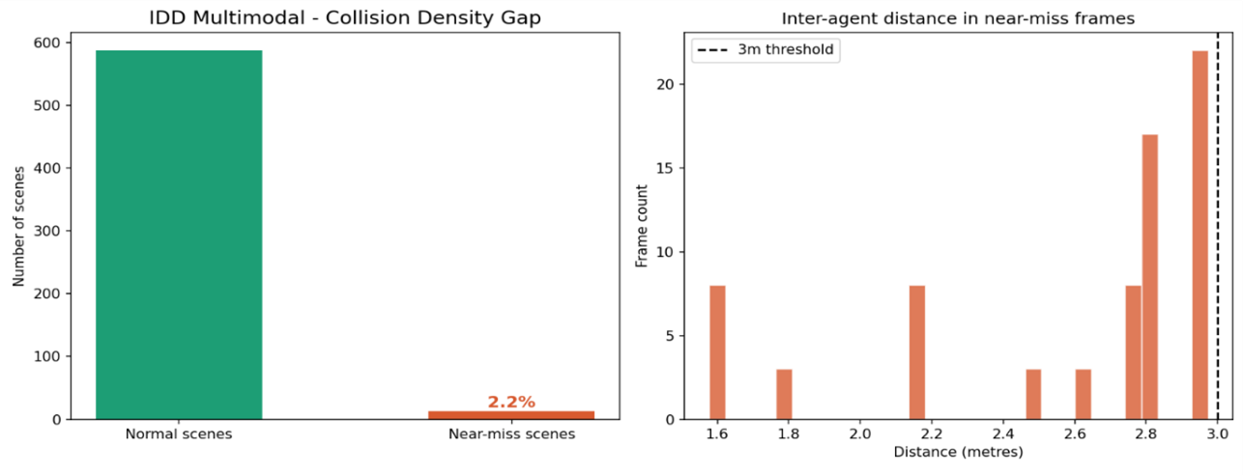
Figure 8.1
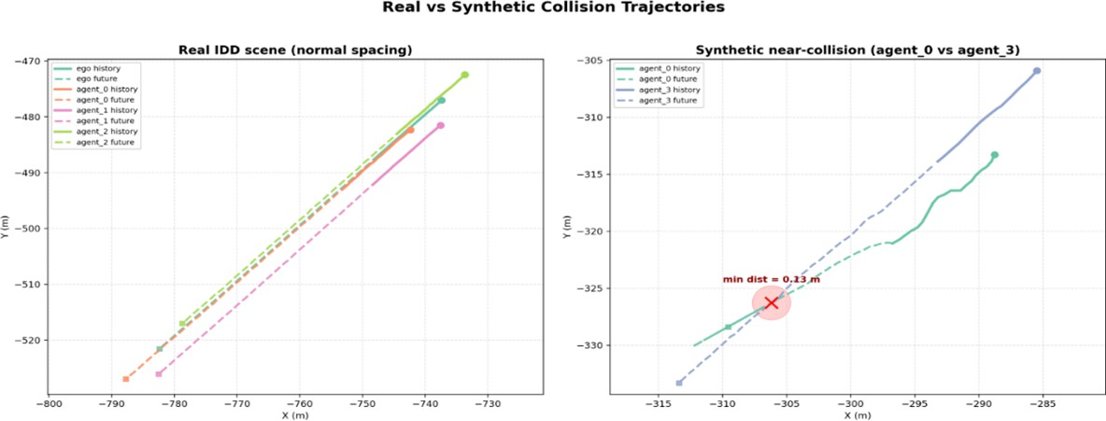

Figure 8.2

Synthetic Data Composition and Near-Miss Augmentation
Figure 8.3 shows the breakdown of synthetic scene types after filtering, illustrating the distribution of head-on, side-impact, and merging collision scenarios. Figure 8.4 shows the change in near-miss augmentation rates before and after synthetic data integration, demonstrating improved coverage of safety-critical interaction types in the augmented training set.
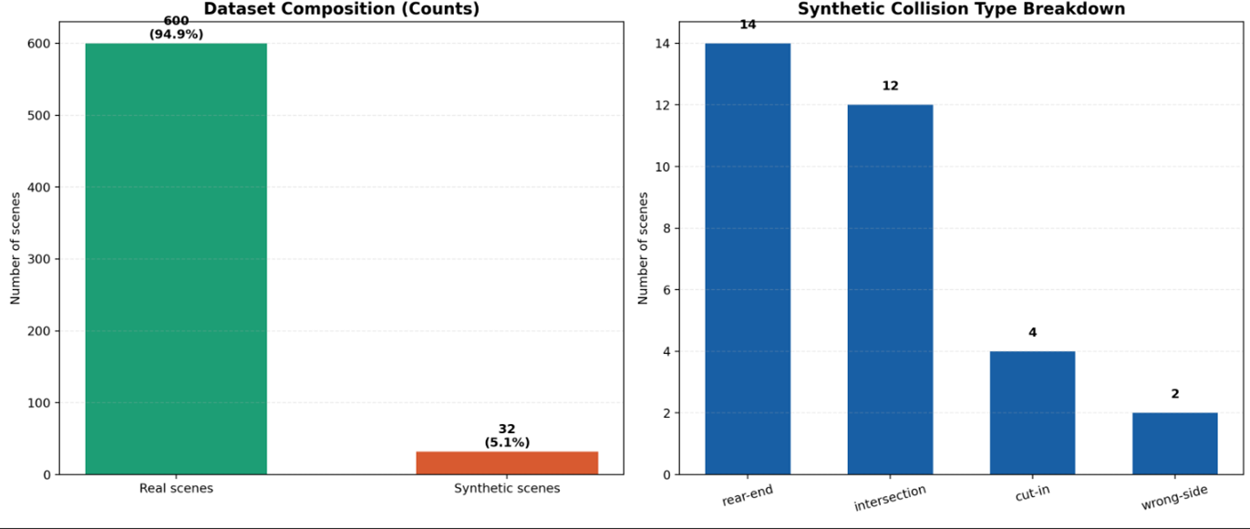
Figure 8.3
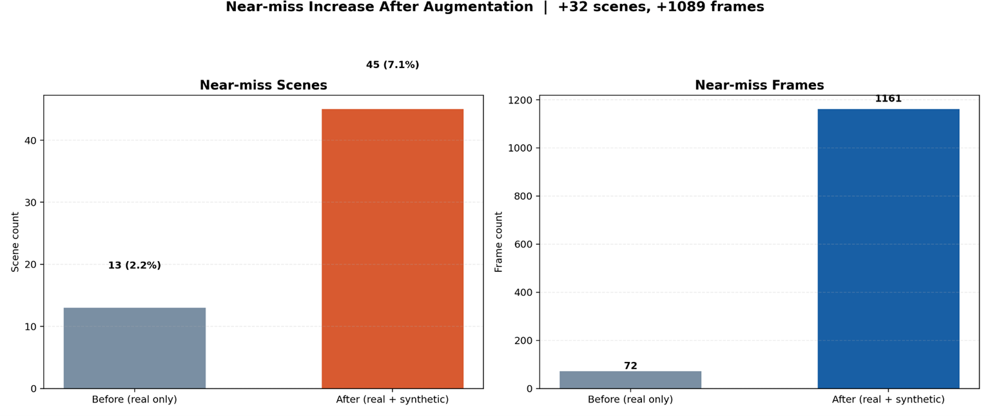
Figure 8.4

Next Steps
The validated 32 synthetic collision scenes will be merged with the real IDD-3D training data for Trajectron++ fine-tuning in the next phase. Additionally, LLM-generated synthetic chaotic scenes (covering lane-less weaving, informal overtaking, and pedestrian dart-out scenarios) are planned to further diversify the training distribution beyond what real-world collection alone can provide.

CHAPTER 9

CARLA SIMULATION

Overview
The CARLA (Car Learning to Act) simulator was configured to support scenario-based evaluation of the DreamDrive prediction system. CARLA provides a flexible, open-source environment for autonomous driving research, supporting sensor simulation (cameras, LiDAR), traffic agent scripting, and weather configuration.

Indianized Traffic Configuration
Since CARLA does not natively model Indian traffic behaviors, a custom Indianized environment was manually scripted. The following approximations were implemented:
    - Lane-less Driving: Agents were scripted to operate without strict lane-keeping constraints, approximating the lateral freedom observed in Indian traffic.
    - Dense Traffic Density: Higher-than-default vehicle spawn rates were configured to approximate the vehicle density typical of Indian urban roads.
    - Informal Overtaking: Overtaking maneuvers were scripted without enforcing right-of-way, simulating the flying overtaking behavior documented in the lane-less traffic literature.
    - Rickshaw Dynamics: Non-standard vehicle types with reduced speed profiles were added as approximate proxies for rickshaws and three-wheelers.

Simulation Scenarios
Two primary scenario categories were implemented in the CARLA environment:
- Collision-Proximate Scenarios: Scenarios in which scripted agents execute trajectories designed to create near-collision situations, aligned with the synthetic collision data described in Chapter 8.
- General Chaotic Traffic: Scenarios involving dense, heterogeneous traffic with multiple simultaneous interactions, designed to stress-test multi-future prediction under high scene complexity.
Figures 9.1 and 9.2 present representative screenshots from the CARLA Indianized simulation environment, illustrating the configured traffic density and agent diversity.
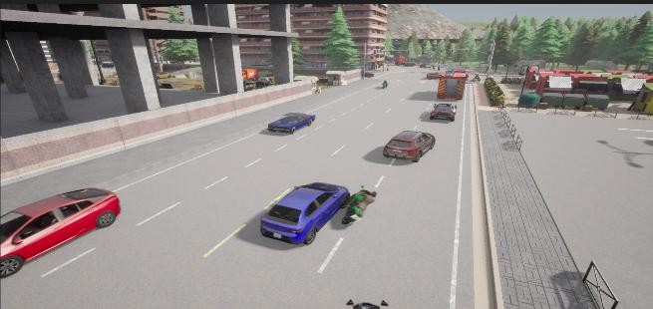
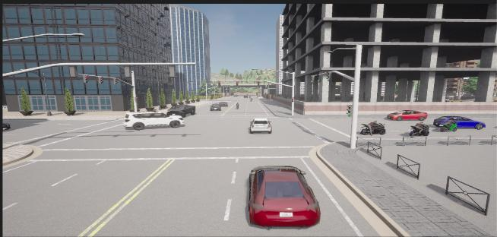
Figure 9.1 Figure 9.2

Future Integration Plan
In the next project phase, the trained trajectory prediction models (including Trajectron++ fine-tuned on synthetic collision data) will be integrated directly into the CARLA loop. Predicted multi-future trajectories will be fed to a safety-aware planner, enabling end-to-end evaluation of prediction quality's impact on collision avoidance in simulation.

CHAPTER 10

CONCLUSION AND FUTURE WORK

Conclusion
Phase 2 of DreamDrive has made significant advances toward the goal of proactive, multi-future trajectory prediction for safe autonomous navigation in chaotic Indian traffic. The key findings and contributions of this phase are:
    - Single-path prediction is insufficient for chaotic traffic: All deterministic (K=1) models underperformed compared to multi-future models in chaotic IDD-3D scenarios, validating the core project premise.
    - Collision scenarios remain underrepresented in real datasets: Real-world data collection naturally under-samples rare but safety-critical collision events. This empirical fact, confirmed quantitatively in our benchmarks, constitutes a structural challenge for model safety.
    - Model performance drops significantly in safety-critical cases: Trajectron++ exhibits a 66% increase in ADE and a 131% increase in FDE on collision data relative to normal data. Any planner relying on these predictions inherits these failures.
    - Synthetic data and multi-future prediction improve robustness: The generation of 32 physically validated synthetic collision scenes provides a foundation for targeted model fine-tuning on underrepresented scenarios.
    - CARLA simulation enables scenario-based evaluation: A custom Indianized CARLA environment was successfully configured, enabling controlled evaluation of model predictions in approximated Indian traffic conditions.

Future Work
The specific roadmap for the next project phase includes:
- Fine-tune Trajectron++ on Collision-Rich Synthetic Data: Perform extensive fine-tuning of Trajectron++ on the validated synthetic collision scenes, targeting the identified 66%/131% ADE/FDE performance gap.
- Extend Hyperparameter Optimization: Conduct systematic hyperparameter search for Trajectron++ (learning rate, latent variable size, prediction horizon) to further improve baseline performance.
- Improve Heterogeneous Agent Modeling: Extend the current vehicle-only scope to incorporate pedestrians, two-wheelers, and rickshaws, leveraging Trajectron++'s built-in heterogeneous agent support.
- LLM-Generated Chaotic Scene Augmentation: Generate diverse chaotic traffic scenarios using large language models to augment training data beyond what synthetic collision generation alone provides.

- Integrate Prediction with Planning: Connect validated trajectory prediction outputs to a safety-aware planner within CARLA to evaluate whether improved predictions translate to measurable collision avoidance gains.
- Comparative Simulation Study: Conduct a side-by-side simulation comparison between Indian (chaotic) and American (structured) environments to quantifiably demonstrate model adaptability and robustness across domains.
- Extend Hyperparameter Optimization: Conduct systematic hyperparameter search for Trajectron++ (learning rate, latent variable size, prediction horizon) to further improve baseline performance.
- Improve Heterogeneous Agent Modeling: Extend the current vehicle-only scope to incorporate pedestrians, two-wheelers, and rickshaws, leveraging Trajectron++'s built-in heterogeneous agent support.
- LLM-Generated Chaotic Scene Augmentation: Generate diverse chaotic traffic scenarios using large language models to augment training data beyond what synthetic collision generation alone provides.
- Integrate Prediction with Planning: Connect validated trajectory prediction outputs to a safety-aware planner within CARLA to evaluate whether improved predictions translate to measurable collision avoidance gains.
- Comparative Simulation Study: Conduct a side-by-side simulation comparison between Indian (chaotic) and American (structured) environments to quantifiably demonstrate model adaptability and robustness across domains.

REFERENCES / BIBLIOGRAPHY

- Salzmann, T., Ivanovic, B., Chakravarty, P., & Pavone, M. (2021). Trajectron++: Dynamically-Feasible Trajectory Forecasting with Heterogeneous Data.
- Wang, Y., He, J., Fan, L., Li, H., Chen, Y., & Zhang, Z. (2023/24). Driving into the Future: Multiview Visual Forecasting and Planning with World Model for Autonomous Driving. CVPR.
- Hwang, J., Xu, R., Lin, H., Hung, W., Ji, J., Choi, K., et al. (2024). EMMA: End-to-End Multimodal Model for Autonomous Driving.
- Xu, M., Liu, Z., Wang, B., & Li, S. (2022). A Survey of Autonomous Driving Trajectory Prediction: Methodologies, Challenges, and Future Prospects.
- Beza, A. D., Xie, Z., Ramezani, M., & Levinson, D. (2021). Lane-less to Lane-free: Implications in the Era of Automated Vehicles.
- Huang, R., Xue, H., Pagnucco, M., Salim, F., & Song, Y. (2024). Vision-Based Multi-Future Trajectory Prediction: A Survey.
- IDD-3D: India Driving Dataset – 3D. Available at: https://idd.insaan.iiit.ac.in/
- DreamDrive Project Repository. Available at: https://github.com/im-mrnull/capstone_dreamDrive

APPENDIX A: DEFINITIONS, ACRONYMS, AND ABBREVIATIONS

  - ADE: Average Displacement Error – Measures average Euclidean distance between predicted and true trajectories over all time steps.
  - CARLA: Car Learning to Act – Open-source autonomous driving simulator.
  - CoT: Chain-of-Thought – Reasoning process used in the EMMA model.
  - CV: Constant Velocity – A physics-based prediction model assuming no acceleration.
  - CVAE: Conditional Variational Autoencoder – Generative model used in Trajectron++.
  - DRAC: Deceleration Rate to Avoid Crash.
  - ELBO: Evidence Lower Bound – Optimization objective for variational inference.
  - FDE: Final Displacement Error – Measures prediction accuracy at the final endpoint.
  - FPS: Frames Per Second – Temporal resolution unit.
  - GAN: Generative Adversarial Network.
  - IDD-3D: Indian Driving Dataset – 3D.
  - KPM: Key Points Matching – A measure of visual consistency in multiview generation.
  - LiDAR: Light Detection and Ranging – 3D depth sensing technology.
  - MFP: Multi-Future Prediction – A trajectory prediction model generating K futures.
  - MLP: Multi-Layer Perceptron – Feedforward neural network.
  - NLL: Negative Log Likelihood – Measures how well the predicted distribution matches the true trajectory.
  - OBB: Oriented Bounding Box – 3D annotation format used in IDD-3D.
  - OOD: Out-of-Distribution – Scenarios not encountered during model training.
  - PCS: Prompt Compliance Score – Metric measuring trajectory alignment with text commands.
  - ST-GAT: Spatial-Temporal Graph Attention Network.
  - TTC: Time to Collision.

