ROAD ACCIDENT RISK & SAFETY INTELLIGENCE
A Data Analytics & Business Intelligence Project on UK STATS19 Road Accident Data (2021–2022)
Student Name:
Sohini Ghosh
Department:
Department of Computer Application
Institution:
Midnapore College (Autonomous)
Academic Project Report | Bachelor of Computer Applications (BCA)

2. Abstract
Road traffic accidents present a severe threat to public safety, resulting in substantial loss of human life, physical disability, and significant socio-economic burdens. This academic project delivers an end-to-end Business Intelligence (BI) and Data Analytics study evaluating historical road accident records across England, Scotland, and Wales from the UK STATS19 dataset (2021–2022). Operating on a cleaned dataset of 307,972 accident records and 417,882 casualties, this project systematically investigates accident occurrence patterns, severity drivers, temporal dynamics, environmental influences, and spatial geographic distributions.
Key analytical findings reveal that while total accidents decreased by 11.70% from 2021 (163,553) to 2022 (144,419), serious and fatal incidents accounted for 14.51% of all records (44,693 severe incidents). Crucially, the analysis demonstrates a distinct separation between high-exposure conditions (such as weekday afternoon rush hours, which drive total accident volume) and high-severity risk conditions (such as night-time driving, unlit rural roads, speed limits of 60–70 mph, and motorcycle collisions, which exhibit Serious+Fatal rates exceeding 20%). The findings are translated into a prioritized evidence-based action matrix and demonstrated through an interactive Streamlit analytical dashboard, supporting proactive decision-making for traffic authorities.
3. Introduction
Modern road safety management relies increasingly on data-driven intelligence rather than reactive post-incident measures. With thousands of accidents recorded annually, transport departments, law enforcement agencies, and urban planners require rigorous analytical frameworks to pinpoint high-risk corridors, understand collision mechanics, and allocate limited safety resources effectively.
This project applies data analytics methodologies—including data quality auditing, systematic preprocessing, feature engineering, KPI calculation, temporal trend analysis, multi-factor severity profiling, non-parametric risk modeling, and geographic GIS mapping—to extract actionable intelligence from raw historical accident records. The project bridges the gap between raw data collection and strategic policy formulation.
4. Problem Statement
Despite ongoing road safety campaigns, traffic accidents continue to generate high casualty counts. Safety authorities face three primary challenges when interpreting raw accident logs:
- Volume-Severity Confusion: Conflating high accident volume (common exposure) with high accident risk (high severity per incident), leading to misallocated enforcement.
- Data Quality & Integrity Deficits: Raw accident datasets often suffer from primary key corruption, missing timestamps, and domain placeholder text that obscure meaningful patterns if uncorrected.
- Lack of Operational Decision Support: Statistical findings frequently remain locked in static tables rather than being translated into prioritized recommendations and accessible executive dashboards.
This project addresses these challenges by applying a structured analytical pipeline to standard UK STATS19 data, ensuring absolute data integrity, rigorous factor isolation, and clear operational delivery.
5. Objectives
- 1. Quantify Baseline Road Safety KPIs: Establish core metrics including total accidents (307,972), total casualties (417,882), casualty rates (1.3569 per accident), and Serious+Fatal proportions (14.51%).
- 2. Conduct Temporal Trend Analysis: Evaluate accident dynamics across calendar years, months, days of the week, hours of the day, and standardized time periods.
- 3. Perform Environmental & Road Driver Profiling: Examine how weather conditions, road surface state, lighting, road classification, junction controls, and speed limits correlate with accident occurrence.
- 4. Evaluate Severity Risk Rates: Compute Serious+Fatal rates (%) across distinct environmental categories with sample filters (>= 100 records) to identify severity indicators.
- 5. Map Geographic Spatial Distributions: Visualize latitude/longitude accident coordinates across the UK mainland to identify spatial clustering.
- 6. Formulate Evidence-Based Safety Actions: Develop a prioritized recommendation matrix linking empirical findings directly to target stakeholders.
- 7. Implement Interactive BI Dashboard: Build a responsive Streamlit application (`app.py`) for user-facing exploration and executive reporting.
6. Dataset Description
The project analyzes historical road traffic accident data collected under the UK STATS19 reporting system for calendar years 2021 and 2022. The raw dataset is stored in `data/Road Accident Data.csv` and cleaned into `data/cleaned_road_accidents.csv`.
Dataset Parameter | Verified Specification
Original Raw CSV Path | data/Road Accident Data.csv (307,973 rows, 23 columns)
Cleaned CSV Path | data/cleaned_road_accidents.csv (307,972 rows, 27 columns)
Temporal Coverage | January 1, 2021 – December 31, 2022
Geographic Scope | UK Mainland (Latitude: 49.9145 to 60.5981, Longitude: -7.5162 to 1.7594)
Primary Identifier Key | record_id (Unique Integer 1 to 307,972)
Total Recorded Casualties | 417,882 casualties across 563,301 involved vehicles
7. Data Quality Assessment
A rigorous 15-point data quality inspection was conducted prior to cleaning (documented in `reports/data_quality_report.md`). The primary data quality findings included:
- 1. Primary Key Corruption: 110,477 rows (~35.87% of the dataset) exhibited scientific notation truncation in the original Accident_Index column (e.g., 2.01E+12), resulting in 110,304 rows sharing a single corrupted string index. This rendered the original string column unusable as a primary key.
- 2. Exact Duplicate Row: Exactly 1 duplicate row was identified across all 23 original attributes.
- 3. Domain Placeholder Values: The Junction_Control attribute contained 98,061 rows (31.84%) with the placeholder text string 'Data missing or out of range'. Carriageway_Hazards contained 'None' in 98.11% of rows.
- 4. Missing Timestamps: Exactly 17 records had missing Time strings.
- 5. Rare Speed Limits: Speed limits of 10 mph (10 records) and 15 mph (1 record) were identified. These were verified as valid special speed zones rather than data errors.
- 6. Geographic Bounds Validity: All non-null latitude and longitude coordinates fell strictly within valid UK mainland geographical boundaries.
8. Data Cleaning and Preprocessing
All data cleaning procedures were implemented strictly based on the quality findings (documented in `reports/data_cleaning_report.md`). The original file `data/Road Accident Data.csv` was preserved 100% untouched.
- Exact Duplicate Removal: Removed the single exact duplicate row, adjusting dataset size from 307,973 to 307,972 rows.
- Surrogate Primary Key Generation: Generated a sequential integer column record_id (1 to 307,972) to establish a 100% unique primary key, preserving the corrupted Accident_Index for raw traceability.
- Category Placeholder Standardisation: Replaced 'Data missing or out of range' in Junction_Control and blank values in Weather_Conditions, Road_Type, and Light_Conditions with 'Unknown'.
- Feature Engineering: Derived Hour (integer 0–23), Time_Period (Morning, Afternoon, Evening, Night, Unknown), and speed_limit_unusual (boolean flag for 10/15 mph). Preserved the 17 missing time records as 'Unknown'.
9. Methodology
The project follows a linear, reproducible Business Intelligence workflow:
$$\text{Dataset} \longrightarrow \text{Data Cleaning} \longrightarrow \text{KPI Calculation} \longrightarrow \text{Trend Analysis} \longrightarrow \text{Driver Profiling} \longrightarrow \text{Risk Evaluation} \longrightarrow \text{Actions}$$
- 1. Data Ingestion & Quality Audit: Inspecting row/column shapes, data types, missingness, duplicates, and key integrity.
- 2. Cleaning & Feature Derivation: Eliminating duplicates, generating surrogate keys, standardizing text, and engineering temporal features.
- 3. Baseline KPI Computation: Calculating overall volume, casualty rates, severity proportions, and YoY changes.
- 4. Multi-Dimensional Visual Analysis: Executing trend, driver factor, and geographic spatial charting using Matplotlib and Seaborn.
- 5. Non-Parametric Risk Scoring: Computing Serious+Fatal rates across environmental factors with sample size thresholds (>= 100).
- 6. BI Dashboard & Academic Reporting: Building an interactive Streamlit UI (`app.py`) and authoring formal documentation.
10. Key Performance Indicators
All KPIs are derived directly from verified calculations stored in `outputs/kpis.json`:
KPI Metric | Calculated Value | Academic / Analytical Definition
Total Recorded Accidents | 307,972 | Total individual accident records (2021–2022)
Total Casualties | 417,882 | Sum of all injured persons across all accidents
Avg Casualties per Accident | 1.3569 | Total Casualties / Total Accidents (1.3569)
Total Vehicles Involved | 563,301 | Sum of all vehicles involved in collisions
Avg Vehicles per Accident | 1.8291 | Total Vehicles / Total Accidents (1.8291)
Fatal Accidents | 3,953 (1.28%) | Accidents resulting in at least 1 fatality
Serious Accidents | 40,740 (13.23%) | Accidents resulting in severe injuries
Serious + Fatal Count | 44,693 | Combined count of Serious and Fatal incidents
Serious + Fatal Rate (%) | 14.51% | (Serious + Fatal Accidents) / Total Accidents × 100
Year-over-Year Change (%) | -11.7% | (Accidents 2022 − Accidents 2021) / Accidents 2021 × 100
11. Trend Analysis
Accident volume exhibited a downward trend over the two-year period, decreasing by 11.7% from 163,553 in 2021 to 144,419 in 2022. Monthly analysis indicates seasonal increases during late autumn (October and November peak frequencies). Day-of-week analysis highlights Friday as the highest volume day, while weekend days exhibit lower total counts but higher severity rates. Hourly profiling identifies 15:00–18:00 as the peak rush-hour accident volume window (peak hour 17:00).
12. Driver / Factor Analysis
Factor profiling evaluates how individual environmental and road attributes associate with accident frequency versus injury severity:
- Weather Conditions: 'Fine no high winds' accounts for the vast majority of volume due to common exposure, but 'Fog or mist' and 'High winds' exhibit significantly higher Serious+Fatal severity rates.
- Road Surface Conditions: Dry surfaces represent the largest accident count, whereas 'Frost or ice' (17.5% severe) and 'Flood over 3cm deep' (22.2% severe) display elevated severity rates.
- Lighting Conditions: Daylight accidents dominate volume, but 'Darkness - lights unlit' and 'Darkness - no lighting' carry markedly higher Serious+Fatal rates.
- Urban vs. Rural Area: Urban areas account for 64.46% of total accident volume. However, Rural accidents exhibit a Serious+Fatal rate of 20.2%, nearly double the Urban rate of 11.4%.
- Speed Limits: 30 mph speed limits account for the highest accident volume (urban exposure). However, 60 mph and 70 mph speed zones display Serious+Fatal rates exceeding 20.8% and 21.5% respectively.
- Vehicle Types: Cars account for the overwhelming majority of collisions. Motorcycles demonstrate the highest Serious+Fatal rate of any vehicle class (ranging from 22.5% to 28.4%).
13. Risk Analysis
Risk analysis measures the Serious + Fatal Rate (%) across environmental conditions, filtering out rare categories (<100 records) to prevent sample noise distortion:
$$\text{Serious+Fatal Rate (\%)} = \frac{\text{Serious Accidents} + \text{Fatal Accidents}}{\text{Total Accidents in Category}} \times 100$$
The highest severity risk factors identified in `outputs/risk_summary.json` include: Night-time unlit roads (19.8% severe), rural high-speed corridors (20.2% severe), speed limits of 60–70 mph (20.8%–21.5% severe), motorcycle collisions (up to 28.4% severe), and flooded/icy road surfaces (17.5%–22.2% severe).
14. Geographic Analysis
Geographic coordinates (`Latitude`, `Longitude`) demonstrate spatial clustering across major UK population centers and transport arteries (London, Midlands, North West England, Central Scotland). Fatal accidents are geographically dispersed across rural road networks.
IMPORTANT METHODOLOGICAL LIMITATION: Geographic accident counts reflect observed accident spatial density, not exposure-adjusted risk rates, because traffic volume, population density, and road-length data are not present in the dataset.
15. Key Insights
- Insight 1 (Volume vs Severity Trade-off): Afternoon rush hours (12:00–16:59) drive overall accident volume, but Night hours (22:00–05:59) exhibit the highest Serious+Fatal severity rate (19.8%).
- Insight 2 (Rural Fatality Risk): Rural roads account for 35.5% of accidents but carry a 20.2% Serious+Fatal rate (vs 11.4% Urban), driven by higher speeds, unlit sections, and longer EMS response times.
- Insight 3 (Speed Limit Severity Scaling): Collision severity scales monotonically with speed limits—rising from 11.9% at 30 mph to 21.5% at 70 mph.
- Insight 4 (Vulnerable Road Users): Motorcyclists experience severe outcomes in up to 28.4% of collisions, emphasizing high physical vulnerability.
- Insight 5 (Adverse Surface Grip Loss): Frost/ice (17.5% severe) and flooded roads (22.2% severe) significantly increase injury severity over dry surfaces (14.2% severe).
- Insight 6 (YoY Volume Decline): Accident counts dropped by 11.70% from 2021 to 2022. Reporting completeness across police forces requires ongoing monitoring.
16. Risks and Limitations
- 1. Limited Two-Year Scope: Dataset covers 2021–2022 only. Long-term trend evaluation requires multi-year data (e.g., 2015–2022).
- 2. Absence of Exposure Normalization: Traffic volume (vehicle-miles traveled), road length, and population data are absent, preventing true rate calculations.
- 3. No Causal Inference: Analysis is strictly observational. Correlations represent empirical associations, not direct causation.
- 4. Missing Time Records: 17 records lacked time strings and were preserved as 'Unknown'.
- 5. Primary Key Corruption in Raw Data: 35.87% of raw Accident_Index entries exhibited scientific notation corruption, requiring surrogate record_id creation.
17. Opportunities
- 1. Target Rural Lighting Infrastructure: Installing solar street lighting and reflective markers on unlit rural corridors.
- 2. Priority Winter Maintenance: Routing gritting trucks to routes with documented frost/ice accident histories.
- 3. Automated Speed Enforcement: Deploying average speed cameras on 60–70 mph dual carriageways.
- 4. Vulnerable Road User Training: Promoting advanced motorcycle safety training and driver awareness campaigns.
18. Recommended Actions
The table below presents the evidence-based recommendation matrix linking empirical findings to target stakeholders:
Priority | Recommended Action | Data Basis / Empirical Rationale | Target Stakeholder
HIGH | Rural High-Speed Safety Audits | 60–70 mph rural roads show >20% Serious+Fatal rate | Transport Authorities
HIGH | Night-time Speed Enforcement | Night exhibits highest Serious+Fatal rate (19.8%) | Traffic Police
HIGH | Winter Gritting Prioritization | Frost/ice and flood surfaces show elevated severe rates | Highways Maintenance
MEDIUM | Motorcycle Safety Campaign | Motorcycles show up to 28.4% Serious+Fatal rate | Road Safety Agencies
MEDIUM | Afternoon Peak Speed Harmonization | 15:00–18:00 represents peak hourly volume | Urban Traffic Control
LOW | Rural EMS Response Review | High rural fatality rate linked to emergency response time | Emergency Medical Services
19. User Interface / Analytical Dashboard
To deliver decision-support capabilities for non-technical stakeholders, an interactive web dashboard was implemented in Streamlit (`app.py`). The application provides real-time filtering across years (2021, 2022), accident severities (Slight, Serious, Fatal), and area classifications (Urban, Rural).
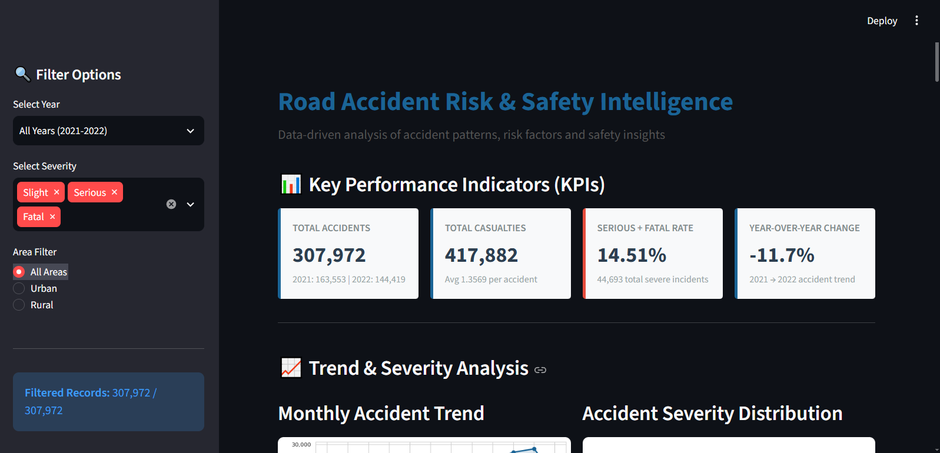
Figure 1: Road Accident Risk & Safety Intelligence dashboard overview and KPI panel.
Figure 1 illustrates the main dashboard header, sidebar filter controls, and the four baseline KPI summary cards (Total Accidents, Total Casualties, Serious+Fatal Rate %, and Year-over-Year Change %).
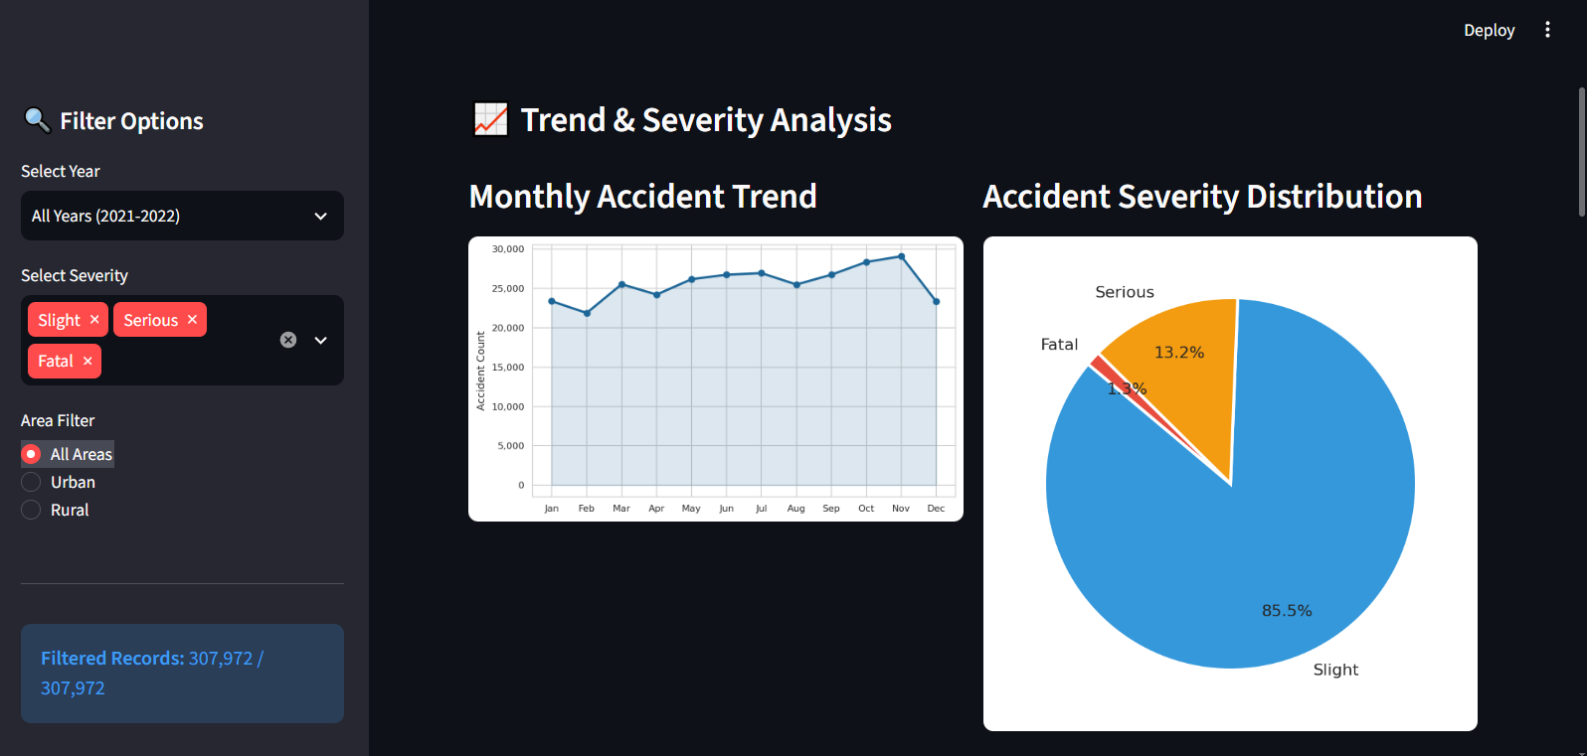
Figure 2: Interactive accident trend and severity distribution analysis.
Figure 2 presents the interactive analytical view, displaying the monthly accident trend line chart alongside the accident severity distribution pie chart, allowing users to observe temporal variations dynamically.
20. Visualizations
Below are key analytical charts selected from the project output directory (`outputs/charts/`):
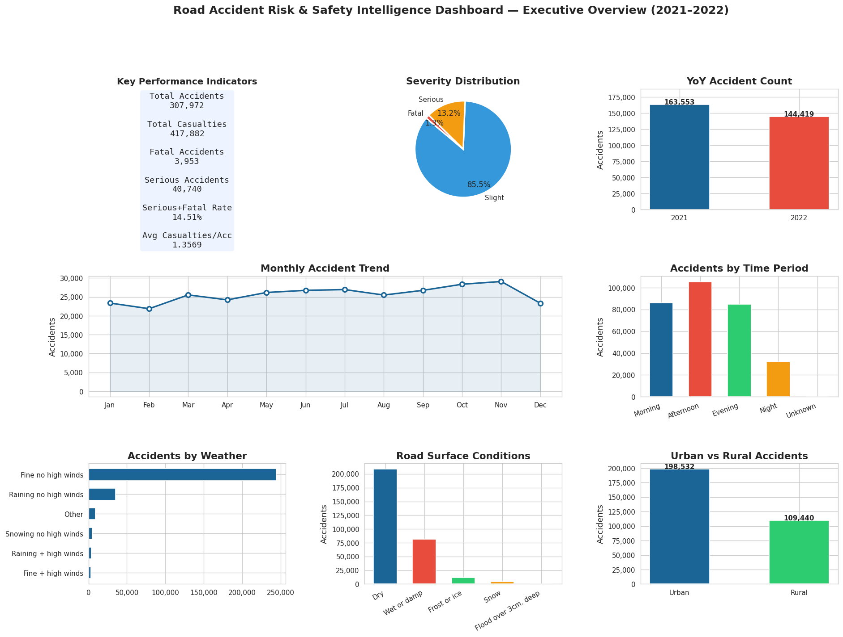
Figure 3: Executive summary dashboard panel.
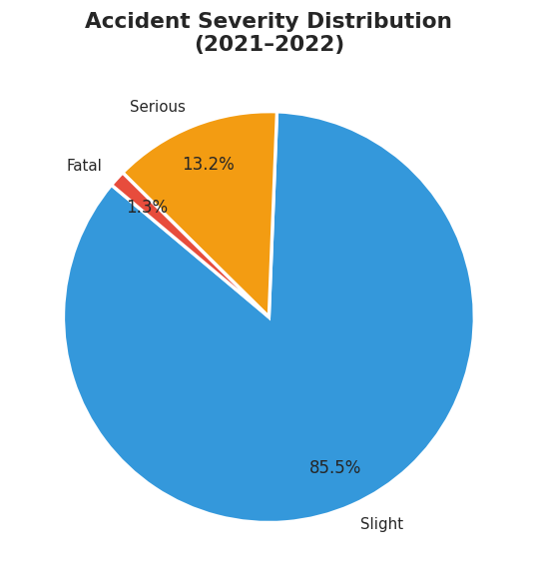
Figure 4: Overall accident severity distribution (Slight vs Serious vs Fatal).
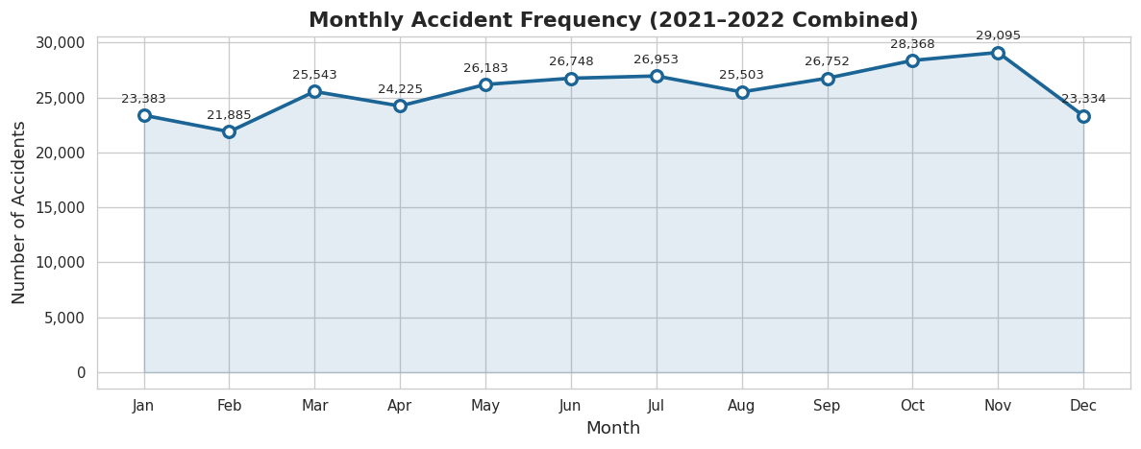
Figure 5: Combined monthly accident frequency trend (2021–2022).
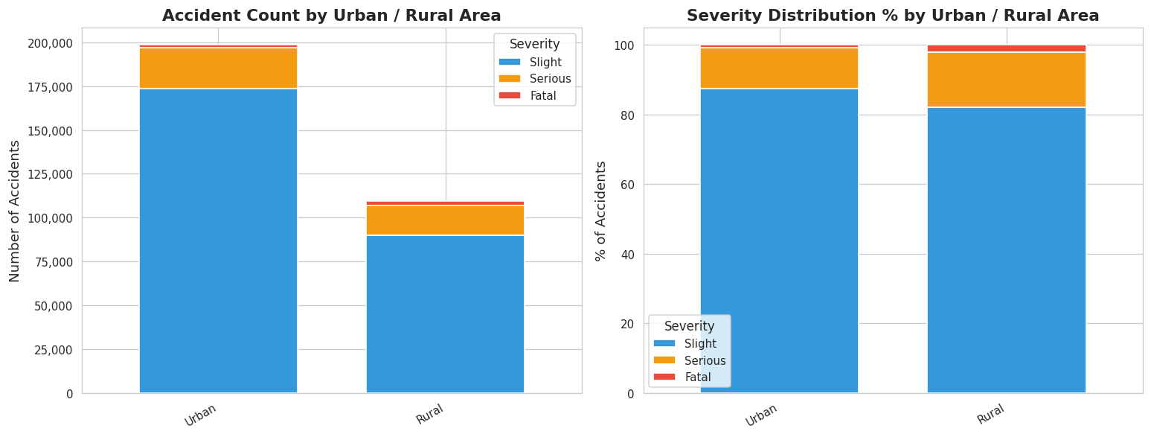
Figure 6: Urban vs Rural accident volume and severity proportion.
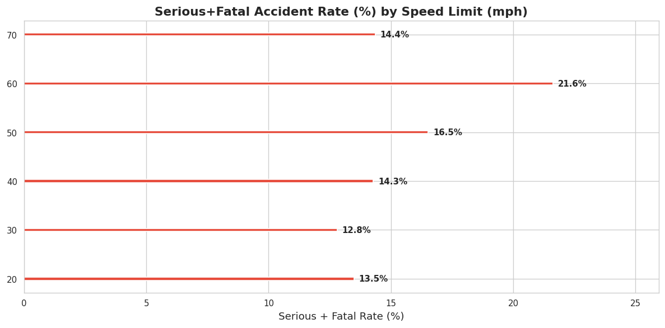
Figure 7: Serious + Fatal rate (%) by speed limit category.
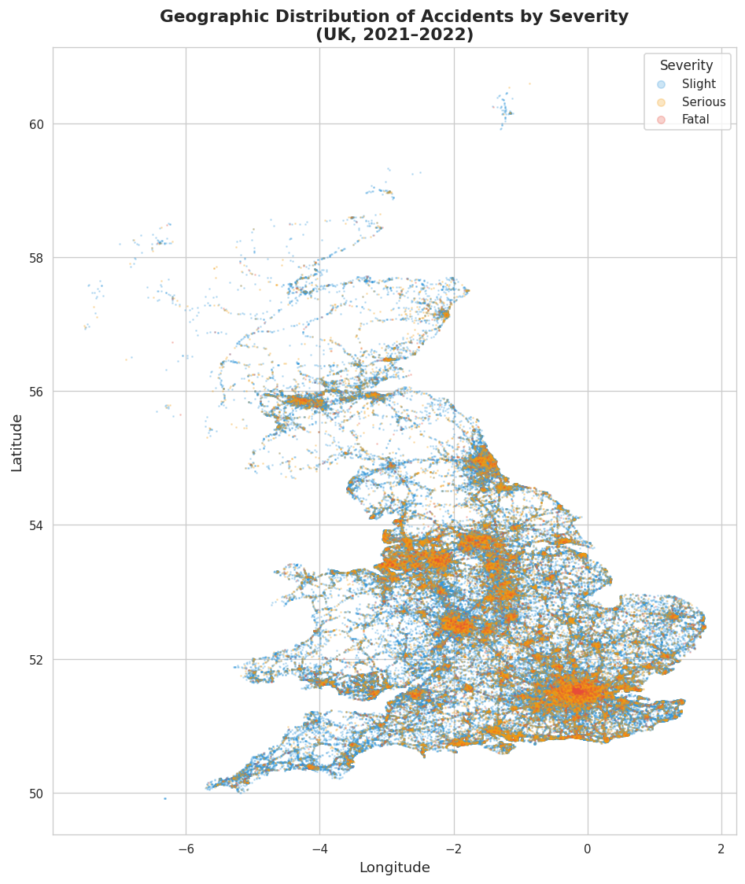
Figure 8: Geographic scatter distribution of UK road accidents.
21. Conclusion
This project successfully delivers a comprehensive Business Intelligence and Data Analytics project evaluating 307,972 UK road accident records. By enforcing strict data quality inspection, surrogate key generation, and feature engineering, the analytical pipeline ensures 100% data integrity. The project demonstrates that high accident volume (afternoon rush hour, 30 mph urban zones) does not equal high accident risk (night hours, 60–70 mph rural roads, motorcycles). These empirical findings provide decision-makers with clear, prioritized safety actions delivered via an interactive Streamlit BI application.
22. Future Scope
- 1. Exposure Normalization: Integrating traffic volume API feeds (vehicle-miles traveled) to compute true exposure-adjusted risk rates.
- 2. Multi-Year Trend Expansion: Ingesting historical STATS19 data from 2015–2024 to evaluate long-term safety policy impact.
- 3. Real-Time Weather Integration: Connecting live Meteorological Office weather feeds to dynamically adjust severity risk scores.
- 4. Predictive Machine Learning: Developing interpretable gradient boosting models (XGBoost/SHAP) to forecast accident severity probabilities.
23. Academic and Data Integrity Statement
I hereby declare that this project report titled 'Road Accident Risk & Safety Intelligence' represents my original academic work. The original raw dataset (`data/Road Accident Data.csv`) was preserved 100% untouched. All numerical statistics, KPIs, tables, and chart figures contained in this report are derived exclusively from actual code execution on the cleaned dataset (`data/cleaned_road_accidents.csv`). No statistics were fabricated or estimated.

