**ISE Assignment** Marks: 10

**5CS403 Humanities-4 Legal, IPR, Safety Sem I AY 2022-23**

**PRN of First Student**: 2019BTECS00089

**PRN of Second Student**: 2019BTECS00081

--------------------------------------------------------------------------------------------------------------------------------------

**Q1. Comment on the impact of IPR protection on a company**

Intellectual property (IP) is one of the most valuable intangible assets that businesses have and is extremely vulnerable to leaks, theft, and other threats. Hence, the protection of IPR is important for any ogranization today.

The impacts of IPR protection on a company are as follows:

**Keep the Ideas safe:** When a company of any size has an idea for a product or service, people or other competitors will try to steal the idea and sell it as their own. Depending on circumstances, you can use patents, trademarks or copyrights – all of which cover different areas of intellectual property. These can be used to prevent competitors or anyone else from using your ideas for their own profit without your consent.

**Protect business growth**: It protects the unique products or services that the company owns as competitors can use your success to take away market share, resulting in slow growth or loss of revenue. Losing market share in the early stages can be devastating and time consuming if trying to chase the guilty party without any legal protection.

**Feature the identification of assets**: An organization's patent portfolio is vital for its future success along its various intellectual property assets as designs, trademarks, and copyrights. It server as indicator of the innovation of the company.

**Identification of Target Markets**: Organizations are always looking to identify the patent landscape of competitors' patents so that they can develop similar innovations without causing legal infringement.

**Q2. List the activities which are not allowed and are under prohibition as per the Paris Convention for the Protection of Industrial Property.**

Ans =>

The Paris Convention applies to industrial property in the widest sense, including patents, trademarks, industrial designs, utility models (a kind of "small-scale patent" provided for by the laws of some countries), service marks, trade names (designations under which an industrial or commercial activity is carried out), geographical indications (indications of source and appellations of origin) and the repression of unfair competition.

Violation of the following activities is prohibited as per the Paris Convention for the Protection of Industrial Property.

1. **Patents** granted for different member states for the same invention must operate independently. In fact, whether a patent is granted, canceled, or declined in one country does not affect the status of that patent in other countries. Also, the provision requires that the inventor be named in granted patents.
2. **Trademark** registration requirements are not regulated by the Paris Convention. Instead, each member state must determine its own guidelines based on its local laws. Similarly, registered marks must operate independently without undue influence from other member countries. Also, member countries cannot refuse to register a mark because the mark is not registered in its country of origin.
3. **Industrial Designs:** Industrial designs must be protected in each Contracting State, and protection may not be forfeited on the ground.
4. **Trade Names:** Protection must be granted to trade names in each Contracting State without there being an obligation to file or register the names.
5. **Indications of Source:** Measures must be taken by each Contracting State against direct or indirect use of a false indication of the source of goods.
6. **Unfair competition:** Each Contracting State must provide for effective protection against unfair competition.

**Illustrate what is Cyber-squatting and its types. Under which Law do Cyber-squatting cases fall?**

**Ans=>**

The term **cybersquatting** refers to the unauthorized registration and use of Internet domain names that are identical or similar to trademarks, service marks, company names, or personal names. Cybersquatting registrants obtain and use the domain name with the bad faith intent to profit from the goodwill of the actual trademark owner. Both the federal government and the Internet Corporation for Assigned Names and Numbers have taken action to protect the owners of trademarks and businesses against cybersquatting abuses.

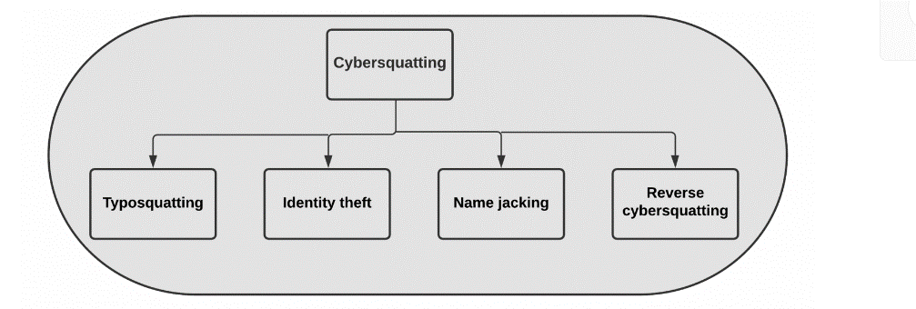

1. **Typo-squatting**

Typo-squatting (a.k.a URL hijacking) targets Internet users who enter a website address incorrectly into their browser. ***For example***, typing “Gooogle.com” instead of “Google.com.”

1. **Identity theft**

Identity theft describes crimes where someone unlawfully obtains and uses another individual’s private data to involve deception or fraud, usually for financial gain.

***For example***, cybersquatters may buy a domain that was inadvertently not renewed by the previous owner. Cybersquatters use specialized software applications to easily monitor the expiration dates of targeted domain names. After registering expired domain names, cybersquatters may link them to websites duplicates of the previous domain name owners’ websites. As a result, cybersquatters will track visitors to their websites into thinking they are visiting the websites of the last name domain owners.

1. **Name jacking**

The registration of a domain name associated with an individual’s name, usually a celebrity or a well-known public figure, is referred to as name jacking. Name jackers profit from web traffic related to the individuals being targeted.

***For example***, Tom Cruise took his case to the WIPO in 2006 against Jeff Burgar, who had owned the domain TomCruise.com for over ten years. Users were redirected to his website Celebrity1000.com, which earns money through third-party advertisements.

1. **Reverse-cybersquatting**

Reverse-cybersquatting is an aggressive action that a cybersquatter uses to obtain a specific domain name on the Internet. Cybersquatters may use intimidation and pressure to transfer legitimate ownership of a domain name to the person or organization that owns a registered trademark reflected in the domain name.

**With the help of example, illustrate Prior Art. What are the four types of prior art.**

Ans =>

Prior art is **any** evidence that your invention is already known. Prior art does not need to exist physically or be commercially available. It is enough that someone, somewhere, sometime previously has described or shown or made something that contains a use of technology that is very similar to your invention. A prehistoric cave painting can be prior art. A piece of technology that is centuries old can be prior art. A previously described idea that cannot possibly work can be prior art. **Anything** can be prior art. An existing product is the most obvious form of prior art. This can lead many inventors to make a common mistake: just because they cannot find a product containing their invention for sale in any shops, they assume that their invention must be novel.

Types of Prior Art:

1. A **novelty** helps an inventor to determine if the invention is novel before the inventor commits the resources necessary to obtain a patent and is done before an inventor file a patent application.
2. A **validity** is done after patent issues, the purpose of which is to find prior art that the patent office overlooked. These can be useful for competitors looking to contest the validity of a granted patents.
3. A **clearance** is a search of issued patents to see if a given product or process violates someone else’s existing or pending patent(s).
4. A **landscape** provides a high-level view of the technology space and is normally performed to understand the lay of the land when entering a new technological area.

**Q5. Comment on whether software can be patented in India.**

**Ans =>**

Software by itself is **not patentable** in India. However, software **can be patented** **if it is part of an invention** that is both inventive and capable of industrial use.

In the **Patents (Amendments) Act 2002**, it is mentioned that computer programme per se is not patentable. It is very important to note that only the word computer programme has the words per se attached to it. All other items excluded from patent registration do not have the words per se attached. The general dictionary meaning of “per se” is “by itself” or “in itself” or “as such” or “intrinsically” – to show that you are referring to something on its own, rather than in connection with other things. Hence, software by itself would not be patentable. However, a software that is part of a Computer Related Invention is patentable.

There is **no legal or conclusive** definition of a software patent. A suggested definition of software patent has been proposed by the Foundation for a Free Information Infrastructure (FFII) as being a patent on any performance of a computer realized by means of a computer program. But as we know, Protection of Computer software is one of the most contentious issues in the field of IPR. So, there is an established law for software protection i.e., **Software protection under Copyright Law** which states that Copyright was usually associated with artistic products, but today in addition to all this copyright is now an important tool in protecting computer software