**SDN ISE**

DATE : 03/11/22

Group members :

PRN : 2019BTECS00089

PRN : 2019BTECS00091

**Installation of mininet:**

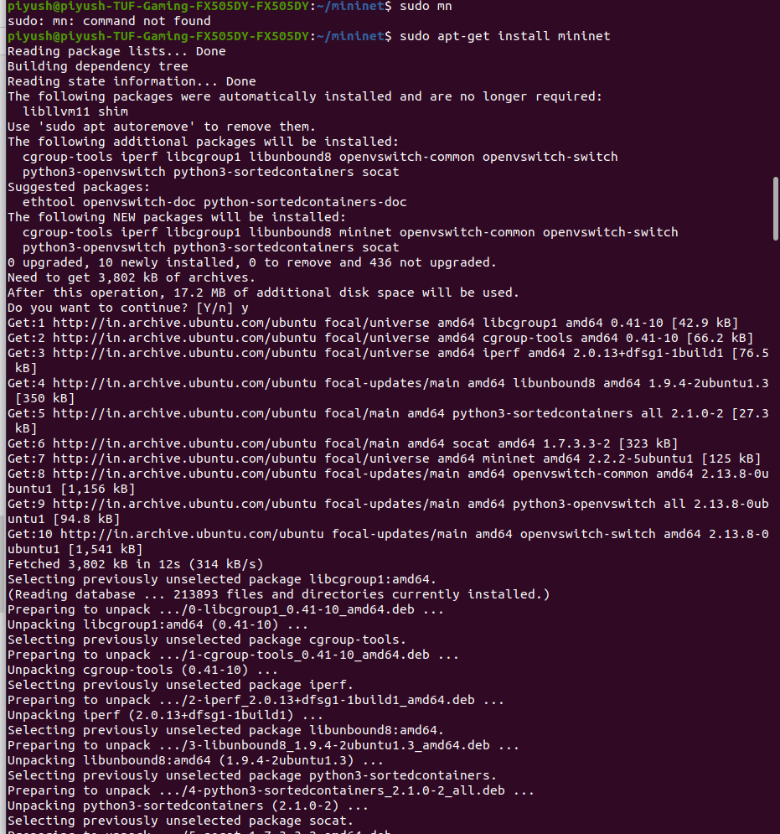

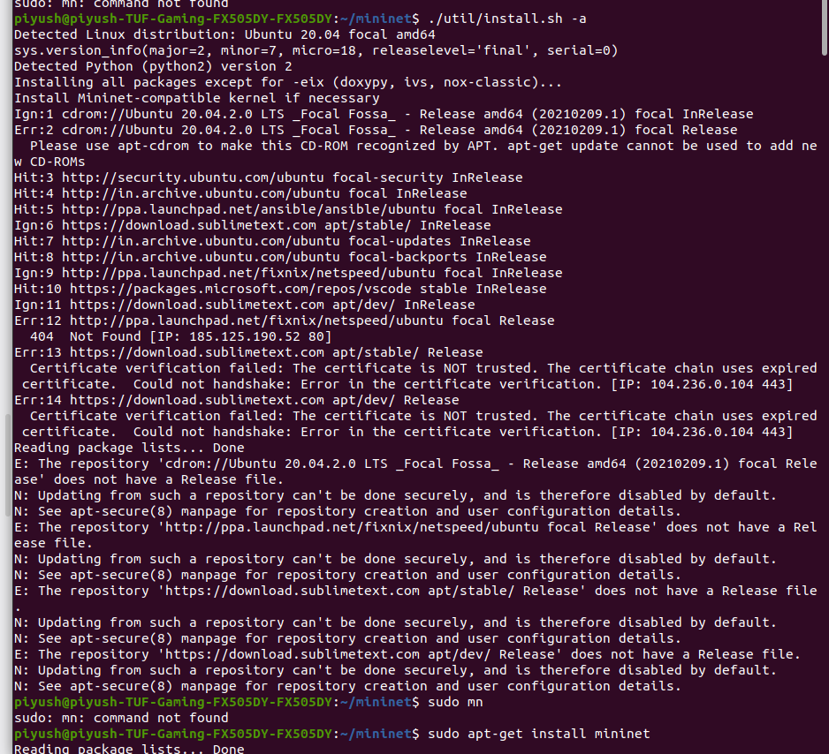

**Using the Mininet :**

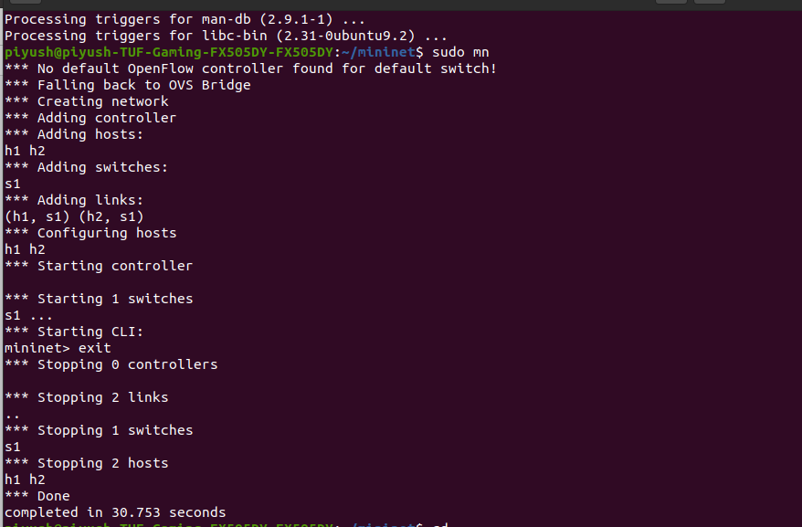

Creatiging a simple CLI :

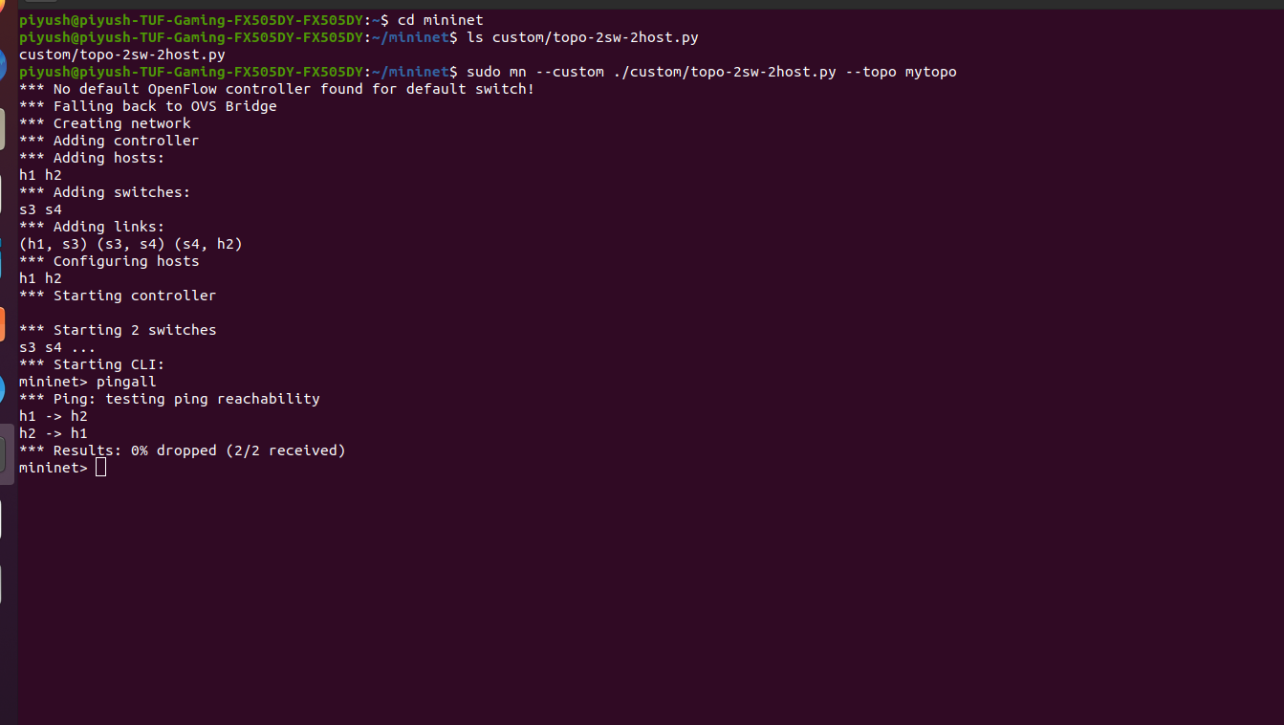

**Creating using GUI :**

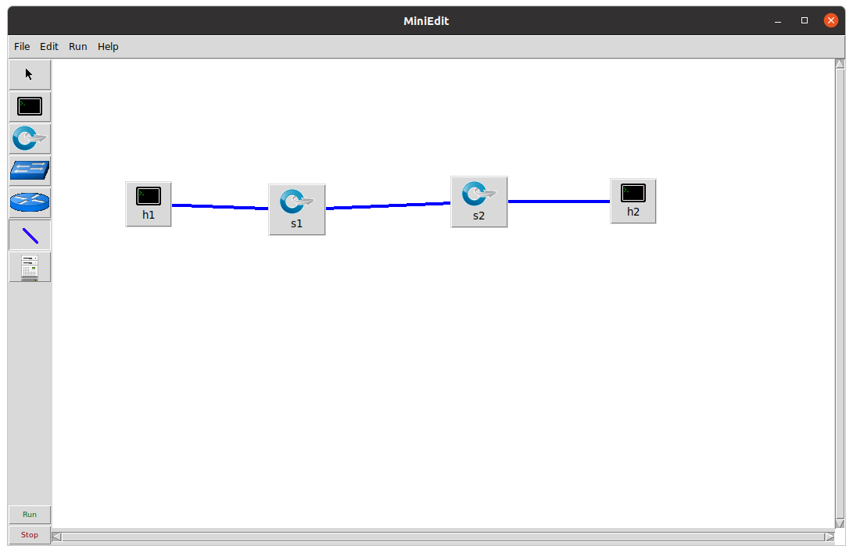

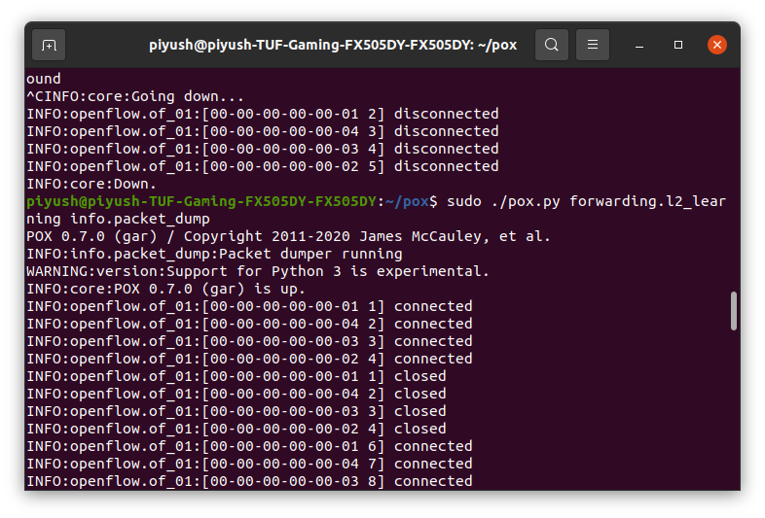

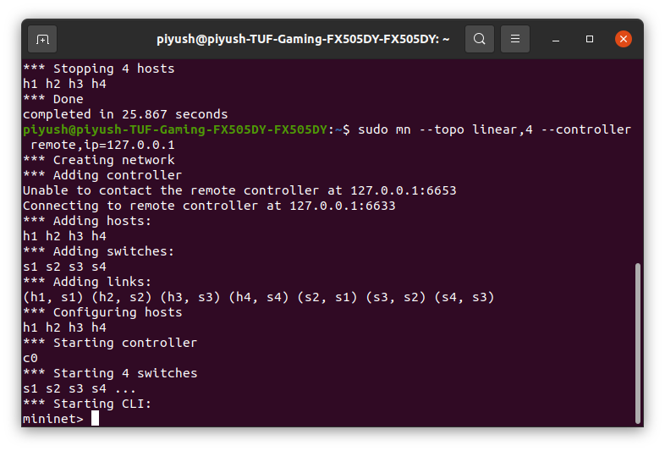

**Assignments**

**Assignment 1: Keep bandwidth and delay as 50 Mbps and 5 ms for all the links. Validate your topology using dump,**

**pingall and arp. Install some flows into the flow table for creating firewall. Display the Flow Rules/ dump**

**Flows.**

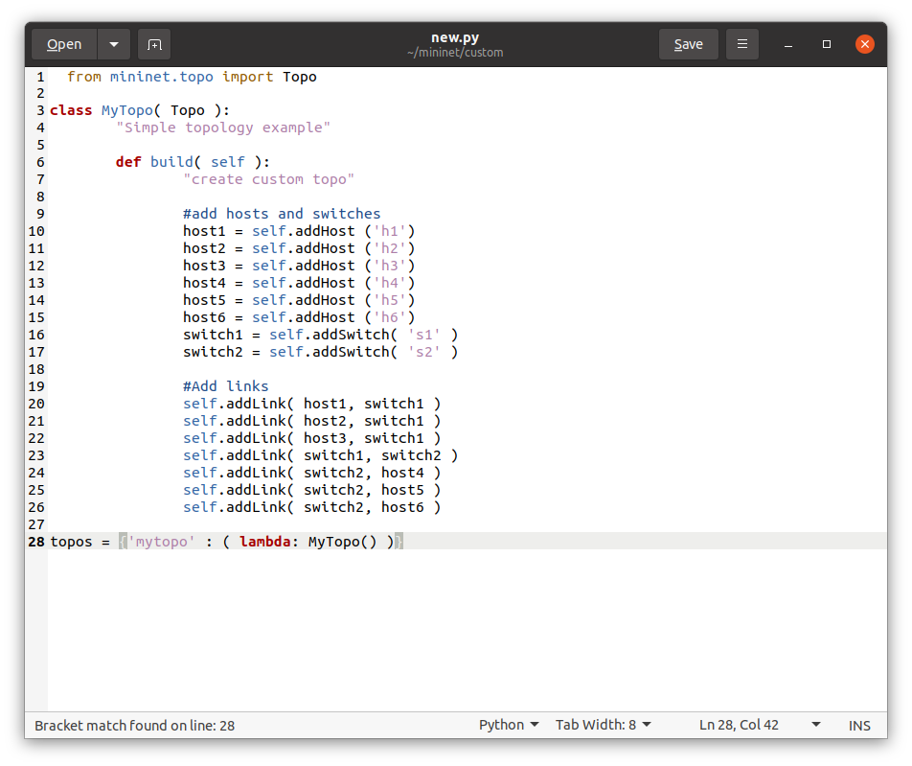

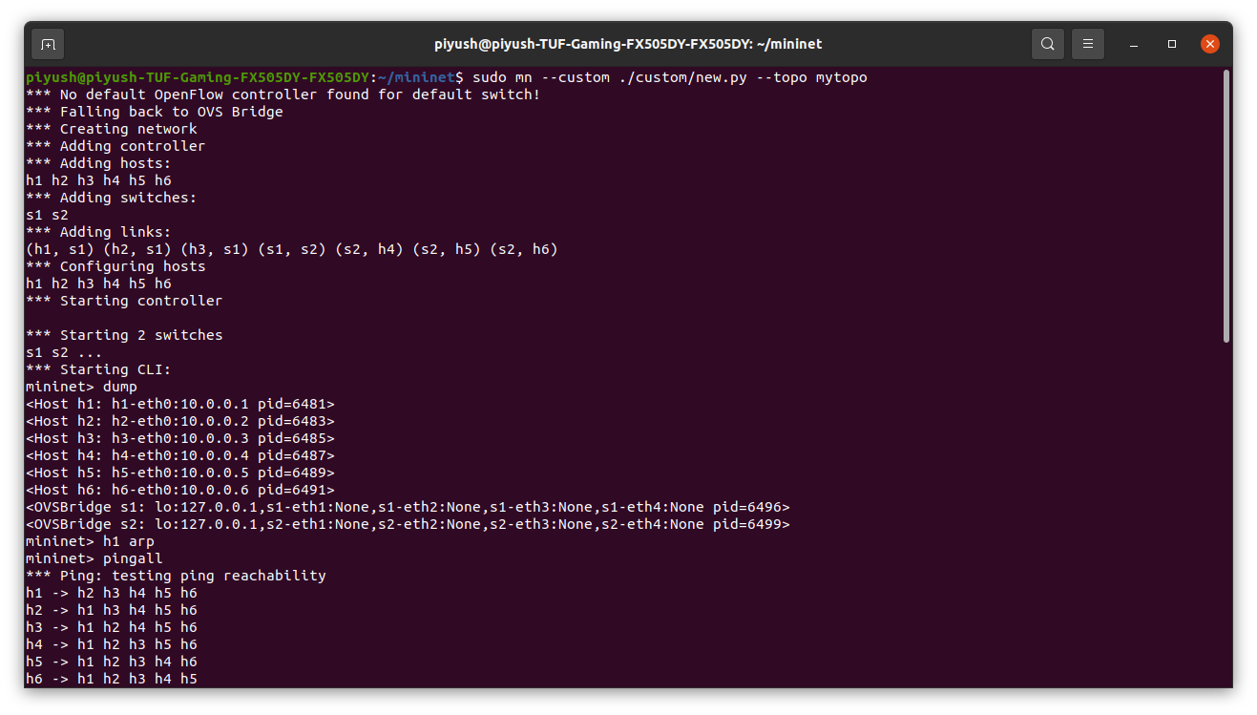

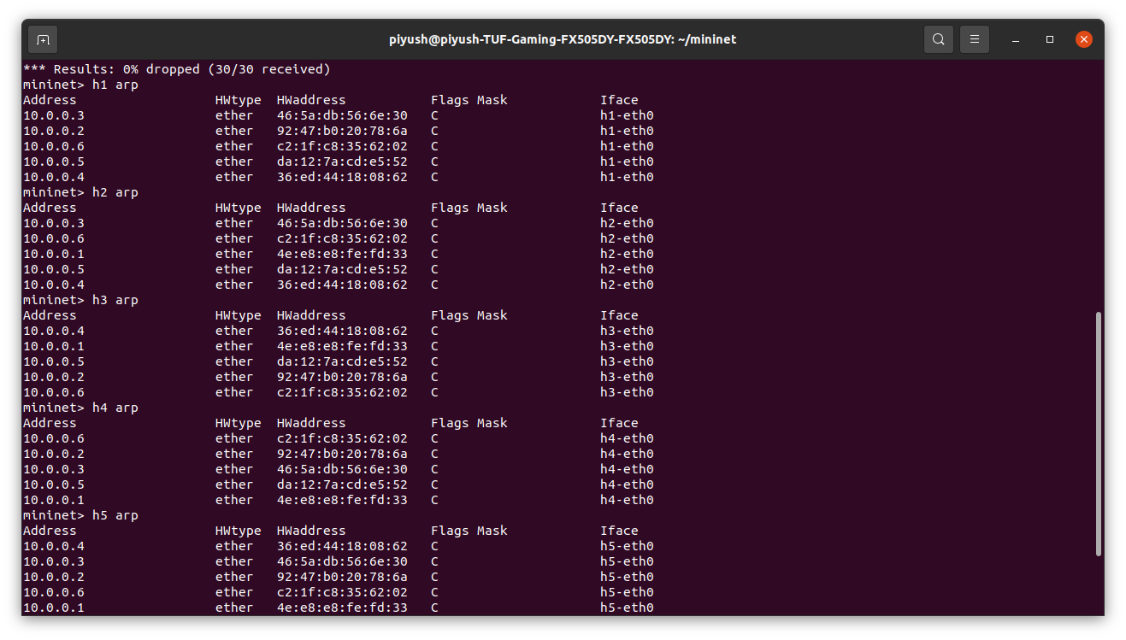 

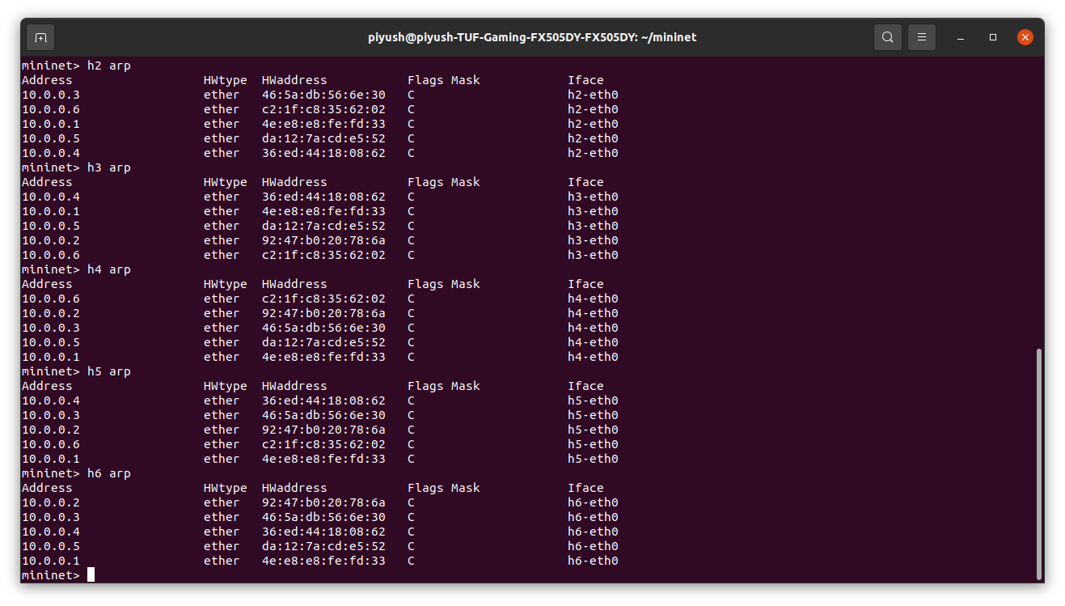

Adding firewall :

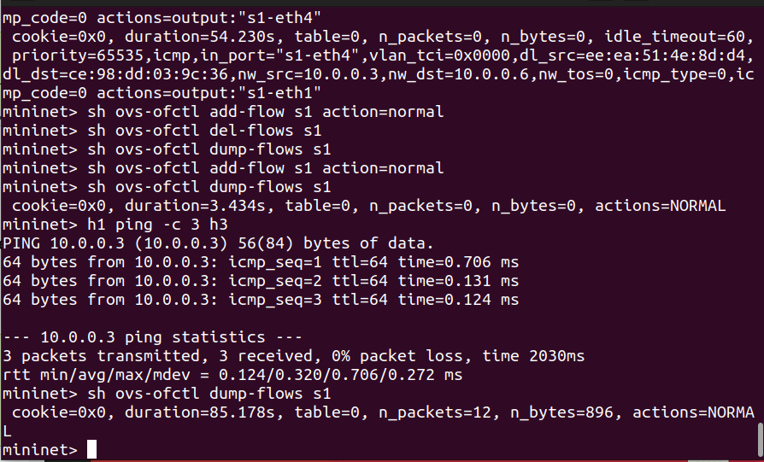

**Assignment 2: Configure the example described in assignment 1, but with an Opendaylight controller (you should install opendaylight first).**



