**Mongo CRUD**

Create a database called "contact"



Create a collection called "contactlist"



Insert 3 persons in "contactlist" :

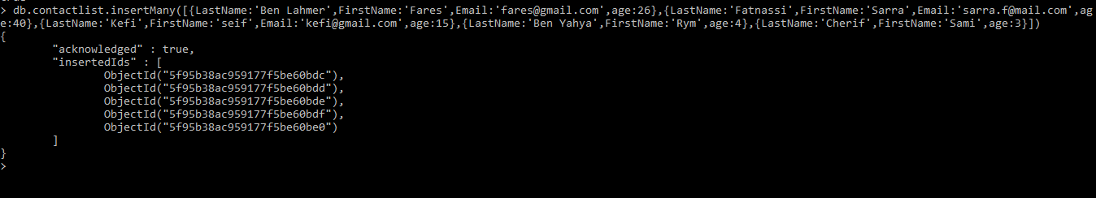

Display all the contact list

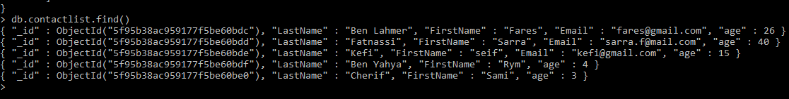

Display all the information about only one person using his  
id



Display all the contact list having age>18

Display all the contact list having age>18 and name  
containing "ah"



Change the contact first name of "kefi Seif" by  
"Kefi Anis



Delete the the contact list having age < 5

Display all the contact list

