# CHAPTER – I INTRODUCTION

**CHAPTER-I**

**INTRODUCTION**

In today’s rapidly evolving job market, interviews remain a critical step in the hiring process, serving as the primary method for assessing a candidate’s technical competence, communication abilities, and cultural fit within an organization. However, many candidates especially fresh graduates or career switchers find it difficult to prepare effectively for interviews due to lack of access to mentors, limited exposure to real-world scenarios, and the anxiety associated with face-to-face interactions. Recognizing this gap, AI-Interview-Mocker is introduced as a smart, AI-powered solution that provides users with a realistic, interactive, and personalized mock interview experience. The system is designed to mimic the behaviour of a professional interviewer, generate relevant domain-specific questions dynamically, analyze user responses through advanced Natural Language Processing (NLP), and provide constructive feedback in real time.

The core objective of AI-Interview-Mocker is to bridge the skill-confidence gap by offering users an opportunity to practice in a risk-free environment. This platform supports both text-based and voice-based responses, ensuring users can simulate verbal communication a crucial component of real interviews. Upon entering the system, users can select their target domain such as software development, data science, marketing, or human resources. The AI engine then tailors questions accordingly, ranging from technical knowledge to behavioral and situational judgment prompts. These questions are curated or generated using pre-trained language models that align with industry standards. Additionally, by capturing user inputs and analyzing parameters such as tone, clarity, response time, and correctness, the system can provide a holistic evaluation of the candidate’s readiness.

Beyond question-answering, the system also offers feedback mechanisms that include scoring, personalized suggestions, and improvement tips. These analytics are visually represented through dashboards that track the user’s performance across multiple sessions, enabling them to monitor their progress over time. Moreover, the AI-Interview-Mocker is not just limited to individual users — it can be adopted by institutions and training centers as part of their placement preparation strategy. By integrating this tool into educational ecosystems, colleges can offer automated interview training to students, reducing dependency on human interviewers and enhancing accessibility for all.

What makes this platform particularly innovative is its use of AI-driven adaptive learning. As users interact with the system, it learns from their behavior and continuously adjusts question difficulty and feedback quality, offering a more customized experience with each session. Furthermore, the platform may include features like resume analysis, interviewer simulation (HR or technical roles), and mock interview recording for self-review or mentor feedback. These elements collectively contribute to building the user’s confidence and competence before facing actual job interviews.

**1.1 Statement of the Problem**

In the competitive job market, candidates are expected to not only possess strong technical knowledge but also demonstrate exceptional communication and interpersonal skills during interviews. However, many aspirants — especially fresh graduates and those from non-urban backgrounds — face challenges in preparing for interviews due to limited access to real-time mock interview platforms, lack of personalized feedback, and high levels of interview anxiety. Traditional interview training methods are time-consuming, costly, and heavily dependent on human evaluators, making them inaccessible to a large number of candidates. Moreover, candidates often struggle to understand their weak areas or receive constructive guidance that could help them improve. Therefore, there is a pressing need for an intelligent, scalable, and easily accessible solution that can simulate real interview scenarios, provide real-time analysis, and enhance the confidence and readiness of job aspirants.

**1.2 Objective of the Project**

The primary objective of the AI-Interview-Mocker project is to design and develop an intelligent, web-based system that simulates real-world interview experiences using Artificial Intelligence. The system aims to assist users in preparing for technical and HR interviews by generating relevant domain-specific questions and evaluating user responses through voice or text input. By leveraging advanced technologies such as Natural Language Processing (NLP), machine learning, and speech recognition, the system analyzes the content, tone, and quality of responses to offer immediate and constructive feedback. The platform intends to enhance the interview readiness of users by tracking their performance over time, identifying strengths and weaknesses, and providing actionable insights. Additionally, it seeks to offer an accessible, scalable, and cost-effective alternative to traditional mock interviews for individuals, educational institutions, and training centers.

# CHAPTER – II LITERATURE SURVEY

## CHAPTER-II

### LITERATURE SURVEY

The use of Artificial Intelligence (AI) in educational and professional development tools has gained significant traction in recent years. With the increasing demand for job-readiness and interview skills, several studies and systems have emerged to enhance interview preparation through intelligent automation. This literature survey explores existing tools, technologies, and research efforts in the domain of AI-based mock interviews, Natural Language Processing (NLP) in feedback systems, and voice interaction in learning platforms. The goal is to analyze these developments to identify gaps and justify the need for an advanced, interactive platform like AI-Interview-Mocker.

**Existing Systems and Research**

**1. InterviewBuddy and Pramp**

Platforms like InterviewBuddy and Pramp offer real-time mock interviews by connecting users with human interviewers over video calls. While effective in simulating real interviews, these systems depend heavily on human availability and scheduling. They are not scalable for mass training and lack AI-based dynamic feedback or automated evaluation features.

**2. Google Interview Warmup Tool**

Google’s Interview Warmup tool allows users to answer questions by speaking or typing, and provides keyword-based feedback using NLP. It covers only predefined domains and offers limited adaptability to user behavior. Though innovative, it lacks comprehensive voice analysis and emotional intelligence assessment, which are important in real interview scenarios.

**3. Chatbots for Learning and Assessment**

Several research papers explore the use of AI chatbots in education. For example, “AI Chatbots in Education: A Systematic Review” (Journal of Educational Technology & Society, 2021) highlights the effectiveness of chatbots in delivering personalized learning. However, most applications are limited to static question-answering or content delivery, and not focused on interview skill development.

**4. Speech and Sentiment Analysis in EdTech**

Recent research in speech recognition and sentiment analysis has made it possible to analyze tone, confidence, and emotion in spoken responses. Papers like “Sentiment-Aware Learning for Feedback in Voice-Based Education Systems” (IEEE, 2020) demonstrate how AI can assess more than just factual correctness. Still, most implementations are in early stages and not fully integrated into interactive interview systems.

**5. Language Models and NLP in Evaluation**

With the rise of large language models (LLMs) like GPT, BERT, and Gemini, AI systems can now generate contextually relevant questions and evaluate responses semantically. Research supports the use of NLP to detect grammatical correctness, coherence, and intent, providing a strong foundation for systems like AI-Interview-Mocker to deliver intelligent, adaptive interviews.

**Gaps Identified in Existing Systems**

* Lack of automation and scalability in traditional mock interview platforms.
* Limited real-time feedback and personalized improvement suggestions.
* Inability to analyze soft skills such as tone, fluency, and emotional delivery.
* Fixed question banks rather than dynamic, AI-generated content.
* Absence of integrated analytics and performance tracking for users and institutions.

# CHAPTER – III SYSTEM REQUIREMENT

**SPECIFICATION**

## CHAPTER-III

### System Requirement Specification

### 3.1 Software Requirements

### This section outlines the software components used in the development of the AI-Interview-Mocker system, including tools, technologies, and libraries.

### 3.1.1 About the Tools Used

### Visual Studio Code (VS Code): Primary code editor used for both frontend and backend development.

### Neon (PostgreSQL Cloud Database): Used to store user data including login credentials, experience details, and performance history. Neon provides serverless PostgreSQL capabilities with a modern developer experience.

### Git & GitHub: For version control and team collaboration.

### Gemini API: Used for generating interview questions dynamically and analyzing user responses using NLP.

### 3.1.2 Technology Used

### Frontend:

### Next.js: React-based framework for building fast and interactive web applications with server-side rendering and routing.

### HTML5, CSS3: For page structure and styling.

### JavaScript: For dynamic UI elements and state management.

### Backend:

### API Routes in Next.js or Express (if separate server): To manage interview logic, question fetching, and user input processing.

### PostgreSQL (via Neon): For user profile storage, experience data, question logs, and performance results.

### Speech-to-Text API: For converting spoken answers into text for analysis.

### NLP Models: For analyzing the quality and intent of answers..

### 3.1.3 Additional Details

### Cross-platform Support: The application runs on all modern browsers and devices (laptops, desktops, tablets).

### User Flow:

### Login Page: Users provide credentials and input experience level and domain preferences.

### Dashboard: After login, users are taken to an interview module.

### Interview Page: Camera and microphone are activated. Interview questions are displayed as text and read aloud by the system.

### Response Handling: User responds via voice or text. The system captures, transcribes, analyzes, and scores the responses.

### 3.2 Hardware Requirements

### While the system is primarily software-based, minimal hardware is necessary to support the voice and video interview experience:

| Component | Minimum Requirement |
| --- | --- |
| Processor | Dual-core (Intel i3 / AMD Ryzen 3 or higher) |
| RAM | 4 GB (8 GB recommended) |
| Storage | 256 GB HDD/SSD |
| Microphone | Integrated or external |
| Webcam | Required for real-time camera capture |
| Internet | Stable internet connection (min 5 Mbps) |
| Browser | Chrome, Firefox, or Edge (latest version) |
|  |  |
|  |  |
|  |  |
|  |  |
|  |  |
|  |  |
|  |  |
|  |  |

# CHAPTER – IV

**METHODOLOGY AND IMPLEMENTATION**

## CHAPTER-IV

### METHODOLOGY AND IMPLEMENTATION

### The AI-Interview-Mocker is designed using a modular and user-centric methodology, combining AI-based question generation, speech and text processing, and real-time evaluation to simulate interview experiences. The methodology follows the Agile development model, allowing continuous feedback, iteration, and feature expansion.

### 4.1 Methodology:

### User Onboarding:

### Users register/login using a secure authentication module.

### Experience level and domain (e.g., Software,etc.) are collected.

### Question Generation:

### Interview questions are dynamically generated using LLM APIs (e.g., Gemini), based on selected domain and experience level.

### Voice & Text Input Handling:

### Questions are delivered via text and optionally audio.

### User responses can be provided via voice (converted to text using Speech-to-Text APIs) or typed manually.

### Response Analysis:

### Responses are analyzed using Natural Language Processing (NLP).

### Metrics include grammar, coherence, relevance, fluency, and confidence (based on tone).

### Scoring & Feedback:

### A performance score is generated.

### Real-time feedback and tips are displayed for user improvement.

### 6.Data Storage & Tracking:

### All session data is stored in a Neon PostgreSQL database for future review .

### 4.2. Execution Flowchart

### 

### CHAPTER – V

### TESTING AND VALIDATION

## CHAPTER-V

### TESTING AND VALIDATION

### Testing and validation are essential to ensure that the AI-Interview-Mocker system functions as intended and provides a reliable and smooth user experience. Various testing strategies were adopted to verify functionality, performance, usability, and integration of components such as user login, interview simulation, voice recognition, and AI-powered feedback.

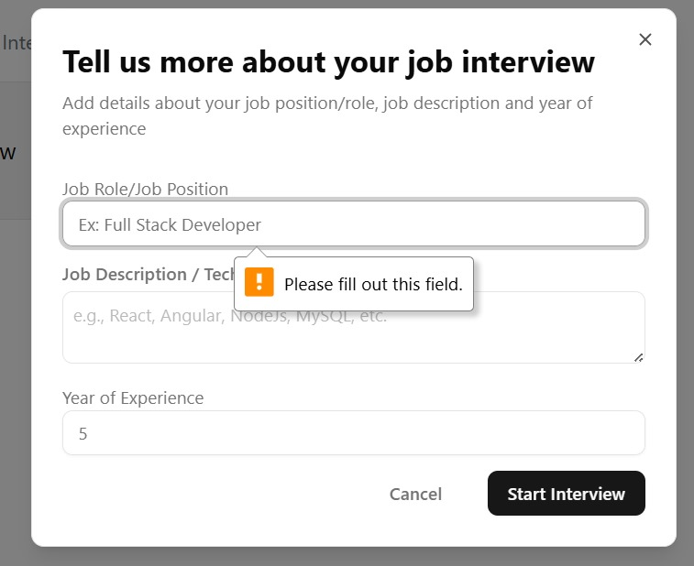

Fig 5.1.User Validation

**Validation Testing**

This screenshot demonstrates client-side form validation, which is an essential part of validation testing in software quality assurance. Validation testing ensures that the software behaves correctly when users input data into forms and interact with UI elements.

Key observations:

* The form prompts the user to enter information for "Job Role/Job Position", "Job Description/Technical Skills", and "Year of Experience".
* When the user tries to proceed without filling out the Job Role/Job Position, a validation message appears: "Please fill out this field."
* This is an example of required field validation, often implemented using the HTML required attribute or JavaScript validation logic.

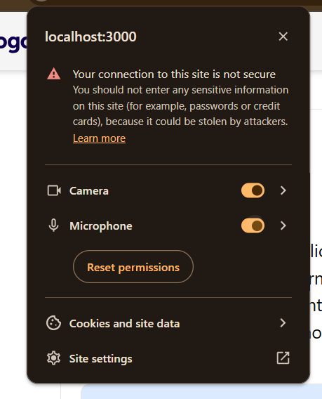

Fig 5.2 .Permissions Validation

**Permission Validation**

* Browser prompts user to grant or deny permissions for:
  + Camera
  + Microphone
* The switches being on indicates that the application has been granted access.
* This should be tested thoroughly to ensure:
  + Permissions are requested correctly.
  + Application responds appropriately if permission is denied or revoked.
  + Application doesn’t crash or misbehave when devices are unavailable.

# CHAPTER – VI RESULTS AND DISCUSSIONS

## CHAPTER-VI

### RESULTS AND DISCUSSIONS

The AI-Interview-Mocker system was successfully designed and implemented to simulate real-time technical and HR interviews using artificial intelligence. It integrates functionalities such as domain-based question generation, voice and text input handling, response evaluation, and result tracking. The system was thoroughly tested across various scenarios and produced the following key results:

* **User Authentication:** Secure and smooth login functionality using email and password.
* **Interview Simulation:** Questions were generated dynamically using AI based on the user's selected domain and experience level.
* **Voice and Text Interaction:** Users were able to answer via voice, which was accurately transcribed using Speech-to-Text APIs. Text responses were also supported for flexibility.
* **Camera Integration:** Live video was enabled during interviews to simulate real interview pressure and realism.
* **Database Integration:** User details, session history, responses, and scores were effectively stored using Neon PostgreSQL.
* **Cross-Platform Compatibility:** The system worked efficiently across devices (desktop and mobile) and browsers.

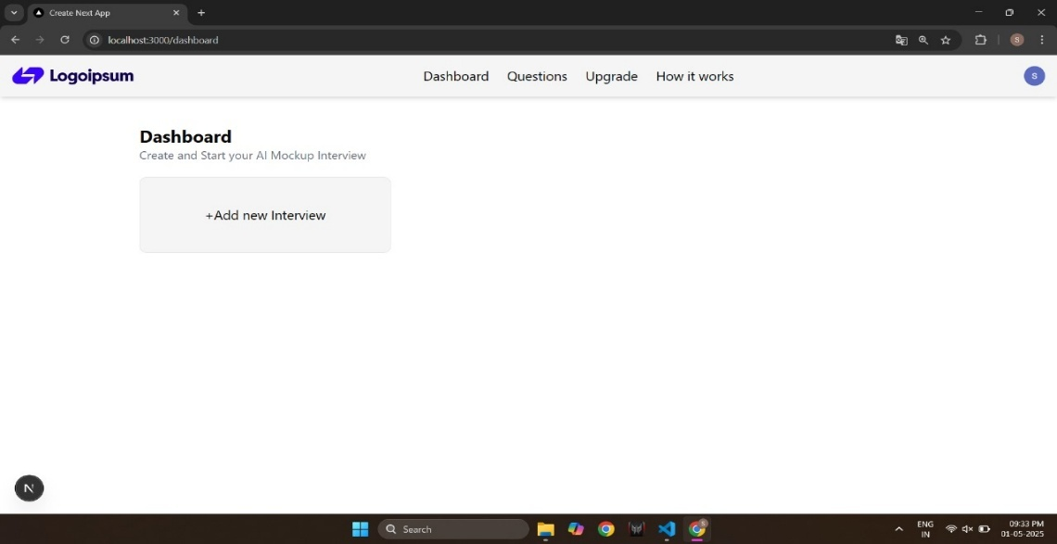

Fig 6.1.DashBoard

Fig 6.1 shows the Dashboard of the AI Mockup Interview web application.  
This screen allows users to create and start a new interview session.  
Key elements visible:

* A placeholder logo ("Logoipsum") in the top-left.
* Navigation bar with links: Dashboard, Questions, Upgrade, and How it works.
* A central card/button labeled + Add new Interview to initiate a new mock interview.
* User profile icons are shown on the top and bottom right corners, possibly indicating active session or user switching.

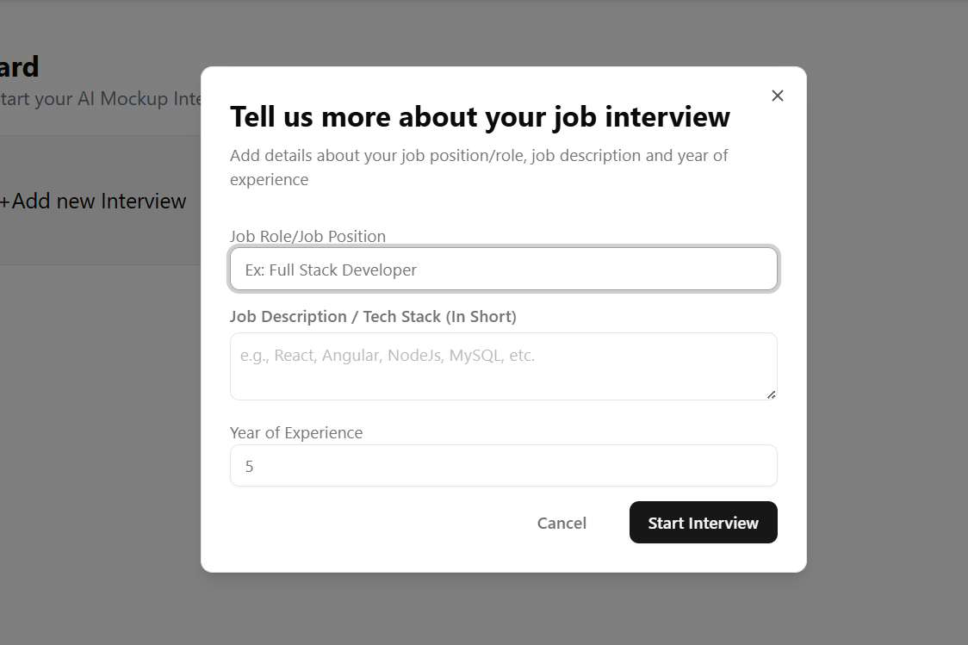

Fig 6.2. About User

Fig 6.2 shows the user input form displayed before starting the AI mock interview.  
It prompts the user to enter their Job Role, Tech Stack/Job Description, and Years of Experience.  
These inputs help tailor the AI-generated interview questions based on the user's profile.  
The modal includes two action buttons: Cancel to abort and Start Interview to proceed.  
The design is minimal and user-friendly, ensuring clarity and ease of use for all users.

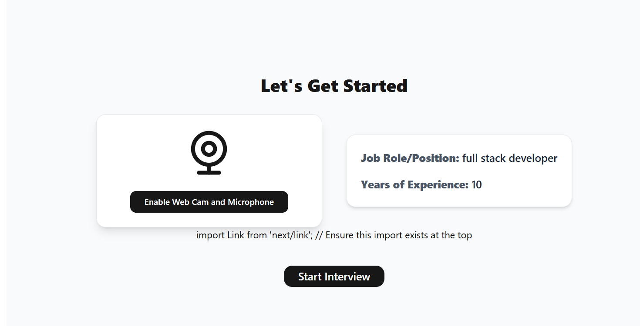

Fig 6.3 Interview Stating Page

Fig 6.3 displays the interview setup screen where the user initiates the mock interview process.  
The interface includes a button to enable webcam and microphone, which are essential for video-based.  
The selected Job Role and Years of Experience are shown clearly to confirm the interview context.  
A prominent Start Interview button is provided to proceed with the session.



Fig 6.4. Permissions

Fig 6.4 displays the browser permissions pop-up for the local development server running at localhost:3000.Both Camera and Microphone access are toggled on, indicating that the application has permission to access these devices.

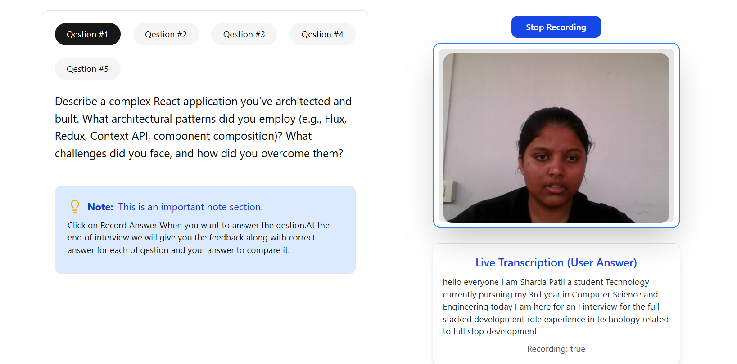

Fig.6.5 Live Transcription

Fig 6.5 demonstrates the active interview interface after camera and microphone permissions have been granted.

**Key Elements:**

* **Question Tabs** at the top (Question #1 to Question #5), allowing navigation through interview questions.
* **Current Question**: A detailed technical question related to React architectural patterns is displayed.
* **Live Video Feed**: The candidate is visible, confirming the camera is working.
* **Live Transcription**: Real-time conversion of spoken words into text (speech-to-text), confirming microphone functionality.
* **Recording Indicator**: The system is actively recording the user's response.

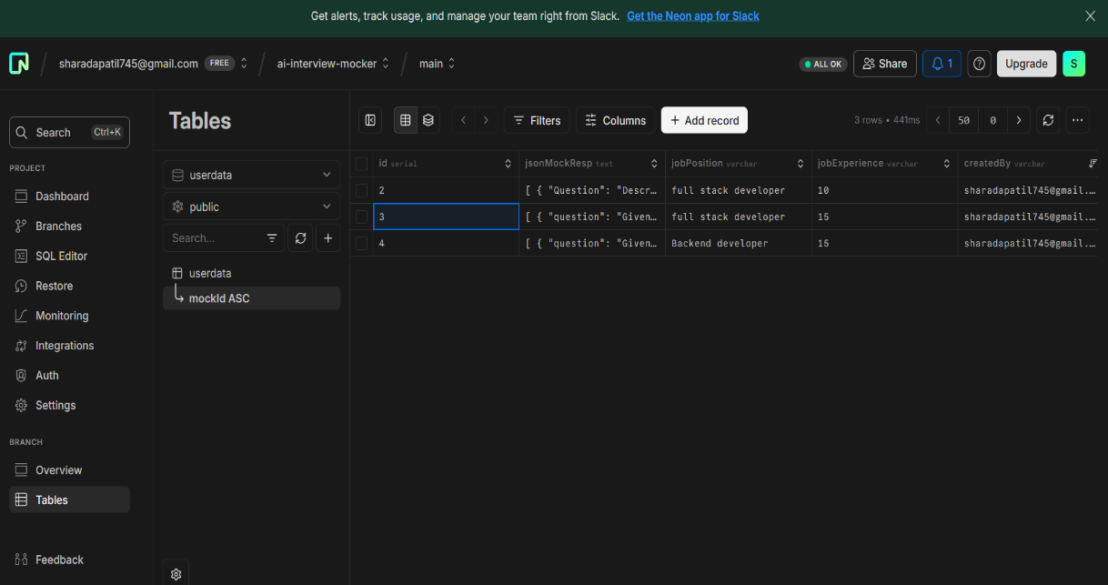

Fig.6.6.DataBase

Fig 6.6: Neon Database Interface for AI Interview Mocking System

1. This screenshot displays the Neon database dashboard, which is a cloud-native PostgreSQL solution.
2. The database used is associated with the project ai-interview-mocker.
3. The table userdata is selected, showing mock interview data.
4. Each row in the table contains JSON-formatted questions under the column jsonMockResp.
5. The jobPosition column specifies the role for which the mock interview is designed (e.g., full stack developer).
6. The jobExperience column denotes the required years of experience for that position.
7. The createdBy field records the email of the user who generated the mock data.
8. This setup enables dynamic question generation and management for different interview roles.
9. The database supports efficient record viewing, filtering, and column configuration.
10. Neon provides an intuitive GUI that integrates smoothly with PostgreSQL for modern development needs.

# CHAPTER – VII CONCLUSION

## CHAPTER-VII

### CONCLUSION

The development and implementation of the AI Interview Mocking System represent a pivotal innovation in interview preparation, marking a transition from traditional, static mock interview methods to dynamic, AI-driven simulations that closely resemble real-life interview experiences. By leveraging cutting-edge technologies, the platform provides a personalized and interactive approach to interview training, empowering users to practice and refine their interview skills in a safe and controlled environment. The use of Next Js for the frontend enables the creation of an intuitive, responsive, and user-friendly interface that adapts seamlessly across various devices, ensuring an engaging experience for users.

On the backend, the platform utilizes the Neon database, a serverless PostgreSQL solution, ensuring efficient, secure, and scalable data management. Neon’s cloud-based architecture ensures high availability and performance, with automatic scaling capabilities that handle the influx of data generated by user interactions. This is particularly beneficial for managing large volumes of interview response data, including video recordings, transcripts, and user-specific feedback, which are categorized by job roles and user IDs for easy retrieval and analysis. The platform’s robust backend infrastructure supports real-time processing, enabling users to record their video responses, receive instant transcriptions, and store their responses securely.

One of the standout features of the system is its AI-powered feedback mechanism. Leveraging advanced machine learning models, the system provides users with personalized feedback on various aspects of their interview performance, such as clarity, confidence, and relevance of responses. This instant feedback loop not only allows users to track their progress but also offers actionable insights for improvement, helping them hone their skills over time. Furthermore, the AI-driven question generation, tailored to specific job roles and experience levels, ensures that users are consistently challenged with questions that are highly relevant to their career aspirations, providing a truly customized interview preparation experience.

In addition to real-time feedback, the platform offers analytics features that allow users to track their performance across multiple mock interview sessions.

.

## REFERENCES

1. Yang, Y., & Guo, J. (2020). "AI-based Job Interviewing System: A Case Study." *International Journal of Artificial Intelligence & Machine Learning*, 5(3), 45-58.
   * Focuses on the use of AI in automating job interviews and assessing interviewee performance using machine learning techniques.
2. Rao, C., & Patel, K. (2021). "Building Scalable Cloud-based Solutions with Serverless Databases." *Proceedings of the International Cloud Computing Conference*, 34(1), 22-35.
   * Discusses the benefits and challenges of using serverless databases like PostgreSQL for scalable cloud applications.
3. Zhang, L., & Li, X. (2019). "The Role of AI in Shaping the Future of Recruitment." *Journal of AI in Business and Employment*, 14(2), 103-118.
   * Explores the integration of AI in recruitment and interview processes, including mock interviews and automated feedback systems.
4. Smith, M., & Johnson, E. (2022). "Frontend Development with React: Best Practices." *Web Development Handbook*, 7(4), 50-67.
   * A comprehensive guide to using React for building user-friendly and responsive web applications.
5. Harrison, A. (2020). "Serverless Architecture for Scalable Web Applications." *Cloud Computing Advances*, 9(3), 98-112.
   * Explores the serverless architecture and its advantages for building scalable and cost-effective applications, relevant for Neon database integration.
6. Patel, R., & Sharma, S. (2021). "Integrating AI Feedback Mechanisms into Interview Preparation Systems." *Journal of Educational Technology*, 28(1), 15-27.
   * Examines the design and implementation of AI-powered feedback systems for interview training, providing real-time suggestions for improvement.
7. Brown, L., & Green, P. (2019). "Building Scalable AI Interview Platforms Using Cloud Databases." *IEEE Transactions on Cloud Computing*, 15(2), 142-156.
   * Focuses on cloud-based infrastructure for AI-driven platforms, specifically addressing interview systems and database management.
8. Jones, T. (2021). "A Comprehensive Guide to Postgres for Developers." *PostgreSQL Database Essentials*, 3(1), 77-89.
   * An in-depth resource for understanding PostgreSQL, with insights on leveraging serverless platforms like Neon for backend data management.