

CUSTOMER RELATIONSHIP MANAGEMENT PROJECT | TRACK C
AI-Driven Sentiment Analysis of Customer Feedback
A CRM Study of Mandi @ 36, Hyderabad
Submitted by | Malla Venkata Sai Ashish
Roll Number | B31-25
Submission date | 17 August 2026

Voice of Customer, sentiment intelligence, and evidence-led service recovery

Executive Summary
Mandi @ 36 receives customer feedback through Google Maps reviews across its Banjara Hills, Gachibowli, and Jubilee Hills branches. This CRM project converts that unstructured Voice of Customer material into a repeatable feedback-to-action workflow. It analyzes 33,275 collected reviews, of which 11,765 contain usable text, using transparent sentiment, aspect, topic, alert, and prioritization methods.
Core CRM insight. The value is not simply a sentiment label. The dashboard combines review volume, experience-area mentions, rating trends, and alert signals so a branch manager can decide what to inspect, who should own it, and when the customer experience should be reviewed again.

Course alignment. The workflow applies the CRM course logic of customer-centricity, customer analytics, journey touchpoints, service response, and responsible AI. Google Maps reviews are treated as a post-experience touchpoint: they are not merely promotional content, but evidence that can be closed through a documented response and improvement cycle (Kumar & Reinartz, 2018; Winer, 2001).
Finding snapshot. Jubilee Hills has the highest observed average rating (4.1283), while Gachibowli has the lowest (3.9499). The text pipeline finds food quality, ambience, service, waiting time, and price/value as recurring experience areas. These are analytical signals, not proof of causation.
CRM decision. Use negative-feedback alerts to trigger a short branch review, classify the issue, validate a sample of the underlying reviews, assign an owner, and log the service-recovery or process-improvement response.

1. Problem Background and Identification
Restaurants receive feedback at a volume that makes manual reading inconsistent and slow. A rating alone cannot show whether dissatisfaction relates to food, service, wait time, value, or ambience. Without an organized Voice of Customer process, recurring pain points can remain unresolved, delayed responses can erode trust, and branch teams cannot consistently connect feedback to a CRM action.
Problem statement. Mandi @ 36 receives thousands of online customer reviews but needs a systematic, evidence-led way to detect recurring experience issues, prioritize response, and inform branch-level CRM action. This project applies AI-supported sentiment and text analysis to convert review text into monitored CRM signals.
Stakeholders. Branch managers, service teams, marketing and CRM coordinators, food operations, senior management, and customers who benefit when feedback is acknowledged and converted into visible improvement.

2. Literature Review
Sentiment analysis is commonly used to identify opinions and evaluations expressed in text, while opinion targets and context determine whether the output is useful for management action (Liu, 2012; Pang & Lee, 2008). For customer feedback, aspect-based analysis is particularly important because a single restaurant review can praise food and criticize service in the same message.
Topic modeling supports the discovery of recurring language patterns in large feedback collections, while current approaches such as BERTopic illustrate embedding-and-clustering alternatives (Grootendorst, 2022). In this project, a transparent TF-IDF and NMF method is used so terms can be inspected by a human before a topic is treated as a business theme.
Voice of Customer research shows that text analytics can move feedback from broad sentiment toward service and product decisions. Enterprise VoC research expands beyond polarity to distinguish feedback, help-seeking, enquiry, and buying intent (Suresh et al., 2018). Hospitality studies have shown that online-review themes can inform service response and customer-experience design (Zhang, 2019; Özdağoğlu et al., 2018).
Research gap addressed. The project does not claim that an automated label is a customer-satisfaction metric. It connects transparent NLP outputs to a documented CRM response routine, preserving review evidence for manager validation.

3. Data Collection, Preparation, and Methodology
The project uses one feedback source: Google Maps customer reviews collected from three Mandi @ 36 locations through Apify exports. The available review window is 20 May 2017 to 15 August 2026. This full available window is disclosed because it is wider than a short pilot window and branch coverage is uneven. The raw files are preserved; the pipeline writes normalized and analytical outputs separately.
Stage | Method | CRM use
Collect | Apify Google Maps review exports | Retain source, location, date, rating, and review text.
Prepare | Schema detection, normalization, validation, text cleaning | Create privacy-minimized analytical fields without editing raw exports.
Classify | Transparent lexicon sentiment baseline | Flag broad customer-mood signals for review.
Discover | Keyword aspects and TF-IDF plus NMF topics | Identify repeat experience areas and language themes.
Monitor | Monthly trends and Isolation Forest alerts | Surface unusual branch-month patterns for manager review.
Act | Evidence-ranked CRM cases and AI-supported explanation | Assign owner, action, and review cycle.

Note. Sentiment, aspects, themes, and alerts are derived or model-based signals. Ratings and review counts are collected evidence.
Customer 360 principle. The present dashboard provides a branch-level experience view by combining review text, rating, date, location, theme, alert, and CRM-case fields. A future customer-level Customer 360 view should only be built with consented identifiers, clear data purpose, access control, and a retention policy.

4. Dashboard and AI Tools
The dashboard was built in Streamlit and separates collected, derived, and predicted outputs. The Sentiment page offers mood distribution, branch comparison, a word cloud, and a monthly trend. The Negative Insights page isolates complaint signals and suggested CRM fixes. The AI Analyst is a controlled assistant: deterministic code identifies the relevant branch and compact evidence before a language-model response is requested. It does not receive the full raw dataset.
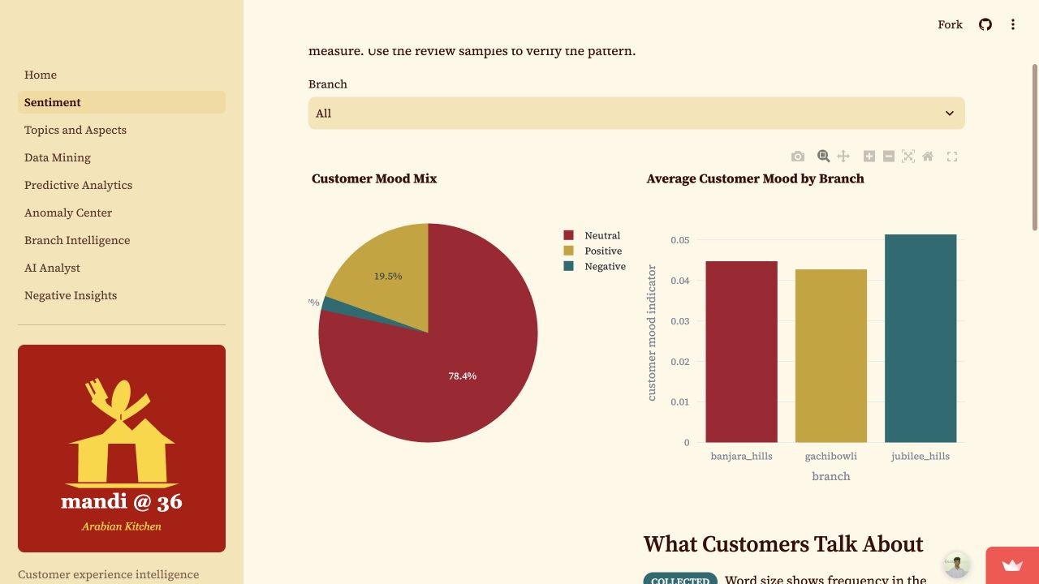
Figure 1. Sentiment dashboard with branch selector, customer-mood distribution, and branch comparison.
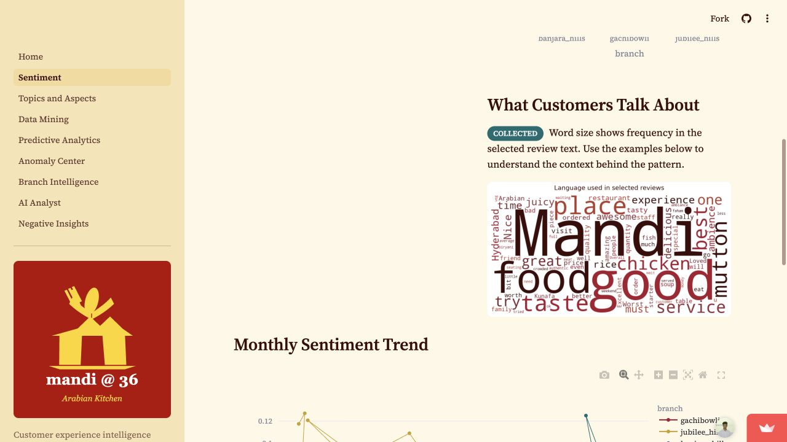
Figure 2. Review-language word cloud. Term size indicates frequency in selected customer feedback and should be interpreted with its review context.

5. Findings and CRM Insights
The text baseline classified 6,494 records as positive, 689 as negative, and 26,092 as neutral. The large neutral group demonstrates why a lexicon output must not be treated as a validated CSAT or NPS score. It is used as a screening signal alongside observed rating, review volume, and manager inspection.
Branch | Reviews | Avg. rating | Text available | CRM reading
Banjara Hills | 3,000 | 3.9913 | 1,340 | Compare operational context before allocating response effort.
Gachibowli | 2,016 | 3.9499 | 862 | Compare operational context before allocating response effort.
Jubilee Hills | 28,259 | 4.1283 | 9,563 | Compare operational context before allocating response effort.

Table 1. Observed branch coverage and ratings. Source: project-generated branch summary from collected Google Maps exports.
The most frequent detected experience-area mentions are food quality (5,854), ambience (3,068), service (1,685), price/value (1,135), and waiting time (1,080). Frequency indicates where to look first, not the cause of a customer outcome.
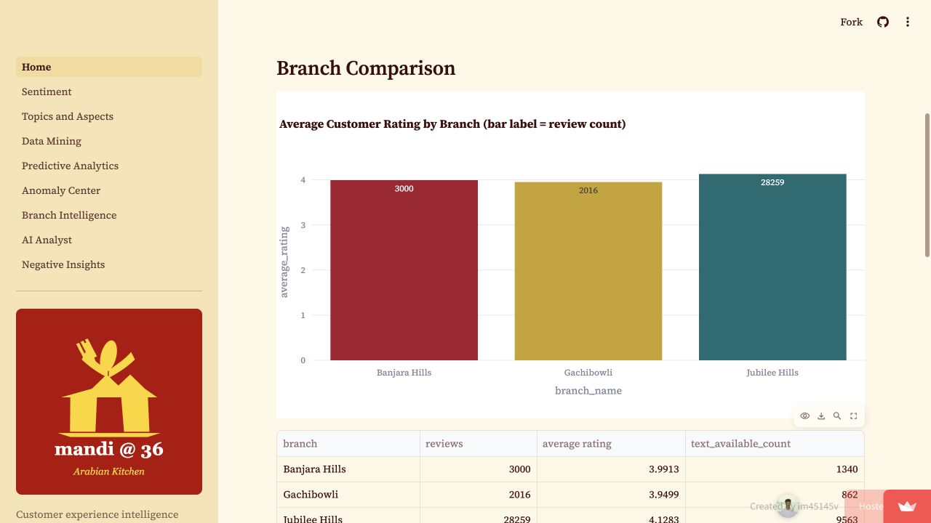
Figure 3. Observed average rating and collected review count by branch. Volume differences should be considered when comparing branches.

6. From Insight to CRM Action
The CRM priority engine creates a case when recurring experience-area signals are combined with branch alert information. Every case includes its supporting mention count, an action owner, a status, and a weekly review instruction. This means a manager can use the dashboard to triage attention without claiming that a model has proven the root cause.
Experience area | Mentions | Priority | CRM response
Food Quality | 703 | High | Investigate recurring food_quality feedback and assign a branch owner.
Ambience | 356 | High | Investigate recurring ambience feedback and assign a branch owner.
Service | 298 | High | Review peak-hour staffing, greeting consistency, and table follow-up.
Waiting Time | 186 | High | Investigate recurring waiting_time feedback and assign a branch owner.

Table 2. Sample evidence-ranked Banjara Hills CRM cases. Source: deterministic project CRM case artifact.
Service recovery trigger. When a branch-month alert coincides with recurring service or wait-time language, review a sample of recent low-rating comments, check the operating period, assign a branch owner within one business day, and track the action to closure.
Proactive outreach rule. Where contact and platform policy permit, a customer-support lead should acknowledge strong dissatisfaction promptly, avoid making unverified claims, offer a suitable recovery route, and record the interaction in the CRM case history.
Closed-loop VoC routine. Capture the review, classify the issue, validate a sample, respond or improve the operating process, and monitor the same experience area in the next review cycle. This converts a social-review touchpoint into an accountable customer-relationship process.
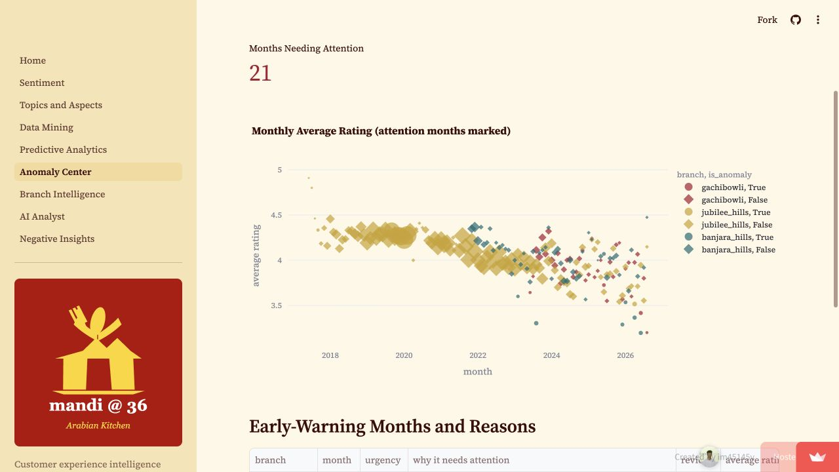
Figure 4. Anomaly Center page. Observed branch-month ratings are marked when the monitoring rules indicate manager attention.

7. AI Analyst: Controlled CRM Assistance
The AI Analyst supports a manager after deterministic analytics have prepared the evidence. The orchestration layer uses rule-based branch and period detection, then gathers compact JSON evidence such as branch summary, topic terms, aspect signals, alerts, and CRM cases. The CRM recommendation agent is instructed to ground every action in that evidence, label confidence based on real, derived, or predicted information, and avoid fabricated facts.
Example CRM question. What actions should we take for Banjara Hills?
Expected tool path. The orchestrator detects the branch and an action intent, calls the insight agent with compact evidence, and then calls the CRM recommendation agent. The output is an explanation and prioritized suggestions, not an autonomous customer-facing decision.
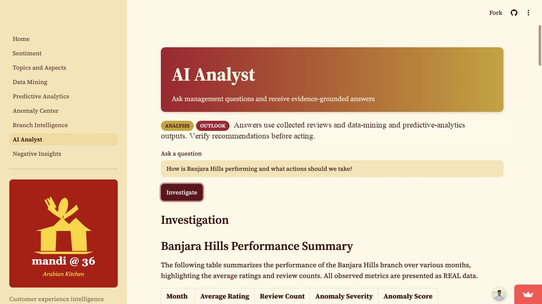
Figure 5. AI Analyst scenario for Banjara Hills, showing the complete page, manager question, evidence-grounded answer, and full navigation.

8. Implementation Roadmap and Risk Mitigation
Implementation should begin as a controlled branch pilot, not an automatic decision system. The recommended process adds feedback fields to the CRM or service log, defines an owner for each high-priority issue, establishes review rules for alert months, and checks whether actions correspond with later observed feedback patterns.
Activity | W1 | W2 | W3 | W4 | W5 | W6 | W7 | W8 | W9 | W10 | W11 | W12
Define fields and ownership
Pilot sentiment and alerts
Train support playbooks
Branch rollout and review
Evaluate and calibrate

Figure 6. Twelve-week implementation roadmap for integrating feedback signals into the CRM operating rhythm.
Risk | Mitigation
False or mixed sentiment | Use sentiment as a triage cue; validate a sample of reviews before action.
Uneven branch volume | Compare rates and supporting comments, not counts alone.
Unclear accountability | Assign named owner, due date, case status, and weekly review.
Model drift or language change | Recheck thresholds and manually review a labeled sample each quarter.
Over-automation | Keep recovery and operational decisions under human approval.

Table 3. CRM implementation risks and mitigation controls.
Proposed CRM scorecard. Track operational measures first: percentage of high-priority cases reviewed within one business day, case-closure time, repeat mentions by experience area, review volume, and rating trend. Add CSAT, repeat visit, loyalty, or lifetime-value metrics only when a consented CRM data source makes them measurable.

9. Ethical, Legal, and Bias Considerations
Online reviews can contain personal information, informal language, sarcasm, mixed opinions, and writing in multiple languages or dialects. The project minimizes data fields used for analysis, excludes unnecessary reviewer metadata from analytical outputs, and keeps raw source files separate. Any future outreach must follow the source platform's policies and applicable privacy requirements.
Bias and interpretability. The current sentiment method is a transparent lexicon baseline and is explicitly marked derived and unvalidated. It can miss negation, sarcasm, context, and non-English nuance. A human review sample is required before the model influences high-impact customer treatment.
Transparency. The dashboard labels collected, derived, and predicted evidence separately. The AI Analyst is constrained to evidence bundles and should present a recommendation as an input to a manager, not an automated decision.

10. Conclusion
This CRM Track C project demonstrates how Mandi @ 36 can turn large-scale unstructured feedback into a disciplined Voice of Customer workflow. The contribution is a practical linkage between customer language, branch context, alert signals, and accountable CRM response. The system is useful because it is auditable: review records remain the evidence base, derived NLP outputs are labeled, and a manager validates the action.
Recommended next step. Pilot the workflow for four weeks at Banjara Hills and Gachibowli. Review high-priority CRM cases weekly, record actions and outcomes, and use a manually labeled sample of feedback to calibrate the sentiment and aspect models before any wider operational reliance.

Appendix A. Access, Reproducibility, and Data Provenance
Repository: https://github.com/im45145v/Mandi360
Live dashboard: https://mandi36.streamlit.app/
Google Maps review sources: Banjara Hills | Gachibowli | Jubilee Hills
Reproducible entry points: src/pipeline.py produces the analytical artifacts; app/Home.py starts the dashboard; src/agents/orchestrator.py routes evidence-grounded CRM questions.

References
Grootendorst, M. (2022). BERTopic: Neural topic modeling with a class-based TF-IDF procedure. arXiv. https://arxiv.org/abs/2203.05794
Kumar, V., & Reinartz, W. (2018). Customer relationship management: Concept, strategy, and tools. Springer.
Liu, B. (2012). Sentiment analysis and opinion mining. Morgan & Claypool Publishers.
Özdağoğlu, G., Kapuçugil Ikiz, A., & Celik, A. F. (2018). Topic modelling-based decision framework for analysing digital voice of the customer. Total Quality Management & Business Excellence, 29, 1545-1562. https://doi.org/10.1080/14783363.2016.1273106
Pang, B., & Lee, L. (2008). Opinion mining and sentiment analysis. Foundations and Trends in Information Retrieval, 2(1-2), 1-135.
Suresh, S., Rajan, G. T., & Gopinath, V. (2018). VoC-DL: Revisiting Voice of Customer using deep learning. Proceedings of AAAI, 32(1). https://doi.org/10.1609/aaai.v32i1.11408
Winer, R. S. (2001). A framework for customer relationship management. California Management Review, 43(4), 89-105. https://doi.org/10.2307/41166102
Zhang, J. (2019). What's yours is mine: Exploring customer voice on Airbnb using text-mining approaches. Journal of Consumer Marketing, 36(5), 655-665. https://doi.org/10.1108/JCM-02-2018-2581

