
MANDI @ 36
Customer Experience Intelligence
A Multi-Branch Data Mining and Predictive Analytics Study of a Hyderabad Restaurant Brand

Report details | Submission information
Course | Data Mining and Predictive Analytics | Term IV | AY 2026-27
Report type | Individual Working with AI Project Report
Submitted by | Malla Venkata Sai Ashish
Roll number | B31-25
Faculty | Prof. Pradip Kumar Bala
Submission date | 16 August 2026

Live deployment, click to open: https://mandi36.streamlit.app/
Source repository, click to open: https://github.com/im45145v/Mandi360

Report Guide
This report is organized around the six required Working with AI components. The sections below are supported by live dashboard evidence, two recorded AI Analyst scenarios, and referenced source links.
Section | Focus
Executive Summary | Project scope, verified dataset scale, and dashboard access.
(i) Business Objectives | Decision problem, rationale, and review-source provenance.
(ii) Methodology Used | Reproducible data pipeline, governance, and analytical methods.
(iii) Details of AI Use | Guardrailed evidence agent and safeguards.
(iv) Prompt Use and Output | Two live scenario questions, routing, evidence, and outputs.
(v) Results and Discussion | Observed metrics, text mining, forecasting, and anomaly results.
(vi) Business Implications | Operational routine, recommendations, and limitations.
Appendices and References | Dashboard access, reproducibility resources, and APA references.

Executive Summary
Mandi @ 36 is a customer experience intelligence system developed for a Hyderabad restaurant brand. The project converts collected Google Maps reviews into a manager-friendly Streamlit dashboard that supports data mining, predictive analytics, and evidence-led branch review. It combines review-volume and rating analysis with text-based sentiment, topic discovery, clustering, association rules, anomaly detection, linear trend forecasting, and an evidence-grounded AI Analyst. The dashboard is available for assessment at the https://mandi36.streamlit.app/ and the complete reproducible codebase is available in the https://github.com/im45145v/Mandi360.
The analytical dataset contains 33,275 collected reviews across Banjara Hills, Gachibowli, and Jubilee Hills. The overall observed average rating is 4.1051 on a five-point scale. Review text is available for 11,765 records, so text-based findings are explicitly limited to that subset. The project deliberately separates collected facts, derived model outputs, and predicted outputs. This design makes the tool useful for management review without presenting correlation or forecasts as certainty.
Indicator | Verified value | Evidence type
Collected review records | 33,275 | Collected
Branches | 3 | Collected
Observed average rating | 4.1051 / 5 | Collected
Reviews with usable text | 11,765 | Collected
Note. All values in this table are computed from collected review exports after schema validation.
The report follows the six required project-report parts: business objectives, methodology, AI use, prompt and output, results and discussion, and business implications.

(i) Business Objectives with Rationale Behind the Problem
Restaurant managers receive a large volume of unstructured customer feedback but often lack a systematic way to compare branches, detect deteriorating experience, or translate patterns into timely actions. Manual reading is slow, inconsistent, and difficult to scale across locations. Mandi @ 36 addresses this problem by creating one evidence-oriented workspace for the brand and its three Hyderabad branches.

Business Objectives
- Consolidate customer feedback from the three branches into one validated and normalized review table.
- Compare observed rating, review volume, text availability, and experience signals by branch.
- Discover recurring language patterns, review groups, and issue combinations that warrant manager investigation.
- Identify unusual branch-month patterns and use transparent forecasts as an early-warning signal.
- Convert analytical evidence into a branch action-priority view, including issue priorities, suggested ownership, and review cycles.
- Allow a manager to ask natural-language questions while keeping the LLM constrained to compact, evidence-based inputs.

Why This Matters
The operational value lies in shortening the path from customer feedback to action. Instead of navigating individual review pages, a manager can see branch performance, drill into experience areas, review alert months, and compare predicted direction with historical evidence. This aligns with the course focus on applying data mining and predictive analytics to a real business problem and interpreting outputs for managerial decision-making (Larose & Larose, 2015).
Branch | Collected reviews | Observed average rating | Reviews with text
Banjara Hills | 3,000 | 3.9913 | 1,340
Gachibowli | 2,016 | 3.9499 | 862
Jubilee Hills | 28,259 | 4.1283 | 9,563
Note. Ratings and counts are collected-data metrics. The different branch volumes are a key interpretation limitation.

Scope and Source Locations
The data were collected from Google Maps review pages using Apify's Google Maps scraping workflow. The supplied location pins were verified against the visible Google Maps address fields. The following branch locations provide source provenance and can be opened for context: Banjara Hills; Gachibowli; and Jubilee Hills.
Banjara Hills, Alcazar Plaza, Road No. 1, click to open: https://maps.app.goo.gl/Q3ThcUTcjc2UsFoS8
Gachibowli, Lumbini Avenue, click to open: https://maps.app.goo.gl/5rGRF4CdBzZYRULw8
Jubilee Hills, Road No. 36, click to open: https://maps.app.goo.gl/DTt6HFX2THJhiixg8

(ii) Methodology Used
The methodology was designed as a reproducible Python pipeline. Raw branch exports are read only. The pipeline first normalizes schema differences, validates data quality, creates a privacy-minimized analytical table, writes deterministic analytical artifacts, and then presents those artifacts in the dashboard. The LLM layer is deliberately separated from deterministic analytics.
Stage | What happens | Control
1. Collection | Apify exports Google Maps reviews for three branch locations. | Source provenance retained.
2. Data foundation | Schema detection, normalization, and validation produce an analytical table. | Raw exports are not modified.
3. Analytics | EDA, NLP, topics, clustering, association rules, anomaly detection, forecasting, and action-priority signals are produced. | Results are tagged collected, derived, or predicted.
4. Decision support | The Streamlit dashboard exposes separate management views and the AI Analyst uses compact evidence bundles. | LLM does not receive the full dataset.
Note. The methodology intentionally keeps deterministic analytics separate from the LLM feature.

Data Preparation and Governance
The three Apify-style JSON exports are not structurally identical. Banjara Hills and Gachibowli use flatter records, while Jubilee Hills contains nested reviewer and place structures. The ingestion module detects the record shape and maps it into a common schema containing review identifier, branch, date, rating, review text, language, owner response, and provenance. Validation checks inspect missing values, rating range, duplicate identifiers, generated identifiers, branch counts, and the observed date range. Reviewer profile URLs, photographs, and other unnecessary scraper metadata are excluded from the analytical output.

Analytical Methods
Component | Method | Purpose and interpretation
Descriptive analysis | Branch and monthly aggregation | Observed ratings, review counts, and coverage; collected evidence.
Sentiment and aspects | Baseline lexicon and keyword aspects | Derived customer-mood and experience-area signals; review examples should be checked.
Topic discovery | TF-IDF plus NMF | Eight derived text themes from reviews with usable text.
Review clustering | TF-IDF plus KMeans; silhouette selection | Eight recurring review groups; group labels require human interpretation.
Association rules | Apriori, support 0.01, confidence 0.30 | Issue co-occurrence patterns, not causal relationships.
Anomaly detection | Isolation Forest; contamination 0.10 | Unusual branch-month combinations for manager review, not confirmed incidents.
Forecasting | Per-branch linear regression | Three-month rating outlook and risk label; a transparent, unvalidated early-warning signal.
Action prioritization | Evidence-ranked rules | Priority issue, owner, and weekly review cycle.
Note. Derived and predicted methods are not presented as causal proof or certainty.

Dashboard Experience
The Streamlit application organizes the evidence into distinct pages: Executive Overview, Sentiment, Topics and Aspects, Data Mining, Predictive Analytics, Anomaly Center, Branch Intelligence, AI Analyst, and Negative Insights. This multipage design lets a user start with a brand-level question and then move to the relevant analytic layer. Streamlit supports interactive data applications with charts, tables, widgets, and multipage workflows (Streamlit, n.d.).
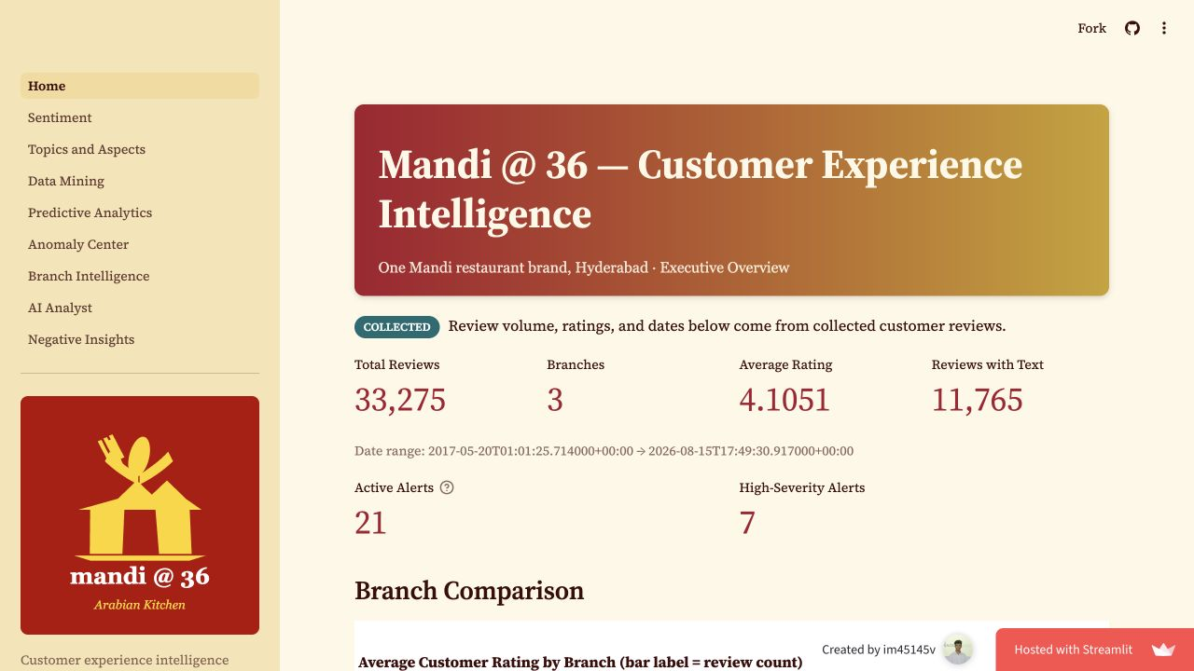
Figure 1. Executive Overview page, showing the full navigation, collected-data framing, and brand-level indicators.
Source: Mandi @ 36 deployed dashboard, captured 16 August 2026.
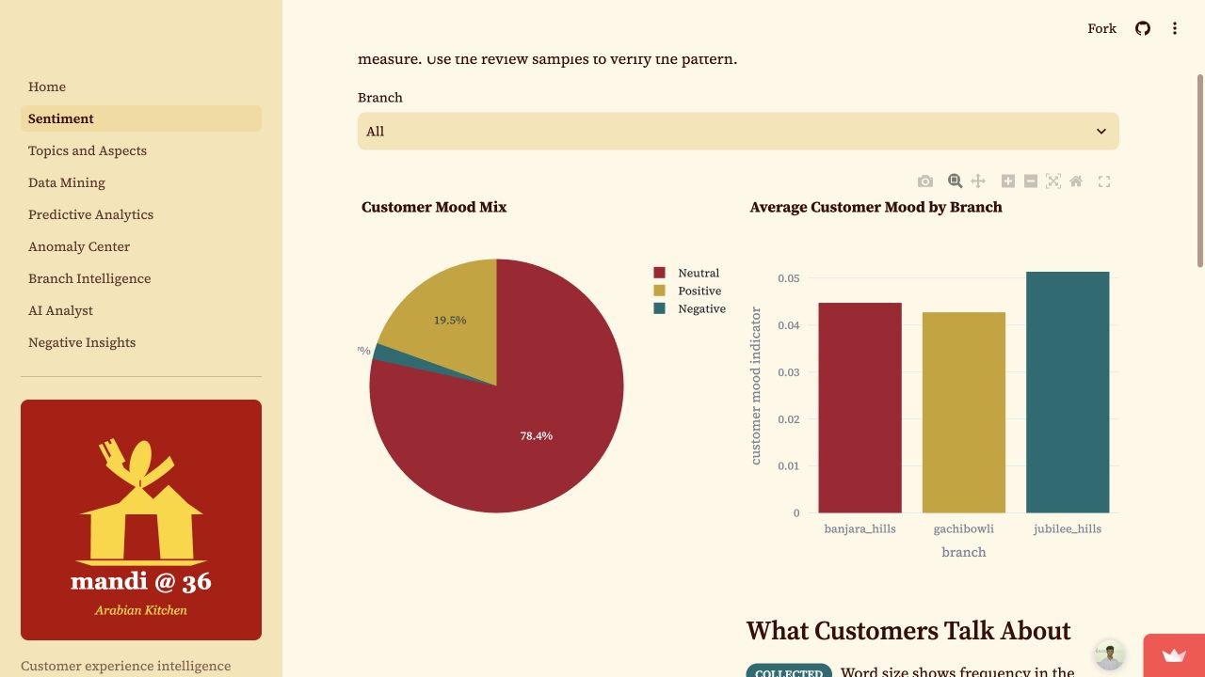
Figure 2. Sentiment page, showing the branch selector, customer-mood mix, and branch-level mood chart.
Source: Mandi @ 36 deployed dashboard, captured 16 August 2026.
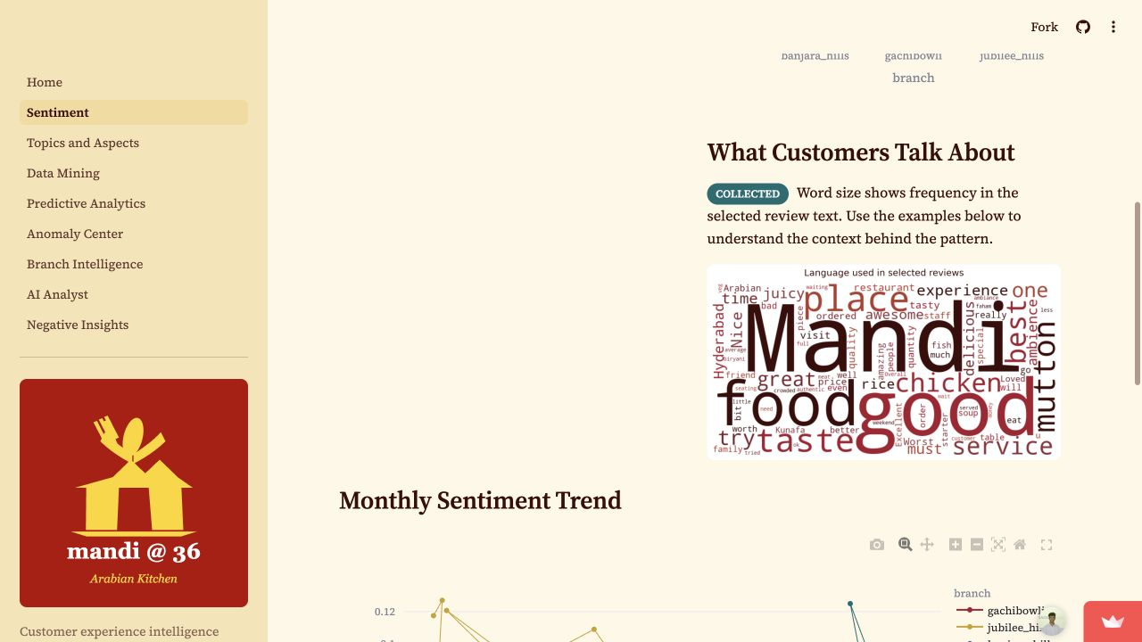
Figure 3. Sentiment page word cloud: term size represents frequency in collected review text, while the chart below shows monthly derived customer-mood signals.
Source: Mandi @ 36 deployed dashboard, captured 16 August 2026.

(iii) Details of AI Use
AI is used only in the AI Analyst feature. The deterministic pipeline calculates and stores the analytical outputs first. When a manager asks a question, rule-based code identifies the branch, comparison intent, and any explicitly requested month. It then assembles a compact JSON evidence bundle. The bundle can contain the brand summary, branch performance, monthly trend, aspect sentiment, anomaly flags, forecast, topics, association rules, and action-priority signals. The full raw review dataset is not sent to the LLM.
When an API key is configured, the application uses the OpenAI chat-completions client with the gpt-4o-mini model. The system instruction requires the model to distinguish REAL values from DERIVED outputs and PREDICTED outlooks, avoid inventing facts, avoid causal claims from correlation, and state when evidence is sparse. The action-recommendation stage then asks for concrete prioritized actions, an evidence basis, and a confidence label. If the LLM service is not configured, the dashboard still presents the deterministic evidence table rather than pretending to generate an answer. This fallback is important for auditability and robust use.

AI Safeguards
- Rule-based routing is deterministic; the LLM does not decide which branch or period is in scope.
- The LLM receives compact aggregated evidence rather than 33,275 raw records or reviewer-identifying metadata.
- System instructions prohibit fabricated facts and causal claims from correlations.
- The interface labels collected, derived, and predicted evidence so the user can judge confidence appropriately.
- Manager validation is required before operational action, especially for forecasts and derived text signals.

(iv) Step-by-Step Use of Prompt in AI and the Output
The following illustrates the actual in-application workflow for the default management question used in the deployed AI Analyst. It is presented as a reproducible prompt pathway rather than as an uncontrolled general-purpose chat interaction.

Step 1: Manager Question
How is Banjara Hills performing and what actions should we take?

Step 2: Deterministic Routing
The orchestration layer detects the Banjara Hills branch and recognizes that the phrase 'what actions should we take' requests evidence-led action recommendations. It selects the relevant evidence functions before any LLM call is made.

Step 3: Compact Evidence Bundle
The AI Analyst compiles a branch summary, observed monthly performance, aspect-level signals, alert months, forecast information, top topics, association rules, and the relevant action-priority signals. This is the only analytical material forwarded for reasoning.

Step 4: Guardrailed Prompt
Role: data-mining investigation analyst for the Mandi @ 36 restaurant brand
Required behavior: distinguish REAL, DERIVED, and PREDICTED evidence; do not invent facts; do not claim causation from correlation; state sparse evidence.
User question: How is Banjara Hills performing and what actions should we take?
Evidence: compact JSON bundle generated from precomputed artifacts.

Step 5: Evidence-Grounded Output
The resulting investigation reports observed monthly ratings and review counts, identifies alert reasons, and proposes actions such as staff-training review, feedback monitoring, and food-quality checks. Figure 4 shows the linked branch-evidence view used to interpret these suggestions. The output must be treated as a managerial decision aid. The ratings and counts are observed evidence; the narrative, aspect signals, and forecasts have different confidence levels and should be verified before action.
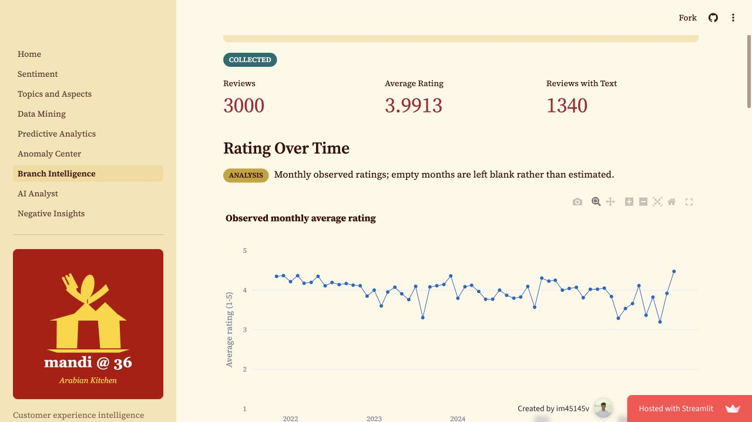
Figure 4. Branch Intelligence page for Banjara Hills, combining collected, derived, and predicted evidence used in focused investigation.
Source: Mandi @ 36 deployed dashboard, captured 16 August 2026.

Live AI Analyst Scenario 1: Branch Investigation
Question submitted: How is Banjara Hills performing and what actions should we take?
The deployed AI Analyst returned a Banjara Hills performance summary, bringing together observed branch-month ratings, review counts, alert severity, and a prioritized action plan. The response recommended investigating alert months, reviewing service quality, monitoring future performance, and using feedback follow-up to verify and improve the customer experience. Each recommendation was presented with an evidence basis and confidence label.
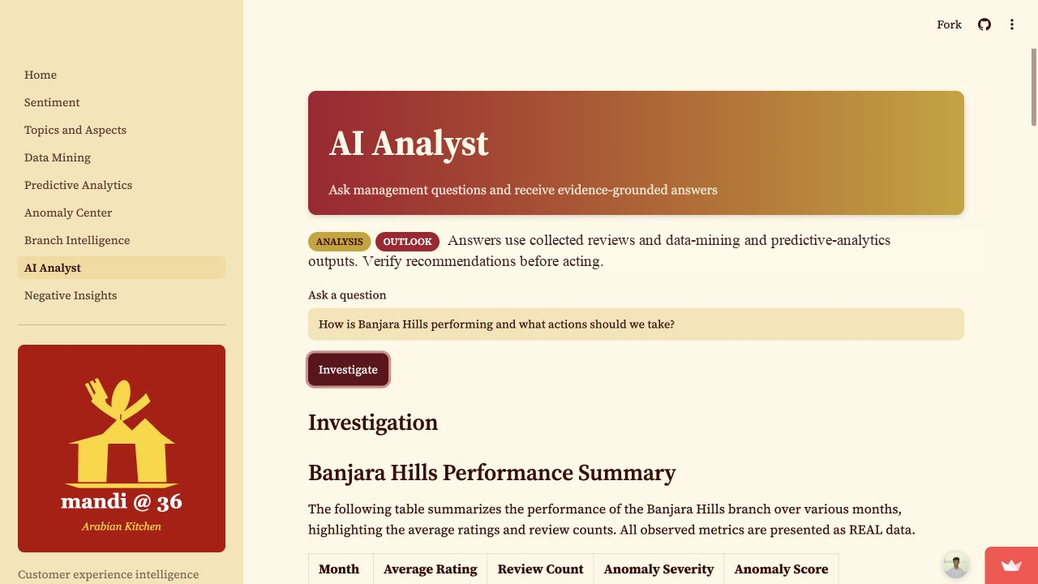
Figure 5. Live AI Analyst Scenario 1: complete AI Analyst page, submitted Banjara Hills question, and generated investigation output.
Source: Mandi @ 36 deployed dashboard, captured 16 August 2026.

Live AI Analyst Scenario 2: Comparative Priority
Question submitted: Compare Banjara Hills and Gachibowli. Which branch needs priority attention and why?
The second live run compared branch-level ratings, alert patterns, and outlook signals. The answer prioritized Banjara Hills for immediate review because the evidence bundle contained several high-severity alert months and larger rating instability. This is a decision-support recommendation, not a causal conclusion, and the manager is expected to validate it with current review samples before action.
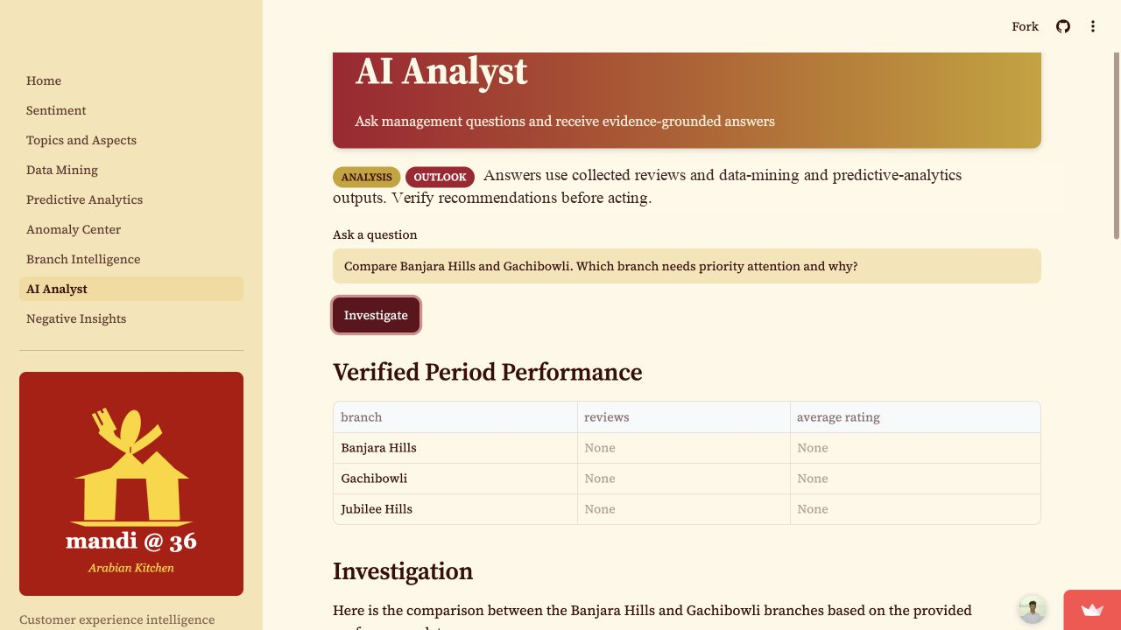
Figure 6. Live AI Analyst Scenario 2: complete AI Analyst page, branch-comparison question, and generated priority investigation.
Source: Mandi @ 36 deployed dashboard, captured 16 August 2026.

(v) Results and Discussion
This section distinguishes observed results from model-derived outputs. The dataset contains 33,275 collected reviews between 20 May 2017 and 15 August 2026. The total includes 16,457 five-star reviews, 9,888 four-star reviews, 3,369 three-star reviews, 1,093 two-star reviews, and 2,468 one-star reviews. Overall ratings are strong, but branch volume is highly uneven: Jubilee Hills accounts for the majority of records. Therefore, raw volume should not be interpreted as a direct measure of branch quality.

Observed Branch Comparison
Jubilee Hills has the highest observed average rating (4.1283) and the largest review volume (28,259). Banjara Hills has an average rating of 3.9913 across 3,000 reviews. Gachibowli has the lowest observed average rating (3.9499) across 2,016 reviews. These differences are descriptive observations, not a causal evaluation of branch operations. The recommended interpretation is to use the comparison as a starting point for branch-level review.
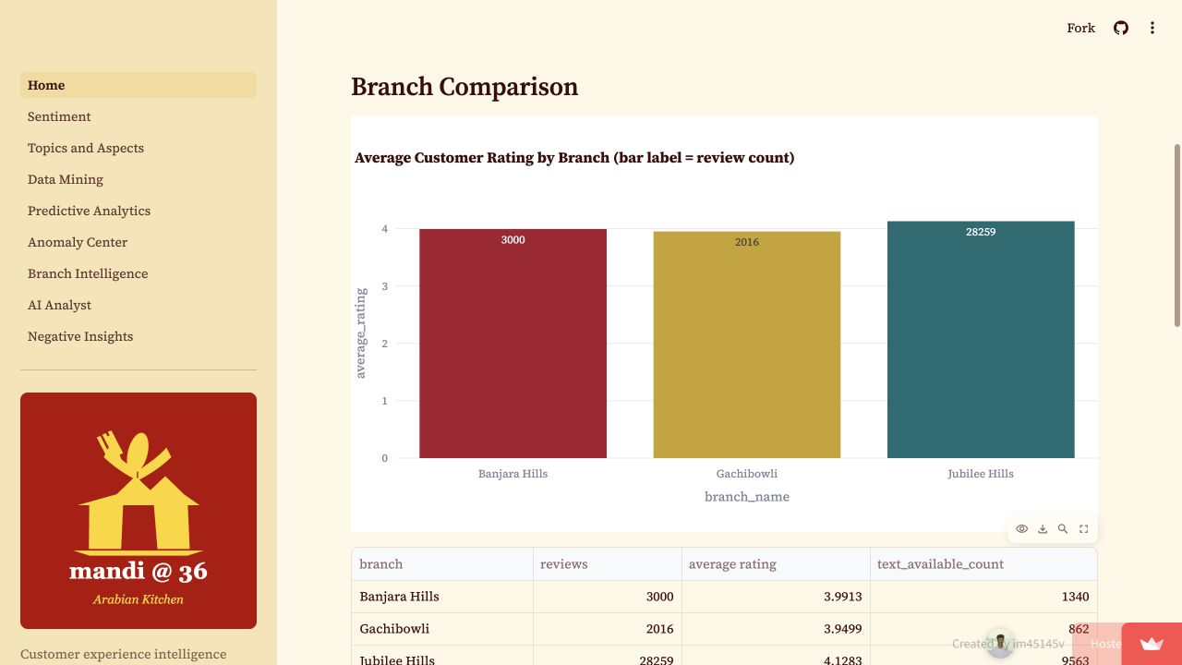
Figure 7. Branch Comparison chart from the app: bar height represents observed average rating and the bar label gives the collected review count.
Source: Mandi @ 36 deployed dashboard, captured 16 August 2026.
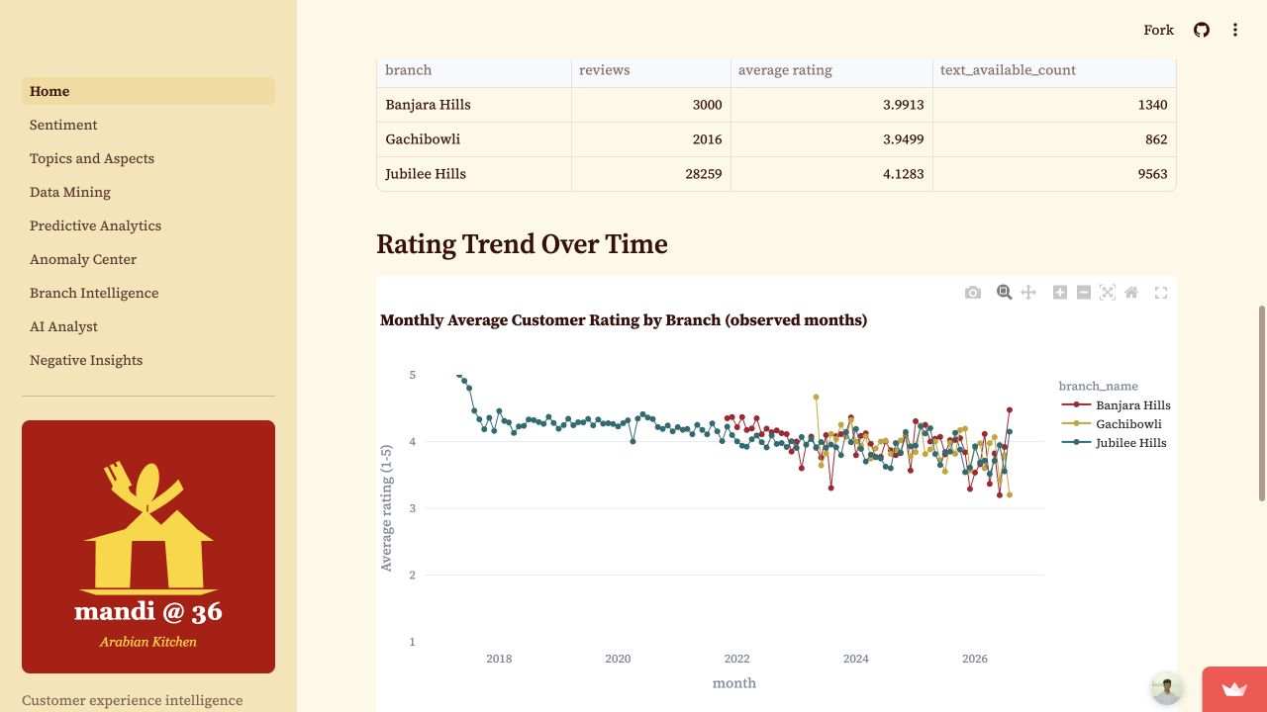
Figure 8. Observed monthly average-rating trend by branch, as displayed on the Executive Overview page.
Source: Mandi @ 36 deployed dashboard, captured 16 August 2026.

Text Mining and Pattern Discovery
Of the collected reviews, 11,765 have usable text. The topic model fitted 8 NMF topics using 11,765 documents and a vocabulary of 4,098 terms. The review-clustering model selected 8 groups from 11,765 review texts. Common terms include food, taste, service, ambience, mutton, chicken, good, and best. These are language patterns rather than direct satisfaction scores and are intended to focus human reading of customer comments.
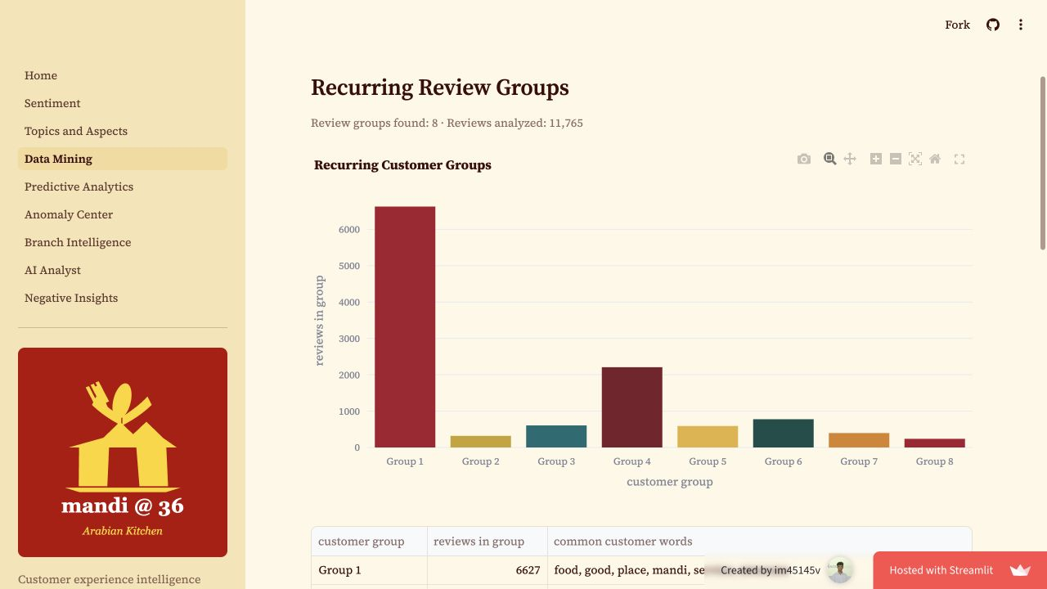
Figure 9. Data Mining page, presenting the eight recurring customer-review groups and their distribution.
Source: Mandi @ 36 deployed dashboard, captured 16 August 2026.

Early-Warning and Predictive Results
The anomaly process analyzed 207 eligible branch-month observations using review count, average rating, average sentiment score, and negative ratio. It flagged 21 months for attention. An alert is not proof of an operational incident; it is a signal to inspect contemporary reviews and branch context. The dashboard makes this distinction explicit.
Branch | Months | Trend per month | Risk | Holdout MAE | Beats naive?
Banjara Hills | 58 | -0.007171 | Watch | 0.4819 | Yes
Gachibowli | 40 | -0.010242 | Watch | 0.2959 | Yes
Jubilee Hills | 112 | -0.006402 | Watch | 0.3004 | No
Note. Forecasts are three-month linear-trend extrapolations and are marked predicted and unvalidated. Holdout MAE is included to make model quality visible.
All three branches are currently classified as WATCH because their fitted monthly trend slopes are negative but not below the elevated-risk threshold. Banjara Hills is forecast at 3.7672 for September 2026, Gachibowli at 3.7128, and Jubilee Hills at 3.7335. These are model outputs, not actual future ratings. The Gachibowli and Banjara Hills models beat the naive holdout baseline, while the Jubilee Hills model did not. This is a useful caution against overconfident use of the forecast.
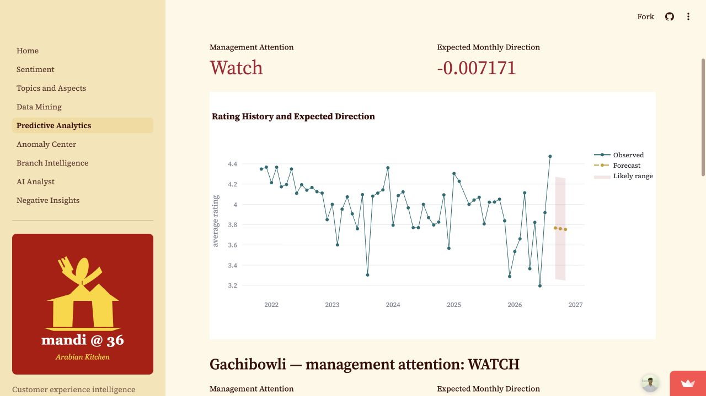
Figure 10. Predictive Analytics page: observed Banjara Hills ratings, transparent forecast, and likely range.
Source: Mandi @ 36 deployed dashboard, captured 16 August 2026.
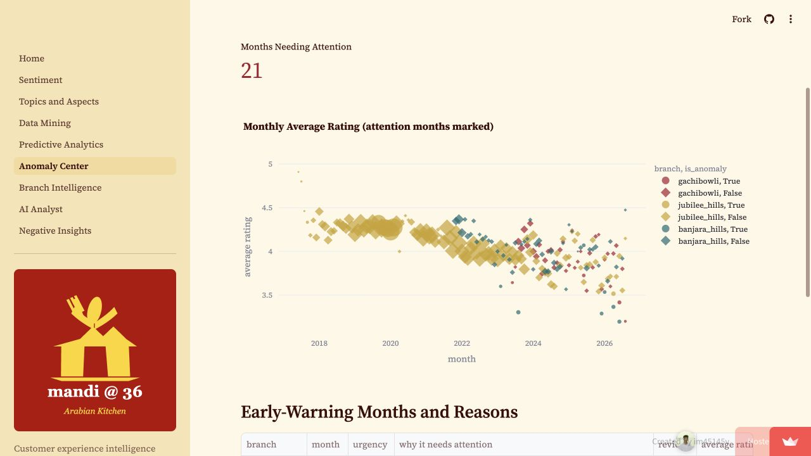
Figure 11. Anomaly Center: observed branch-month ratings with attention months visibly marked.
Source: Mandi @ 36 deployed dashboard, captured 16 August 2026.

Evidence-Led Action Priorities
The deterministic action-priority table ranks recurring branch issues using derived evidence and supporting alert counts. For Banjara Hills, service, waiting time, food quality, ambience, hygiene, price/value, and quantity are high-priority review areas in the current artifact set. For example, the service signal has 298 mentions and seven supporting alert months, while food quality has 703 mentions and seven supporting alert months. These numbers indicate where managers should investigate, not that the source terms are proven causes of lower ratings.

(vi) Business Implications
Mandi @ 36 can improve customer-experience management by turning a large review archive into a disciplined weekly operating rhythm. At the brand level, leadership can compare observed performance across branches. At the branch level, managers can identify a specific experience area, read the supporting feedback samples, and assign an owner. At the early-warning level, the team can examine an unusual month before an issue becomes persistent. At the AI Analyst level, a decision-maker can ask a focused question and receive an answer grounded in the same prepared evidence used by the dashboard.

Recommended Management Routine
- Weekly branch huddle: review high-priority action signals, new alert months, and a small sample of customer comments.
- Monthly brand review: compare observed ratings and text coverage across branches, then ask why a difference may exist before changing operations.
- Service recovery: where service or waiting-time signals persist, review staffing, greeting, order follow-up, and peak-period process checks.
- Food and value review: where food quality, quantity, or price/value appears in the action-priority queue, inspect recipes, portions, menu communication, and recent low-rating comments.
- Forecast review: treat WATCH labels as an invitation to monitor leading indicators, not as a claim that customer satisfaction will decline.
- Governance: retain the REAL, DERIVED, and PREDICTED distinction in every managerial presentation, and use human validation for actions affecting staff, customers, or promotions.

Limitations
The findings represent available Google Maps reviews, not a random survey of all customers. Only 11,765 records contain review text, and the branch review volumes are markedly unequal. Sentiment, aspects, topics, clusters, association rules, and anomaly flags are model-derived signals. Association rules do not demonstrate cause and effect. The forecast model is intentionally simple and transparent, uses a short holdout evaluation, and remains unvalidated for production forecasting. These constraints are not defects to hide; they are essential conditions for responsible interpretation.
The project nevertheless demonstrates a strong end-to-end application of data mining and predictive analytics: real review collection, data normalization, descriptive analysis, unsupervised learning, anomaly detection, transparent forecasting, action prioritization, controlled LLM assistance, and a deployed application that makes the results accessible to non-technical users.

Appendix A: Dashboard Access and Screens
Figures 1 to 11 show the app's different pages, charts, word-cloud section, and two complete AI Analyst scenarios rather than isolated navigation fragments. The user can test the complete application through the https://mandi36.streamlit.app/.

Appendix B: Reproducibility and Technical Resources
The report is supported by an executable Python project. The ingestion module normalizes source records; preprocessing creates clean text fields; analytics modules generate EDA, NLP, topic, clustering, association, anomaly, forecast, and action-priority artifacts; the Streamlit app presents these artifacts. The complete source code and notebook are available in the project repository. The pipeline entry point is src/pipeline.py and the companion notebook is notebooks/data_mining_predictive_analytics.ipynb.
Repository, click to open: https://github.com/im45145v/Mandi360
Live deployment, click to open: https://mandi36.streamlit.app/
Representative pipeline command:
python -m src.pipeline
streamlit run app/Home.py

References
Apify. (n.d.). Google Maps Scraper. https://apify.com/apify/google-maps-scraper
Google. (n.d.). Google Maps. Retrieved August 16, 2026, from https://www.google.com/maps
Han, J., Kamber, M., & Pei, J. (2012). Data mining: Concepts and techniques (3rd ed.). Morgan Kaufmann.
Larose, D. T., & Larose, C. D. (2015). Data mining and predictive analytics (2nd ed.). Wiley.
OpenAI. (n.d.). OpenAI API documentation. https://platform.openai.com/docs/overview
Pedregosa, F., Varoquaux, G., Gramfort, A., Michel, V., Thirion, B., Grisel, O., Blondel, M., Prettenhofer, P., Weiss, R., Dubourg, V., VanderPlas, J., Passos, A., Cournapeau, D., Brucher, M., Perrot, M., & Duchesnay, E. (2011). Scikit-learn: Machine learning in Python. Journal of Machine Learning Research, 12, 2825-2830.
Streamlit. (n.d.). Streamlit documentation. https://docs.streamlit.io/

