Intelligent Post-lockdown Management System For Public Transportation

**1. INTRODUCTION**

**1.1) Overview**

Transportation sector has been one of the primary victims of COVID-19. Even after the situation normalises, the perception of risk associated with crowded areas could lead to shift in preferences towards personal travel modes. That is, people may avoid using public transport modes to avoid crowds.

**1.2) Purpose**

Purpose behind development of this application id to normalise the transportation in a modified way. This application will help us to avoid the over occupancy at

**2. LITERATURE SURVEY:**

**2.1) Existing Problem**

Intelligent Post-lockdown Management System For Public Transportation

* 1. **Proposed Solution:**   
     We will be doing it through a real time monitoring application which will focus on details like no. of people at the station and present inside the bus and will create a solution to the problems we are currently facing by avoiding overcrowding at a place.

1. **Flowchart**

**Understanding development:**

**(APPLICATION Working Flowchart)**

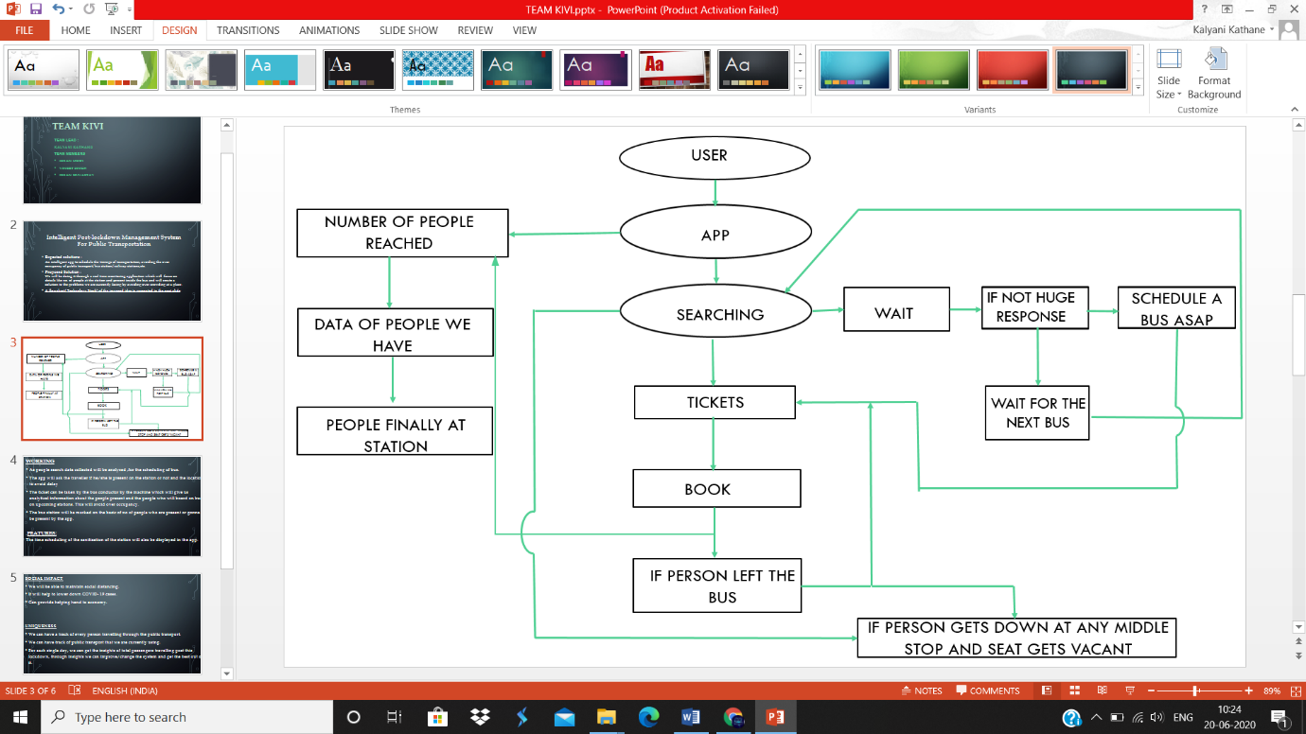

**IBM CLOUD ACCOUNT**

The further project starts with creating IBM accounts in order to access the tools provided.

<http://cloud.ibm.com/>

**CONNECTIVITY THRU NODE RED**

As in the future we will be linking the software with the hardwares. So keeping the futuristic view in mind we have added this.

**DATABASE MAKING**

Technologies used for the creation of databse is IBM cloudant instance.

Database is created on IBM Cloudant.   
It is having 1 gb storage, it will be consisting user id, and credentials and locations wherever the public transport system is linked with the application.

**CHATBOT MAKING**

Technologies used for the creation of chatbot are **Watson assistant** and

**Natural language translator module**

Link for the chat bot:

<https://web-chat.global.assistant.watson.cloud.ibm.com/preview.html?region=eu-gb&integrationID=cc43c12c-3519-42b9-8ee8-f2b0aa974fa0&serviceInstanceID=31baeb74-1351-4b88-86d4-2b91f8ceeede>

**APPLICATION:**

Technologies used for the creation of chatbot

1)Android Studio

2)IBM Service

Link for the application <https://drive.google.com/drive/folders/1MsHGw4NxqV3v53XhjexLZZFoP6jhcHIN?usp=sharing>

**4. Advantages and Disadvantages**

Advantages

* We will be able to maintain social distancing.
* It will help to lower down COVID- 19 cases.
* Can provide helping hand to economy

Disadvantages

* Hardware implementation is tough

**5. Conclusion**

* We can have a track of every person travelling through the public transport.
* We can have track of public transport that we are currently using.
* For each single day, we can get the insights of total passengers travelling post this lockdown, through insights we can improve/change the system and get the best out of it.

**6. Future Scope**

This project can help us to avoid the over occupancy inside the vehicles and at the station.

This can help us to normalise way of living.

**7. Bibliography**

* Google
* <https://youtu.be/CkJmpiF-ikc>
* <https://youtu.be/CkJmpiF-ikc>
* <https://www.youtube.com/channel/UCvB8PgOZdb2y7lgToPE-Dfw>
* <https://youtu.be/qK0QNA0sMGc>
* <https://youtu.be/z5JlLJO64sk>