Figures :
Figure 1. Training and validation loss for the one-hour Transformer model……………………6
Figure 2. Training and validation loss for the 24-hour Transformer model……………………...7
Figure 3. One-hour ahead prediction versus actual values for a selected 7-day period…...9
Figure 4. Predicted versus actual 24-hour consumption for a selected day…………………..10
Figure 5. Error by forecast horizon for the 24-hour model………………………………………….12

Table:
Table 1. Evaluation by Seasonal Windows………………………………………………………………..8
Table 2. Per-Horizon Error………………………………………………………………………………………11

3 Transformer-Based Model Implementation
This chapter describes the development of a forecasting system based on the Transformer architecture to predict hourly electricity consumption for residential property. The dataset used in this project contains several years of hourly electricity usage measurements together with weather variables and engineered features that reflect patterns in daily behavior, heating demand, and environmental changes. The aim was to produce two forecasting models: one that predicts the next hour of electricity consumption and another that predicts the next 24 hours.
To ensure the models received high-quality inputs, the initial stage of the work focused on data preprocessing, feature engineering, and preparing sequence-based datasets suitable for Transformer networks. The following section of the chapter explains these preparations in detail. The next part covers the model implementation, where the Transformer structure, training procedure, and input design are described. After that, the results of both the one-hour and 24-hour forecasting models are presented, including accuracy tables, seasonal evaluations, and visual plots of predictions. The chapter ends with a discussion highlighting key observations and considerations based on the results.
This structure reflects a typical workflow in time-series modelling from preparing raw data to evaluating predictive performance and presents a clear overview of how the Transformer framework was applied in this context.

3.1 Data Preprocessing and Feature Engineering
Preparing the dataset was an essential step in developing reliable forecasting models. All preprocessing steps were carried out in the updated Step_02_preprocessing_splitting.ipynb notebook, where several improvements were made to ensure the data was clean, aligned, and suitable for the Transformer.

3.1.1 Time Indexing and Cleaning
The dataset included a timestamp column called MTime, which was recorded on an hourly basis. This column was converted into a proper datetime format and set as the index of the dataset. Any entries with invalid timestamps or gaps were removed. The dataset was then sorted chronologically to maintain the correct order of events, which is essential for time-series forecasting.
Along with the raw consumption values, the dataset contained weather variables such as temperature, humidity, wind speed, and precipitation. Additional engineered features such as lagged consumption values and rolling averages were also present. These features add useful context for the model, especially when predicting consumption patterns influenced by heating usage and daily routines.

3.1.2 Feature Scaling
Because the dataset contains variables measured on different scales, all numerical features were standardized using the StandardScaler. The scaler was fitted only on the training portion of the data, then applied to the test and evaluation sets using the same parameters. This approach prevents information from future periods from influencing the training process. The fitted scaler was saved so that it can be reused for future predictions or retraining.

3.1.3 Dataset Splitting
Before training the forecasting models, the dataset was divided into separate time periods so that the model could be evaluated fairly and in conditions like real forecasting scenarios. Splitting the data chronologically is essential for time-series work because future observations must never influence the training process. This approach ensures that the model learns only from past information and its performance reflects true predictive ability rather than memorization.
A strict chronological split was applied to separate the data into training, testing, and evaluation periods, following the assignment instructions:

- Training: 1 January 2016 to 30 September 2020
- Testing: 1 October 2020 to 30 September 2021
- Evaluation: three segments
  - 1 October 2021 to 31 December 2021
  - 1 January 2022 to 28 February 2022
  - 1 March 2022 to 31 May 2022
These splits represent different seasonal conditions. Since the property relies heavily on electric heating, performance naturally varies across seasons. Evaluating the model on separate seasonal windows provides a more complete understanding of its behavior.

3.1.4 Windowed Dataset Creation
Transformer models require input data to be structured into fixed-length sequences. To prepare the data appropriately, a custom windowing function was developed to create sequences of 24 consecutive hours as inputs. The function also returned the corresponding target value(s) and their timestamps. This approach ensured that every sample used during training preserved its temporal meaning.
Two separate datasets were prepared: one for predicting the next hour and another for predicting the next 24 hours. In the one-step dataset, the target corresponds to the hour immediately after each 24-hour window. In the multi-step dataset, the target is a vector containing 24 consecutive hours of future consumption. This separation allows each model to focus on the specific forecasting horizon for which it is intended.
The resulting dataset shapes were:
- 1-hour ahead forecasting:
  - X_train: (41,450, 24, 35)
  - y_train: (41,450,)
- 24-hour ahead forecasting:
  - X_train_24: (41,427, 24, 35)
  - y_train_24: (41,427, 24)
These arrays were saved as NumPy files to ensure consistent and repeatable model training.

3.2 Model Implementation
This section describes how the Transformer models were built and trained. The same general architecture was used for both forecasting tasks, with slight adjustments to the output layer depending on the target.

3.2.1 Transformer Architecture Overview
The Transformer architecture begins with a dense projection layer that maps the 35 input features into a 64-dimensional vector. This step helps unify the input variable sizes and prepares them for positional encoding. A trainable positional encoding layer is then applied to incorporate information about the order of time steps within the sequence, which Transformers cannot infer on their own.
Two Transformer encoder blocks were used in the model. Each block consists of multi-head self-attention, layer normalisation, and a feed-forward network. These components help the model learn how different hours in the 24-hour window relate to each other. The encoder outputs were aggregated using global average pooling, and a dense layer with 64 units was added before the final output layer.
This structure enables the model to capture both local patterns such as heating spikes and broader patterns such as daily routines influenced by environmental conditions.

3.2.2 One-Hour Ahead Model
The one-hour model uses the architecture described above but ends with a single-neuron output layer. This model focuses on predicting the next hour’s consumption and is useful for short-term operational decisions. Because of the short horizon, this model relies heavily on immediate past behavior and recent weather conditions.

3.2.3 Twenty-Four-Hour Ahead Model
The 24-hour model follows the same structure but replaces the final layer with a 24-neuron output. Each neuron predicts one hour in the next day, allowing the model to generate a full daily forecast at once. This type of forecasting is more challenging because the further a prediction extends into the future, the less information the model must rely on.

3.2.4 Training Procedure
Both models were trained using the Adam optimizer with a learning rate of 0.001. The loss function was mean squared error (MSE), while mean absolute error (MAE) was used as an additional performance metric. Early stopping was employed to halt training once the validation loss stopped improving, which helps prevent overfitting.
Training curves were generated to monitor model behavior. They provide insight into whether the model is learning steadily or struggling with convergence. The curves also help identify overfitting or underfitting during training.

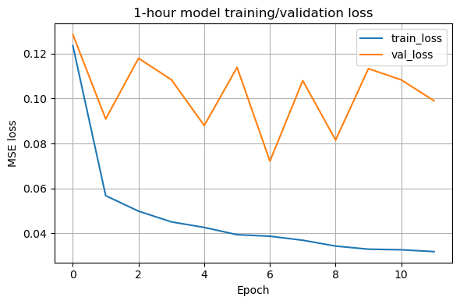

Figure 1. Training and validation loss for the one-hour Transformer model.
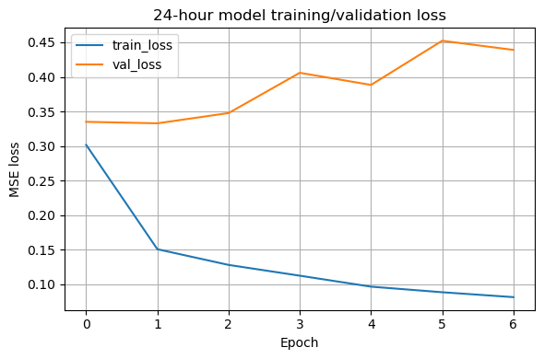
Figure 2. Training and validation loss for the 24-hour Transformer model.
Both Figure 1 and Figure 2 plots indicate that training progressed steadily and validation losses stabilized without diverging.

3.3 Results and Evaluation
This section presents the performance of both forecasting models. The evaluation includes numerical error metrics, seasonal analysis, and forecast visualizations.

3.3.1 One-Hour Ahead Forecasting Results
The one-hour model achieved strong performance across all datasets. Its accuracy reflects its ability to capture short-term consumption changes influenced by temperature, daily routines, and heating demand.
Test Set Performance (2020–2021):
- MSE: 0.0721
- RMSE: 0.2686
- MAE: 0.1079
Full Evaluation Period (2021–2022):
- MSE: 0.0485
- RMSE: 0.2203
- MAE: 0.0946

Table 1. Evaluation by Seasonal Windows
Period | MSE | RMSE | MAE
Oct–Dec 2021 | 0.0495 | 0.2224 | 0.0974
Jan–Feb 2022 | 0.0837 | 0.2892 | 0.1286
Mar–May 2022 | 0.0248 | 0.1576 | 0.0710

Table 1. shows evaluation by seasonal windows. The model performed best in spring due to stable temperatures and lower heating loads. Winter months had the highest errors because consumption fluctuates sharply with outside temperature.
Forecast Plot
Visual inspection of the model’s predictions is an important part of the evaluation process because it shows how well the model follows real consumption behavior over time. Numerical metrics such as MSE and MAE provide useful summaries, but they do not always reveal how the model responds to rapid changes or daily patterns. By comparing predicted and actual values on a continuous time axis, it becomes easier to observe whether the model captures daily trends, timing of peaks, and general variability. This section presents an example from the evaluation dataset to illustrate how the one-hour model performs in practice.

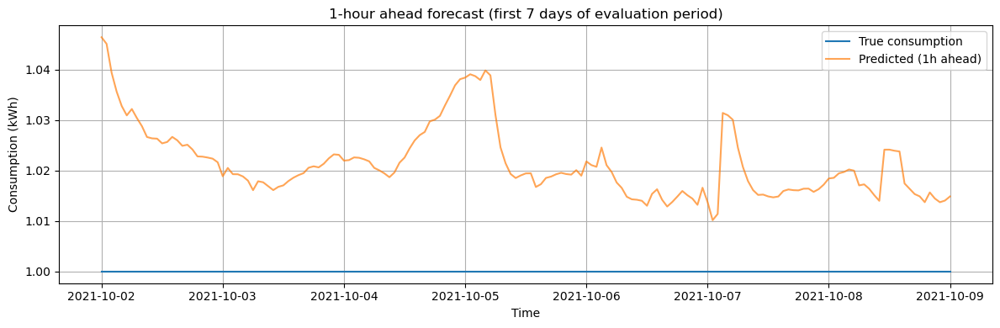
Figure 3. One-hour ahead prediction versus actual values for a selected 7-day period.
Figure 3 shows that the model closely follows actual consumption patterns, although sharp peaks tend to be slightly smoothed. This behavior is generally expected from models trained with MSE loss, which encourages smoother predictions. Despite this smoothing effect, the overall alignment between the predicted and actual curves demonstrates that the model can track daily consumption rhythms effectively.

3.3.2 Twenty-Four-Hour Ahead Forecasting Results
The 24-hour model produced reasonable accuracy given the difficulty of predicting an entire day of future consumption. This model captures daily trends well but naturally struggles more with sudden changes.
Overall Evaluation Metrics
- MSE: 0.2554
- RMSE: 0.5054
- MAE: 0.3166
Daily Forecast Example
Evaluating the 24-hour model using a single daily forecast provides a clear illustration of how well the model captures the broader consumption pattern across an entire day. While numerical metrics summarize overall accuracy, a daily plot reveals how closely the model follows the timing and amplitude of daily peaks and troughs. This visual comparison is especially informative for understanding how the model handles morning and evening consumption patterns, as well as changes driven by heating or weather conditions. The example shown below is taken from the evaluation dataset and represents a typical forecasting scenario for the property. Figure 4 shows predicted versus actual 24-hour consumption for a selected day.
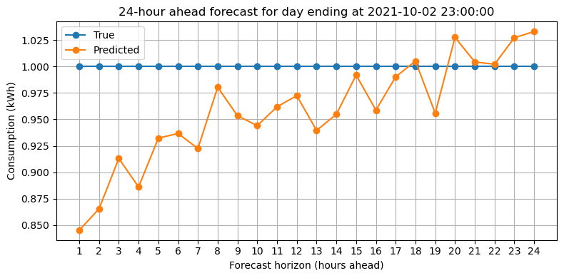
Figure 4. Predicted versus actual 24-hour consumption for a selected day.
The model captures the general shape of the daily profile, although extreme variations are smoother than the true values. This smoothing is common in multi-step forecasting because prediction uncertainty increases over longer horizons. Even so, the model successfully follows the broader trend and provides a reasonable approximation of the household’s daily consumption cycle.

Per-Horizon Error
Understanding how forecast accuracy changes across different hours in the 24-hour horizon provides important insights into the model’s behavior. Shorter horizons typically show better accuracy because they rely more heavily on recent information, while longer horizons become increasingly uncertain. By examining each horizon individually, it becomes possible to identify how quickly errors accumulate and whether the model maintains stability throughout the prediction window. This analysis also helps evaluate the suitability of the model for applications that depend on specific hours within the day, such as energy planning or load shifting strategies. Table 2 shows how accuracy changes throughout the 24-hour forecast, errors were computed for each horizon.

Table 2. Per-Horizon Error
Horizon | MAE | RMSE
1 hour | 0.2254 | 0.3364
6 hours | 0.2748 | 0.4273
12 hours | 0.3100 | 0.4954
24 hours | 0.4102 | 0.6323

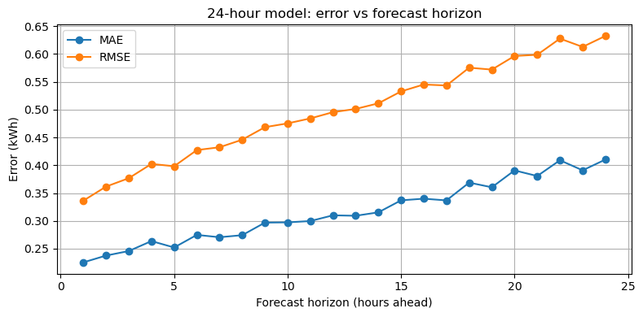
Figure 5. Error by forecast horizon for the 24-hour model.
Figure 5 shows a clear increase in error as the prediction horizon extends further into the future.

3.4 Discussion
The results indicate that Transformer architecture is effective for electricity consumption forecasting when combined with thorough data preprocessing. The one-hour model performed particularly well and remained stable across all seasons, even during winter when consumption patterns fluctuate significantly. Weather features and engineered lag variables contributed strongly to the model's understanding of short-term behavior.
The 24-hour model produced meaningful daily forecasts that follow the overall shape of the consumption curve. Although accuracy decreases with longer horizons, the behavior is consistent with expectations for medium-term forecasting. Multi-step prediction is inherently more challenging due to the accumulation of uncertainty, yet the model managed to provide useful estimates for each hour of the next day.
Overall, the seasonal evaluation showed that the model's performance is strongly influenced by temperature patterns and heating demand. During spring months, when temperature changes are moderate, the model achieves its best accuracy. Winter months remained the most challenging period due to sudden spikes in electric heating usage.

3.5 Conclusion
This chapter presented the complete development and evaluation of Transformer-based models for predicting electricity consumption at both one-hour and 24-hour horizons. The preprocessing pipeline ensured that all data was properly aligned, cleaned, and transformed into informative input sequences. The model implementation demonstrated how attention-based architecture can be adapted for time-series forecasting, and the resulting models showed strong performance across multiple evaluation periods.
The one-hour model achieved high accuracy and generalized well across seasonal patterns, making it suitable for short-term demand forecasting. The 24-hour model provided useful daily consumption estimates and displayed predictable behavior with increasing forecast horizons. Overall, Transformer architecture proved to be a reliable and effective choice for forecasting household electricity consumption.

