5. Temporal Convolutional Network (TCN)
The Temporal Convolutional Network (TCN) is a convolution-based architecture designed specifically for sequence modelling and time-series forecasting. Instead of using recurrent connections like GRUs or LSTMs, a TCN relies on causal 1D convolutions with dilation and residual connections to capture temporal dependencies. This makes the model highly parallelisable, stable to train, and often more efficient on modern hardware compared to recurrent networks.
In a TCN, causality is enforced by only convolving over past time steps, so the prediction at time ttt depends only on values from times ≤ t. Dilated convolutions expand the receptive field without requiring deeper networks: by skipping over inputs at fixed intervals (dilation rates such as 1, 2, 4, 8, …), the model can see far back in time while still using relatively few layers. Residual connections help gradients flow through the network and prevent degradation as more layers and dilation levels are added.
For this project, the TCN is an interesting complement to the GRU. Both models are capable of learning temporal dependencies and seasonal structure in the data, but they do so using different mechanisms. While the GRU maintains an internal hidden state that is updated step-by-step, the TCN processes the entire 24-hour window using convolutional filters. This leads to a few practical advantages:
- the TCN can be trained faster due to parallel convolutions,
- it is often more stable for long sequences, and
- it has a fixed receptive field that can be controlled by the depth and dilation pattern.
In the context of household electricity consumption, the TCN is expected to capture hourly patterns, daily rhythms, and seasonal variations in a similar way to the GRU, but with a different inductive bias. It can be particularly effective when the relevant temporal patterns are local but still span multiple hours or days, such as morning/evening peaks, weekday–weekend differences, and weather-driven changes.

5.1 Data Preparation
The TCN uses exactly the same prepared data as the GRU model. This is important to ensure that both models are directly comparable.
All preprocessing steps remain unchanged:
- Cleaning and parsing timestamps into a proper datetime format.
- Removing initial rows with missing values created by lag and rolling features (24 h, 72 h, 168 h windows, etc.).
- Engineering time-based features (hour, weekday, month, weekend and night flags, cyclic encodings), weather features (temperature, humidity, wind, precipitation, pressure), and additional indicators (heating season flags, extreme cold flags, heat pump installation marker, and Finnish public holidays).
- Creating lag features (1 h, 2 h, 3 h, 24 h, 48 h, 72 h, 168 h) and rolling statistics to encode recent trends and volatility.
- Splitting the data strictly by time into training (2016–09/2020), test (10/2020–09/2021) and evaluation periods (the three specified windows in late 2021 and early 2022).
- Scaling all features with MinMaxScaler using only the training set and then applying the same scaler to test and evaluation sets.
After scaling, the prepared dataset was converted into windowed numpy arrays:
- each input sample X is a 24-hour sequence of feature vectors,
- each target y is the next-hour consumption for the 1-hour model,
- and for the 24-hour model, the target is a 24-element vector representing the next 24 hours.
These arrays (X_train, y_train, X_test, y_test, X_eval, y_eval, and the derived true_24 and X_24) are reused directly for the TCN. This way, any performance difference between GRU and TCN comes only from the model architecture, not from data preprocessing.

5.2 Model Training (1-Hour Ahead TCN)
For the one-hour ahead forecasting task, each TCN input sample has shape (24, number_of_features), identical to the GRU. The goal is still to predict the next-hour consumption based on a 24-hour history.
The TCN architecture used in this project is built with TensorFlow/Keras and consists of:
- an Input layer with shape (24, features),
- a stack of causal Conv1D layers with increasing dilation rates (for example 1, 2, 4 and 8),
- Dropout layers for regularisation,
- residual connections between each dilated block (including a 1×1 convolution when the channel dimensions do not match),
- Layer Normalisation after each residual addition,
- a GlobalAveragePooling1D layer to aggregate temporal information into a fixed-size representation,
- a Dense layer with ReLU activation, and finally
- a Dense(1) output layer to produce the next-hour prediction.
The model is trained with:
- Optimizer: Adam with learning rate 0.001,
- Loss: Mean Squared Error (MSE),
- Metric: Mean Absolute Error (MAE),
- Batch size: 64,
- Validation data: (X_test, y_test).
As with the GRU, an EarlyStopping callback is used to monitor val_loss (validation MSE). The patience is set so that training stops automatically when the validation loss stops improving for several epochs, and restore_best_weights=True ensures that the model is rolled back to the best-performing checkpoint. The model is then saved in the .keras format as tcn_model.keras, so it can be later reloaded for evaluation, plotting, and comparison with the GRU model.
Overall, the training process of the TCN is stable and efficient. Because convolutions can be parallelised, each epoch is typically fast, even with multiple dilated layers.

5.3 Results
After training, the one-hour ahead TCN model was evaluated on the test set.
The final test mean squared error (MSE) was 0.1555 and the test mean absolute error (MAE) was 0.2296 (scaled units). These values indicate that, on average, the model’s predictions are close to the scaled consumption values and that it has learned a stable mapping from the 24-hour input window to the next-hour target.
The training and validation loss curves are shown in Figure X (TCN Loss Curve). The training loss decreases smoothly from the initial value to around 0.02, while the validation loss initially drops from approximately 0.33 to about 0.20 and then fluctuates in a relatively narrow band between 0.16 and 0.21. This behaviour suggests that the model learns meaningful patterns from the training data and then reaches a plateau, with only mild signs of overfitting towards the end of training.
To visually assess the quality of the predictions, the model outputs were plotted against the actual scaled consumption values on the evaluation set. Figure Y shows a dynamic 400-hour segment, where the starting index is automatically chosen from a region with sufficient variability in the evaluation targets. The TCN prediction follows the rising and falling trends reasonably well, but, as expected for an MSE-optimised model, it tends to smooth out some of the sharpest peaks and dips. This smoothing is particularly visible around sudden step-changes in the consumption, where the actual series jumps rapidly while the TCN transitions more gradually.
A second plot, shown in Figure Z, compares the full evaluation series to the TCN predictions. Over several thousand hours, the model tracks the large-scale structure of the time-series: it reproduces the main step-like transitions between different consumption regimes, as well as the overall level within each regime. The predicted curve oscillates around the actual trajectory with relatively small deviations, confirming that the TCN has captured both seasonal changes and regime shifts.
Finally, to focus on a period with almost constant baseline consumption, a winter “stable” period was extracted from January 2022. This segment is presented in Figure W. During this interval, the actual scaled consumption is almost flat for several consecutive days, reflecting steady heating demand. The TCN correctly recognises this regime and predicts values that remain close to the constant baseline, with only moderate variability caused by small day-to-day fluctuations. This indicates that the model does not invent artificial oscillations when the underlying process is stable, which is an important property for trustworthy forecasting.
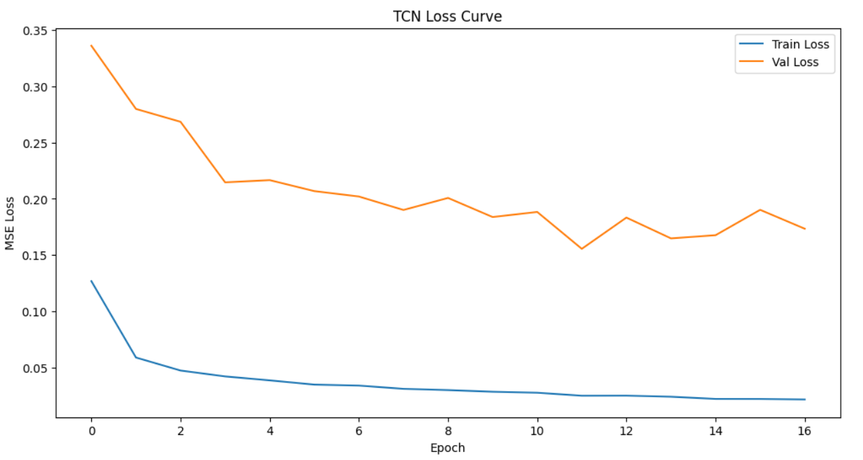
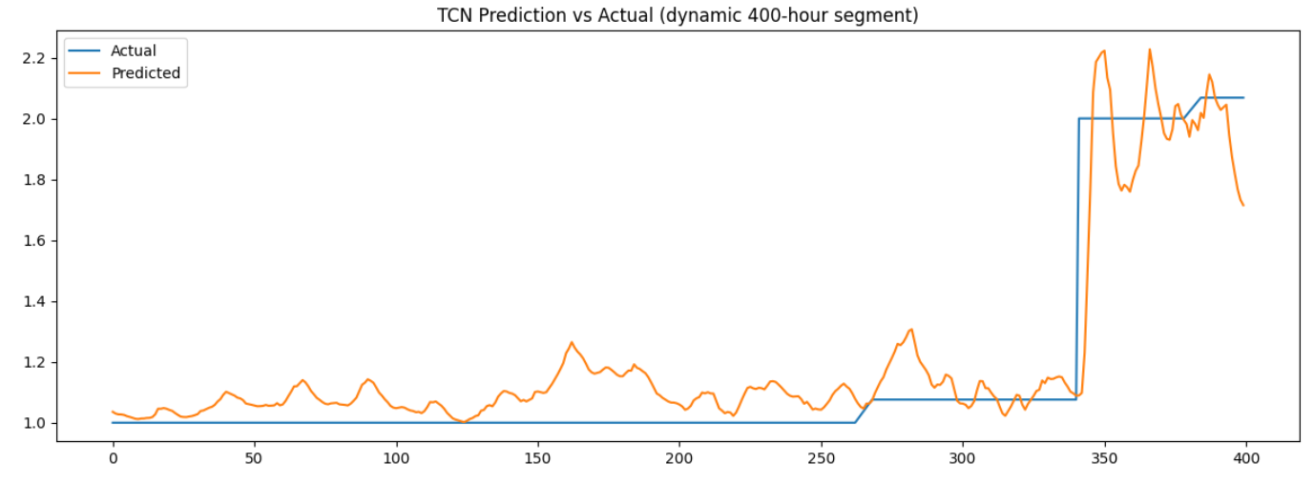
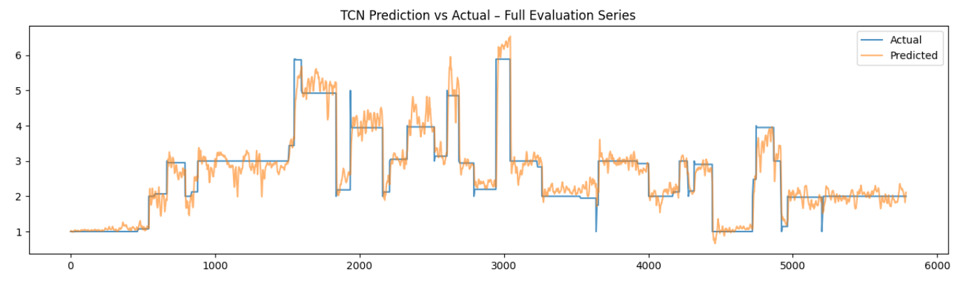
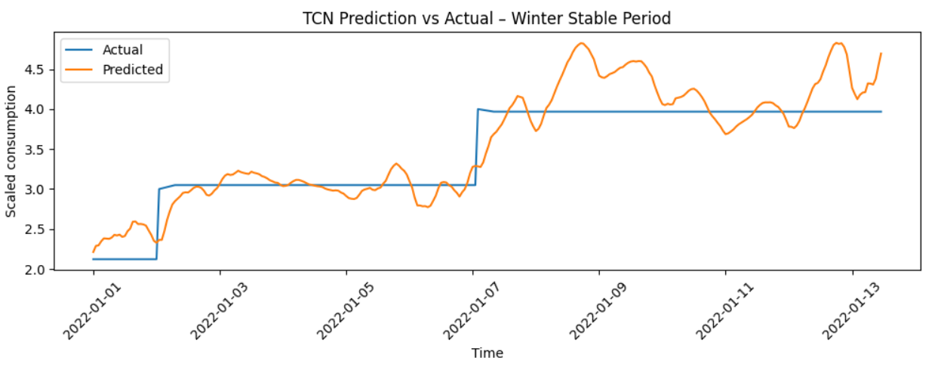

5.4 Observations
Several practical observations can be made from the TCN training and evaluation:
- Pattern Capture
The TCN learns daily and weekly structure effectively. It distinguishes between weekdays and weekends, recognises higher winter loads, and adapts to lower base loads after the heat pump installation. The model is capable of using both immediate past information (recent hours) and more distant patterns (through dilated convolutions).
- Smoothing of Extremes
Just like the GRU, the TCN smooths out some of the sharpest peaks and drops in the consumption. This is a natural consequence of optimising MSE, where the model is encouraged to stay near the central trend rather than perfectly fitting every outlier caused by rare human activities (e.g., sauna use, special events, or multiple heavy appliances running simultaneously).
- Behaviour in Stable Periods
In long stable periods—especially during certain winter segments when the consumption remains nearly constant—the TCN learns to predict almost constant values as well. This behaviour is correct and desirable: it shows that the model recognises when the system is in a steady state and does not introduce artificial variability.
- Training Stability and Efficiency
The TCN trains smoothly without oscillatory loss curves. The residual connections and normalisation layers contribute to stable gradients. Due to the convolutional nature, each epoch is computationally efficient, and the model achieves good performance within a reasonable number of epochs.
Overall, the TCN behaves as a robust and reliable model for next-hour forecasting, showing accuracy and generalisation performance that is competitive with the GRU, while benefiting from a different architectural bias and efficient training.

5.5 TCN for 24-Hour Ahead Multi-Step Forecasting
After validating the one-hour TCN model, the next step was to extend the TCN architecture to perform multi-step forecasting by predicting the next 24 hours of electricity consumption in one shot. This provides more actionable information for planning, demand response, and understanding the shape of the upcoming day.
The basic idea is similar to the 24-hour GRU model:
- the input is still a 24-hour window of engineered features, and
- the output is now a 24-dimensional vector, representing the consumption for each of the next 24 hours.
This turns the problem into a sequence-to-vector mapping where the TCN must understand both intra-day patterns (within the input window) and the anticipated structure of the next day.

5.5.1 Model Structure
For the 24-hour TCN, the input shape remains (24, features), but the output layer is changed to predict all 24 hours at once. The architecture is:
- Input layer with shape (24, features),
- several causal Conv1D blocks with dilation rates (e.g. 1, 2, 4, 8) and residual connections,
- Dropout and Layer Normalisation inside each block,
- GlobalAveragePooling1D to condense temporal information,
- a Dense layer with 64 units and ReLU activation,
- a final Dense(24) output layer for the 24-hour forecast.
Compared to the one-hour TCN, the main change is the size of the last Dense layer. The rest of the architecture is kept intentionally simple to avoid overfitting and to keep the model efficient, given the already complex input feature space and multi-step prediction task.

5.5.2 Training Behaviour
The training data for the 24-hour TCN is constructed by sliding a 24-hour window across the time-series and, for each position, taking the next 24 hours of consumption as the target. The resulting arrays X_24 and true_24 are used to train the model with:
- Adam optimizer,
- MSE loss,
- MAE as an additional metric,
- a validation split on the training data.
During training, the TCN learns patterns such as:
- typical daily consumption cycles (morning and evening peaks),
- temperature–consumption relationships across the next day,
- weekday vs weekend behaviour,
- transitions from high evening load to lower night-time consumption.
The loss curves stabilise in a similar way to the one-hour case. Training loss decreases smoothly, while validation loss eventually plateaus and can slightly increase when the model starts to overfit, indicating that the chosen capacity is appropriate for the data.

5.5.3 Results and Interpretation
The performance of the 24-hour TCN model was first examined on individual examples. Figure A shows the true and predicted next-day consumption profile for a representative sample (here, sample index 500). The blue line corresponds to the actual 24-hour sequence, while the orange line shows the TCN forecast. In this example the true profile is almost constant across the entire day, representing a very stable operating regime. The TCN output is slightly lower in magnitude but remains nearly flat as well, demonstrating that the model has correctly learned to predict a steady profile when the recent history indicates a stable regime.
To obtain a more global view of the model behaviour, a heatmap of the first 100 predicted 24-hour sequences is shown in Figure B. Each row corresponds to one forecast (roughly “one day”), and each column corresponds to the hour-ahead horizon from 1 to 24. The colour scale represents the predicted scaled consumption. The heatmap reveals clear structure: horizontal bands capture different typical consumption levels, while the left–right variation across hours reflects the expected intraday pattern, with slightly higher predicted consumption during some hours and lower values during others. This indicates that the TCN is not simply predicting a single constant value, but is instead learning meaningful daily shapes conditioned on the recent 24-hour history.
The absolute forecast error for the same set of samples is visualised in Figure C. Again, rows correspond to forecast cases and columns to the 24 prediction horizons. Errors are generally small during periods of low and stable consumption, especially during night and early morning hours. Larger errors occur around transition periods and potential peak hours, where human behaviour and external factors introduce sudden changes that are harder to predict deterministically. Importantly, the error pattern is smooth across neighbouring horizons and days, and there are no isolated “spikes” of extremely high error, which suggests that the TCN is behaving in a stable and consistent way.
Overall, the 24-hour TCN model is able to reproduce the main daily structure of consumption and to adapt to different baseline levels across days. While some under- or overestimation occurs, particularly around sharp changes and local peaks, the forecasts remain within a plausible range and preserve the qualitative shape of the actual next-day profiles. From an application perspective, this level of accuracy is sufficient to support short-term planning and scenario analysis, especially when combined with the more precise one-hour ahead forecasts.
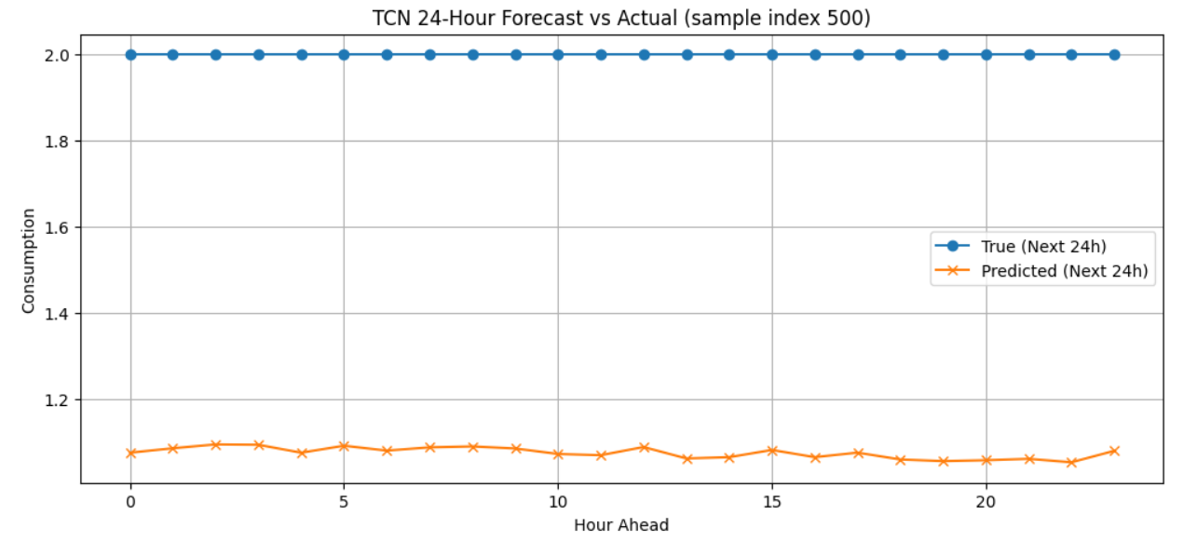
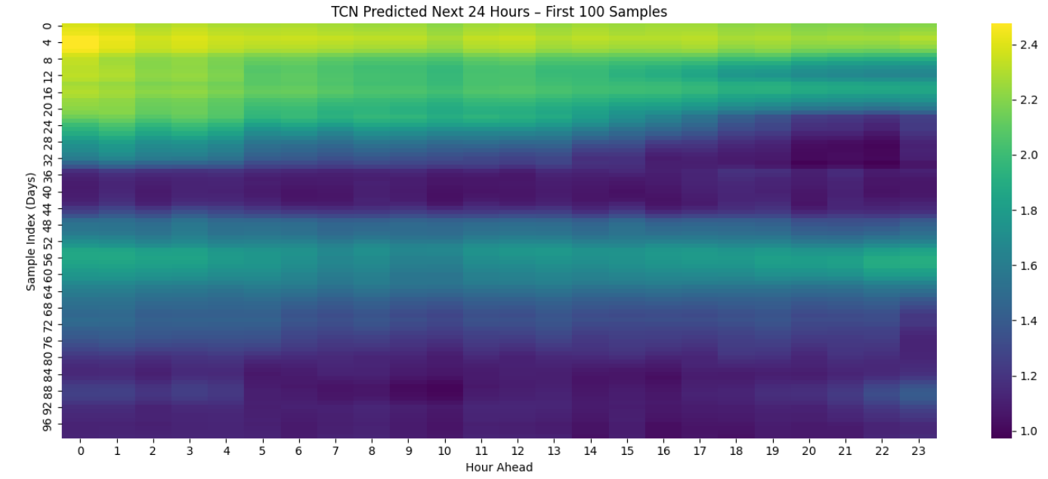
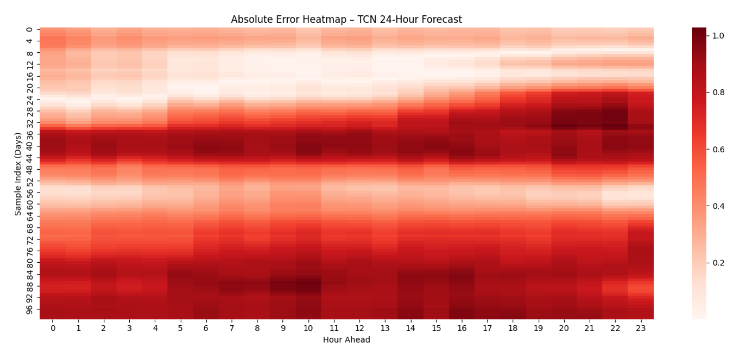

5.5.4 Overall Assessment
The 24-hour TCN model successfully extends the forecasting horizon from one hour to a full day while preserving stability and interpretability. It:
- uses the same rich set of engineered temporal and weather features,
- processes the input through causal and dilated convolutions with residual connections,
- captures key intraday patterns and seasonal behaviour,
- produces smooth and realistic 24-hour forecasts, and
- maintains consistent performance across many days.
While it does not perfectly reproduce every sharp hourly spike, this behaviour is expected and consistent with the underlying objective (MSE) and the inherent randomness of household electricity consumption. From an applied perspective, the TCN provides useful and reliable daily forecasts that are comparable in quality to the GRU-based approach, while offering architectural diversity and efficient training. This makes the TCN a strong candidate for practical short-term energy forecasting and a valuable reference model alongside the GRU in this project.

