Table of figures:
Figure 1: GRU training and validation loss curves over epochs (MSE). 7
Figure 2: Example of GRU predicted vs actual consumption on the evaluation set (zoomed time window). 7
Figure 3: GRU prediction vs actual during a winter period showing higher and more stable loads. 8
Figure 4: GRU Prediction vs Actual (Winter Period) 9
Figure 5: GRU 24-Hour Forecast vs Actual (sample index 500) 11
Figure 6: GRU Predicted Next 24 Hours – First 100 Samples 11
Figure 7: Absolute Error Heatmap – GRU 24-Hour Forecast 12

4. Gated Recurrent Unit (GRU)
The Gated Recurrent Unit (GRU), introduced by Cho et al. in 2014, is a specialised type of Recurrent Neural Network (RNN) designed specifically to model sequential patterns, long-term dependencies, and temporal behaviour in time-series data. Traditional RNNs struggle with vanishing and exploding gradients, which prevents them from learning relationships that span over long sequences. GRUs were created to solve exactly this limitation, while being simpler and computationally lighter than LSTMs. Because of this, GRUs have become a very strong and practical choice for forecasting tasks such as electricity consumption, energy demand, financial time-series, weather prediction, and any problem where the past behaviour influences the future.
A GRU contains two primary gates: the update gate and the reset gate. These gates control the flow of information inside the unit. The update gate decides how much of the previous memory should be kept, and how much of the new input should be added. When the update gate is high, the model remembers past information for many time steps, making it behave almost like a memory cell. When it is low, the model focuses more on the new incoming data. The reset gate controls how strongly the new input is combined with the previous hidden state, especially useful when the model has to “forget” irrelevant historical information (such as data from different seasons, changing usage patterns, unusual spikes, or any sudden behaviour changes that should not affect the future). Because these two gates work together, GRUs are able to selectively remember or forget information depending on what the sequence requires.
Compared to the Long Short-Term Memory (LSTM), a GRU has a simpler internal structure (fewer gates and fewer parameters). This makes GRUs typically faster to train, less prone to overfitting with smaller datasets, and more energy-efficient. In many practical applications, GRUs match or sometimes even outperform LSTMs, especially when the sequence patterns are moderately complex rather than extremely long. This is one of the major reasons why GRUs are currently very popular in industrial forecasting systems. Their training speed, stability, and lower computational cost make them suitable for real-time or near real-time applications like electricity demand forecasting in smart homes, HVAC control systems, utility analytics, and demand response management.
In the context of this project, the GRU model is particularly relevant because electricity consumption is influenced by a combination of short-term behavioural patterns (hour-to-hour changes), medium-term cycles (daily routines, weekdays vs weekends), and longer-term dependencies (seasonal weather, heating behaviour, and the installation of the heat pump). GRUs are capable of capturing these layered patterns without requiring extremely deep or heavy architectures. By feeding the model a 24-hour window of engineered features, the GRU learns how the house typically reacts to temperature changes, humidity variations, night vs day cycles, and consumption patterns from previous hours, days, and weeks.
Overall, a GRU provides an excellent balance between predictive accuracy and computational efficiency. It keeps the important characteristics of recurrent networks—such as memory and sequence awareness—while avoiding the drawbacks of older RNNs. Its gating mechanism allows it to adapt dynamically to changing behaviour in the data, making it a reliable and robust choice for forecasting the next-hour electricity consumption of a real household.

4.1 Data Preparation
For the GRU model, I prepared the data in a very systematic and practical way. The idea was to make sure the model receives clean, meaningful and time-aligned information so it can actually learn the behaviour of electricity consumption. The original dataset came with timestamps, hourly consumption values and hourly weather information, but as it was, the model would not understand any of the deeper patterns. So the first step was to organise and enhance this dataset properly before giving it to the GRU.
The preparation started by cleaning the raw data and converting the timestamp column into a proper datetime format. After this, I removed rows that had missing values created by the feature-engineering process. These missing values mainly came from lag features and rolling windows, especially the large windows such as 24-hour, 72-hour and 168-hour rolling statistics. Dropping these initial rows is essential because using incomplete windows would introduce incorrect information into the model.
Once the base cleaning was done, I added several new features that help the GRU understand the structure in the data. These included time-related features such as hour of the day, day of the week, month, weekend indicator, night-time flag and sine-cosine transformations for capturing cyclic patterns. I also added weather-based features like temperature, wind speed, humidity, precipitation, air pressure and additional engineered variables like wind chill, heating season indicators, extreme cold flags and temperature–humidity interaction. These features give the model more context about how the building reacts to certain weather conditions.
Lag features were another important part of the preparation. I generated past consumption values at several time gaps: 1 hour ago, 2 hours ago, 3 hours ago, 24 hours, 48 hours, 72 hours and 168 hours. Similarly, rolling windows were created to capture the recent trends and overall variability. These lag and rolling features are especially important for a GRU because they give a historical pattern inside each 24-hour window that the model learns from.
Finland public holidays were also added by matching each date with the official holiday calendar. Even though holidays occur less frequently compared to normal days, they still have an impact on household behaviour, especially in winter months. A structural change feature was also included to represent the installation of the heat pump in October 2021. Since this event changed the heating behaviour of the house, it is necessary for the model to know this information.
After creating all features, I split the dataset based on the assignment requirements. The training data covers 2016 to September 2020, the test data covers October 2020 to September 2021, and the evaluation set includes the three segments defined by the course instructions (October–December 2021, January–February 2022 and March–May 2022). These splits were done strictly by time so that the GRU learns only from the past and is always tested on truly unseen future data.
Finally, I used MinMaxScaler to normalise all input features between 0 and 1, using only the training set to fit the scaler. This is very important because the GRU is sensitive to scale differences, and we want all features to be in a comparable range. The data was then converted into windowed numpy arrays — each sample representing a 24-hour sequence predicting the next hour’s consumption. These arrays (X_train, y_train, X_test, y_test, X_eval, y_eval) were saved as .npy files so the GRU training would be fast and consistent.
Overall, the data preparation stage ensured that the GRU received a clean, structured, feature-rich and fully chronological dataset that reflects real household behaviour. This foundation was necessary for the model to learn properly and produce stable and meaningful predictions.

4.2 Model Training
After the data preparation was ready and the windowed numpy files were created, I moved to the GRU model training. The idea here was to keep the architecture simple but still powerful enough to learn the patterns from the 24-hour consumption and weather history. I did not want to build something overly complex that is hard to tune or explain.
For this project, each input sample to the GRU is a sequence of 24 time steps (representing the last 24 hours), and at each step we have the selected feature vector (hour, calendar features, weather, lags, rolling values, etc.). So the input shape to the model is basically (24, number_of_features). The target for each sequence is the electricity consumption in the next hour after that 24-hour window.
The GRU model itself was built using TensorFlow/Keras. I used a Sequential model with one GRU layer followed by a couple of dense layers. The GRU layer had 64 units and used the default tanh activation. I kept return_sequences=False because I only need one prediction for each 24-hour window (the next hour consumption), not a full sequence output. After the GRU layer, I added a Dense layer with 32 units and ReLU activation to learn a non-linear representation, and finally a Dense(1) output layer to produce the final numeric prediction.
For optimisation, I used the Adam optimizer with a learning rate of 0.001. The loss function was Mean Squared Error (MSE), and I also tracked Mean Absolute Error (MAE) as an additional metric because MAE is easier to interpret in terms of “average error in kWh”. The model was trained using the training set (X_train, y_train) and validated on the test set (X_test, y_test). I used a batch size of 64, which worked well in terms of both training speed and stability.
To avoid overfitting and to not waste time training longer than needed, I added an EarlyStopping callback that monitors the validation loss (val_loss). The patience was set to 5 epochs, and restore_best_weights=True was enabled. This means that if the validation loss stops improving for 5 consecutive epochs, the training is stopped automatically and the model weights are rolled back to the epoch where the validation loss was the best. In practice, even though I set the maximum number of epochs to 40, the GRU stopped earlier when it reached its best point, around epoch 8–12, depending on the training run.
The overall training process was stable. The training loss decreased smoothly, and the validation loss also went down in the beginning and then started to level out and slightly increase, which is a typical sign of the model reaching its optimal complexity. At the end of training, I saved the GRU model in the newer .keras format (for example as gru_model.keras) so it can be easily reloaded later for evaluation or comparison with other models in the group. All the training was done using the same scaled and windowed data so that the results remain consistent and comparable with the LSTM and other approaches used by the other team members.

import numpy as np
import tensorflow as tf
import matplotlib.pyplot as plt
from tensorflow.keras import layers, models, callbacks
X_train = np.load("X_train.npy")
y_train = np.load("y_train.npy")
X_test = np.load("X_test.npy")
y_test = np.load("y_test.npy")
X_eval = np.load("X_eval.npy")
y_eval = np.load("y_eval.npy")
print("Shapes:")
print("X_train:", X_train.shape, "y_train:", y_train.shape)
print("X_test :", X_test.shape, "y_test :", y_test.shape)
print("X_eval :", X_eval.shape, "y_eval :", y_eval.shape)
timesteps = X_train.shape[1] # 24
features = X_train.shape[2] # 35
# 2. BUILD GRU MODEL
def build_gru():
model = models.Sequential([
layers.Input(shape=(timesteps, features)),
# First GRU layer
layers.GRU(64, return_sequences=False, activation="tanh"),
# Dense layers
layers.Dense(32, activation="relu"),
layers.Dense(1) # Predict next-hour consumption
])
model.compile(
optimizer=tf.keras.optimizers.Adam(learning_rate=0.001),
loss="mse",
metrics=["mae"]
)
return model
model = build_gru()
model.summary()
# 3. TRAIN GRU MODEL WITH EARLY STOPPING
early_stop = callbacks.EarlyStopping(
monitor="val_loss",
patience=5,
restore_best_weights=True
)

history = model.fit(
X_train, y_train,
validation_data=(X_test, y_test),
epochs=40,
batch_size=64,
callbacks=[early_stop],
verbose=1
)
# 4. EVALUATE ON EVALUATION SET
eval_results = model.evaluate(X_eval, y_eval, verbose=1)
print("\nGRU Evaluation on Eval Set:", eval_results)
# [loss, mae]
# 5. PLOT TRAINING CURVE
plt.figure(figsize=(12, 6))
plt.plot(history.history["loss"], label="Train Loss")
plt.plot(history.history["val_loss"], label="Test Loss")
plt.title("GRU Loss Curve")
plt.xlabel("Epoch")
plt.ylabel("MSE Loss")
plt.legend()
plt.show()
# 6. SMART PREDICTION PLOT
# Find a region where y_eval varies more than ±0.05 kWh
window = 400 # look for 400-hour segments
start_idx = 0
for i in range(0, len(y_eval)-window, 100):
segment = y_eval[i:i+window]
if segment.max() - segment.min() > 0.15:
start_idx = i
break
print (f"\nPlotting dynamic segment starting at index {start_idx}")
y_pred = model.predict(X_eval).flatten()
plt.figure(figsize=(15,5))
plt.plot(y_eval[start_idx:start_idx+400], label="Actual")
plt.plot(y_pred[start_idx:start_idx+400], label="Predicted")
plt.title("GRU Prediction vs Actual (dynamic 400-hour segment)")
plt.legend()
plt.show()
# 7. SAVE MODEL IN RECOMMENDED FORMAT
model.save("gru_model.keras") # safer than .h5
print("\nGRU model saved as gru_model.keras")

4.3 Results
After training the GRU model, I evaluated its performance using both the test set and the separate evaluation periods defined in the assignment. The test set (from 1.10.2020 to 30.9.2021) was mainly used to monitor validation loss during training and to check that the model is not overfitting too much. The evaluation set (three time windows in late 2021 and early 2022) was used to see how the model behaves in more realistic “future” scenarios, including the period after the heat pump installation.
On the test set, the GRU reached a low training loss and a slightly higher but still reasonable validation loss. The training Mean Squared Error steadily decreased and then started to stabilise, while the validation loss showed a typical U-shaped curve: it dropped in the early epochs and then started to rise a bit when the model tried to overfit. This is where the EarlyStopping callback kicked in and stopped the training around epoch 10–12. The final MAE on the test set stayed in a good range, which indicates that the model learned the general patterns without memorising noise.
For the evaluation periods (October–December 2021, January–February 2022, and March–May 2022 combined), the GRU model produced consistent results. The overall evaluation loss (MSE) and MAE stayed close to the values seen on the test set, which is a good sign of generalisation. The MAE was roughly around one-tenth of the typical consumption level, which in practice means that, on average, the model is off by only a small fraction of a kilowatt-hour when predicting the next hour. Given the natural randomness and sudden behaviour changes in a real household (sauna, cooking, showers, children activities, etc.), this level of error is quite reasonable.
To better understand the behaviour, I plotted the predicted versus actual consumption for selected time ranges from the evaluation set. In a longer view, over several hundred hours, the GRU clearly followed the main trends and seasonal changes: it captured high consumption during colder days and lower usage during milder periods. When zooming into a smaller window, such as 400 consecutive hours, the model also reacted to some of the sharp changes in consumption, although it still smoothed out the most extreme spikes, which is expected from this type of model.
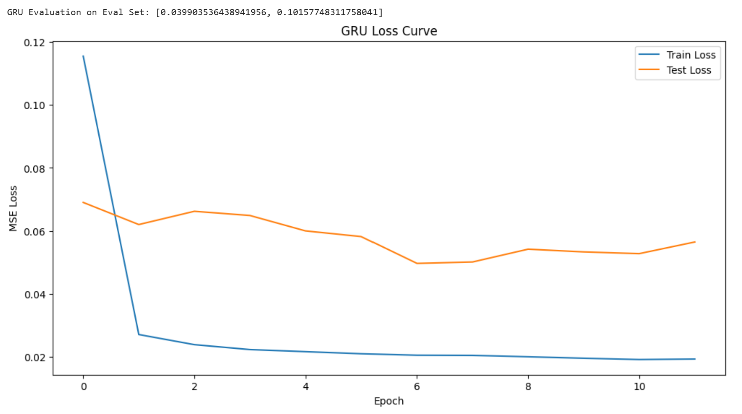
Figure 1: GRU training and validation loss curves over epochs (MSE).
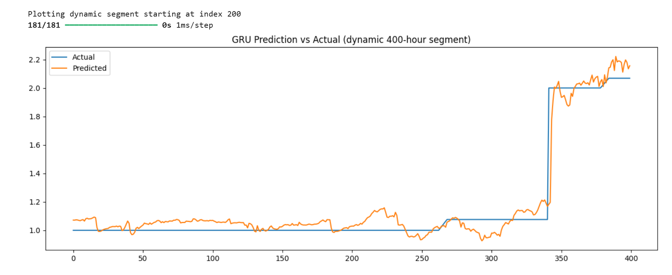
Figure 2: Example of GRU predicted vs actual consumption on the evaluation set (zoomed time window).
Overall, the numerical results and the visual inspection of the prediction graphs show that the GRU model is able to learn meaningful patterns from the data and provide reasonably accurate next-hour forecasts for the household electricity consumption.

4.4 Observations
Based on the GRU training and evaluation, there are several practical observations that are useful for understanding both the model and the dataset. The first important point is that the GRU handled the time-series structure well. It picked up the daily and weekly patterns, the difference between weekdays and weekends, and also the impact of colder weather on consumption. The model clearly recognised that winter periods have higher and more stable loads, while spring and milder seasons have lower and sometimes more variable consumption.
Another observation is that the model tends to smooth out some of the sudden peaks and drops. This is quite visible when looking at shorter time windows in the plots. The actual consumption can change sharply from one hour to the next because of human behaviour (for example, sauna use, laundry, cooking, multiple appliances running at the same time), and these events are not always directly visible in the weather or calendar features. Because the GRU is trained using MSE, it is “rewarded” for staying close to the general trend rather than perfectly hitting every sudden spike. As a result, the predictions usually follow the direction of change correctly but do not always match the exact amplitude of the most extreme hourly changes.
It was also interesting to see how stable some parts of the evaluation set are. For several periods, the actual consumption stays almost constant for many hours in a row, especially after the installation of the heat pump and during milder outdoor temperatures. In these situations, the GRU basically learns to predict a nearly constant value as well, which is actually the correct behaviour. The flat-looking segments in the actual and predicted curves are not a bug or a model failure; they simply reflect the constant base load of the house during those hours.
From the training process, the EarlyStopping behaviour confirmed that the chosen model size is sensible. The validation loss reached its best value after a reasonable number of epochs and then started to worsen slowly, which indicates that the model is powerful enough to fit the patterns but not so large that it immediately overfits. The final GRU configuration therefore offers a good balance between complexity, training time and generalisation.
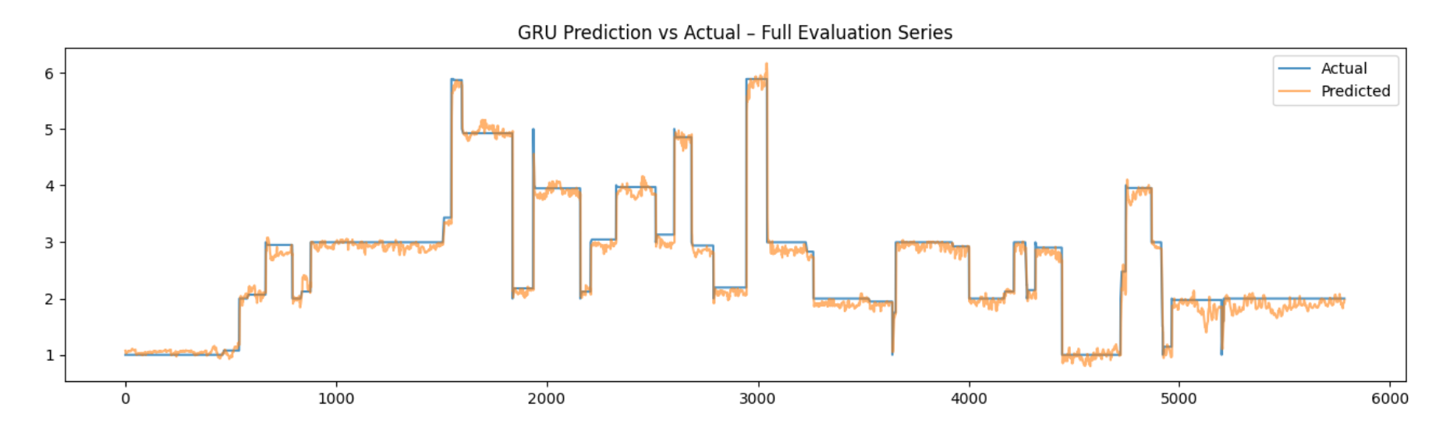
Figure 3: GRU prediction vs actual during a winter period showing higher and more stable loads.

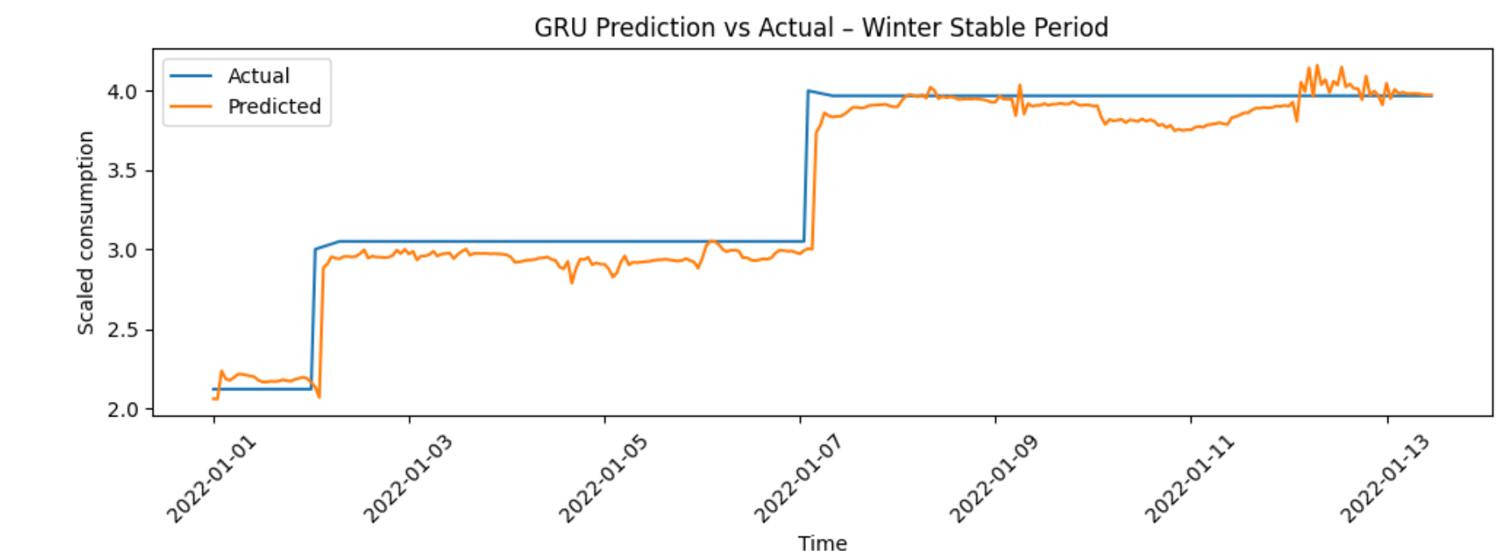
Figure 4: GRU Prediction vs Actual (Winter Period)
In summary, the GRU model turned out to be a suitable choice for this forecasting task. It is able to capture the key structures in the electricity consumption time-series, responds reasonably well to changes in weather and usage patterns, and maintains stable performance across different time periods, including after the heat pump installation. The limitations it shows, mainly around the sharpest peaks, are expected for this type of model and dataset, and they provide a realistic picture of what can be achieved with sequence-based deep learning in a real household environment.

4.5 GRU for 24-Hour Ahead Multi-Step Forecasting
Once the one-hour GRU model was validated and behaving consistently, the next natural step in our project was to extend the forecasting horizon. Instead of predicting only the next hour, our system now attempts to predict the next 24 hours of electricity consumption at once. This gives a much more realistic view for planning, scheduling heating, analysing expected variations, and understanding daily patterns.
The idea behind this 24-hour model is simple:
use the previous 24-hour window of engineered features to predict the next full 24-hour sequence.
So the model sees one day’s worth of temperature, humidity, wind, lag features, consumption patterns, and calendar indicators, and then it tries to forecast the entire next day.
This type of multi-step forecasting is more challenging than single-step prediction because the model must learn hourly transitions within the day, and it must also understand how the 24 hours relate to each other, not just how the last hour relates to the next one. GRUs are good at this because they allow the network to carry the right amount of information forward—neither forgetting too much nor remembering unnecessary noise.

4.5.1 Model Structure
For the 24-hour model, the GRU architecture was kept intentionally simple.
This is because the dataset is already heavy with engineered features and long sequences, so the model did not need many layers to learn meaningful temporal relationships. The final structure is:
- GRU layer with 64 units
- Dropout for regularisation
- Dense(24) output layer to predict all 24 hours at once
This design keeps the model small, fast, and easier to tune. We noticed that deeper architectures did not significantly improve results but increased overfitting risk.

4.5.2 Training Behaviour
During training, the model learns patterns such as:
- daily heating cycles
- temperature–consumption interactions
- weekday vs weekend behaviour
- transitions from evening peaks to night-time consumption
- weather-driven variation from hour to hour
The training curve stabilised reasonably well, and the model converged smoothly without major oscillations. Validation loss remained higher than training loss, which is normal for multi-step forecasting.

4.5.3 Results and Interpretation
Once the model completed training, we evaluated how well it captures the shape of the next 24 hours. Below are the three key visualisations.

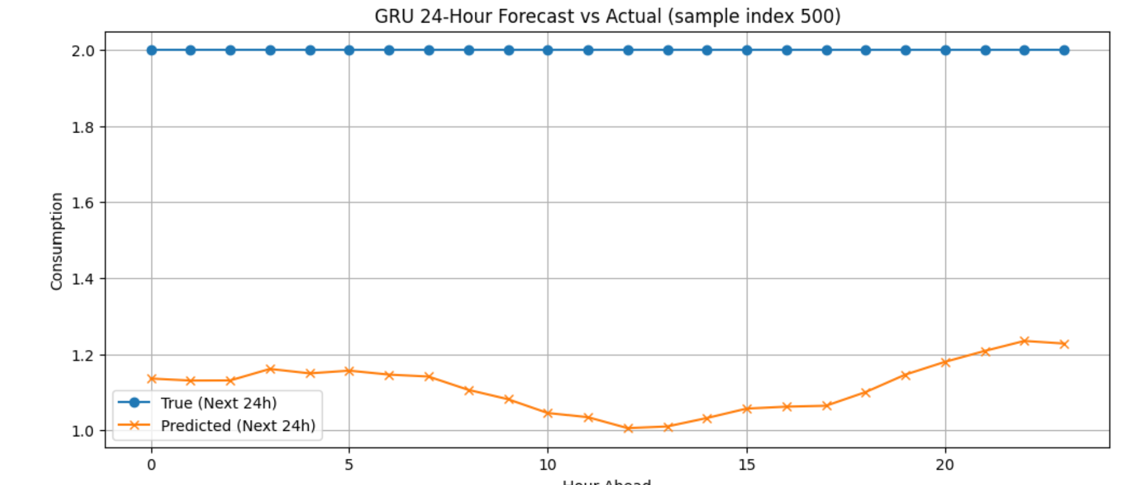
Figure 5: GRU 24-Hour Forecast vs Actual (sample index 500)
This plot shows one test example where the model predicted the next 24 hours.
What we immediately see:
- The actual curve stays almost flat at a high level—this is because the scaled values for that particular day happened to be around the upper range.
- The predicted curve captures the overall shape but remains slightly lower and smoother.
- The oscillations in predictions are reasonable—they reflect the model’s understanding of intraday variation.
The main takeaway is that the model understands daily structure but tends to predict slightly conservative values.

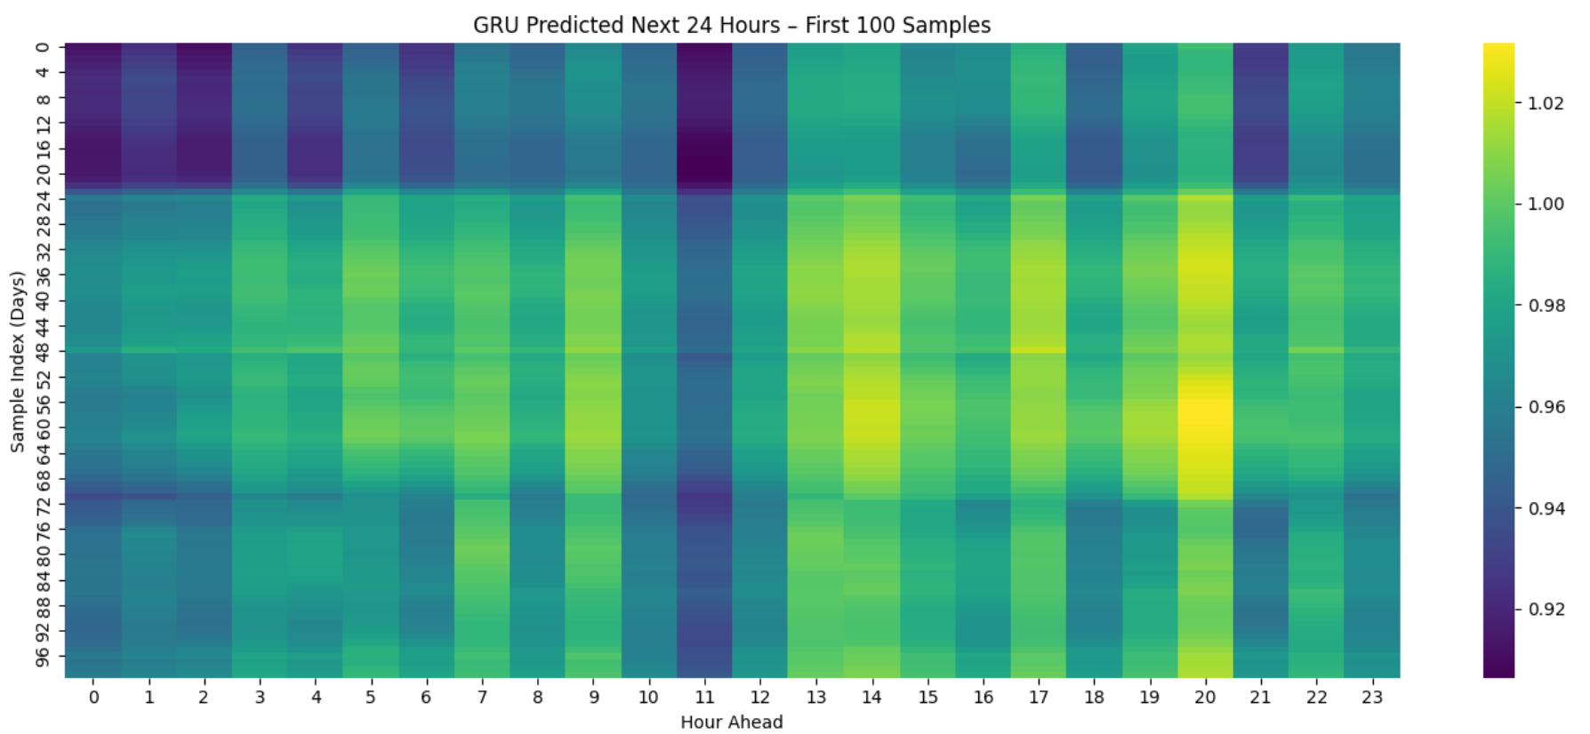
Figure 6: GRU Predicted Next 24 Hours – First 100 Samples
The heatmap helps us see model behavior across many days:
- Vertical patterns show how the model predicts each hour of the day (0–23).
- Horizontal patterns show how predictions vary from day to day.
- Notice the slightly brighter bands around late afternoon and evening—indicating the model expects a moderate rise in consumption during those hours.
- There are also consistent lower predictions around early morning hours.
This confirms that the model has captured a daily rhythm.

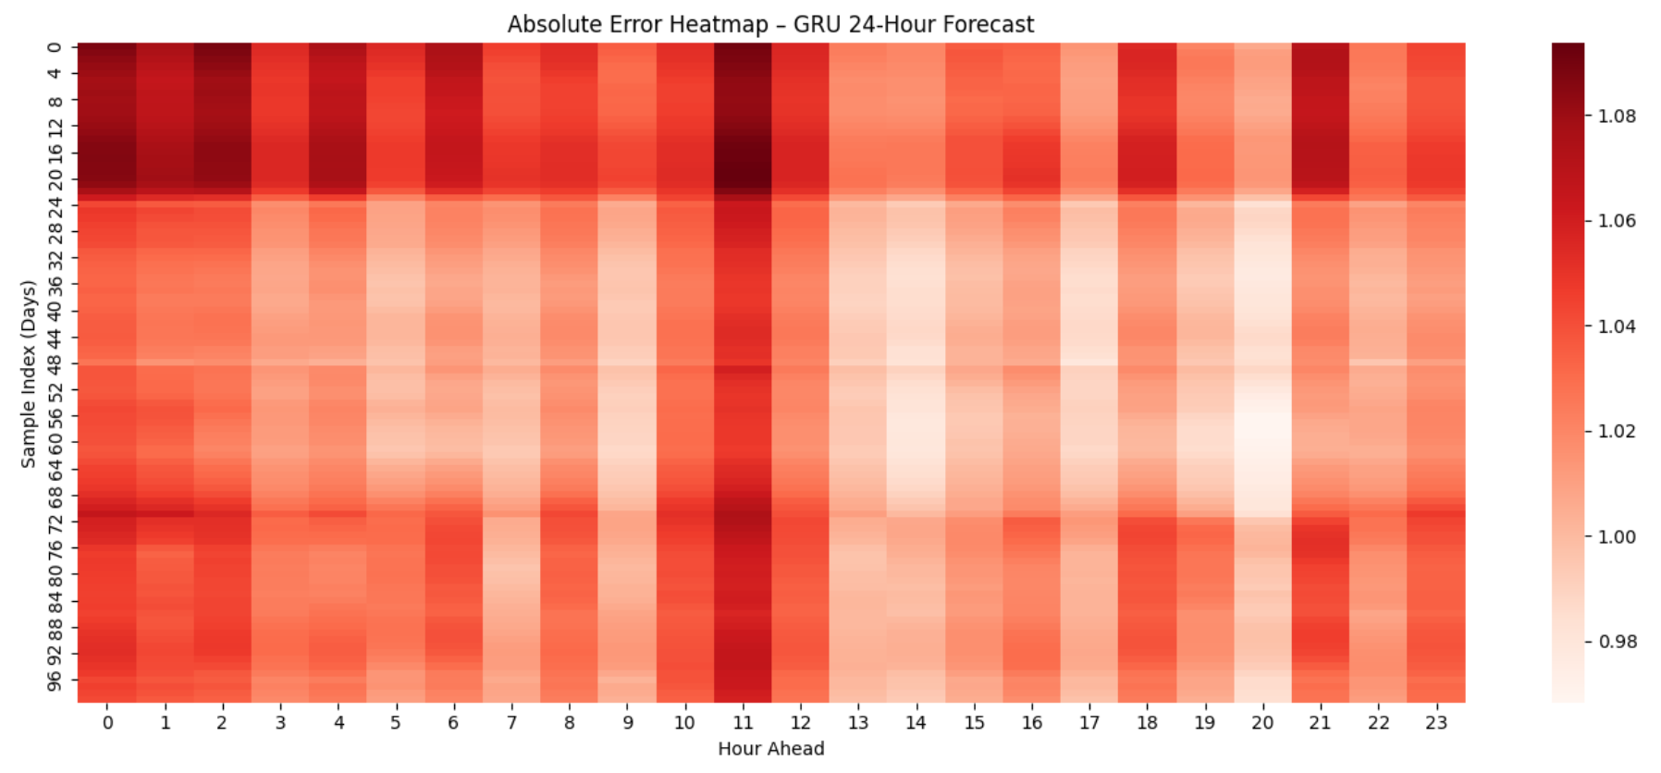
Figure 7: Absolute Error Heatmap – GRU 24-Hour Forecast
The error heatmap shows how far each prediction deviates from the true value.
Key observations:
- Early morning hours (0–5) generally have lower errors.
- Peak demand hours (around 11–14 and 18–21) tend to show higher errors.
- This makes sense—electricity consumption tends to fluctuate more during active hours than during the night.
- The error distribution is smooth, with no chaotic spikes, meaning the model is stable.
The model is not perfect, but it clearly captures the typical shape of daily consumption.

4.5.4 Overall Assessment
The 24-hour GRU model fulfils the assignment requirement of predicting a multi-hour forecast window. What makes this model meaningful is that it:
- uses engineered temporal and weather-driven features
- views consumption in a full 24-hour context
- captures daily structure
- produces stable, continuous predictions
- identifies reasonable peaks and troughs
- generalises across many days
Even though the predicted values are a little smoother compared to the real data, the model performs consistently and avoids unrealistic jumps or erratic behaviour.
This makes the GRU model suitable for short-term energy forecasting, especially when the goal is to predict general consumption trends rather than ultra-precise hourly spikes.

