PSC assaignment:-

question 1-

#include<bits/stdc++.h>

using namespace std;

class Company {
public :
string com_name, com_address ;
int com_year, com_phno ;

void company_input(){
cout<<"\nNAME: " ;
cin>>com_name ;
cout<<"\naddress: " ;
cin>>com_address ;
}

void company_details() {
cout<<"\nName: "<<com_name ;
cout<<"\nCOmpany address: "<<com_address ;
}

private :
string gstid ;

void gst_detail(){
cout<<"\nGST_id = "<<gstid ;
}
void gst_input() {
cout <<"\nGst id = ";
cin>>gstid ;
}

};

class Bank {
public :
string bank_name, ifsc_code, address ;
long int loan_amt;

void bank_details(){
cout<<"\nBank name is "<<bank_name ;
cout<<"\nBank IFSC code is "<<ifsc_code ;
cout<<"\nAddress: "<<address ;
cout<<"\nLoan amount : "<<loan_amt;
}

void bank_input(){
cout<<"\nEnter the name of the bank: ";
cin>>bank_name ;
cout<<"\nEnter the ifsc code for the bank: " ;
cin>>ifsc_code;
cout<<"\nEnter the address: ";
cin>>address;
cout<<"\nEnter the loan amount: ";
cin>>loan_amt ;
}

private :
string acc_holder_name, acc_no ;
void acc_detail(){
cout<<"\nThe account holder name is : "<<acc_holder_name ;
cout<<"\nThe acc number is : "<<acc_no ;

}

void acc_input(){
cout<<"\nacc holder name: ";
cin >>acc_holder_name ;
cout<<"\nacc no: ";
cin>>acc_no;
}
};

class insurance {
public:
string name, plan ;

void ins_input(){
cout<<"\nEnter the name of the insurance: ";
cin>>name ;
cout<<"\nEnter the plane: ";
cin>>plan ;
}

void ins_detail(){
cout<<"\nInsurance name is "<<name ;
cout<<"\nInsurance plan is "<<plan;
}

private:
string insurance_id;
void id_input(){
cout<<"\nEnter the insurance id: ";
cin>>insurance_id;
}
void id_det(){
cout<<"\nThe insurance id is: "<<insurance_id;
}
};

class product: public Company, public Bank, public insurance {
public:
string model_name;
int max_seat_capacity, price, year;

void product_input(){
cout<<"\nEnter the name of the model of the vehicle: ";
cin>>model_name;
cout<<"\nEnter the max seating capacity of the vehicle: ";
cin>>max_seat_capacity;
cout<<"\nEnter the price of the product: ";
cin>>price;
}

void product_detail(){
cout<<"\nName of the model is "<<model_name;
cout<<"\nmax seat capacity: "<<max_seat_capacity;
cout<<"\nThe price of the product is : "<<price;

}

private:
string nu;
};

int main(){
product car ;

car.company_input();
car.bank_input();
car.ins_input() ;
car.product_input();
cout<<"\n";
car.company_details();
cout<<"\n";
car.bank_details();
cout<<"\n";
car.ins_detail();
cout<<"\n";
car.product_detail();

}

OUTPUT-

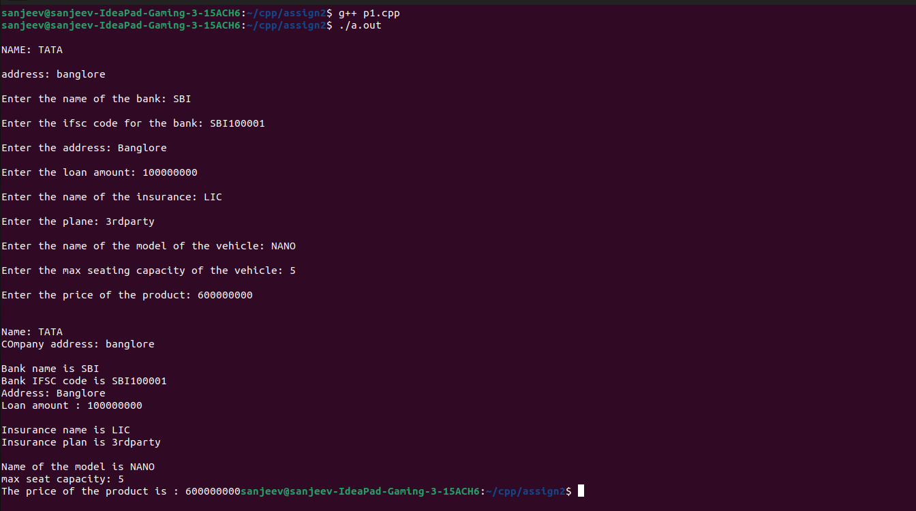

QUESTION 2

#include<bits/stdc++.h>

using namespace std;

class College {
public :
string clg_name, clg_address ;
int com_year, com_phno ;

void clg_input(){
cout<<"\nNAME of the college: " ;
cin>>clg_name ;
cout<<"\naddress of the college: " ;
cin>>clg_address ;
}

void clg_details() {
cout<<"\nName of college: "<<clg_name ;
cout<<"\nCollege address: "<<clg_address ;
}

private :
string clgno ;

void gst_detail(){
cout<<"\nclg_no = "<<clgno ;
}
void gst_input() {
cout <<"\nclg no = ";
cin>>clgno ;
}

};

class Hostel {
public :
string hostel_name, address ;
int room_no;

void hostel_details(){
cout<<"\nHostel name is "<<hostel_name ;
cout<<"\nAddress of hostel: "<<address ;
cout<<"\nroom number: "<<room_no;
}

void hostel_input(){
cout<<"\nEnter the name of the Hostel: ";
cin>>hostel_name ;
cout<<"\nEnter the address of the hostel: ";
cin>>address;
cout<<"\nEnter the room no : ";
cin>>room_no ;
}

};

class dept{
public:
string name, hod ;

void dept_input(){
cout<<"\nEnter the name of the Department: ";
cin>>name ;
cout<<"\nName of the hod: ";
cin>>hod ;
}

void dept_detail(){
cout<<"\nDepartment name is "<<name ;
cout<<"\nHOD plan is "<<hod;
}
};

class student: public College, public Hostel, public dept{
public:
string stu_name, roll_no;
int stu_age, year;

void stu_input(){
cout<<"\nEnter the name of the Student: ";
cin>>stu_name;
cout<<"\nEnter the roll no of the student: ";
cin>>roll_no;
cout<<"\nEnter student age: ";
cin>>stu_age;
cout<<"\nEnter the year in which student is studing: ";
cin>>year;
}

void stu_detail(){
cout<<"\nName of the Student is "<<stu_name;
cout<<"\nRoll no of the student : "<<roll_no;
cout<<"\nAge of the student : "<<stu_age;
cout<<"\nthe present year of the student is: "<<year;
}

private:
string nu;
};

int main(){
student s ;

s.clg_input();
s.hostel_input();
s.dept_input() ;
s.stu_input();
cout<<"\n";
s.clg_details();
cout<<"\n";
s.hostel_details();
cout<<"\n";
s.dept_detail();
cout<<"\n";
s.stu_detail();
cout<<"\n";

}

OUTPUT-

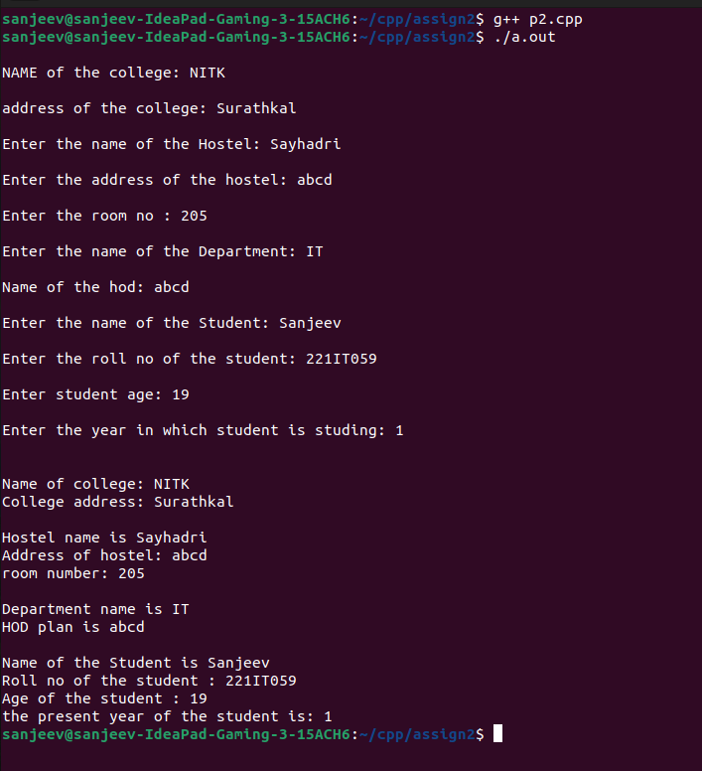

QUESTION 3-

#include<bits/stdc++.h>

using namespace std;

class College {
public :
string clg_name, clg_address ;
int com_year, com_phno ;

void clg_input(){
cout<<"\nNAME of the college: " ;
cin>>clg_name ;
cout<<"\naddress of the college: " ;
cin>>clg_address ;
}

void clg_details() {
cout<<"\nName of college: "<<clg_name ;
cout<<"\nCollege address: "<<clg_address ;
}

private :
string clgno ;

void gst_detail(){
cout<<"\nclg_no = "<<clgno ;
}
void gst_input() {
cout <<"\nclg no = ";
cin>>clgno ;
}

};

class hcc {
public :
int height, weight;
string health_issue;

void hcc_details(){
cout<<"\nThe weight of the faculty is "<<weight ;
cout<<"\nHeight of the faculty is "<<height ;
cout<<"\nAny health issues "<<health_issue;
}

void hcc_input(){
cout<<"\nEnter the weight of the faculty: ";
cin>>weight ;
cout<<"\nEnter the height of the faculty: ";
cin>>height;
cout<<"\nEnter the health issues : ";
cin>>health_issue ;
}

};

class dept{
public:
string name, hod ;

void dept_input(){
cout<<"\nEnter the name of the Department: ";
cin>>name ;
cout<<"\nName of the hod: ";
cin>>hod ;
}

void dept_detail(){
cout<<"\nDepartment name is "<<name ;
cout<<"\nHOD plan is "<<hod;
}
};

class faculty: public College, public hcc, public dept{
public:
string fac_name, reg_no;
int fac_age;

void fac_input(){
cout<<"\nEnter the name of the faculty: ";
cin>>fac_name;
cout<<"\nEnter the roll no of the faculty: ";
cin>>reg_no;
cout<<"\nEnter faculty age: ";
cin>>fac_age;
}

void fac_detail(){
cout<<"\nName of the faculty is "<<fac_name;
cout<<"\nRoll no of the faculty : "<<reg_no;
cout<<"\nAge of the faculty : "<<fac_age;
}

private:
string nu;
};

int main(){
faculty s ;

s.clg_input();
s.hcc_input();
s.dept_input() ;
s.fac_input();
cout<<"\n";
s.clg_details();
cout<<"\n";
s.hcc_details();
cout<<"\n";
s.dept_detail();
cout<<"\n";
s.fac_detail();
cout<<"\n";

}

OUTPUT-

