Scenario
My Mirror is building an internal “Team Pulse” tool that allows engineers to anonymously share how they feel each day. Leadership can view aggregated trends, but not individual submissions.

Team pulses are categorized (e.g., Workload, Collaboration, Wellbeing, Team Dynamics). Each submission belongs to exactly one category.
Your task is to build a minimal version of this tool. Please review the test and ask whatever questions you need. When you're done, submit your code to GitHub or another source code repository and send us a link to access it.

Functional Requirements

Feature: Anonymous Team Pulse
- Submit Pulse: A user submits an anonymous pulse score (1–5), an optional comment, and a required category.
- View Summary (overall): A dashboard shows count, average score, and distribution per score (1..5) aggregated across all categories. No raw comments or individual rows should be returned here.
- Manage Categories (read-only): Expose an endpoint to list available categories so the frontend can render a selector. (No admin UI required; seed a few categories in-memory.)

Technical Requirements

Backend
- Platform: .NET 8 or .NET 10 (C#).
- Style: Build a small DDD‑inspired vertical slice:
  - Domain layer: Entities/Value Objects.
  - Application layer: Commands/Queries (use MediatR), DTOs, and orchestration.
  - Infrastructure layer: In‑memory persistence for this test (no real DB). Keep a repository abstraction that could be swapped later.
  - API layer: API endpoints.
- Validation: score validity, max comment length, category required.
- ORM: use Entity Framework Core and create a dbContext that contains the two Domain classes.
- Endpoints:
  - POST /api/pulse → Accept a submission:
Request JSON
{
"score": 1,
"comment": "optional text",
"categoryId": "Guid"
}

Rules: score is required (1..5); categoryId required and must exist; comment optional; persist in memory via repository abstraction.
  - GET /api/pulse/summary → Returns:

Response JSON
{
"count": 24,
"averageScore": 3.8,
"scores": { "1": 2, "2": 3, "3": 4, "4": 9, "5": 6 },
"categories": [
{ "id": 1, "name": "Workload", "count": 10 },
{ "id": 2, "name": "Wellbeing", "count": 8 },
{ "id": 3, "name": "Team Dynamics", "count": 6 }
]
}
Must not include raw comments or IDs.
  - GET /api/pulse/categories
Return list of available categories. Example categories could be: Workload, Collaboration, Wellbeing, Team Dynamics, Environment

- Testing: If time allows, add a small unit test for a domain rule (e.g., score range validation).

T‑SQL Component
Add a T‑SQL artifact in the repo to show SQL fluency without requiring a running database:
- Create a file at sql/pulse_reporting.sql that:
  - Defines a plausible schema and create table statement for a productionized version of both PulseEntry and PulseCategory including the relationship between them.
- Also, include a query that returns the same structure as /api/pulse/summary:
  - total count
  - averageScore (decimal(3,2) or similar)
  - scores distribution as five rows or a pivoted shape (comment inline on approach)
- And finally, include a query to return the PulseEntry total counts by PulseCategory.
No database connection is needed. We only review the SQL for correctness and design reasoning.

Frontend
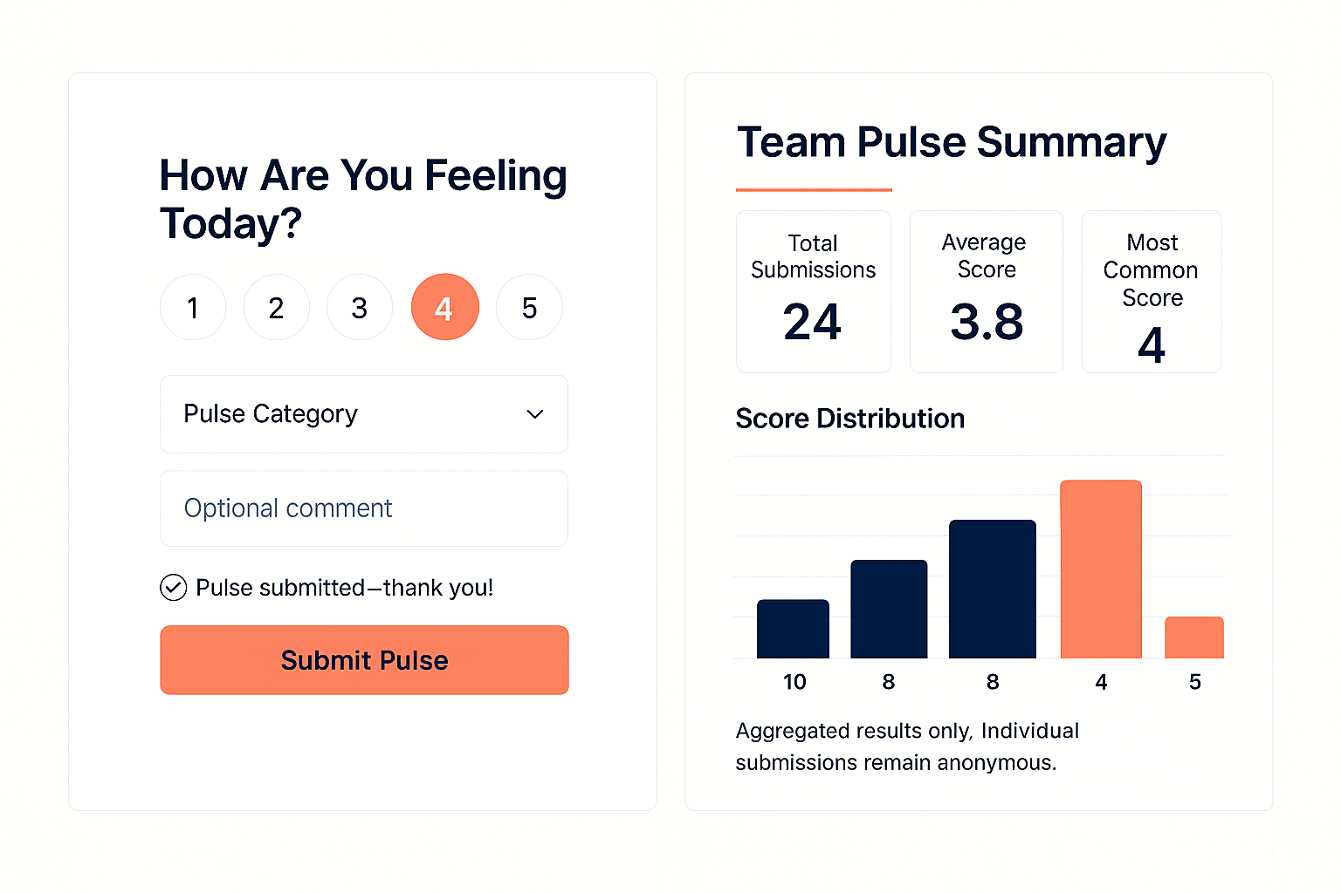
- Framework: Nuxt4 + any build tool (Vite preferred).
- Pages (see UI below):
  - Submit Pulse: score selector (1–5), Category dropdown (populated via /api/pulse/categories), optional comment box, submit button, success confirmation.
  - Summary: show total count, average, and a simple distribution chart (any lightweight chart lib or your own bars).
  - UI must be responsive.
- API calls: Use fetch/axios to call the backend endpoints above.

For help on Nuxt.js:
https://nuxt.com/docs/4.x/getting-started/installation
https://nuxt.com/

