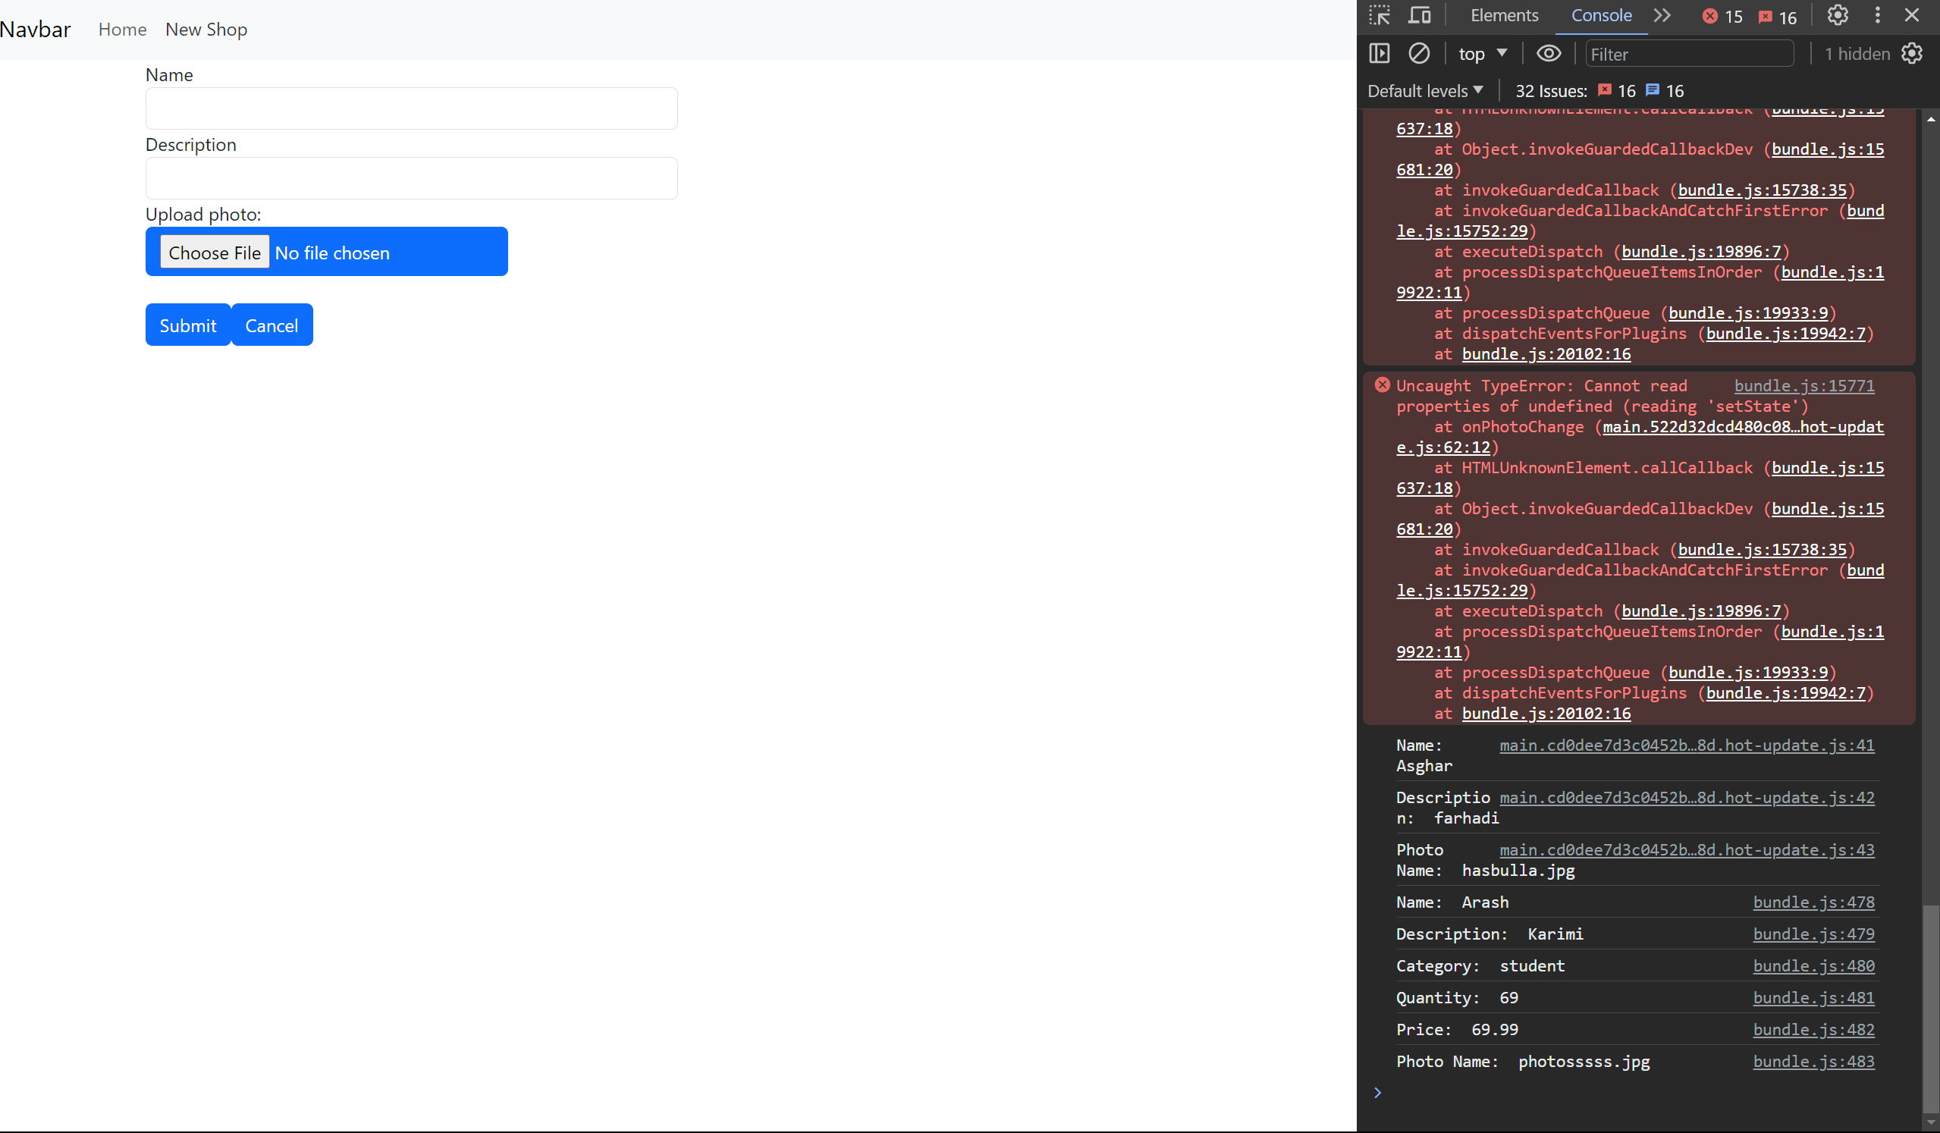

https://github.com/imCaptainG/midtermTestReact