Project Specifications

Programming Language: PHP 7.4.1 cli

Composer: Composer 2.4.1 (Different Composer Version may cause issue due to unsupported php version)

Database: Postgres 10

Domain: elephantSQL (Free)

Git: [GitHub - imJenson123/davos-api](https://github.com/imJenson123/davos-api)

How to Run the project

1. Copy .env.example to paste into root directory and name it .env

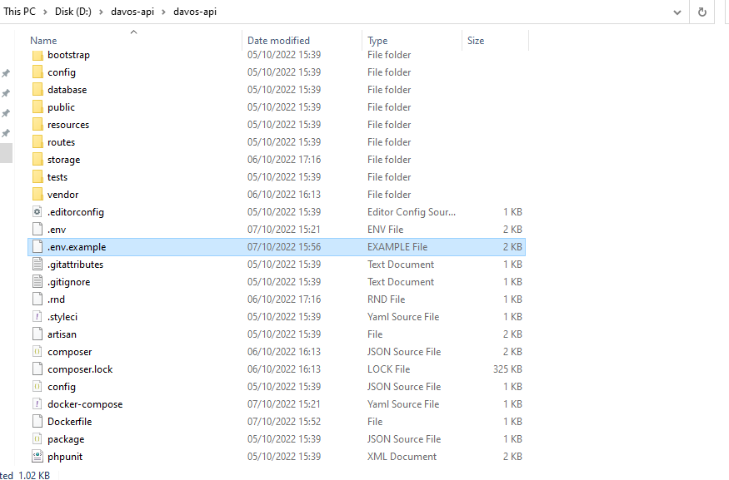

1. Make sure extension=fileinfo in php.ini is uncomment if there is requirement for league flysystem, else it will show error

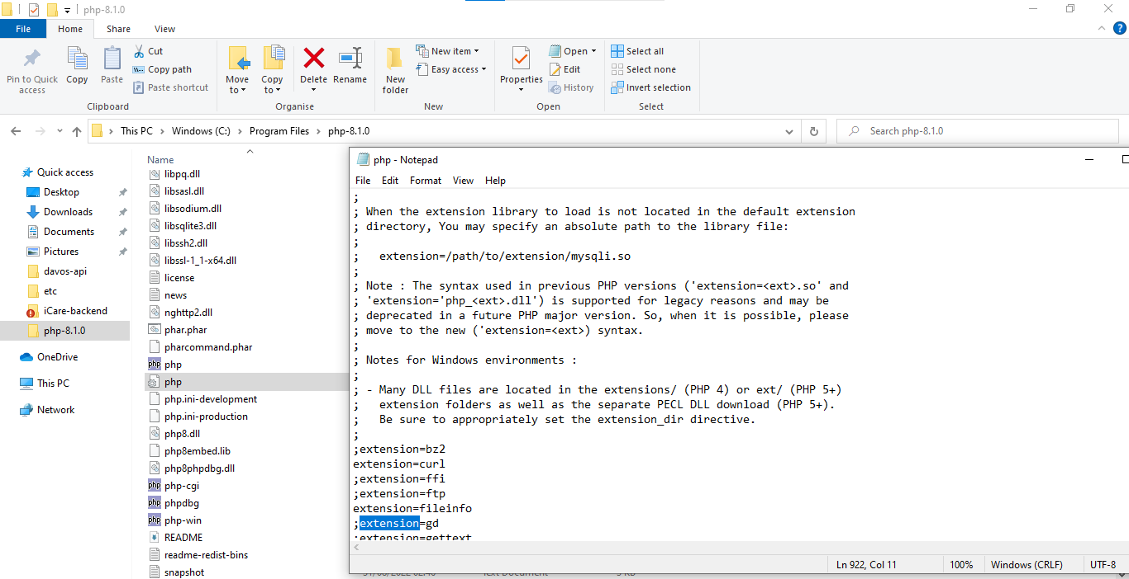

1. Make sure extension=pdo_pgsql and pgsql is uncomment to use postgres database

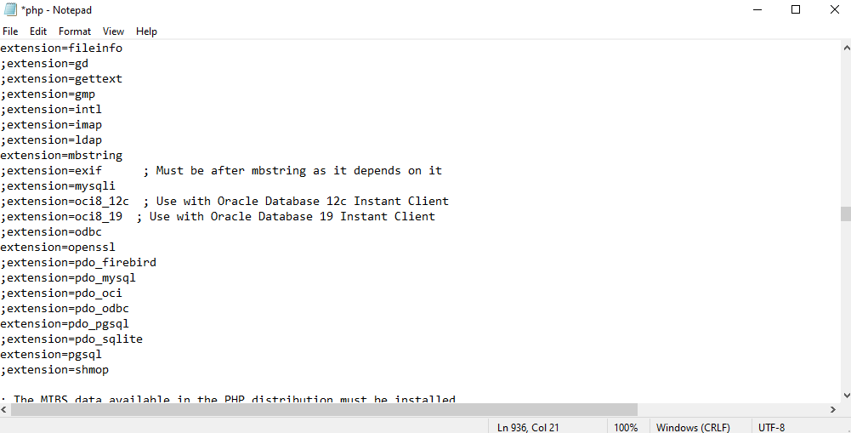

1. Make sure u do php artisan key:generate before generate docker images to use docker encryption if app_key in .env is empty

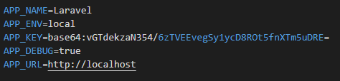

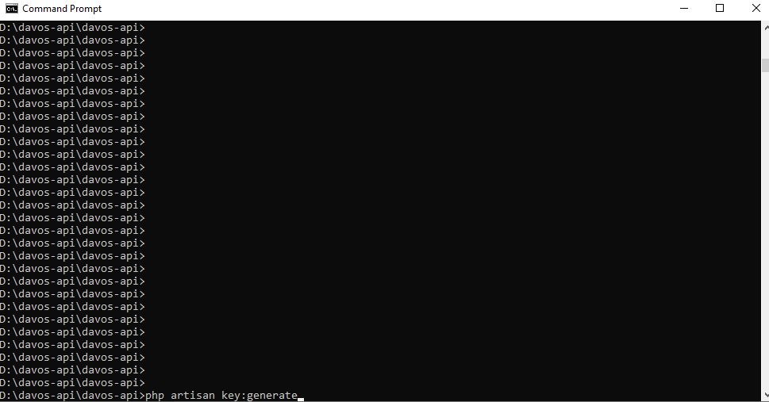

1. Make sure u do php artisan passport:keys before generate docker images for oauth keys and access client creation, If not error personal access client not found please create one will occur

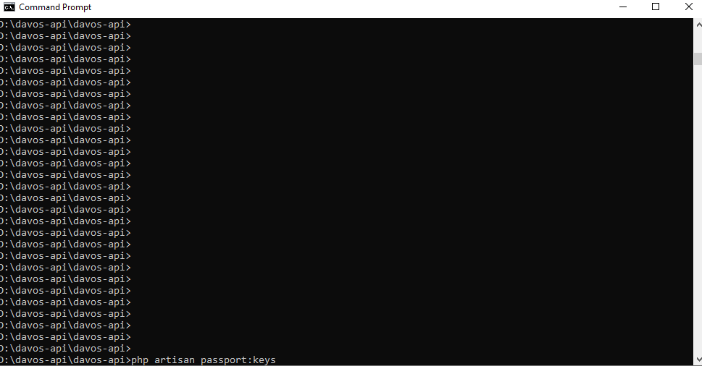

1. Run Docker Compose Up (Make sure u download docker:[Home - Docker](https://www.docker.com/))

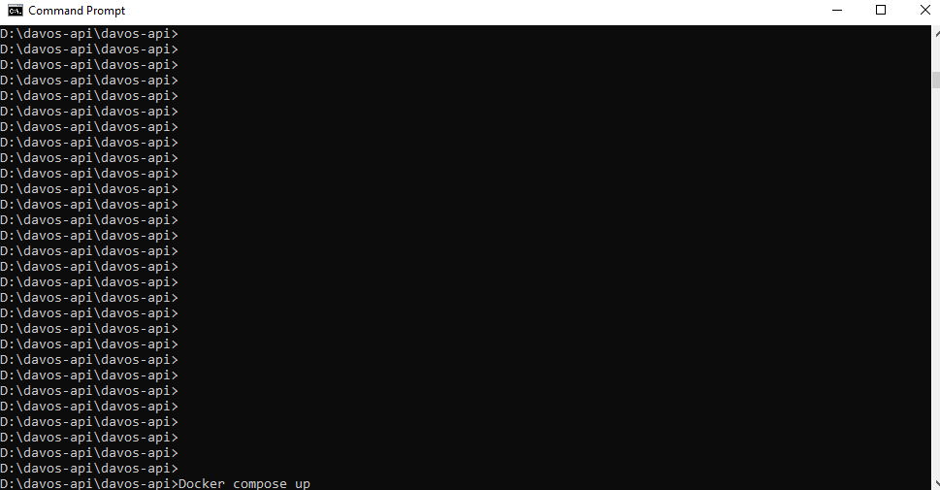

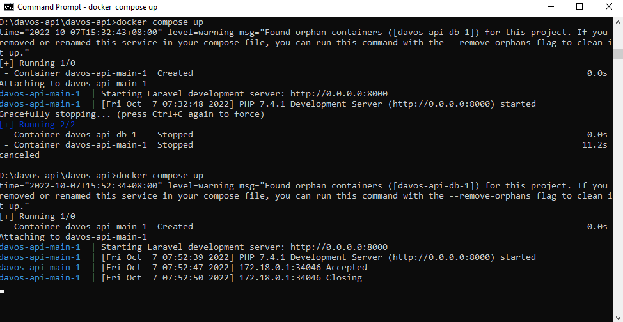

To Run through the api

In my Case I use Postman to do testing, but Curl is viable as well (host: host.docker.internal:8000)

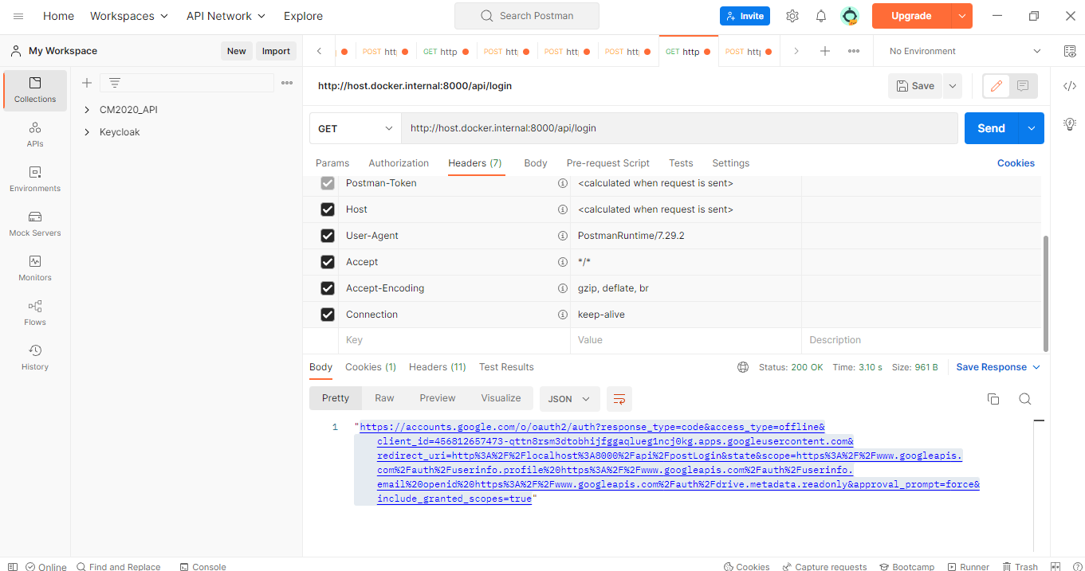

Curl

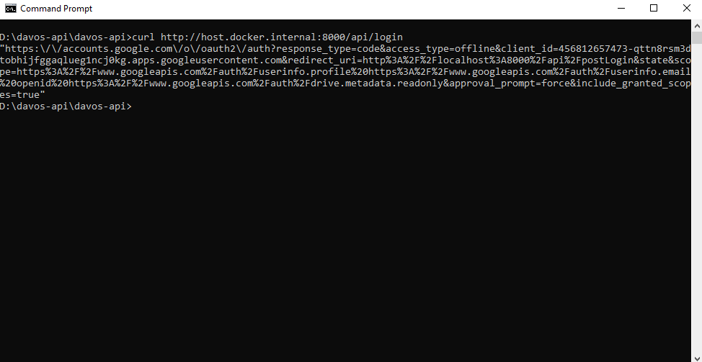

1. Copy url returned from <http://host.docker.internal:8000/api/login>

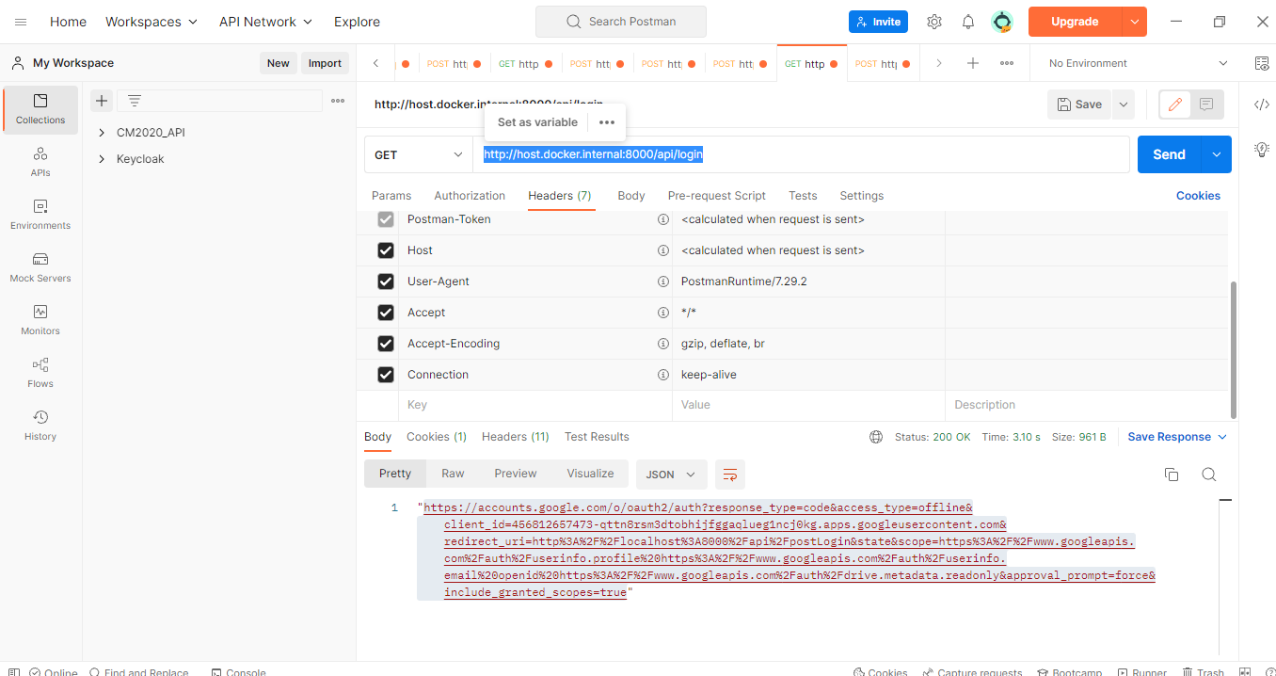

1. Open In browser to do login

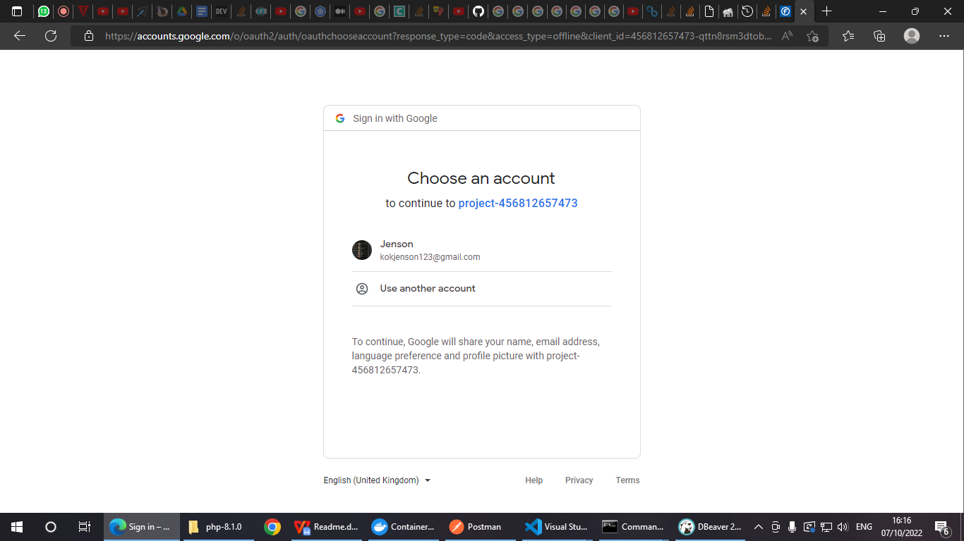

1. Go To Project-****(unsafe)

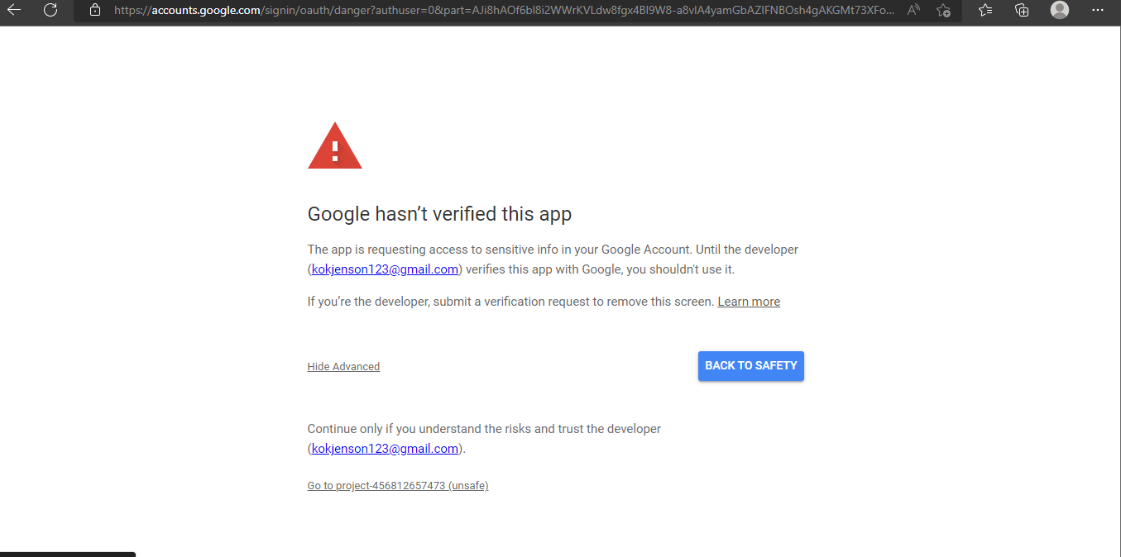

1. Then it will return the access token, Copy it and Put into request header: Authorization = Bearer Access_Token. To Access API

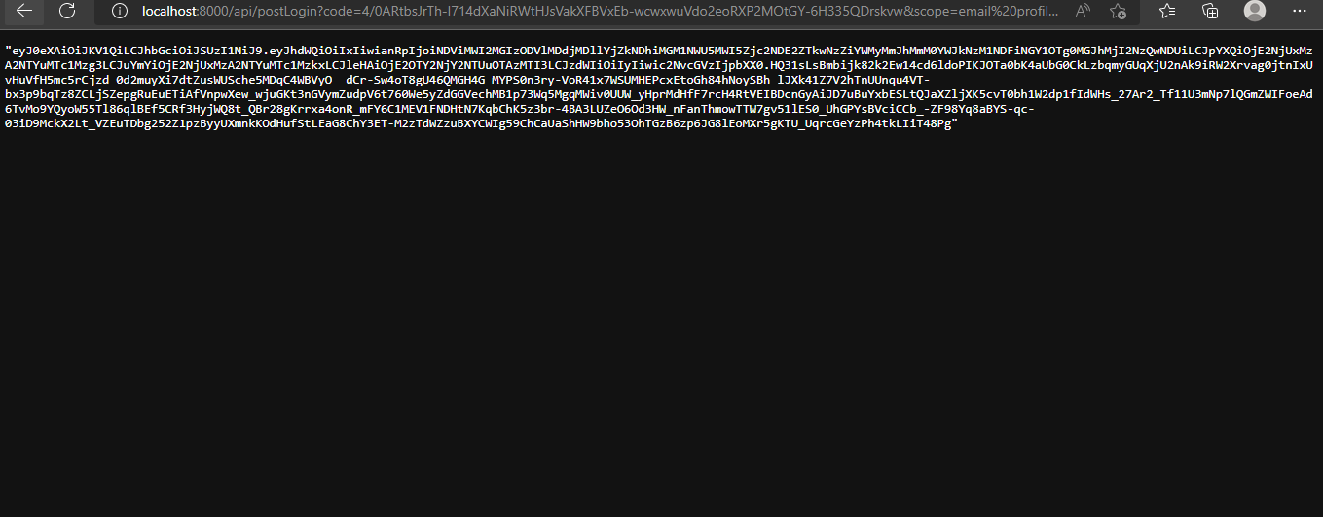

1. If you did not put request api with access token, It will return unauthenticated exceptions

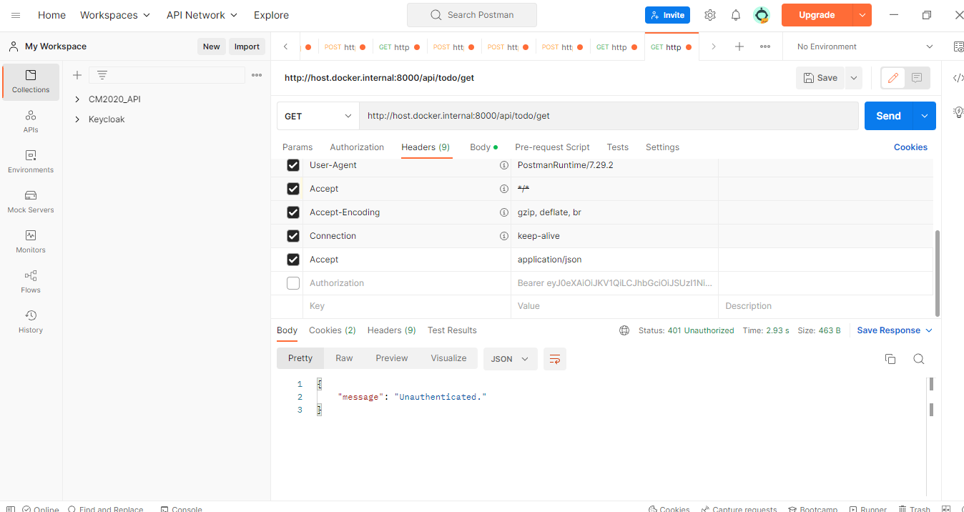

1. Get all todo item

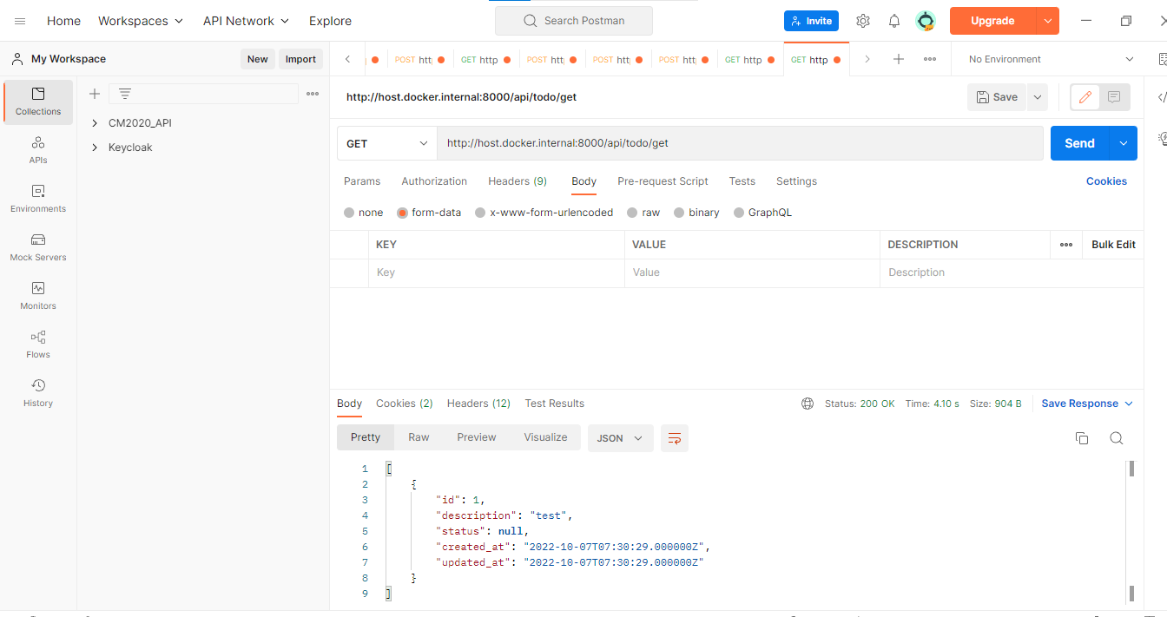

1. Add a todo item

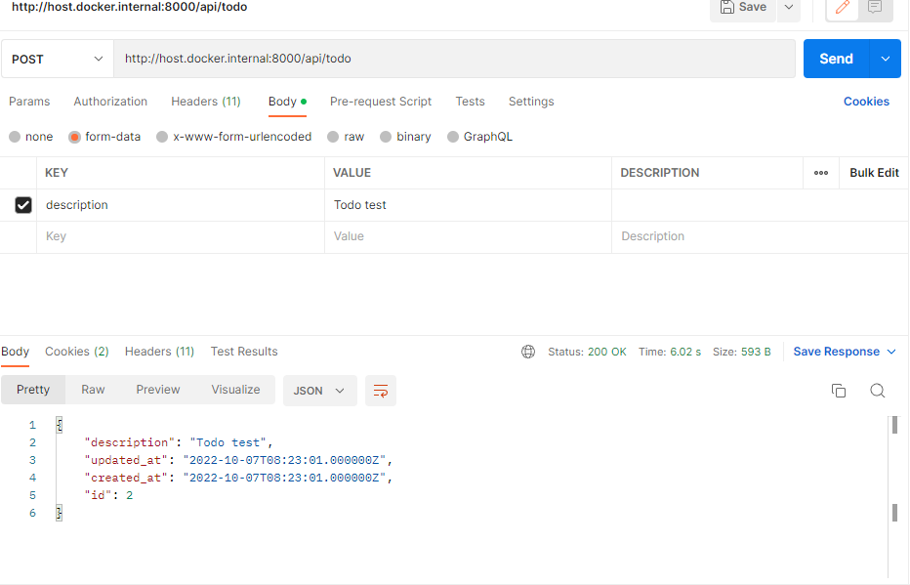

1. Mark Todo Item to complete

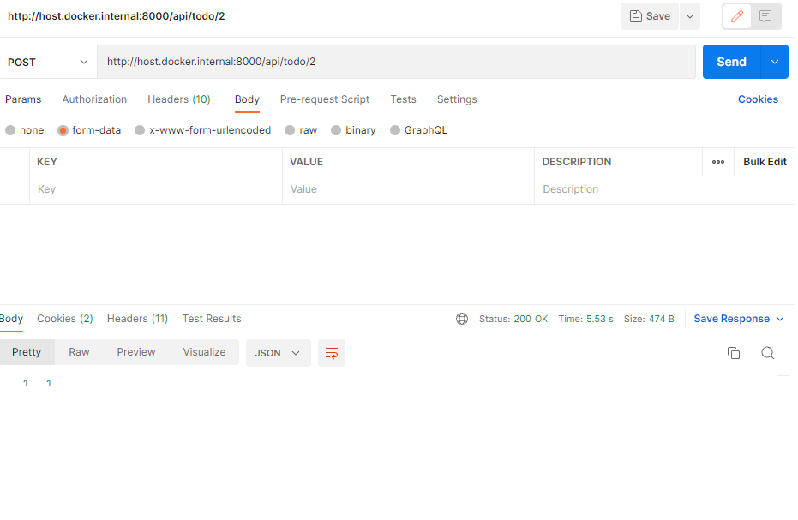

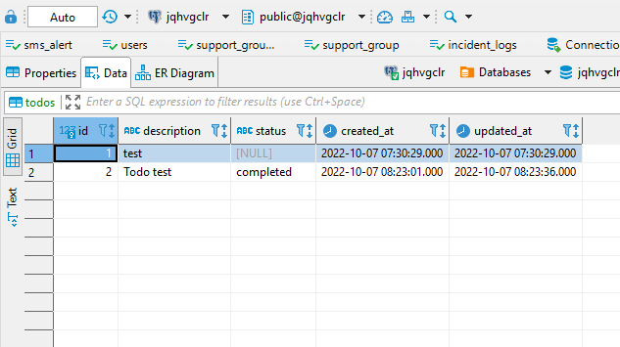

1. Delete todo item

