Master:

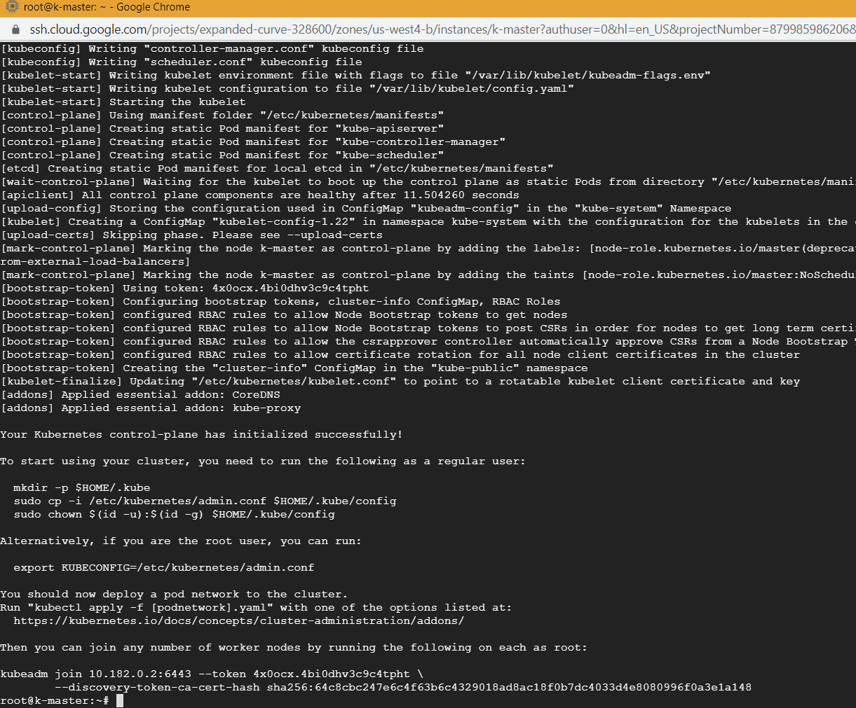

To start using your cluster, you need to run the following as a regular user:

mkdir -p $HOME/.kube

sudo cp -i /etc/kubernetes/admin.conf $HOME/.kube/config

sudo chown $(id -u):$(id -g) $HOME/.kube/config

Alternatively, if you are the root user, you can run:

export KUBECONFIG=/etc/kubernetes/admin.conf

You should now deploy a pod network to the cluster.

Run "kubectl apply -f [podnetwork].yaml" with one of the options listed at:

https://kubernetes.io/docs/concepts/cluster-administration/addons/

Then you can join any number of worker nodes by running the following on each as root:

kubeadm join 10.182.0.2:6443 --token 4x0ocx.4bi0dhv3c9c4tpht \

--discovery-token-ca-cert-hash sha256:64c8cbc247e6c4f63b6c4329018ad8ac18f0b7dc4033d4e8080996f0a3e1a148

Node 1:

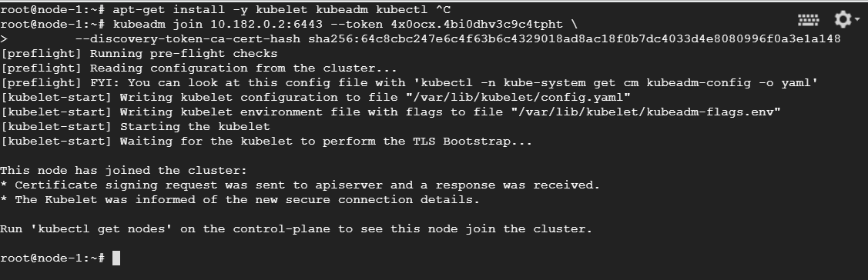

Node -2

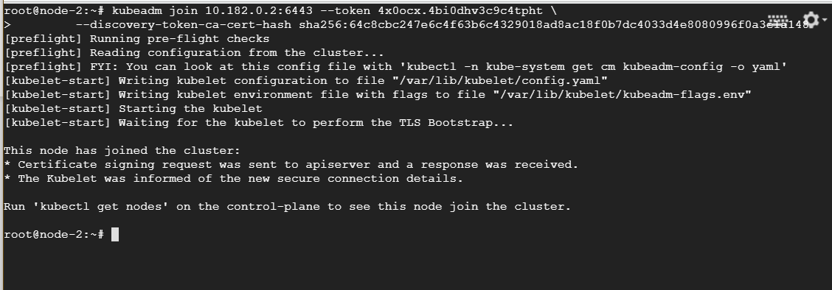

Generate Token later:

