Lab 1: ClusterIP

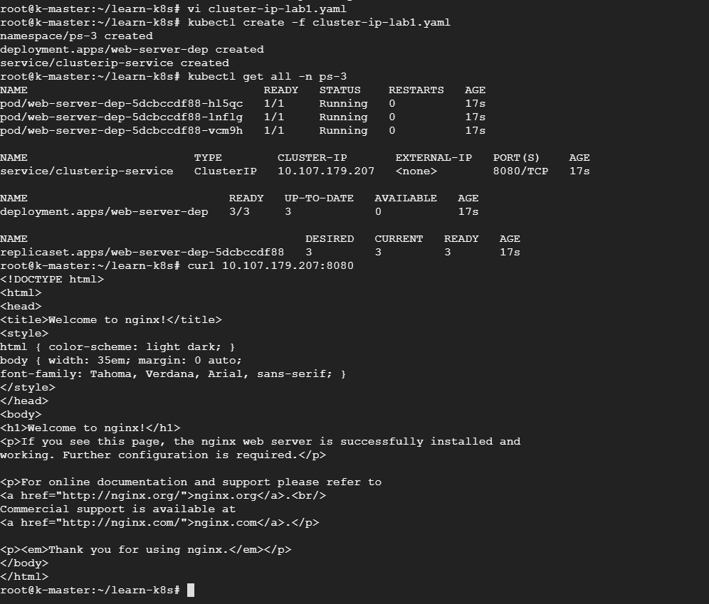

apiVersion: v1

kind: Namespace

metadata:

  name: ps-3

spec: {}

status: {}

---

apiVersion: apps/v1

kind: Deployment

metadata:

  name: web-server-dep

  namespace: ps-3

  labels:

    type: web-server-dep

spec:

  minReadySeconds: 20

  strategy:

    rollingUpdate:

      maxSurge: 1

      maxUnavailable: 1

  selector:

    matchLabels:

      type: web-server

  template:

    metadata:

      labels:

        type: web-server

    spec:

      containers:

        - name: nginx-server

          image: nginx

          ports:

            - containerPort: 80

  replicas: 3

status:

  replicas: 3

---

apiVersion: v1

kind: Service

metadata:

  name: clusterip-service

  namespace: ps-3

  labels:

    type: web-server-svc

spec:

  ports:

    - port: 8080

      protocol: TCP

      targetPort: 80

      #nodePort: 30010 ; its not valid for cluster ip

  selector:

    type: web-server

  #type: NodePort  ;default type is ClusterIP

status:

  loadBalancer: {}

Lab 2: Load Balancer:

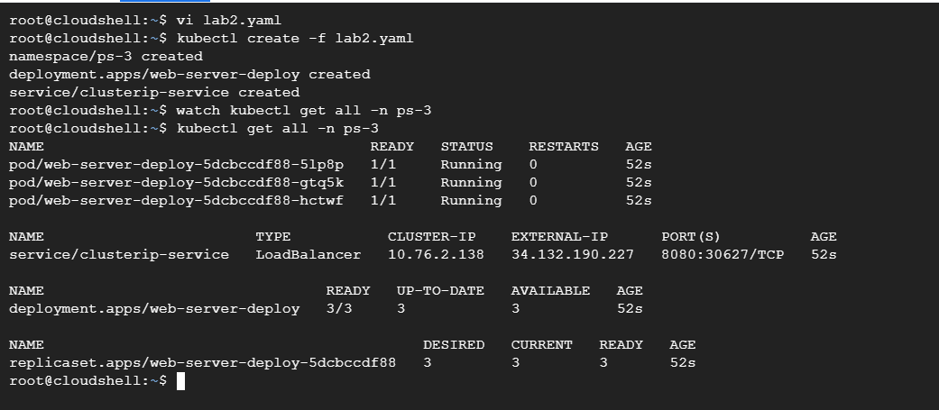

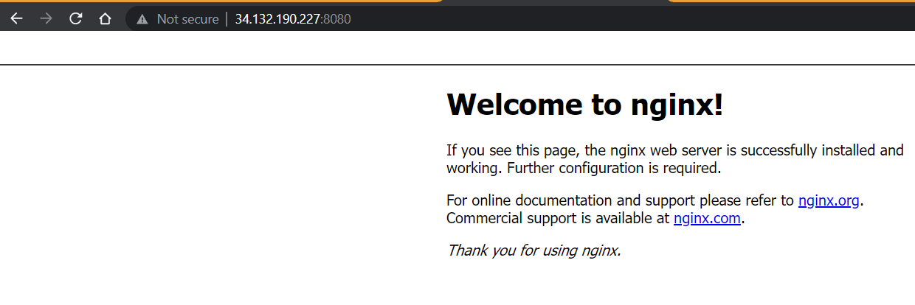

apiVersion: v1

kind: Namespace

metadata:

  name: ps-3

spec: {}

status: {}

---

apiVersion: apps/v1

kind: Deployment

metadata:

  name: web-server-deploy

  namespace: ps-3

  labels:

    type: web-server-deploy

spec:

  replicas: 3

  selector:

    matchLabels:

      type: web-server

  template:

    metadata:

      labels:

        type: web-server

    spec:

      containers:

        - name: nginx-server

          image: nginx

          ports:

            - containerPort: 80

status:

  replicas: 3

---

apiVersion: v1

kind: Service

metadata:

  name: clusterip-service

  namespace: ps-3

  labels:

    type: web-server-svc

spec:

  ports:

    - port: 8080

      protocol: TCP

      targetPort: 80

  selector:

    type: web-server

  type: LoadBalancer

Lab 3- node port:

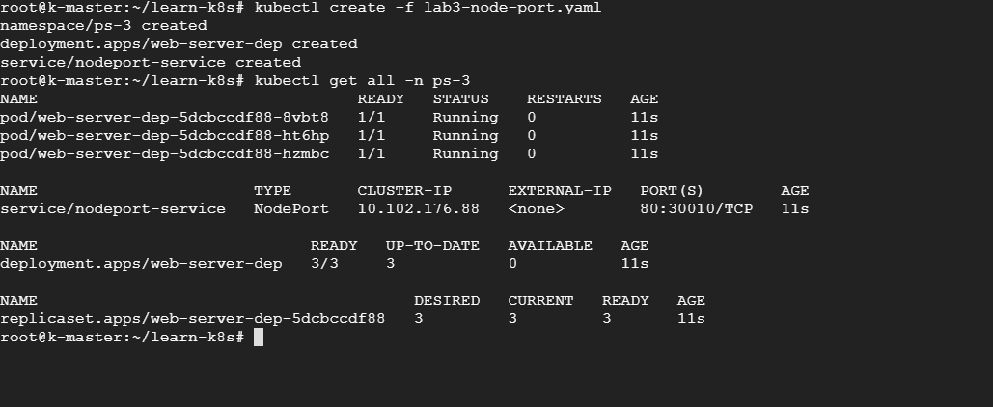

apiVersion: v1

kind: Namespace

metadata:

  name: ps-3

spec: {}

status: {}

---

apiVersion: apps/v1

kind: Deployment

metadata:

  name: web-server-dep

  namespace: ps-3

  labels:

    type: web-server-dep

spec:

  minReadySeconds: 20

  strategy:

    rollingUpdate:

      maxSurge: 1

      maxUnavailable: 1

  selector:

    matchLabels:

      type: web-server

  template:

    metadata:

      labels:

        type: web-server

    spec:

      containers:

        - name: nginx-server

          image: nginx

          ports:

            - containerPort: 80

  replicas: 3

status:

  replicas: 3

---

apiVersion: v1

kind: Service

metadata:

  name: nodeport-service

  namespace: ps-3

  labels:

    type: web-server-svc

spec:

  ports:

    - port: 80

      protocol: TCP

      #targetPort: 80

      nodePort: 30010

  selector:

    type: web-server

  type: NodePort

status:

  loadBalancer: {}

Lab 4: Ingress

apiVersion: networking.k8s.io/v1

kind: Ingress

metadata:

  name: website-ingress

spec:

  rules:

  - host: "website.com"

    http:

      paths:

      - pathType: Prefix

        path: "/backend"

        backend:

          service:

            name: backend-service

            port:

              number: 443

  - host: "website.com"

    http:

      paths:

      - pathType: Prefix

        path: "/test"

        backend:

          service:

            name: test-service

            port:

              number: 8000

  - host: "website.com"

    http:

      paths:

      - pathType: Prefix

        path: "/"

        backend:

          service:

            name: default-service

            port:

              number: 80

