Lab 1:

apiVersion: v1

kind: Pod

metadata:

  name: web-pod

  labels:

    Teir: Web

spec:

  containers:

    - name: web-pod

      image: nginx

      resources: {}

  restartPolicy: Always

status: {}

---

apiVersion: v1

kind: Pod

metadata:

  name: app-pod

  labels:

    Teir: App

spec:

  containers:

    - name: app-pod

      image: nginx

      resources: {}

  restartPolicy: Always

status: {}

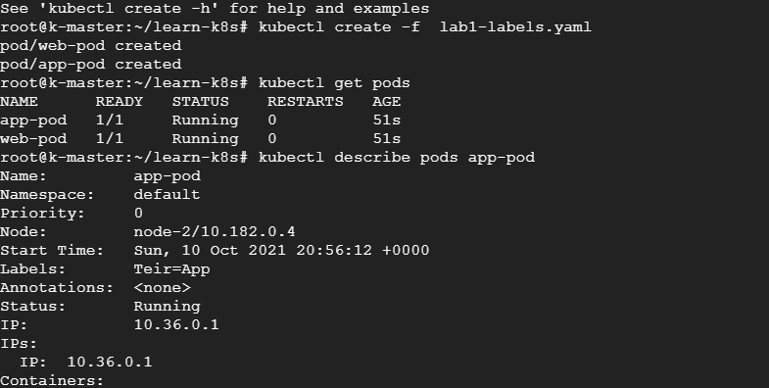

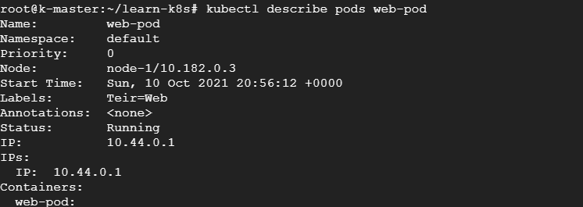

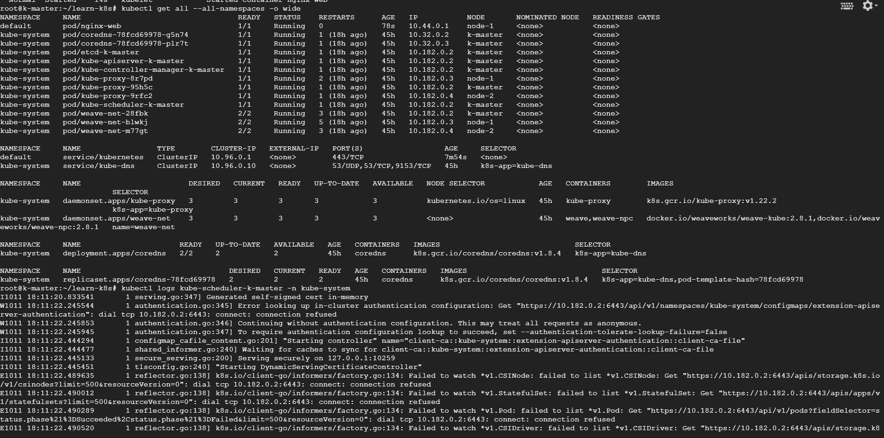

LAB 2

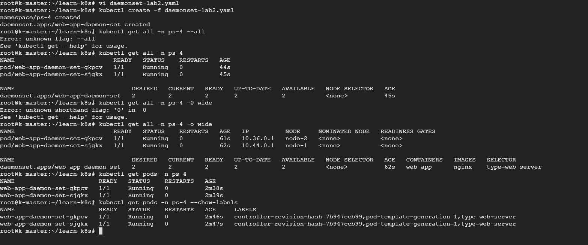

apiVersion: v1

kind: Namespace

metadata:

  name: ps-4

---

apiVersion: apps/v1

kind: DaemonSet

metadata:

  name: web-app-daemon-set

  namespace: ps-4

  labels:

    type: web-server-ds

spec:

  selector:

    matchLabels:

      type: web-server

  template:

    metadata:

      name: web-app

      namespace: ps-4

      labels:

        type: web-server

    spec:

      containers:

        - name: web-app

          image: nginx

          # ports:

          #   - containerPort: 80

          resources:

            limits:

              memory: 200Mi

            requests:

              memory: 100Mi

Lab3

apiVersion: v1

kind: Namespace

metadata:

  name: tenant-b-100mi

spec: {}

status: {}

---

apiVersion: v1

kind: ResourceQuota

metadata:

  name: tenant-b-100mi

  namespace: tenant-b-100mi

spec:

  hard:

    requests.memory: 100Mi

    # limits.memory: 100Mi

---

apiVersion: v1

kind: Pod

metadata:

  name: tenant-b-100mi

  namespace: tenant-b-100mi

spec:

  containers:

    - name: tenant-b-100mi

      image: nginx

      resources:

        limits:

          # memory: "150Mi"

        requests:

          memory: "150Mi"

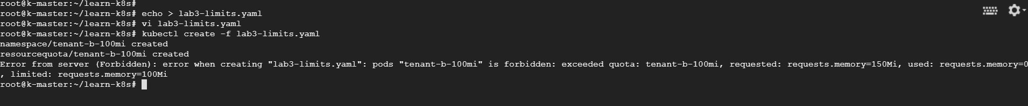

Lab 4

**As suggested left due to issue in Kubernetes official image.**

Lab 5— Static pods

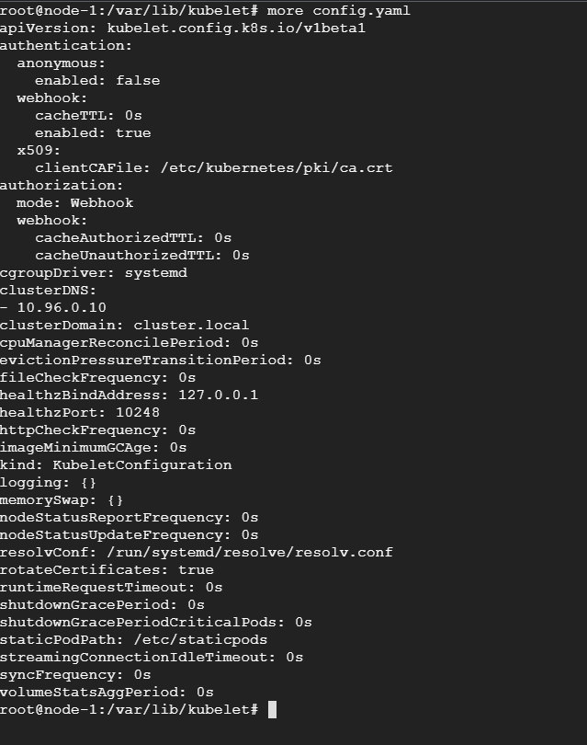

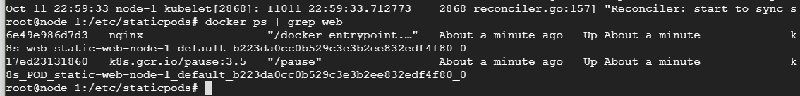

Lab 6

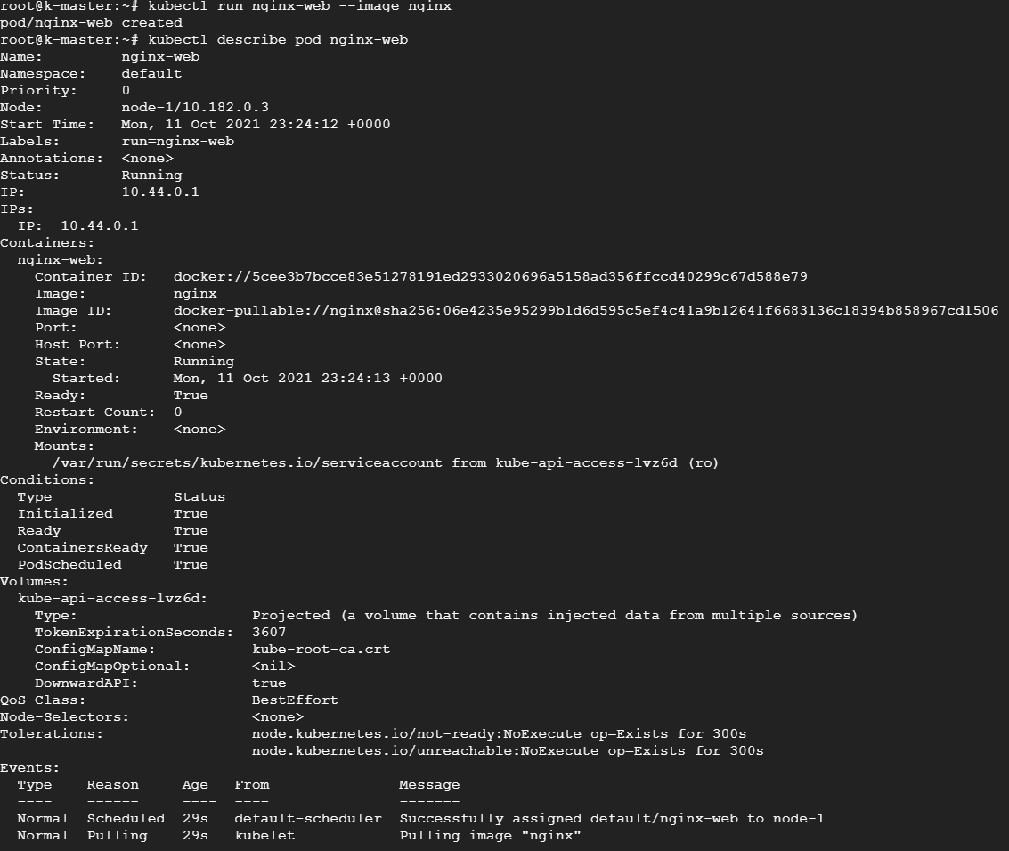

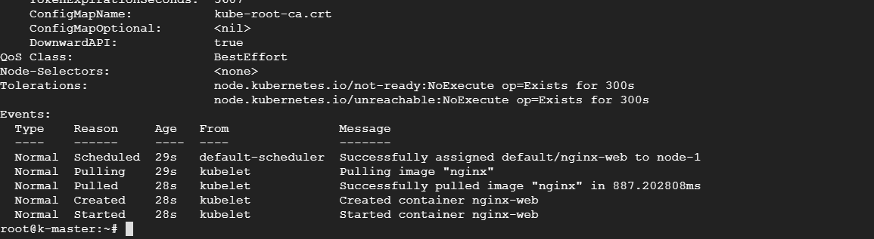



Lab 7:

