Lab 1:

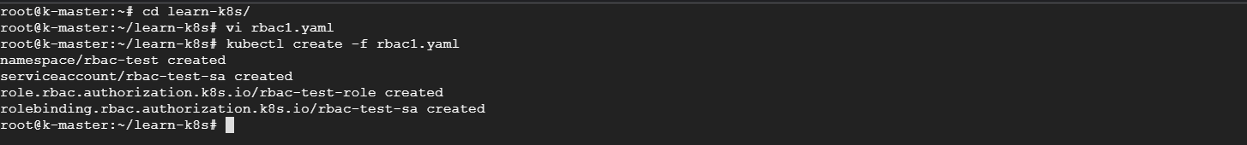



apiVersion: v1

kind: Namespace

metadata:

  name: rbac-test

---

apiVersion: v1

kind: ServiceAccount

metadata:

  name: rbac-test-sa

  namespace: rbac-test

---

apiVersion: rbac.authorization.k8s.io/v1

kind: ClusterRole

metadata:

  name: rbac-test-role

rules:

  - verbs:

      - get

      - watch

      - list

    apiGroups:

      - ""

    resources:

      - pods

---

apiVersion: rbac.authorization.k8s.io/v1

kind: ClusterRoleBinding

metadata:

  name: rbac-test-crb

roleRef:

  apiGroup: rbac.authorization.k8s.io

  kind: ClusterRole

  name: rbac-test-role

subjects:

  - kind: ServiceAccount

    name: rbac-test-sa

    namespace: rbac-test

---

apiVersion: v1

kind: Pod

metadata:

  name: test-pod

  labels:

    run: nginx

spec:

  serviceAccountName: rbac-test-sa

  securityContext:

    runAsUser: 900

  containers:

    - name: test-pod-c

      image: nginx

      resources: {}

  dnsPolicy: ClusterFirst

  restartPolicy: Always

Lab2:

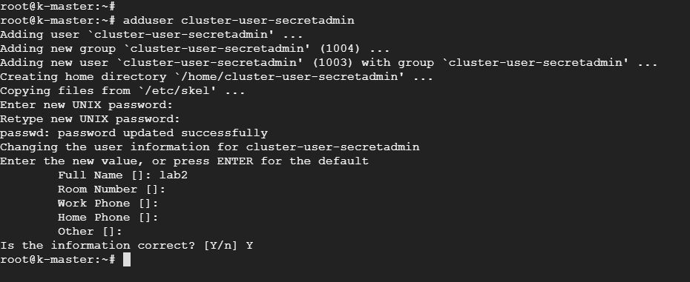

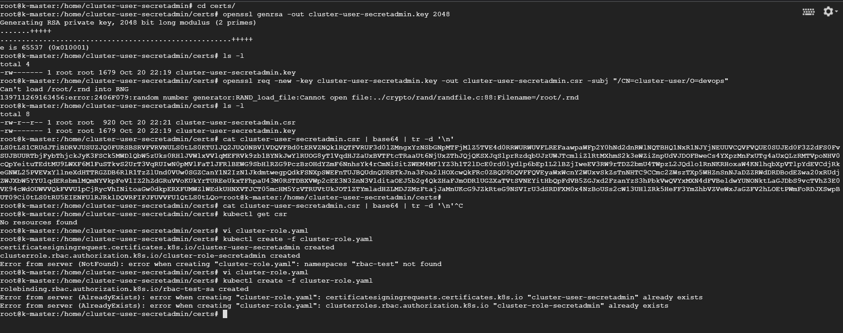

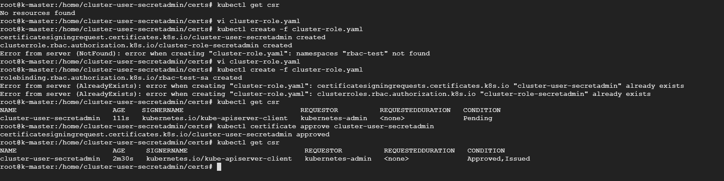



Lab 3:

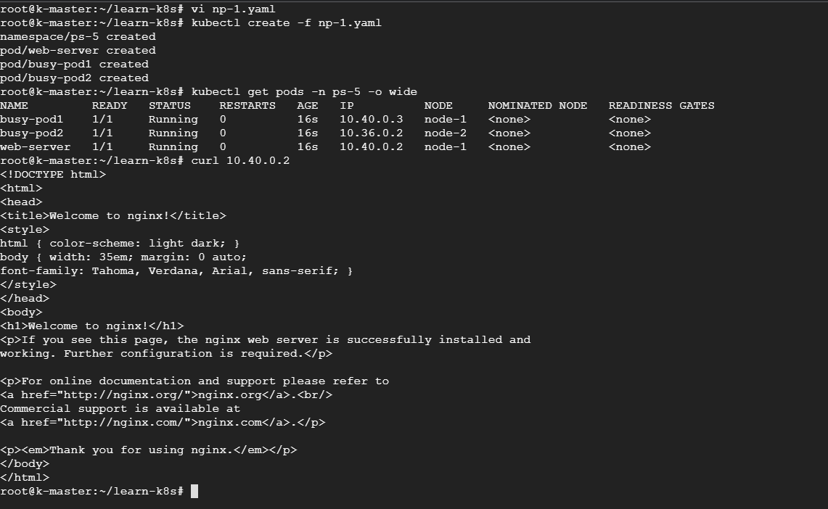

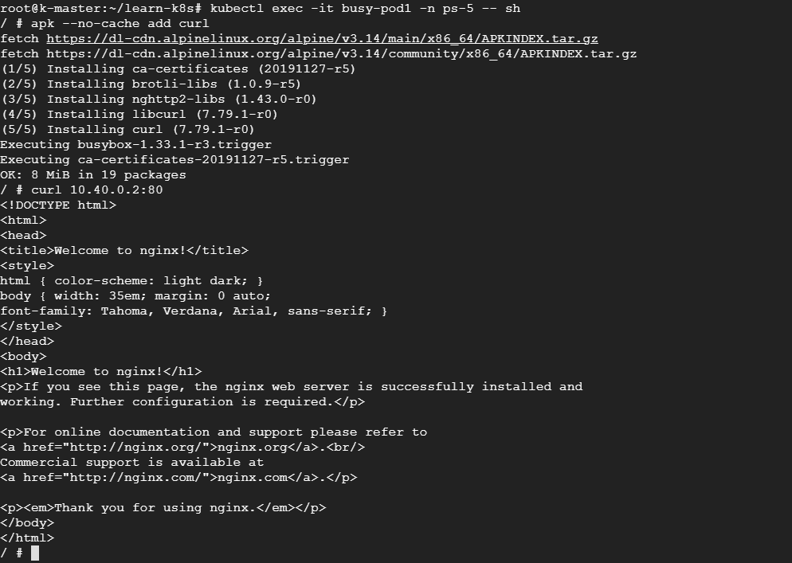

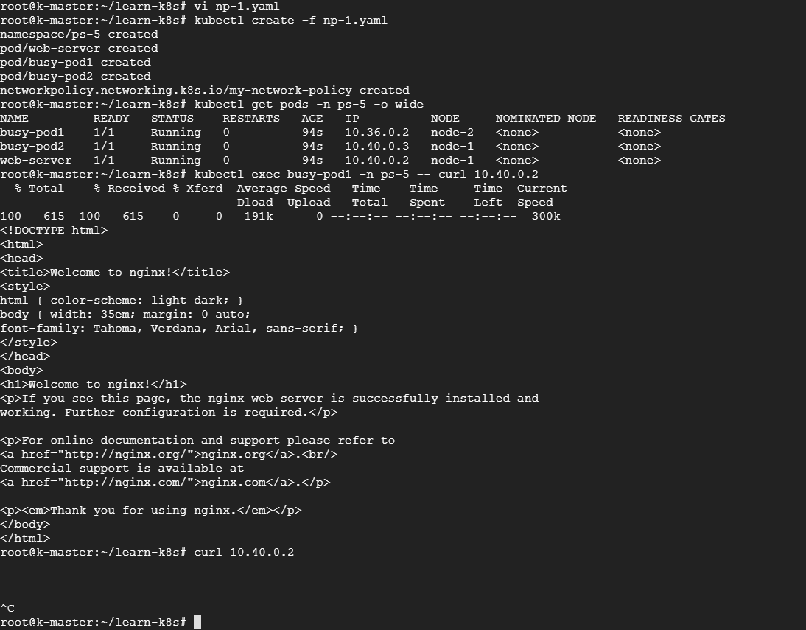

Lab 4:

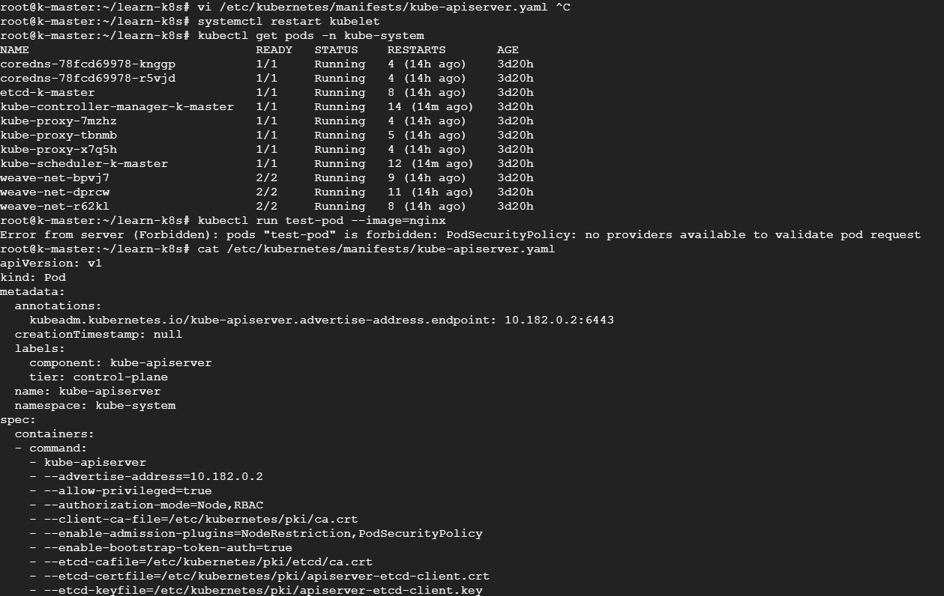

Lab 5:

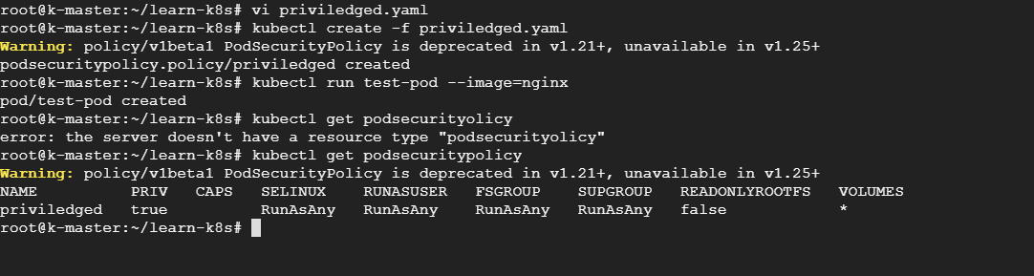

apiVersion: policy/v1beta1

kind: PodSecurityPolicy

metadata:

  name: priviledged

spec:

  fsGroup:

    rule: RunAsAny

  runAsUser:

    rule: RunAsAny

  seLinux:

    rule: RunAsAny

  supplementalGroups:

    rule: RunAsAny

  volumes:

    - "\*"

  hostPorts:

    - max: 0

      min: 65535

  privileged: true

  hostNetwork: true

  hostIPC: true

  hostPID: true

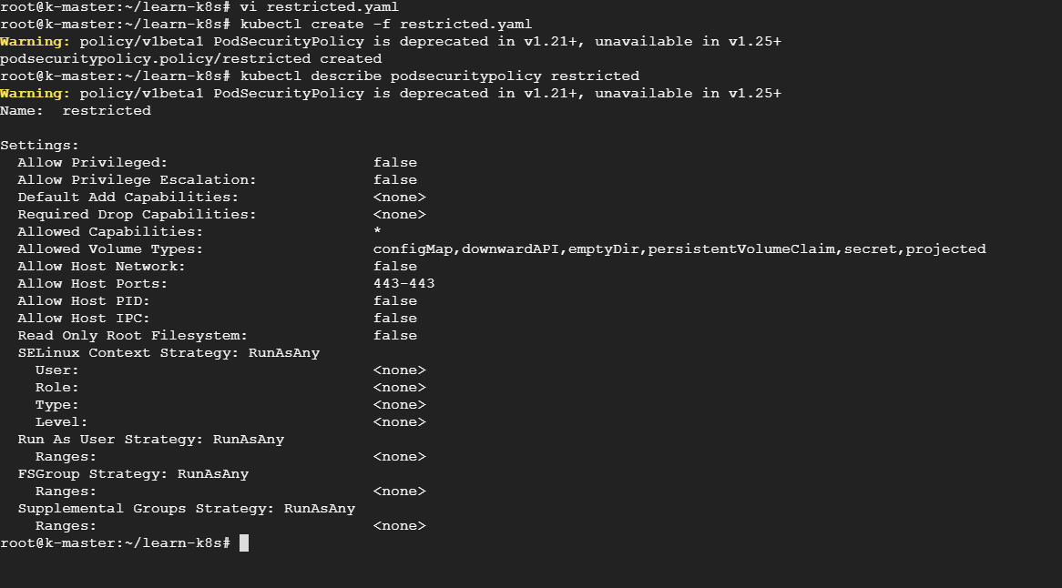

Lab6:

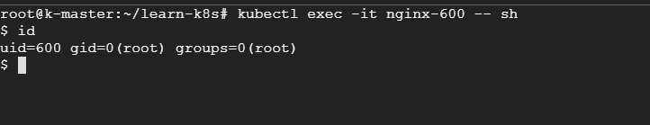

Lab 7:



