Lab 1:

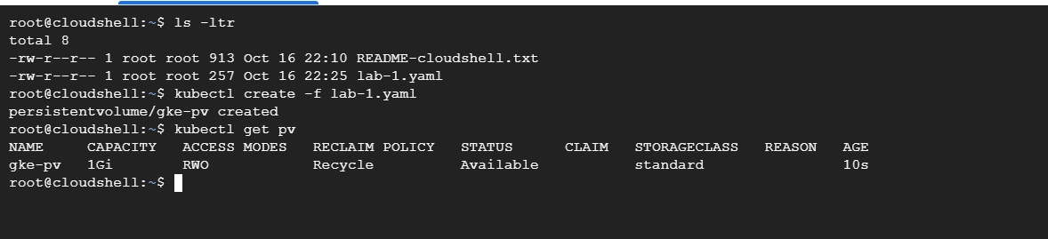

apiVersion: v1

kind: PersistentVolume

metadata:

  name: gke-pv

  namespace: ps-8

spec:

  storageClassName: standard

  persistentVolumeReclaimPolicy: Recycle

  accessModes:

    - "ReadWriteOnce"

  capacity:

    storage: 1Gi

  hostPath:

    path: /tmp/my-pv

Lab -2

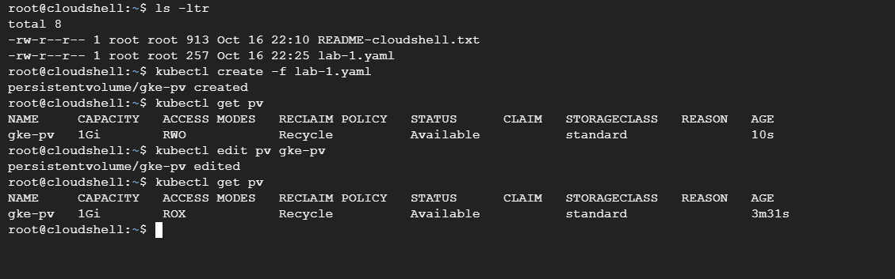

Lab-3

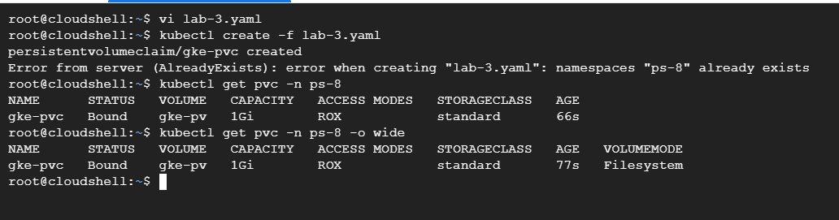

apiVersion: v1

kind: Namespace

metadata:

  name: ps-8

---

apiVersion: v1

kind: PersistentVolumeClaim

metadata:

  name: gke-pvc

  namespace: ps-8

spec:

  storageClassName: standard

  accessModes:

    - ReadOnlyMany

  # volumeName: gke-pv

  resources:

    requests:

      storage: 500Mi

Lab-4:

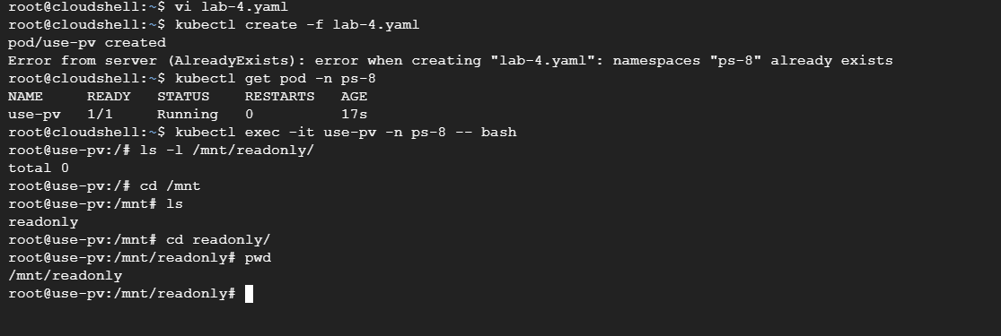

apiVersion: v1

kind: Namespace

metadata:

  name: ps-8

---

apiVersion: v1

kind: Pod

metadata:

  name: use-pv

  namespace: ps-8

spec:

  containers:

    - name: pv-pod

      image: nginx

      volumeMounts:

        - mountPath: /mnt/readonly

          name: gke-pv

  volumes:

    - name: gke-pv

      persistentVolumeClaim:

        claimName: gke-pvc