1. I have used **Angular framework** – For the entire front end spectrum,
2. **Bootstrap 4** – For the UI part of the app and bootstrap-components for sliding image carousel,
3. **Ng-Bootstrap(Angular powered bootstrap components)** – For autocomplete search bar
4. **JQuery** – For modifying and changing the pagination and also for working with bootstrap components.
5. **simplePagination** – For pagination listing
6. **anime.js** – For line drawing of the svg image

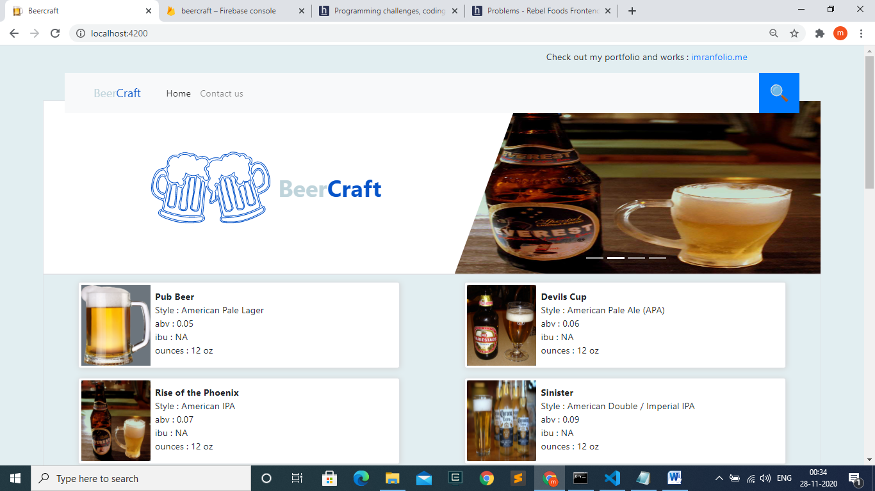

1. The above image shows the front home page of the website with svg image of the beermugs which is animated using **anime.js**  and the sliding image is done using the components from **bootstrap** library.
2. The beer details are listed as horizontal cards as pairs for large screen and single card for small screens. The horizontal card contains the **abv, ibu, ounces, style** and **name**  of the beers

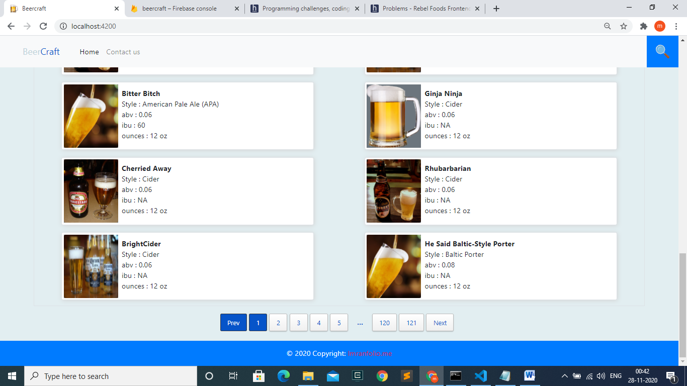

1. The above image shows, the paginations to view all the beers, **as mentioned I have listed 20 cards per page.**  All the page contains 20 lists, except the ending which contains 10 lists **(due to 2410 lists).**
2. Also **as mentioned**, have added the fetched **5 images repeatedly** in the lists.
3. On the top of the page, the header present contains a **search icon,** which on clicking opens a popup modal; which contains the search bar(shown in the below image).

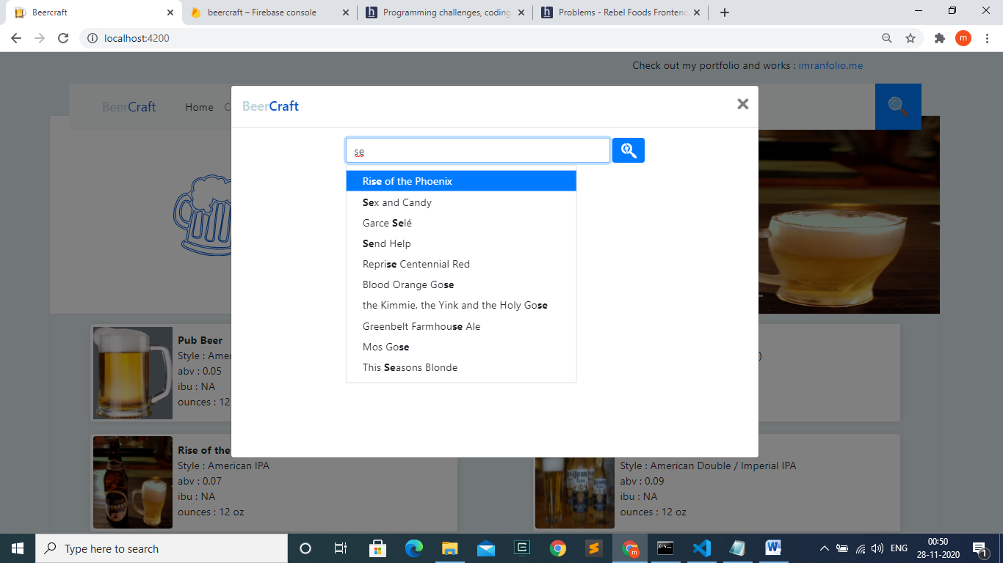

1. This search bar is designed using the **ng-bootstrap** component and on clicking the search icon after selecting the beer name; the respective beer details appears as card.(shown below)

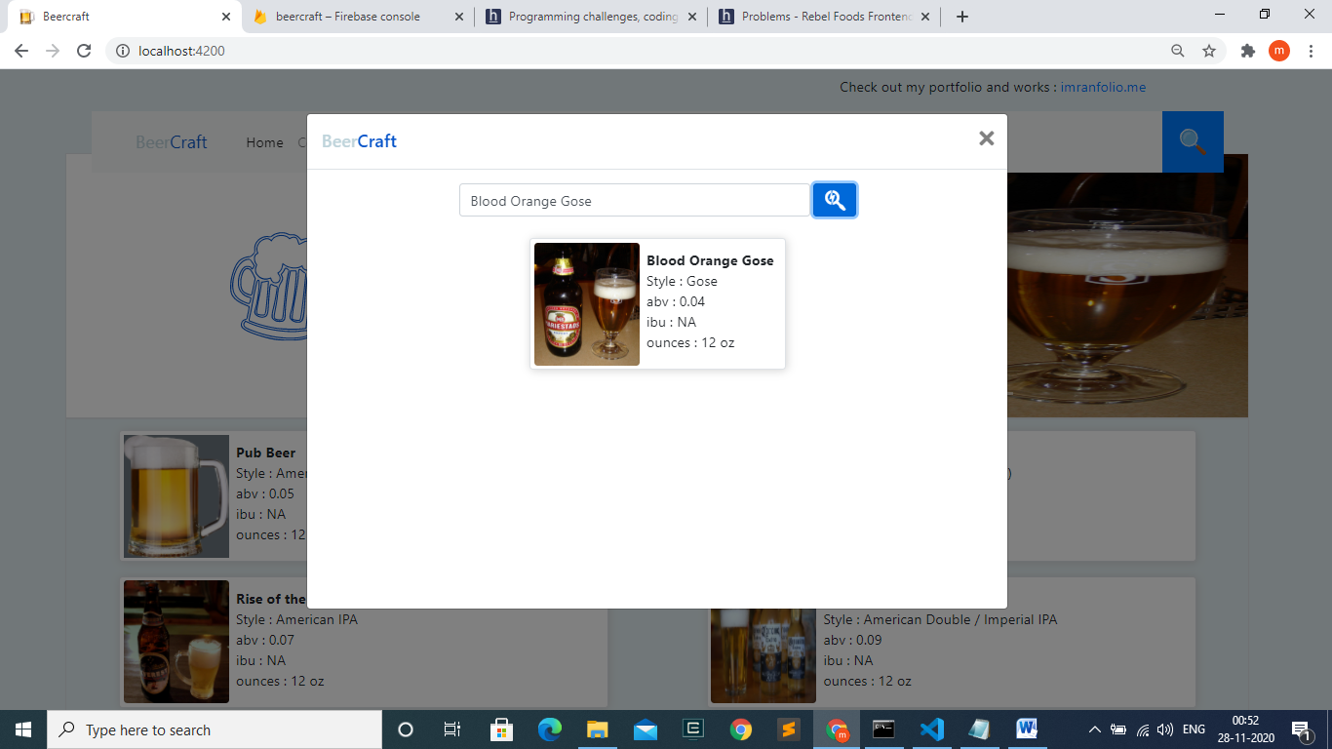

1. Packages to be included

**Install nodejs in the command prompt to run this commands and also add the ANGULAR CLI MODULES; because if I compress the app with the modules, it will go beyond the allowed size to submit the work.**

**13.1** **bootstrap**

npm i bootstrap ( provide the path in angular.json)

* 1. **ng-boostrap**

npm i @ng-bootstrap/ng-bootstrap ( provide the path in angular.json)

* 1. **anime js**

npm i animejs

* 1. **JQuery js ( for working with bootstrap components)**

npm i jquery

npm i popper.js@1.14.3

* 1. **For pagination**

Download the files **jquery.simplePagination.js** and **simplePagination.css,** from the link given below and link it to the angular.json files(as shown below)

<http://flaviusmatis.github.io/simplePagination.js/>

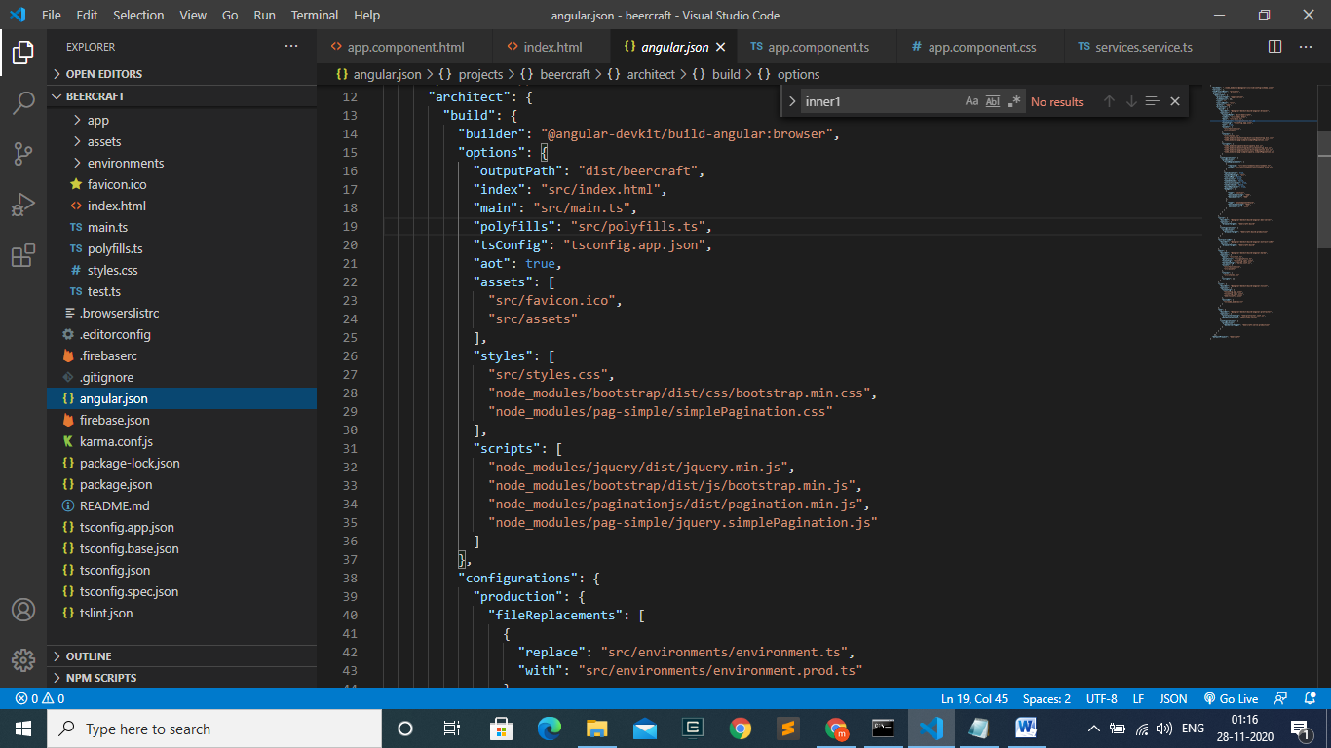

1. I have hosted the webpage in the firebase website

<https://beercraft-b23c8.web.app/>

Do check it out and let me know my review about my work. Do give me a review, because I’m a fresher who needs suggestions to produce better results next time.

Thank you

Yours sincerely,

**Mohammed Imran Z**