1. Front-page

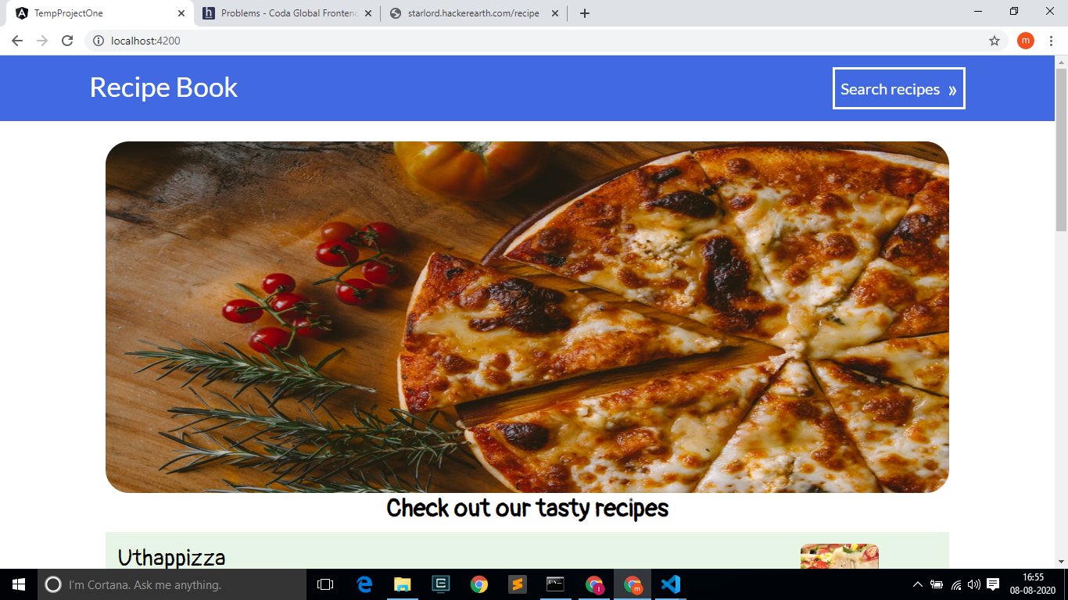

1. Front-page(extended)

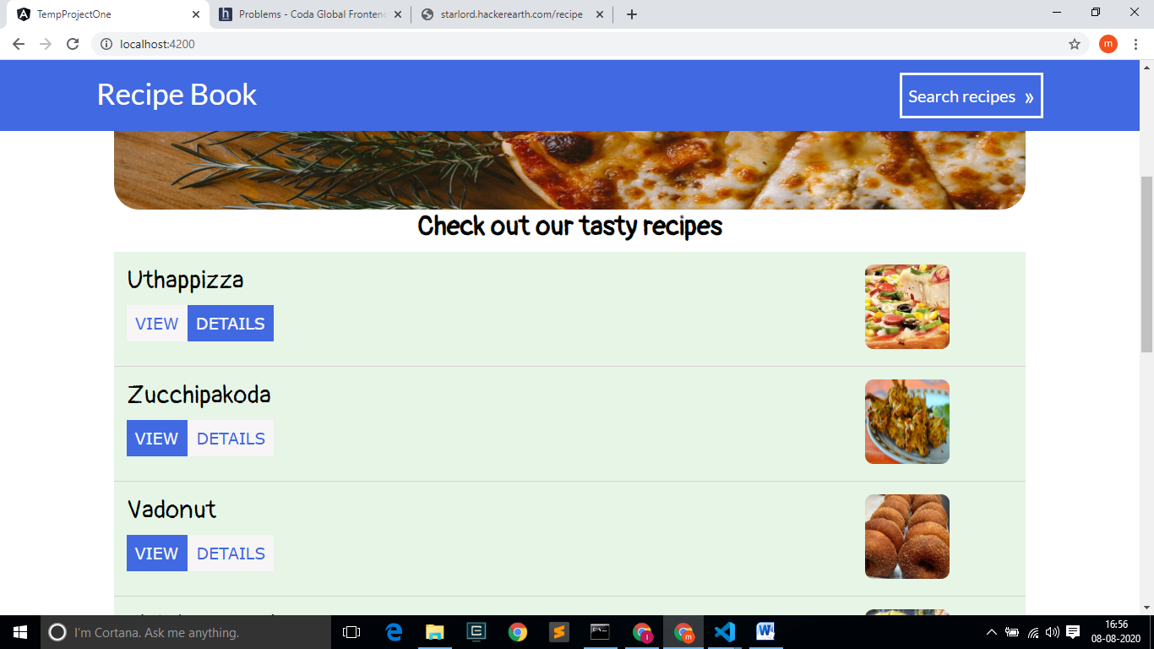

1. On clicking the VIEW DETAILS animated button, the new routing path of RECIPES DETAILS opens as a pop-up for the respective recipe

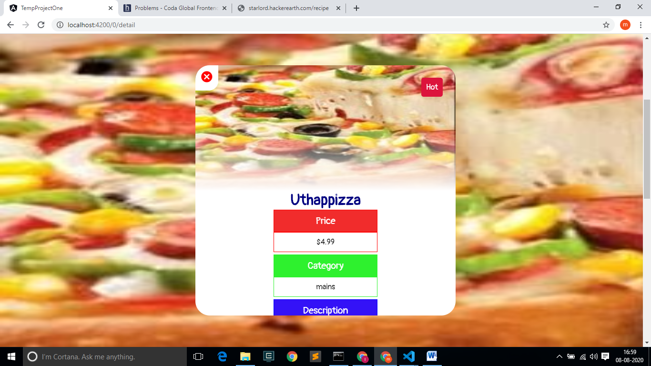

1. Cancel icon is used to navigate back to the home page, and the search button is present in header.

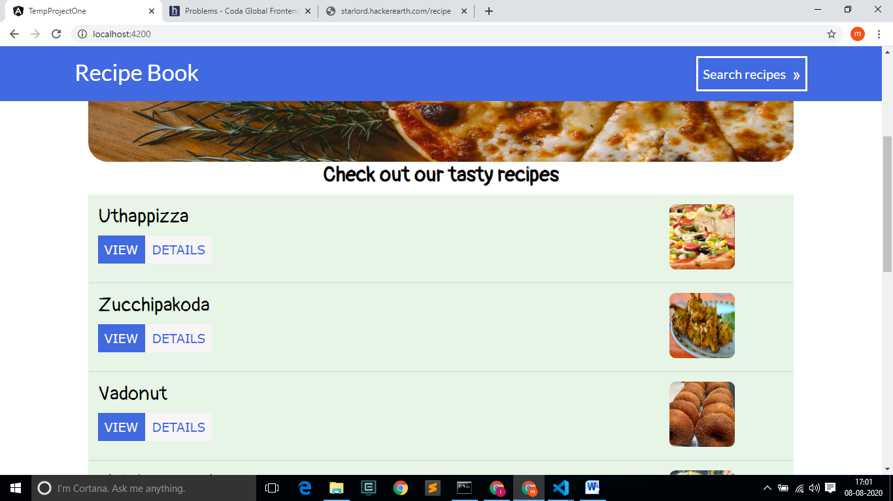

1. On clicking the search recipes button we are navigated to the search page, where the recipes can be searched.

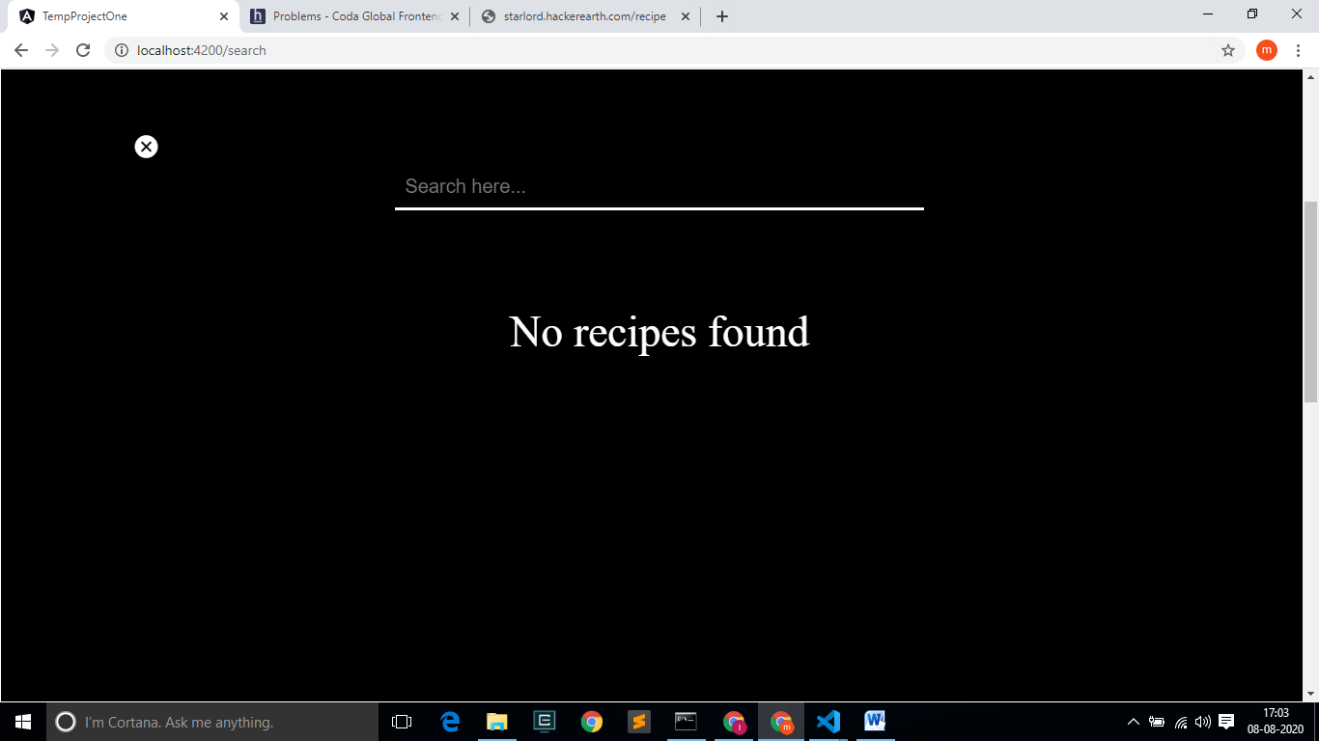

1. On searching the recipe name, the recipes are shown below the search tag, where the recipes listed here in this part are not fetched from API, LOCALSTORAGE concept is used and also a cancel icon is given to go to home page.

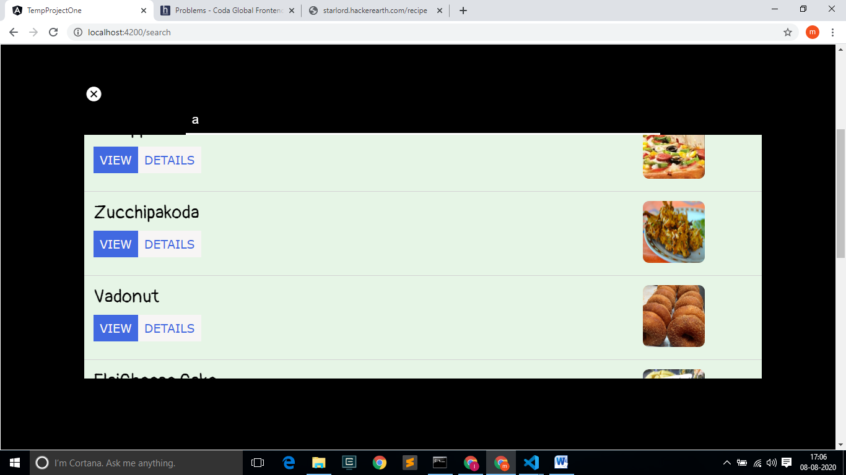

1. On clicking the VIEW DETAILS button the RECIPES DETAIL COMPONENT is again reused in different routing path.

