1. Hosting webpage locally using live server from VScode , used Angular framework to develop the page. Once the page opens it will show all the countries which are fetched from the link <http://starlord.hackerearth.com/TopRamen> provided, then a loader is added to show loading spinner till the response is received.

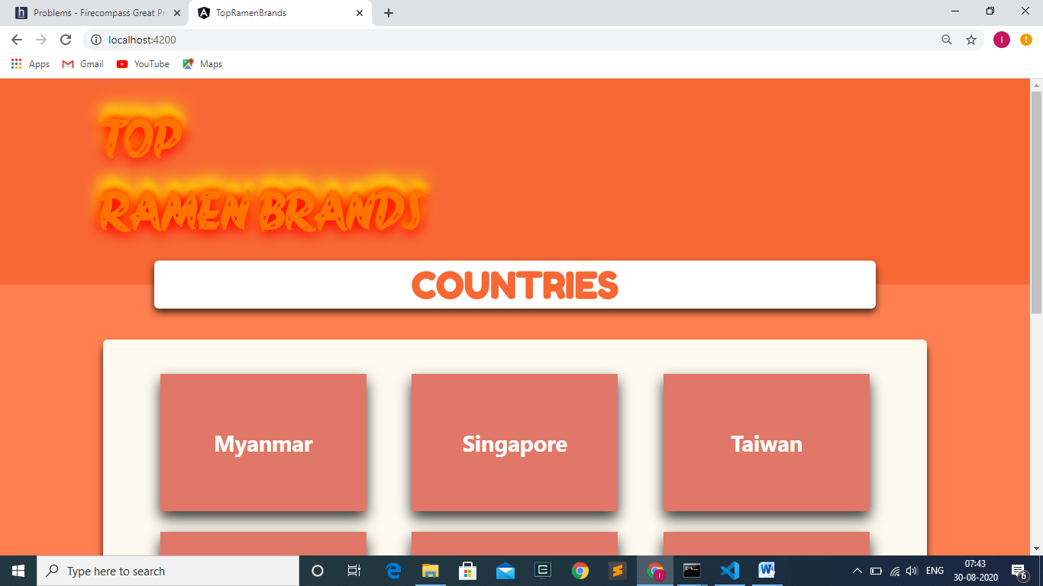

Fig 1

1. As per the instruction the countries are displayed cards (i.e., 3 cards for large screen and singe card for small screen). In addition, each country when hovered opens the card and displays AVERAGE RATING which is calculated by find the average of the stars of the country’s brand. Also REMOVED the DUPLICATE countries by converting the 2-Letter and 3-Letter country codes into a Full Format country code.

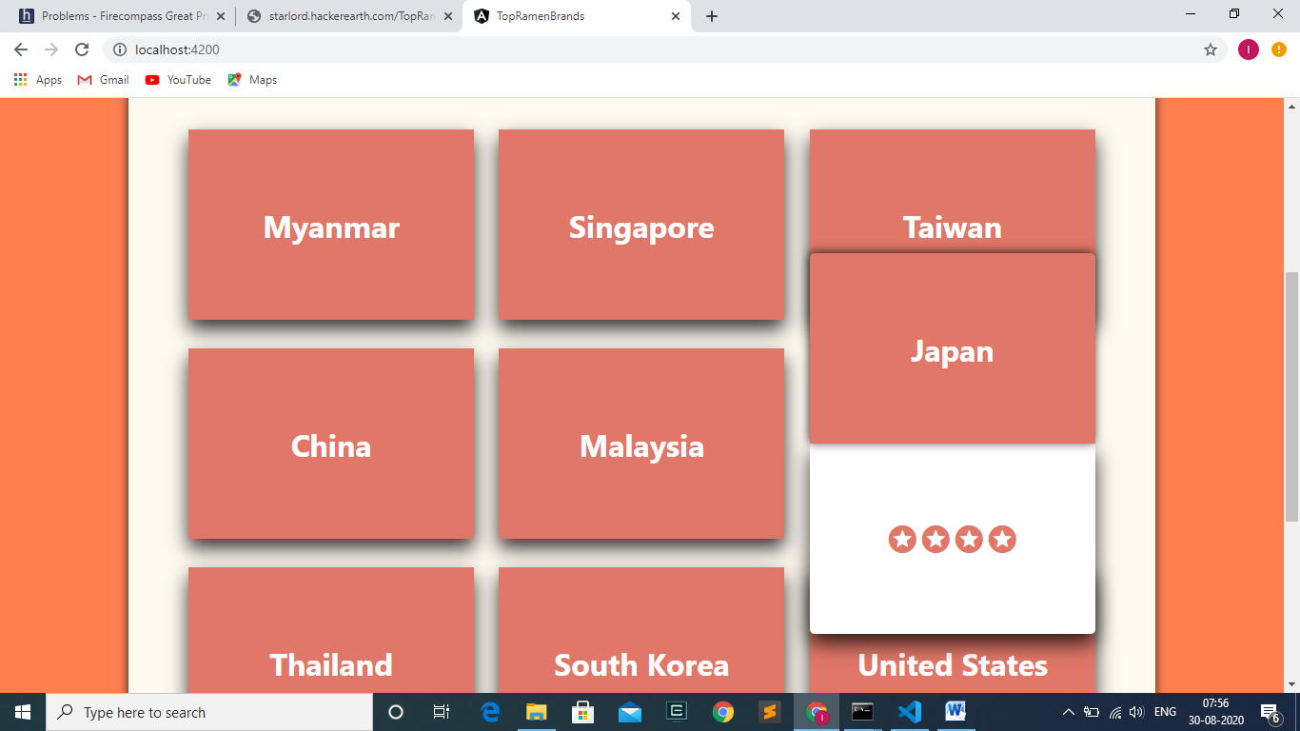

Fig 2

1. Also ERROR is HANDLE, when there is any problem in fetching the data, the error is handle and displayed in the webpage.

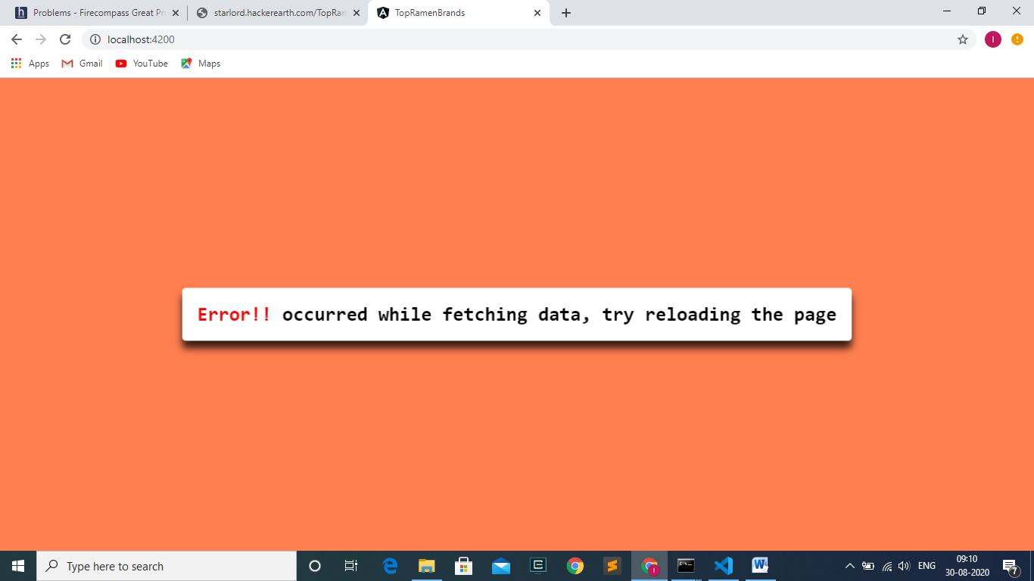

Fig 3

1. When there is no error, the page is displayed as the image shown in Fig 2. On clicking any country displayed on the page, the page is routed to another routing path ( OR another page); Where the brands of the specific country is displayed based on the years. Each year consists of the brands in TOP-TEN ORDER. If the data fetched doesn’t comprises year value, for that data consider the year as NA ( Not Available). Similarly for Rank, Stars and Style data.
   1. Brands under Year 2016.

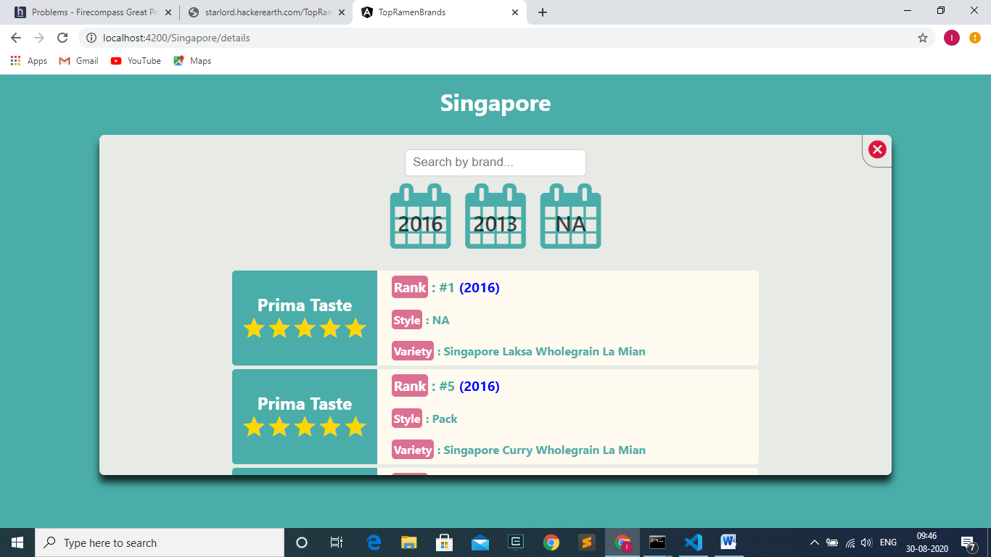

Fig 4

4.2 Brands under Year 2013.

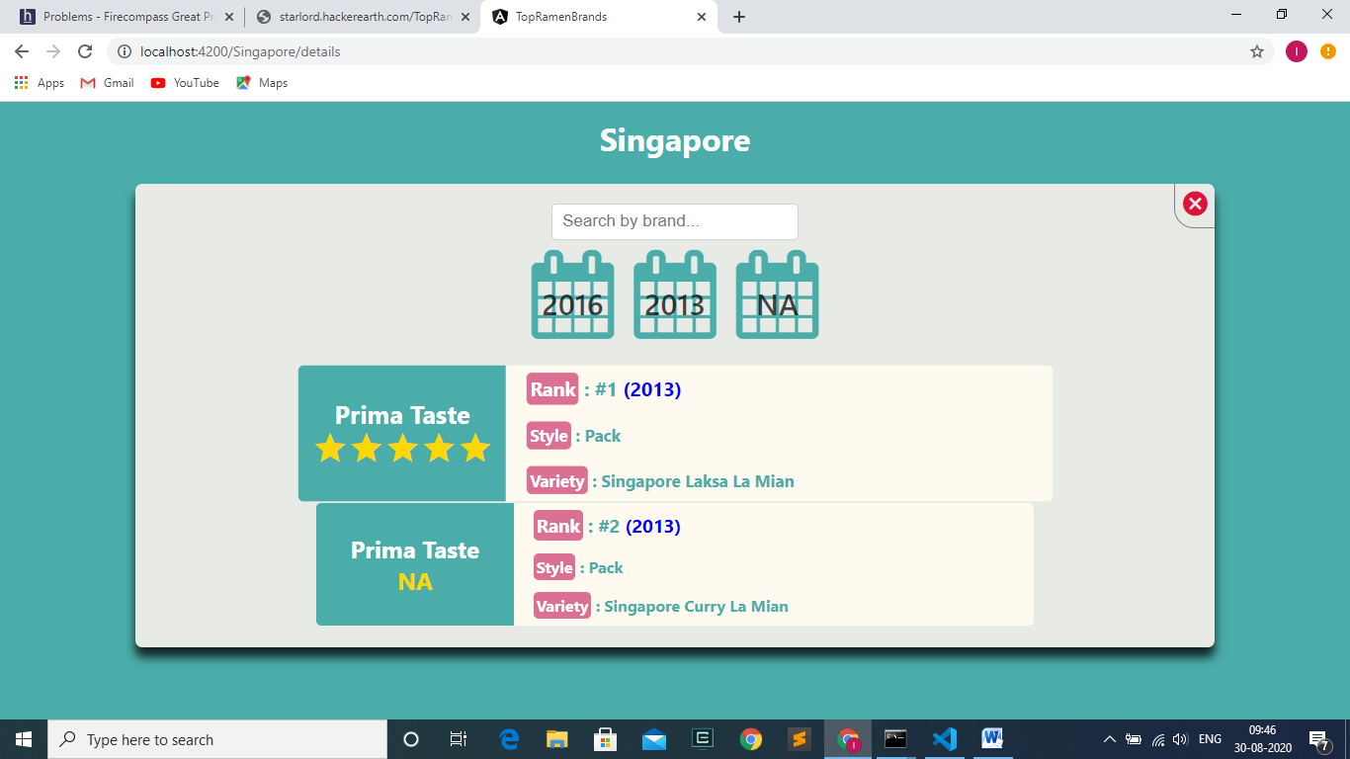

Fig 5

* 1. Brands for year which is NA(Not Available).

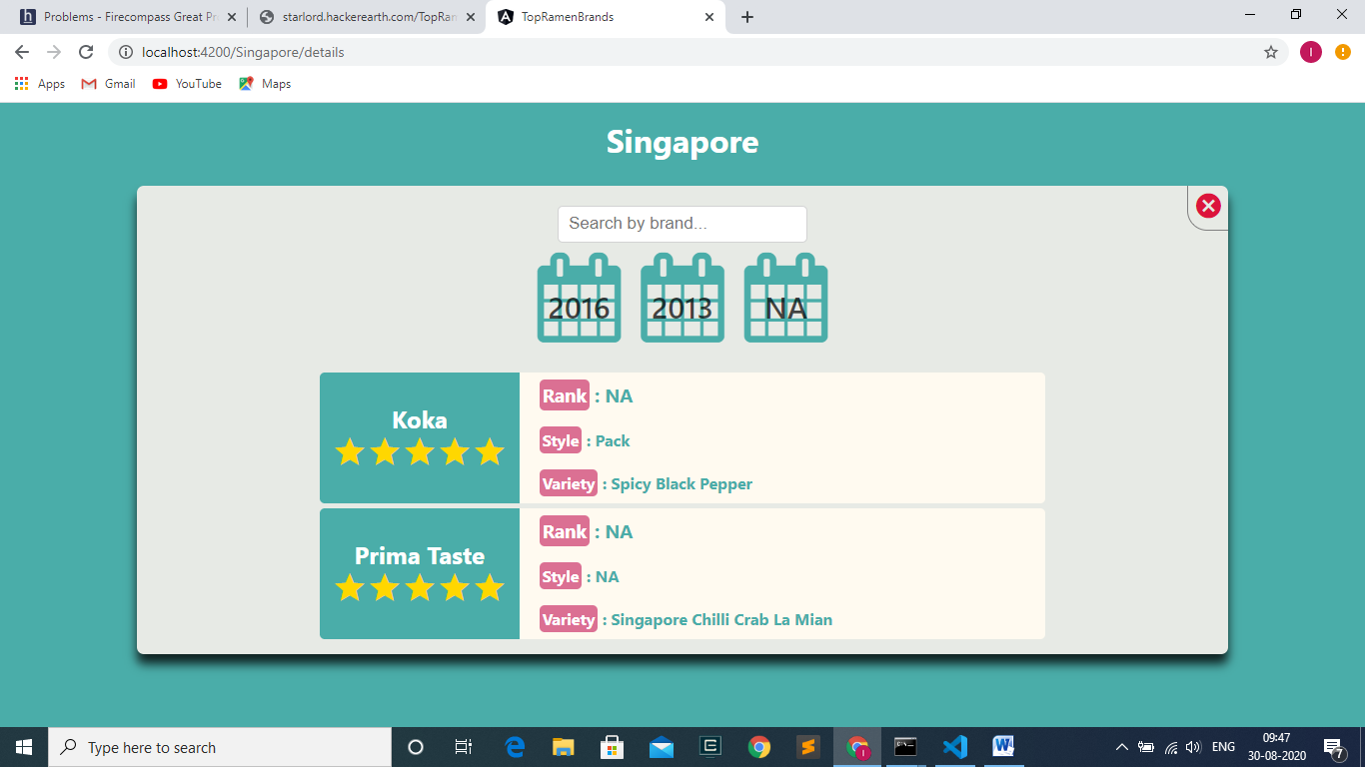

Fig 6

The data on the above page varies depending on the country.

1. There is a search-box added to search the brands within the country. On clicking the age the page navigates to a new CHILD ROUTE of that routing path (OR another page). There the brands load differently by accessing the LOCAL STORAGE. The data is stored into the LOCAL STORAGE once we enter this country’s brands path (OR page).

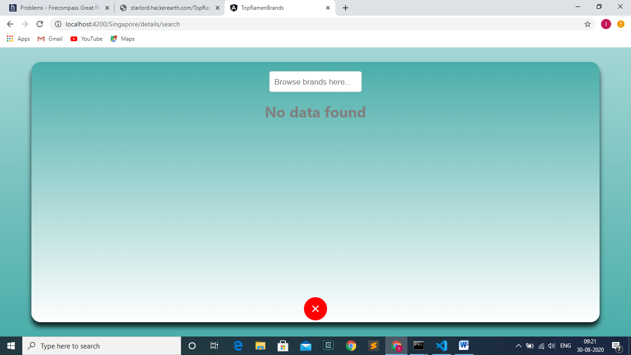

Fig 7

1. On search of the brands, the FLIPPING CARDS are shown which contains all the details of the brands of that respective country

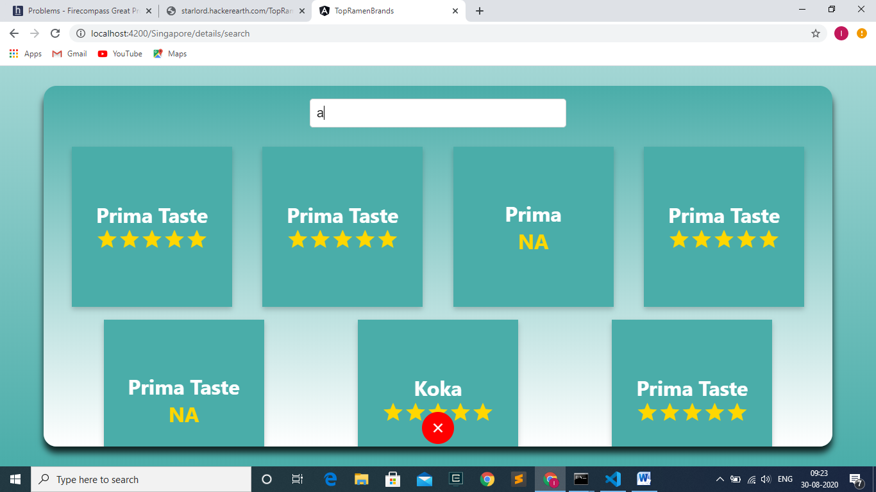

Fig 8

1. In order to prevent loss of data while reloading on all the routing paths(OR pages), angular RESOLVER is used . Also, till the page gets displayed, the LOADER is shown.

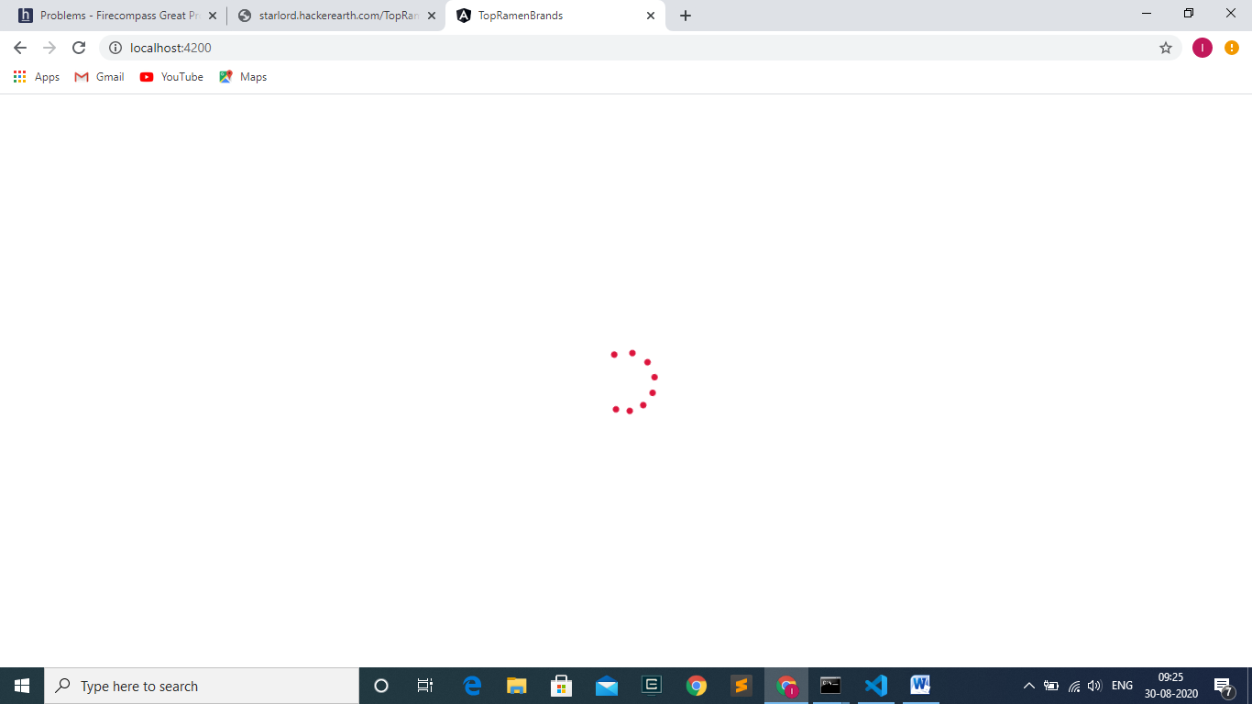

Fig 9

1. I would have hosted this page in a free server mostly in “FIREBASE” and provided you the link, but the URL provided by hacker earth for fetching data is of type HTTP, firebase supports only HTTPS, so it is unable to fetch the data and to display it on the screen, only the LOADER will be rotating till the end, no data is fetched.
2. Also used external animation package ( Ng-animate ), so kindly install if before running the website in your local server.
3. Also I will be removing NODE_MODULUS folder package since it captures more size while compressing the project (Do add NODE_MODULUS folder while running the website).