Double OR Zero ( using angular framework )

1. Commands need to be installed
   1. npm i @angular/animations@latest –save (for installing node_modules folder)
   2. npm i angular-animations (for angular-animations)
2. I have used **Session Storage** concept throughout the project which reduces fetching the api multiple times. Here first time the data is fetched from api then all other time we make use of session storage to fetch the data from there.
3. The main page contains **Animated Datatable,** I would have designed with normal datatables or bootstrap datatables which I have used in my projects. But here I created a datatable of my own with little animation

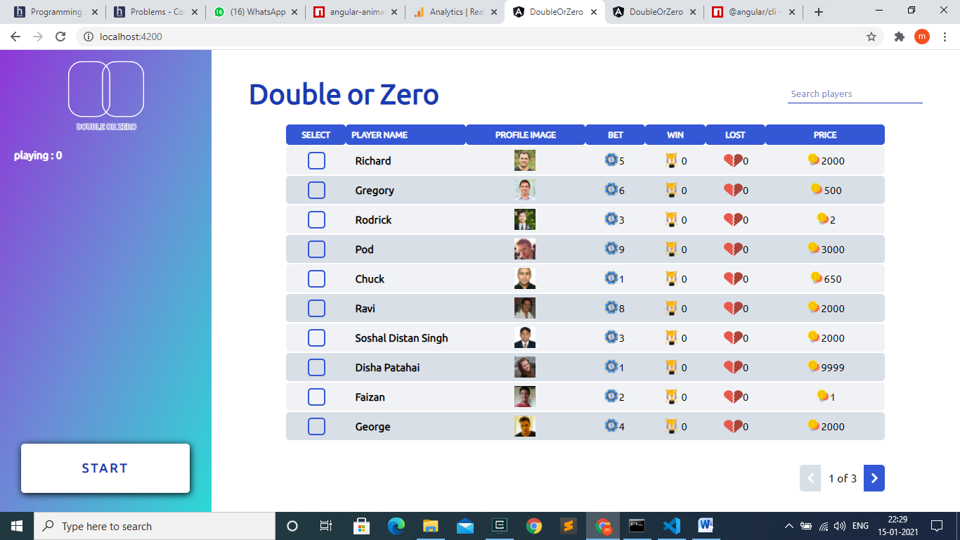

1. A search bar is used to filter out the players by there name and the down **pagination** which is also designed from scratch like datatable.
2. On selecting the user, the user gets added to the left list. This are the players who are ready for the game and when we select a **maximum** of **9 players,** the select icon gets disabled.

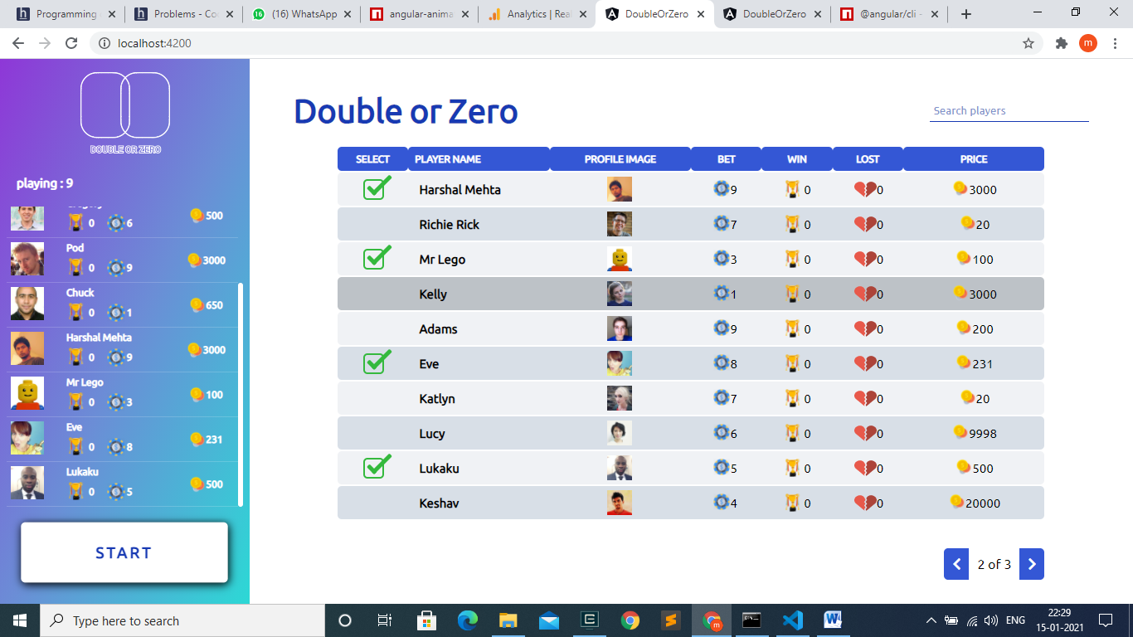

1. And the **START Button** starts to pump and indicates max has reached and **minimum of 2 players** should be available to **start the game**.
2. The second page is the game page

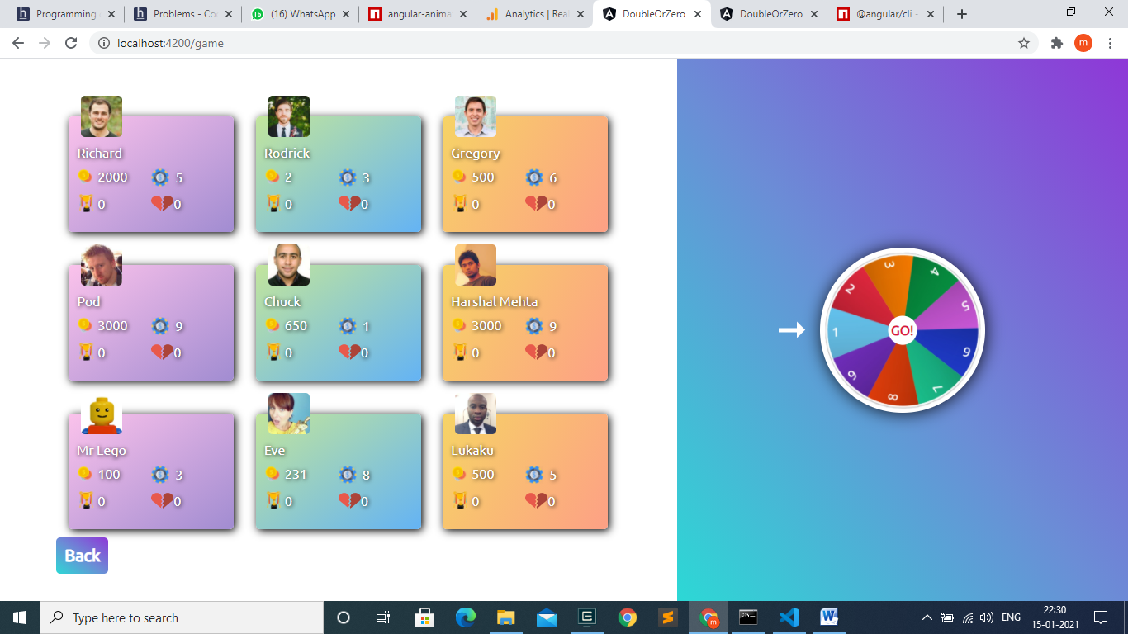

1. The **game page** receives the player from the **main page**, and the wheel on the right decides the winner and the rest are the losers.

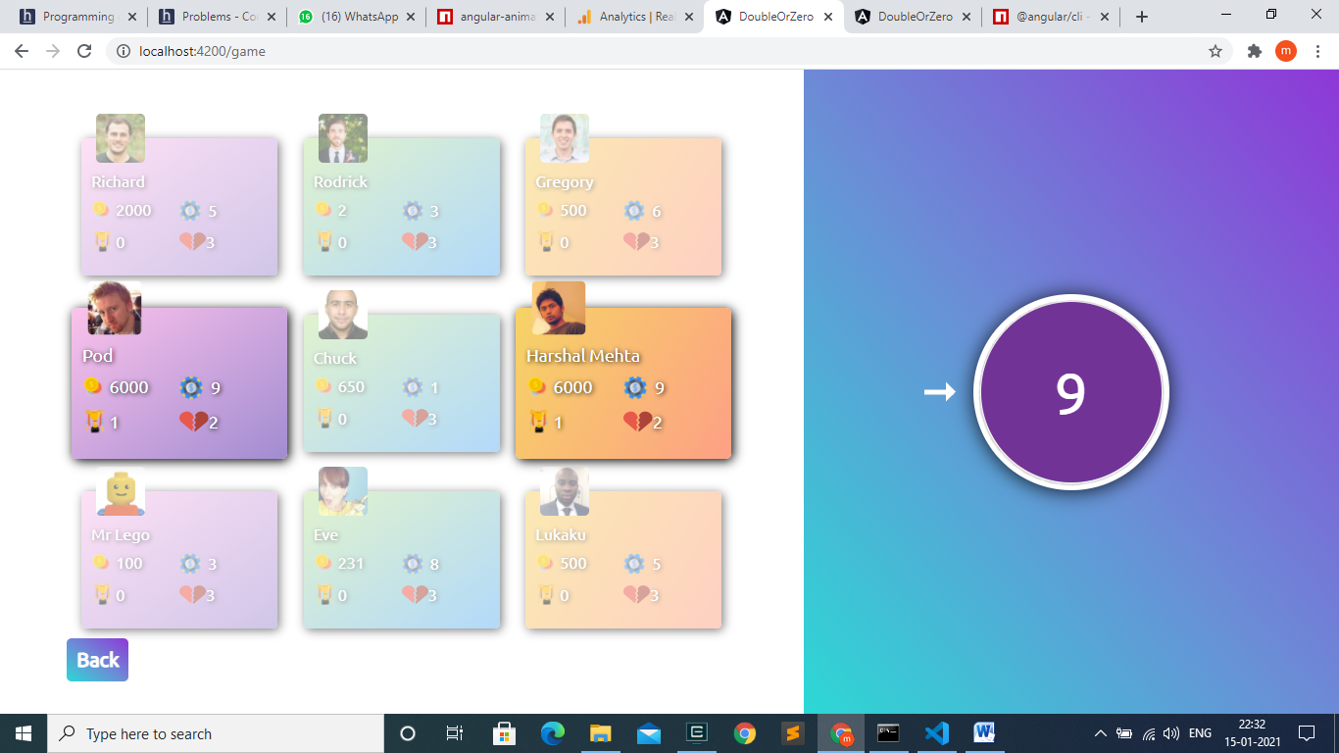

1. The winners are highlighted from the group. Players won will have there **bet equal to opposite bet**. The winner will have
   1. There **price doubled.**
   2. And the winning times is **incremented by one**
   3. Players lost will have **no price double**, and the losing time is **incremented by one.**
2. On Clicking **BACK Button,** the player scores and prices are updated in the datatable.

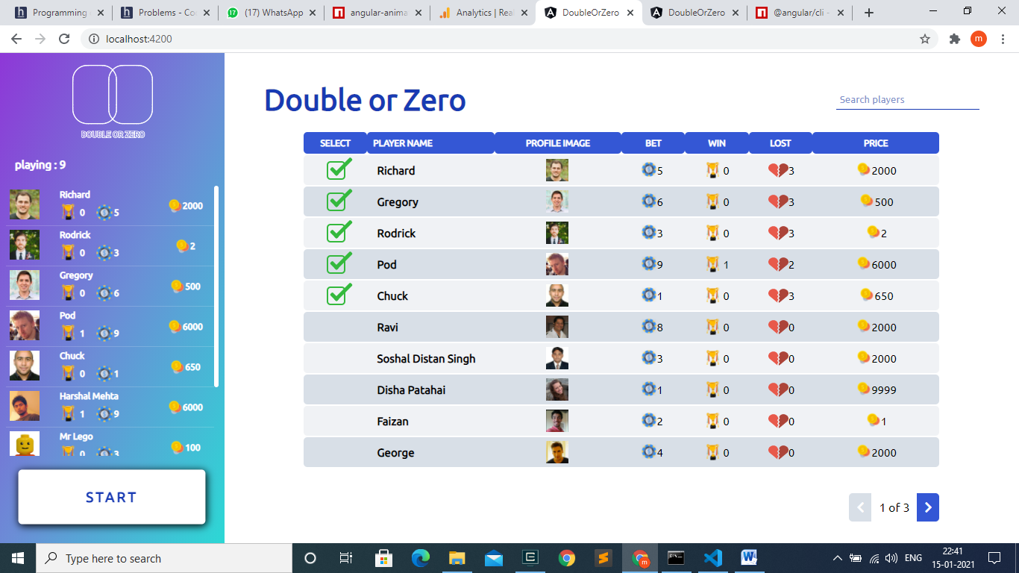

1. Link in which I have deployed the project ( Vercel platform)

<https://double-or-zero-k61oldggv.vercel.app/>

<https://imranfolio.me/> - My funky portfolio used during my part-time freelancing times, to know more about my projects.

* Do Check out my resume to know more about me and my skills.
* The fact about me is that I like to work more the logics than the UI/UX part. So I designed the datatable by on my own.