**DA-IICT**

**CT215 LAB1**

**Name: Patel Raj Kamleshbhai**

**ID: 201901306**

**Date: 31 January 2021**

**EXRCISES**

**[A] Few Basic LabView Commands:**

1. **sort(a, order):** It sorts the matrix column wise. Here, “a” is a matrix or a vector. And “order” specifies the ascending/ descending order of sorting in which we want to sort the given vector. If we don’t specify the order then by default sorting order is ascending order.

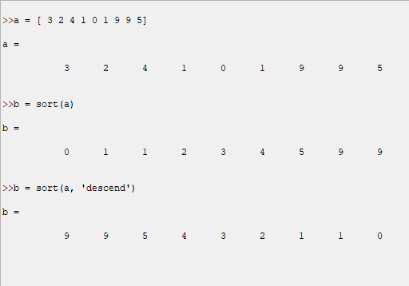

1. **conv(a, b):** It computes convolution of two matrices or vectors. And gives result of convolution theory of two signals. If “b” is not specified then it gives the auto-convolution i.e., conv(a, a).

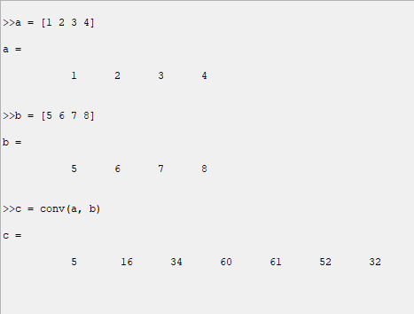

**(3) ones(a, b):** It returns a matrix of ones of size a x b

**zeros(a, b):** it returns a matrix of zeros of size a x b. (#Rows = a & #Columns = b)

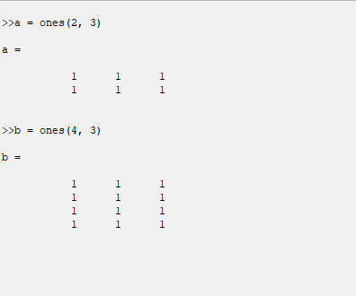

**(4) bitand(a, b):** It computes bitwise AND operation between a and b.

**bitor(a, b)**: It computes bitwise OR operation between a and b.

**bitxor(a, b):** It computes bitwise AND operation between a and b. (All of these bitwise functions return respective answer in the decimal.)

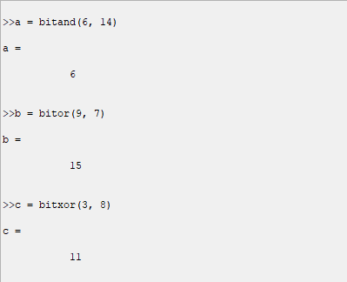

**(5) cat(type, a, b):** It concatenates two matrices or vectors a and b. If we want to concatenate more than two matrix then use cat(1,a,b,c, ……). Here, type “1” specifies column wise concatenation and type “2” specifies row wise concatenation.

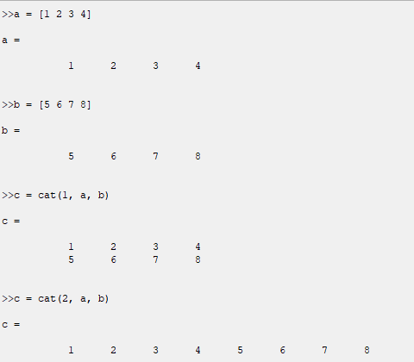

**[B] Compute the Fourier transform (FT) of the signal g(t) = exp(−2t)u(t), where u(.) is the unit step function.**

$• Fourier transform is given by,$

$$G\left(ω\right)=\int_{-∞}^{+∞}{g\left(t\right)e^{-jωt}dt}$$

$And g\left(t\right)= e^{-2t}u\left(t\right) is given$,

$$So, G\left(ω\right)=\int_{-∞}^{+∞}{e^{-2t}u(t)e^{-jωt}dt}$$

$$Here unit step function u\left(t\right)= \left\{\begin{aligned}0; t <0 \\ 1; t ≥0\end{aligned}\right.$$

$$∴G\left(ω\right)= \int_{0}^{+∞}{e^{-\left(2 +jω\right)t}dt}$$

$$∴G\left(ω\right)= \frac{{[e}^{-\left(2 +jω\right)t}]_{0}^{+∞}}{-\left(2 +jω\right)}$$

$$∴G\left(ω\right)= \frac{{[e}^{-∞}- e^{0}]}{-\left(2 +jω\right)}$$

|  |
| --- |
| $$∴G\left(ω\right)= \frac{1}{2 +jω}$$ |

**[C] Next Consider the following code which computes the FT of g(t) (given above) using the FFT method in MathScript. Understand what each and every command is doing (there might be a few new ones):**

**CODE:**

|  |
| --- |
| clear all;  clc;  t_s=0.01;  t=0:t_s:10;  exp_t=t_s*exp(-2.*t);  fft_exp_t=fftshift(fft(exp_t));  mag_exp_t=abs(fft_exp_t);  phase_exp_t=angle(fft_exp_t);  figure(1);  stem(mag_exp_t);  title('Plot of Magnitude Response of the given signal')  figure(2);  stem(phase_exp_t);  title('Plot of Phase Response of the given signal') |

In the above code,

• t_s is the sampling interval, because g(t) is the continuous signal and it can not be stored. So, we have stored its samples. And t is the total time.

• fft() function (Fast Fourier Transform) computes the DFT (Discrete Fourier Transform) of the given signal g(t). And fftshift() function rearranges the array obtained from the fft() function such that 0 frequency sample is at the center of the array.

• abs() and angle() functions compute the magnitude and the phase respectively.

• figure(), stem() and title() functions are for plotting.

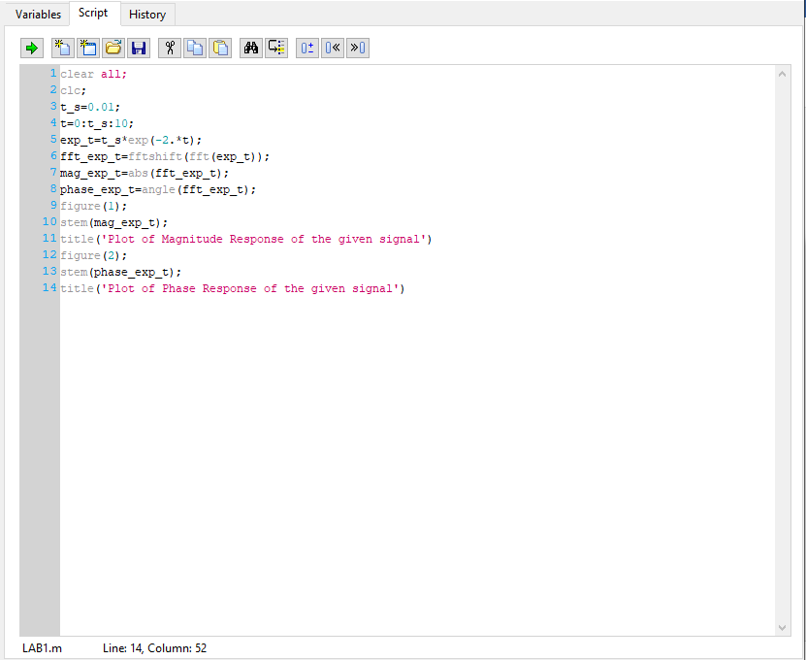

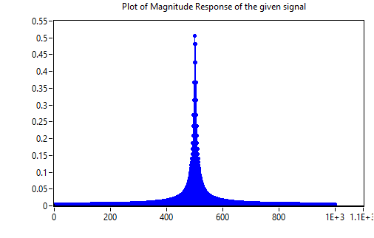

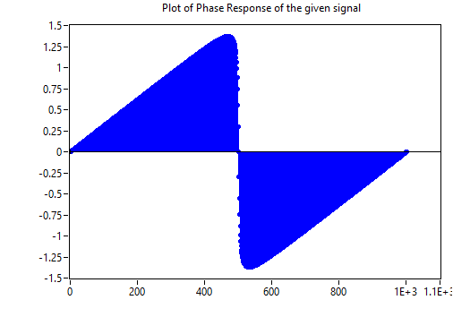

And from the above two plots,

• g(t) is real valued continuous time signal, as the magnitude response of g(t) is an even function and the phase response of g(t) is an odd function.