**DA-IICT**

**CT215 LAB2**

**Name: Patel Raj Kamleshbhai**

**ID: 201901306**

**Date: 7th February 2021**

**EXRCISES**

Assume the message signal x(t) to be

cos (ωmt) + 2 cos (2ωmt) + 4 cos (3ωmt) + 5 cos (5ωmt) ……. (3)

you may assume the frequency of the message fm to be 50 Hz and the carrier frequency fc can be chosen to be (say) 20*fm Hz (since fc >> fm).

**(A) Conventional AM Generation:**

i) Generate and plot the message signal in (3) and the corresponding conventional AM modulated signal xAM(t) for μ = 0.8.

ii) Repeat the second part of part (a) above for μ = 1.2. What do you notice and why??

iii) Compute and plot the spectrum of x(t) and xAM(t).

**Code:** This code is for all the given 3 questions of part (A).

|  |
| --- |
| clc;  close all;  f_s=3000;  t_s=1/f_s;  t=0:t_s:0.1;  fm=50;  wm=2*pi*fm;  xm=cos(wm*t) + 2*cos(2*wm*t) + 4*cos(3*wm*t) + 5*cos(5*wm*t);  figure(1);  subplot(3,1,1);  plot(t,xm);  title('Message Signal');  xlabel('Time(s)');  ylabel('Xm(t)');  Ac=1;  fc=20*fm;  wc=2*pi*fc;  xc=Ac.*cos(wc*t);  subplot(3,1,2);  plot(t,xc);  title('Carrier Signal');  xlabel('Time(s)');  ylabel('Xc(t)');  u=0.8;  x_AM1=(1+u.*xm).*xc;  subplot(3,1,3);  plot(t,x_AM1);  title('Conventional AM Modulated signal');  xlabel('Time(s)');  ylabel('xAM(t)');  u=1.2;  x_AM2=(1+u.*xm).*xc;  figure(2);  subplot(3,1,1);  plot(t,xm);  title('Message Signal');  xlabel('Time(s)');  ylabel('Xm(t)');  subplot(3,1,2);  plot(t,xc);  title('Carrier Signal');  xlabel('Time(s)');  ylabel('Xc(t)');  subplot(3,1,3);  plot(t,x_AM2);  title('Conventional AM Modulated signal');  xlabel('Time(s)');  ylabel('xAM(t)');  Xm=fftshift(fft(xm));  Xc=fftshift(fft(xc));  X_AM1=fftshift(fft(x_AM1));  X_AM2=fftshift(fft(x_AM2));  figure(3);  subplot(3,1,1);  plot(abs(Xm));  title('Spectrum of Message Signal');  xlabel('Frequency(Hz)');  ylabel('Xm(t)');  subplot(3,1,2);  plot(abs(Xc));  title('Spectrum of Carrier Signal');  xlabel('Frequency(Hz)');  ylabel('Xc(t)');  subplot(3,1,3);  plot(abs(X_AM1));  title('Spectrum of Modulated Signal (u=0.8)');  xlabel('Frequency(Hz)');  ylabel('xAM(t)');  figure(4);  subplot(3,1,1);  plot(abs(Xm));  title('Spectrum of Message Signal');  xlabel('Frequency(Hz)');  ylabel('Xm(t)');  subplot(3,1,2);  plot(abs(Xc));  title('Spectrum of Carrier Signal');  xlabel('Frequency(Hz)');  ylabel('Xc(t)');  subplot(3,1,3);  plot(abs(X_AM2));  title('Spectrum of Modulated Signal (u=1.2)');  xlabel('Frequency(Hz)');  ylabel('xAM(t)'); |

i) For μ=0.8: 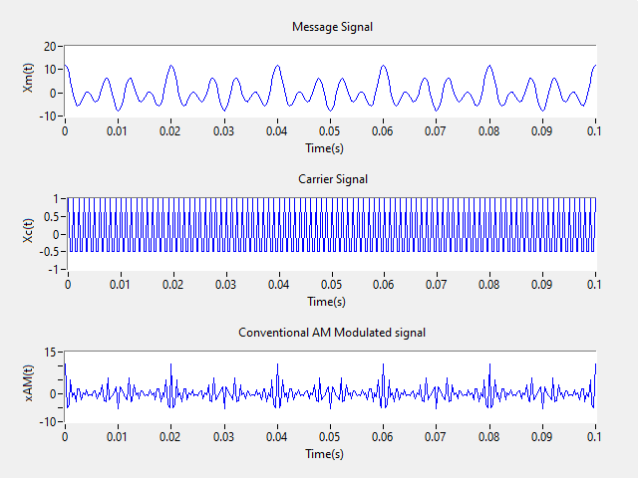

ii) For μ=1.2: 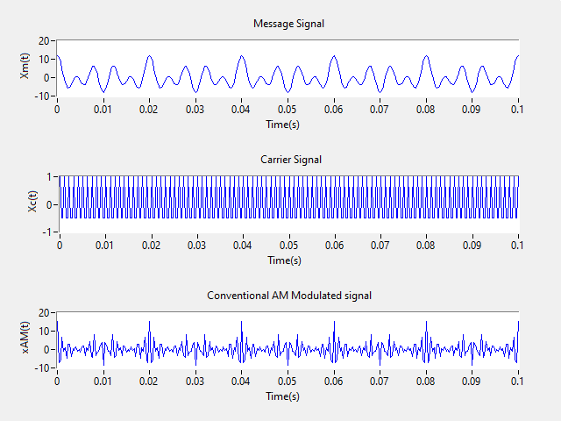

Here, we can see that after increasing the value of μ from 0.8 to 1.2 the amplitude of conventional AM modulated signal increases. Envelope Message Signal of Modulated Signal will be true for μ < 1. So, here for μ = 1.2 Envelop Message Signal is not proper.

iii) Spectrum of Message, Carrier and Modulated Signal:

i) For μ = 0.8:

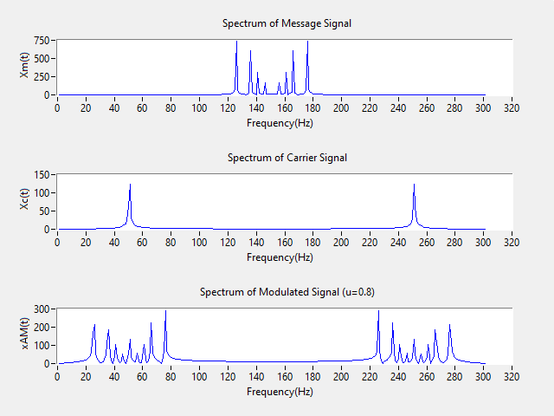

ii) For μ = 1.2:

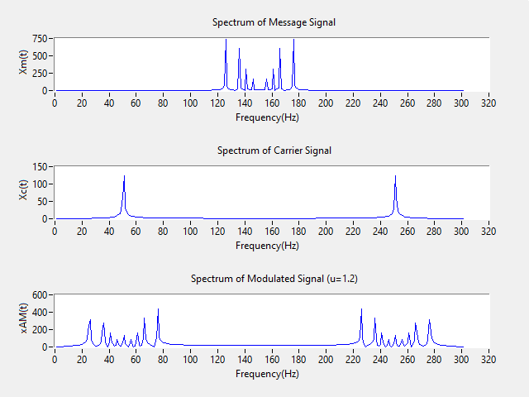

**(B) DSB-SC AM Generation:**

i) Generate and plot the message signal in (3) and the corresponding DSB-SC AM modulated signal xDSB-SC(t) in both frequency and time domain.

**Code:**

|  |
| --- |
| clc;  close all;  f_s=3000;  t_s=1/f_s;  t=0:t_s:0.1;  fm=50;  wm=2*pi*fm;  xm=cos(wm*t) + 2*cos(2*wm*t) + 4*cos(3*wm*t) + 5*cos(5*wm*t);  figure(1);  subplot(3,1,1);  plot(t,xm);  title('Message Signal');  xlabel('Time(s)');  ylabel('Xm(t)');  Ac=1;  fc=20*fm;  wc=2*pi*fc;  xc=Ac.*cos(wc*t);  subplot(3,1,2);  plot(t,xc);  title('Carrier Signal');  xlabel('Time(s)');  ylabel('Xc(t)');  x_DSB_SC=xm.*xc;  subplot(3,1,3);  plot(t,x_DSB_SC);  title('DSB-SC Modulated signal');  xlabel('Time(s)');  ylabel('xDSB-SC(t)');  Xm=fftshift(fft(xm));  Xc=fftshift(fft(xc));  X_DSB_SC=fftshift(fft(x_DSB_SC));  figure(2);  subplot(3,1,1);  plot(abs(Xm));  title('Message Signal');  xlabel('Frequency(Hz)');  ylabel('Xm(t)');  subplot(3,1,2);  plot(abs(Xc));  title('Carrier Signal');  xlabel('Frequency(Hz)');  ylabel('Xc(t)');  subplot(3,1,3);  plot(abs(X_AM2));  title('DSB-SC Modulated Signal');  xlabel('Frequency(Hz)');  ylabel('xDSB-SC(t)'); |

In Time domain:

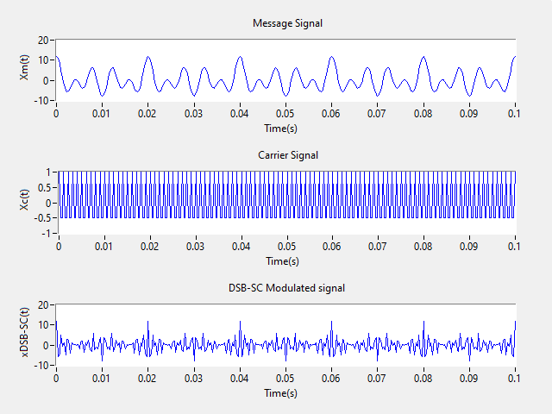

In Frequency domain: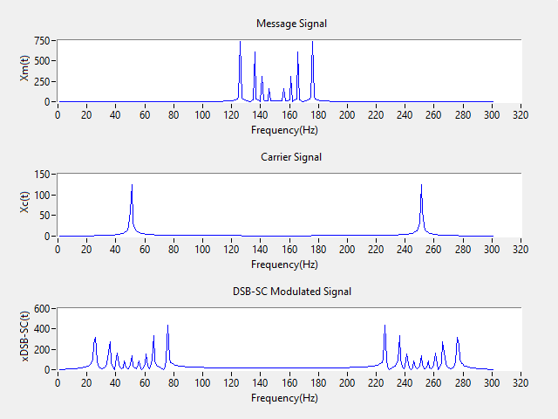

**(C) DSB-SC Demodulation:** For this part generate a DSB-SC AM signal assuming the message signal x(t) = cos(2π50t).

i) Demodulate the above generated bandpass DSB-SC AM signal as per the block diagram given above. You may use the carrier generated at the receiver to be (1) cos(2π50t), (2) cos(2π50t+π/4) and (3) cos(2π50t+π/2). For each case observe the spectrum and comment on it.

**Code:** In this code, the carrier signal is taken as cos(2π50t + ph). And I have taken the value of this ph is 0, π/4, π/2 one by one as per given 3 cases.

|  |
| --- |
| clc;  close all;  f_s=3000;  t_s=1/f_s;  t=0:t_s:0.1;  fm=50;  wm=2*pi*fm;  xm=cos(wm*t);  Ac=1;  fc=50;  wc=2*pi*fc;  ph=0; %take ph 0,pi/4 and pi/2 one by one  xc=Ac.*cos(wc*t + ph);  x_DSB_SC=xm.*xc.*cos(wc*t);  wn=4*fm/f_s;  [z,p]=butter(5,wn);  x_demod=filter(z,p,x_DSB_SC);  Xm=fftshift(fft(xm));  Xc=fftshift(fft(xc));  X_DSB_SC=fftshift(fft(x_DSB_SC));  X_demod=fftshift(fft(x_demod));  figure(1);  subplot(3,2,1);  plot(t,xm);  title('Message Signal');  xlabel('time(s)');  ylabel('Xm(t)');  subplot(3,2,3);  plot(t,x_DSB_SC);  title('DSB-SC Modulated Signal');  xlabel('time(s)');  ylabel('xDSB-SC(t)');  subplot(3,2,5);  plot(t,x_demod);  title('De-Modulated Signal');  xlabel('time(s)');  ylabel('Xm(t)');  subplot(3,2,2);  plot(abs(Xm));  title('Message Signal');  xlabel('Frequency(Hz)');  ylabel('Xm(t)');  subplot(3,2,4);  plot(abs(X_DSB_SC));  title('DSB-SC Modulated Signal');  xlabel('Frequency(Hz)');  ylabel('xDSB-SC(t)');  subplot(3,2,6);  plot(abs(X_demod));  title('De-Modulated Signal');  xlabel('Frequency(Hz)');  ylabel('Xm(t)'); |

Now for three different values of ph = 0, π/4, π/2 different plots are shown one by one.

For ph = 0: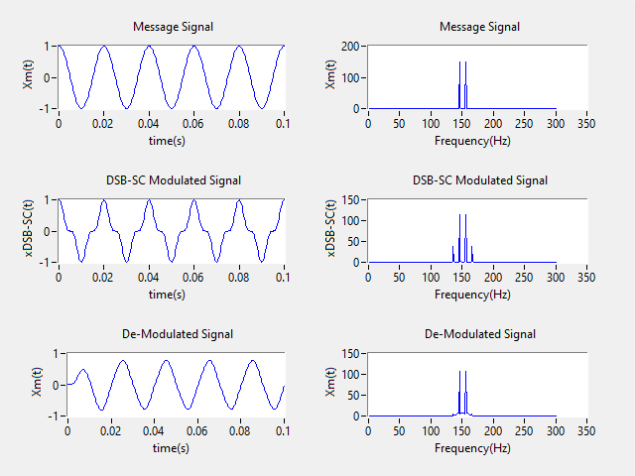

For ph = π/4: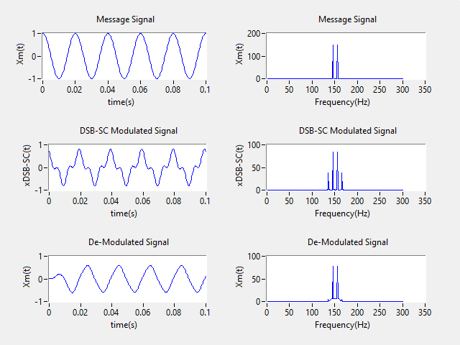

For ph = π/2: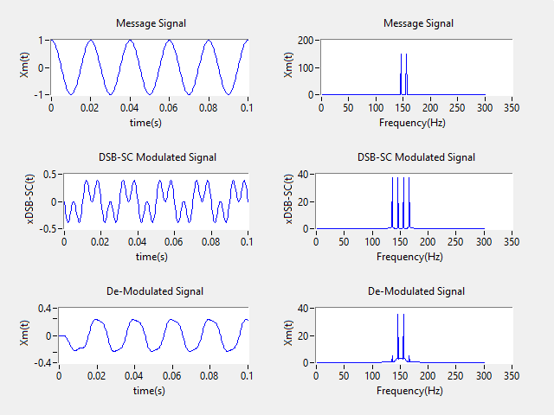

We can see that in all the plots as we move from ph = 0 to ph = π/4 and ph = π/2 (this are the phase values of Carrier Signal we are using at the receiver for demodulation), the difference between Demodulated Signal and Message Signal is increases, means distortion increases. Only in the case when ph = 0 accuracy is acceptable because the Carrier Signal’s phase at transmitter is also 0. So, we can summarize that the phase in the Carrier Signal at the transmitter and Carrier Signal at the receiver has to be close enough (not much differ by phase) to correctly demodulate the Modulated signal, otherwise Message Signal get corrupted while demodulating.