**DA-IICT**

**CT215 LAB3**

**Name: Patel Raj Kamleshbhai**

**ID: 201901306**

**Date: 14th February 2021**

**AMPLITUDE DEMODULATION**

## Generation of AM modulated signal.

* + The figure of the circuit is given below. First, we created sinusoidal signal of message signal and carrier signal.
  + Message signal is SINE(0 3 1k) and Carrier signal is SINE(0 5 150k).
  + The formula for modulated signal is

Modulated_signal = (Carrier_signal)*[1 + m*(Message_signal)]

* + Here, modulation index m = 1/Ac

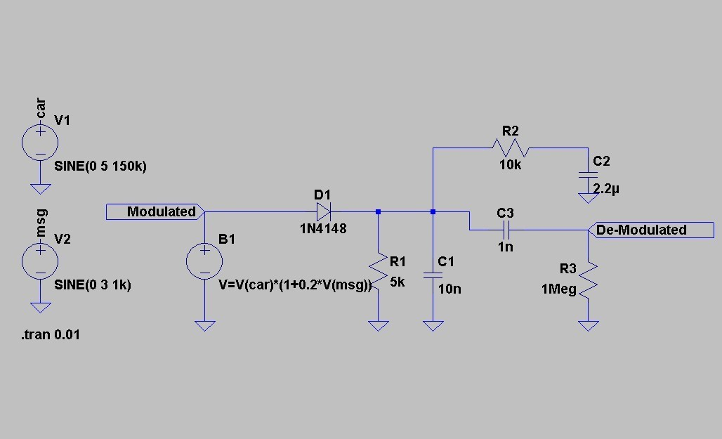

* + In the circuit, we can see that variable voltage source B1 generates the AM modulated signal. And the graph of it is given as below:

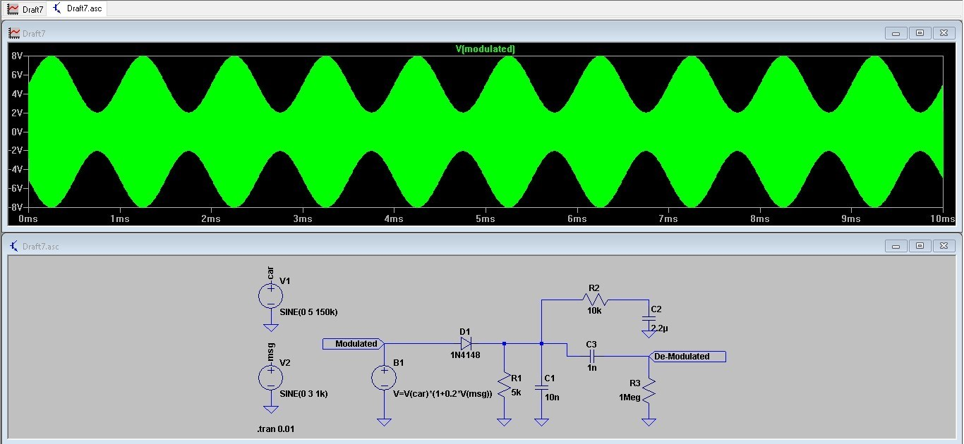

## Analysis of the circuit.

* + This modulated signal will pass through the diode. This works as a half wave rectifier. So, the negative half cycle is removed and only positive half cycle of the modulated signal remains.
  + So, only during the positive half cycle the capacitor C1 will charge up to the maximum voltage.
  + And during the negative half cycle the circuit gets open, capacitor C1 discharges. And because of it we will see some ripples in the graph.
  + The value of R1 and C1 is selected such that, it works as a low pass filter (as we just have to pass the message signal which is having low frequency as compared with carrier signal while demodulation). And this circuit is known as Envelope detector circuit.
  + But the output waveform contains some DC component. And to remove it, we use Automatic Gain Control (AGC) which remove the DC component and work as a high pass filter.
  + At the point A, we get the wave shown below:

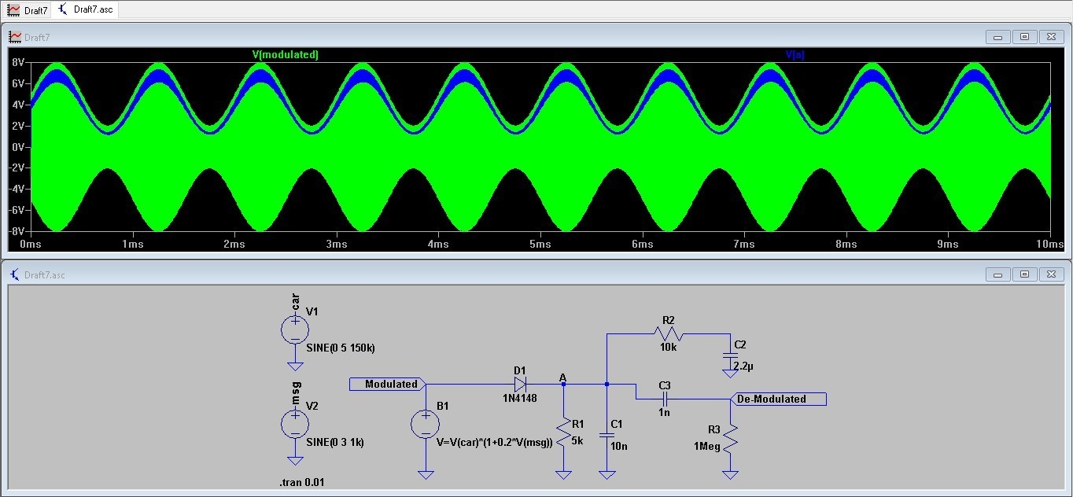

## Amplitude Demodulation.

* + In the below graph, the green line is the input message signal and the blue line is the demodulated signal.
  + Here, we can’t get the modulated signal as same as the input. There are some ripples due to the capacitor charging - discharging process.

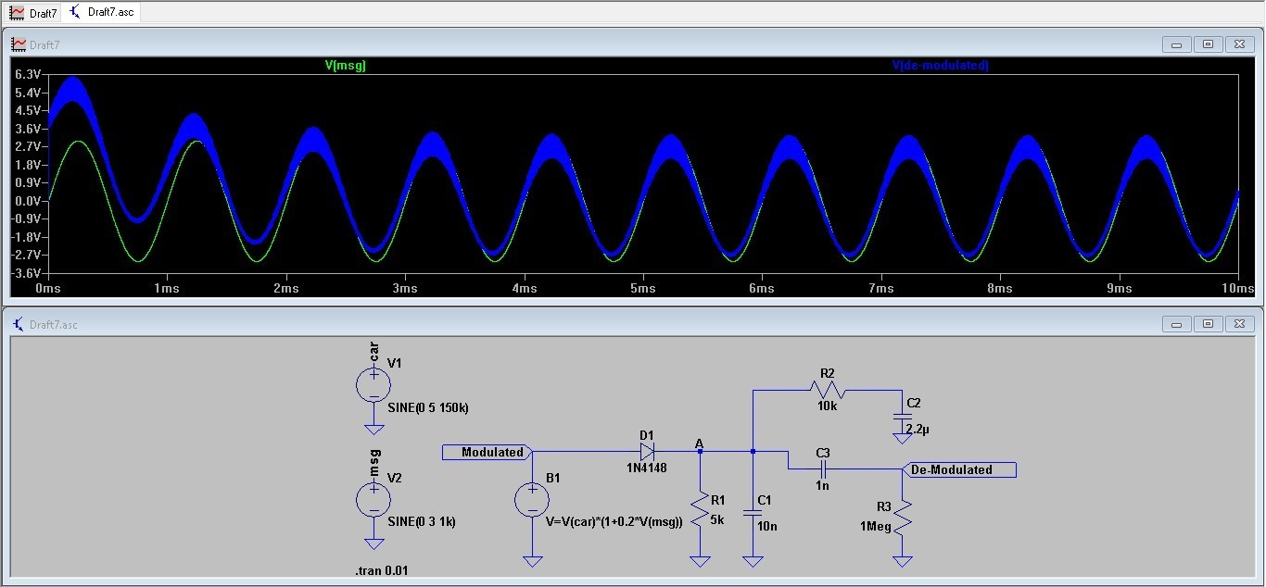

## Conclusion:

* + If the value of R and C is such so the time constant $τ$ = RC, follows the below condition then we can demodulate the given signal accurately.

1/wc < RC < 1/wm

* + If the value of time constant $τ$ = RC is less than 1/wc then the capacitor

discharges fast and we won’t able to regenerate the input message signal.

* + If the value of time constant $τ$ = RC is greater than 1/wm then the capacitor takes more time to discharge and because of that there is a distortion in the demodulated signal.
  + Automatic Gain Control (AGC) will control the gain and remove the DC component.