**DA-IICT**

**CT215 LAB4**

**Name: Patel Raj Kamleshbhai**

**ID: 201901306**

**Date: 21st February 2021**

**Aim:** To study FSK Modulation technique for digital data.

# Introduction:

Frequency-shift keying (FSK) is a frequency modulation scheme in which digital information is transmitted through discrete frequency changes of a carrier wave. The simplest FSK is binary FSK (BFSK). As suggested by the name, BFSK uses two discrete frequencies to transmit binary (0's and 1's) information. The two binary states, logic 0 (low) and 1 (high), are each represented by Analog waveform. Logic 0 is represented by a wave at a specific frequency and logic 1 is represented by a wave at a different frequency. A modem (modulator-demodulator) converts the binary data from a computer to FSK for transmission over telephone lines, cables, optical fiber, or wireless media. The modem also converts incoming FSK signals to digital low and high states, which the computer can "understand.". Figure below shows binary signal (digital states) used as the modulating signal and the corresponding modulated signal for 1 and 0 is also shown (not to scale).

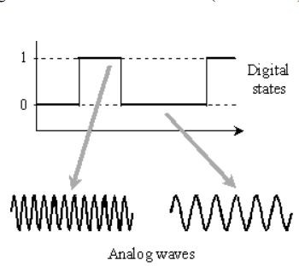

**Apparatus:**

* Function Generator
* Digital Oscilloscope
* Power supply
* Integrated circuit IC – LM565
* Resistors
* Capacitors
* Diode
* Breadboard etc.

# Circuit Diagram:

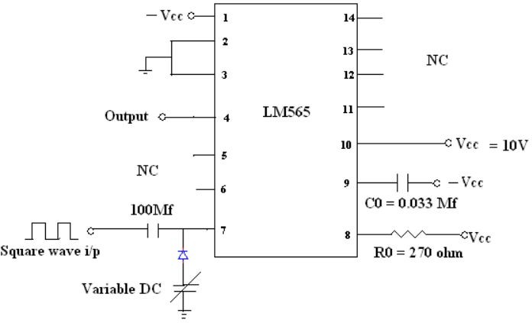

# Procedure:

1. Connect the circuit of FSK Modulator as shown below (The IC used here is LM565, a Phase locked loop (PLL)).
2. Apply 4V P-P square wave (this is the modulating signal having two levels) of frequency in the range of (more than 2KHz) with DC offset which act as a control voltage for VCO (Voltage controlled oscillator inside the PLL IC).
3. Vary the value of DC offset and you will see the frequency of the VCO will change.
4. Check the output and you will see two different frequencies for logic 1 and logic 0.

VCO: Voltage Controlled Oscillator, it is present in the IC – LM565 and it gives an output waveform at pin no. 4.

# Input & Output Waveform Plots:

# Input is 4v P-P square wave given.

# 

* Here, from the waveform plots we can see that the frequencies f1 and f2 are two different frequency obtained by the Frequency Modulated Signal.
* And frequency f1 is gained for the logic 1(high) of the input graph and frequency f2 is gained for the logic 0(low).
* f1 > f2 as amplitude for logic 1 is +2V and it’s -2V for logic 0. And frequency is modulated(shifted) same as FM for analog, F = Fc + k*em(t).

# Conclusion:

* From the waveform plots, we can see that the amplitude for Frequency Modulated Signal is same as the input signal. But the frequencies are varied according to the variation of amplitude of input(message) signal like frequency f1 for logic 1(+2V) and frequency f2 for logic 0(-2V).
* FSK Modulation characteristics are well verified.