**DA-IICT**

**CT215 LAB6**

**Name: Patel Raj Kamleshbhai**

**ID: 201901306**

**Date: 28th March 2021**

**Aim:** Introduction of motorize microstrip transmission line trainer (MMTLT).

**Apparatus:**

* Microstrip Transmission line (Transmission line assembly)
* RFL - MMTLT Control Unit,
* RG 316 - 50 ohm - 50 cm cable
* RG 316- 50 ohm - 2 m cable
* 9 Pin D type male to 5 Pin Din male
* 9 Pin D type male to female
* Load and RFL - MMTLT GUI

**Functional Block Diagram:**

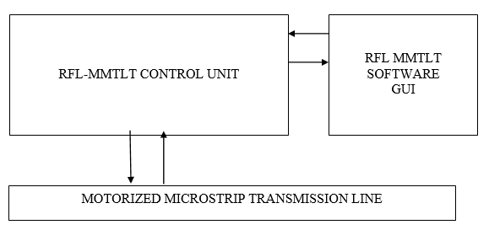

**Procedure:**

1. Connect the “9 Pin D Type Male to 5 pin Din Male Cable” in between 9 Pin D Type Female connector from “stepper motor” Section located on Control Unit and 5 pin Din Female Terminal Located on transmission line Jig.
2. Connect the “9 Pin D Type Male to Female Cable” in between Limit Switch 9 Pin D type female Connector on back side of the control panel unit and 9 Pin D Type Male Connector on Transmission Line Jig.
3. Connect the RF output of the Motorized Microstrip Transmission Line Trainer (**RF OUT**) to the port 1 of the transmission line module using SMA Cable (i.e., signal generated by RFL-MMTLT RF Signal Generator is applied as input to the transmission line)
4. Connect the RF Sensing port of the transmission line Control Unit (RF IN) to the RFL- MMTLT port 2 using SMA Cable (i.e., Movable probe from the Transmission line module assembly is applied as an input to RF Detector of RFL-MMTLT).
5. Connect Load at Port 3 of transmission line assembly.
6. Turn ON the RFL-MMTLT System. Apply Power using Power Cable and switch ON the Trainer Kit using Power ON switch present backside the trainer kit.

Display will show following messages.



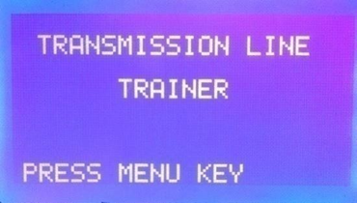

1. Press **MENU** button on Front Control unit.
2. To select the PC Control Mode, Press MENU key.

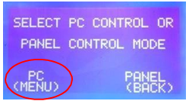

1. Make sure that Software is running, and press **ENTER**.

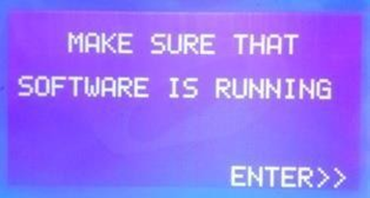

1. A continuous Window will be appeared throughout the experiment.

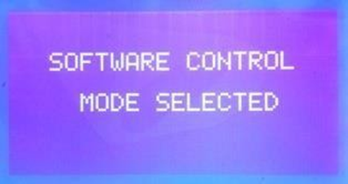

1. Connect USB cable in between PC and RFL-MMTLT System.
2. Double click the RFL- MMTLT icon to run the Software in PC.
3. Select **File ~> Control Mode ~> PC** to choose PC control Mode.
4. Select **COM PORT** in the new window that is opened.
5. Select Operating Mode ~> Transmission Line ~> Standing Wave ~>

Transmission Line Parameters.

1. Select resolution and frequency **1 mm & 900 MHz** respectively.
2. Click on the RUN button to start the experiment.

When we press RUN button motor starts running and signal sensing probe at port 2 starts moving from 0 cm of transmission line towards 59 cm (Total 600 mm). After completion of this distance moving probe returns to 0 cm position.

**Note: During start of experiment, if moving probe position is not at 0cm, you can still RUN the experiment. It automatically comes to 0 cm i.e., home position and then starts the experiment.**

The sensor probe takes some minutes to complete its full rotation from generator to load the graph will display on screen. Save the graph on computer.

To save the image of wave go to **file>save as>Image File.**

To save the excel data of wave go to **file>save as>CSV File.**

Now repeat the same procedure to take readings for frequency 500 MHz and 1200 MHz.

Save multiple frequency waves in CSV for to particular location and the compare all the graphs.

To compare the graphs, go to **Settings>plot comparison.**

Browse the graphs you want to compare and observe the waves on software.