**DA-IICT**

**CT215 LAB7**

**Name: Patel Raj Kamleshbhai**

**ID: 201901306**

**Date: 11th April 2021**

**Aim:** To understand the purpose and operational principle of the standing wave using maxima & minima.

**Apparatus:**

* Microstrip Transmission line (Transmission line assembly)
* RFL - MMTLT Control Unit
* RG 316 - 50 ohm - 50 cm cable
* RG 316- 50 ohm - 2 m cable
* 9 Pin D type male to 5 Pin Din male
* 9 Pin D type male to female
* Load and RFL - MMTLT GUI

**Objectives:**

To explore the properties of TRANSMISSION LINE

* Analysis of minima and maxima creation at various frequencies.
* Observation of standing wave pattern at various frequencies.

# Functional Block Diagram:

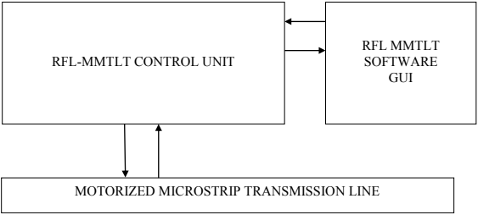

**Procedure:**

Hardware set-up of motorize microstrip transmission line trainer (MMTLT) - Fig.1.

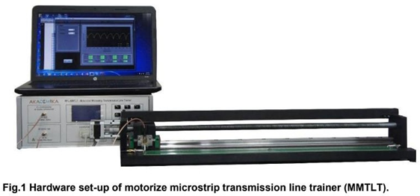

1. Connect the “9 Pin D Type Male to 5 pin Din Male Cable” in between 9 Pin D Type Female connector from “stepper motor” Section (Fig 2) located on Control Unit and 5 pin Din Female Terminal Located on transmission line Jig.

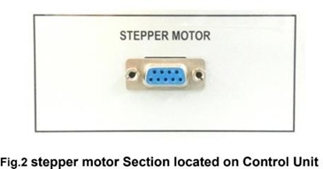

1. Connect the “9 Pin D Type Male to Female Cable” in between Limit Switch 9 Pin D type female Connector on back side of the control panel unit and 9 Pin D Type Male Connector on Transmission Line Jig.
2. Connect the RF output of the Motorized Microstrip Transmission Line Trainer (**RF OUT**) to the port 1 (Fig 3) of the transmission line module using SMA Cable (i.e., signal generated by RFL-MMTLT RF Signal Generator is applied as input to the transmission line).

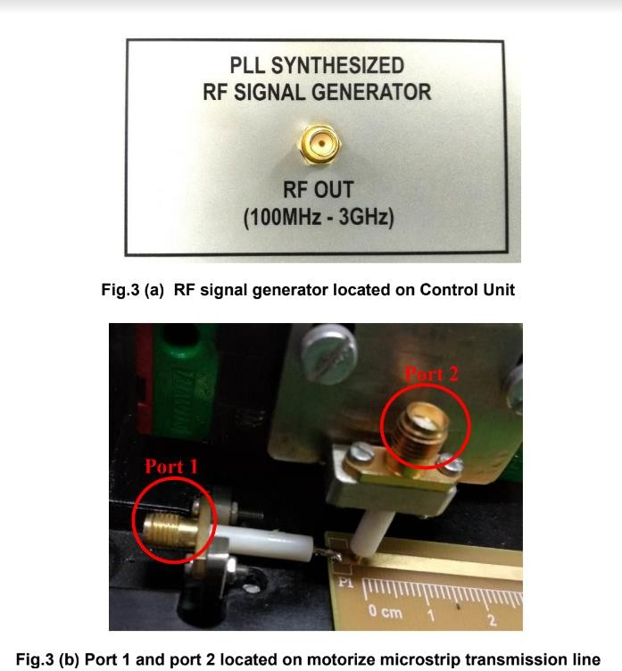

1. Connect the RF Sensing port of the transmission line Control Unit (RF IN) to the RFL- MMTLT port 2 (Fig 3) using SMA Cable (i.e., Movable probe from the Transmission line module assembly is applied as an input to RF Detector of RFL-MMTLT).
2. Connect Load at Port 3 of transmission line assembly (Fig 4).

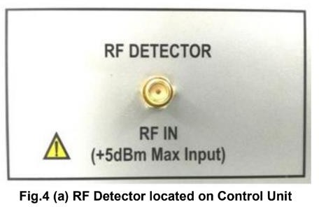

1. Turn ON the RFL-MMTLT System (Fig 5). Apply Power using Power Cable and switch ON the Trainer Kit using Power ON switch present backside the trainer kit.

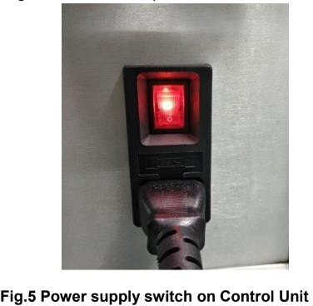

Display will show following messages.



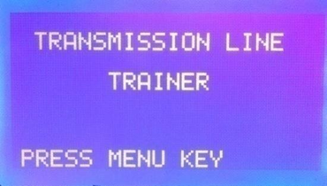

1. Press **MENU** button on Front Control unit.
2. To select the PC Control Mode, Press MENU key.

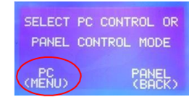

1. Make sure that Software is running and press **ENTER**.



1. A continuous Window will be appeared throughout the experiment.

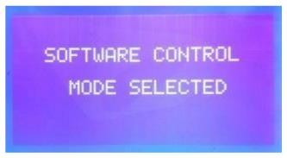

1. Connect USB cable in between PC and RFL-MMTLT System.



1. Select **COM PORT** in the new window that is opened.

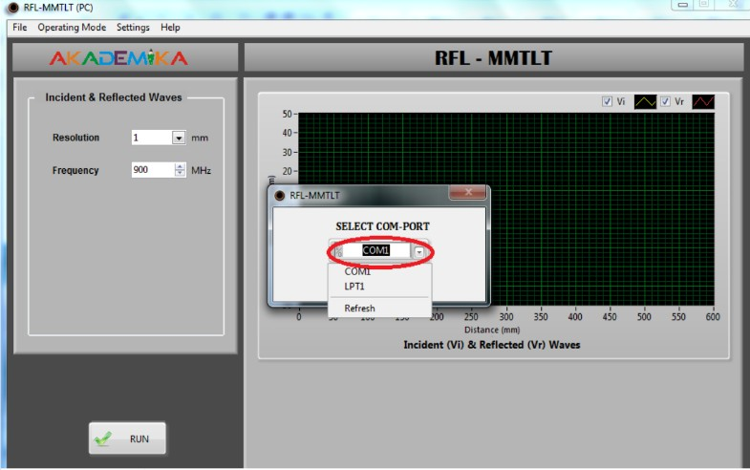

1. Select Operating Mode ~> Transmission Line ~> Standing Wave ~> Transmission Line Parameters.
2. Select resolution and frequency **1mm & 900MHz** respectively.

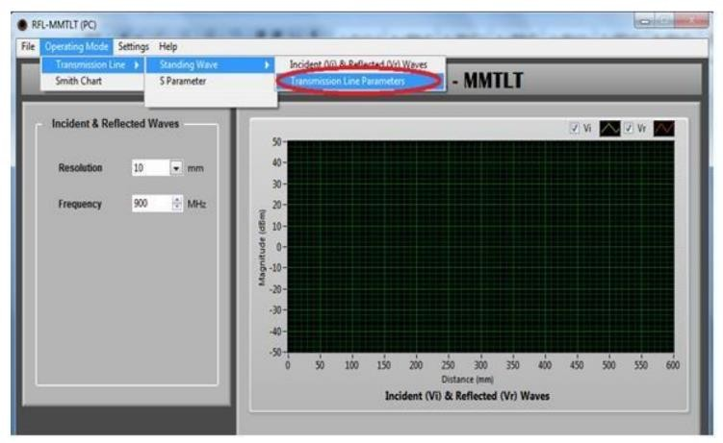

1. Click on the RUN button to start the experiment.

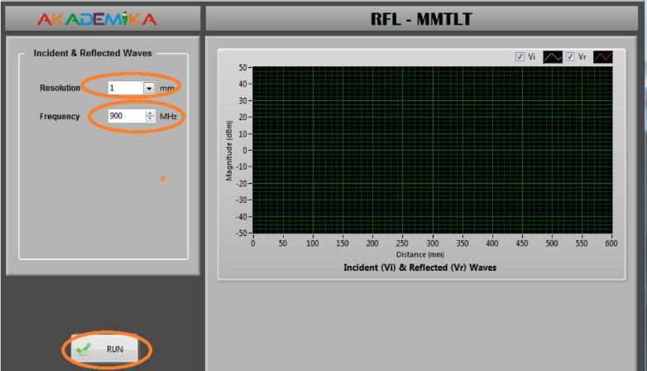

When we press RUN button, motor starts running and signal sensing probe at port2 starts moving from 0 cm of transmission line towards 59 cm (Total 600 mm). After completion of this distance moving probe returns back to 0 cm position. This was all about the procedure of the experiment.

**Note: During start of experiment, if moving probe position is not at 0 cm, you can still RUN the experiment. It automatically comes to 0 cm i.e., home position and then starts the experiment.**

The sensor probe takes some minutes to complete its full rotation from generator to load the graph will display on screen. Save the graph on computer.

# Results and Observations:

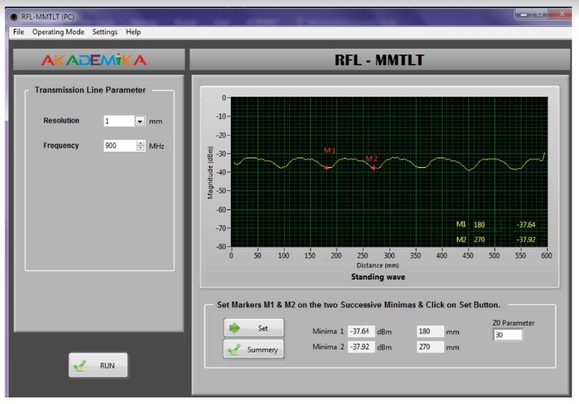

* The above output shows a standing wave for frequency 900 Hz. Here, we have selected two minima. The distance between them is 90 mm. We can also select two maxima and get the same results. The distance between two maxima or minima is equal to half of the wavelength of the standing wave.

# Observation Table for PC mode:

|  |  |  |  |  |  |  |
| --- | --- | --- | --- | --- | --- | --- |
| **Total Number of maxima observed for 900 MHz** | 7 | | | **Total Number of minima observed for 900 MHz** | 6 | |
| **Frequency 900 MHz** | **1st minima** | **1st maxima** | **2nd minima** | **2nd maxima** | **3rd minima** | **3rd maxima** |
| **Power level in dBm or**  **dBuV** | -37.64 | -31.32 | -37.92 | -31.61 | -37.75 | -31.58 |
| **Location of movable port (cm)** | 18 | 22.5 | 27 | 31.5 | 36 | 40.5 |

|  |  |  |  |  |  |  |
| --- | --- | --- | --- | --- | --- | --- |
| **Total Number of maxima observed for 500 MHz** | 4 | | | **Total Number of minima observed for 500 MHz** | 4 | |
| **Frequency 500 MHz** | **1st minima** | **1st maxima** | **2nd minima** | **2nd maxima** | **3rd minima** | **3rd maxima** |
| **Power level in dBm or dBuV** | -27.55 | -19.34 | -22.57 | -21.34 | -30.31 | -22.47 |
| **Location of movable port (cm)** | 2.8 | 5.4 | 7.4 | 11.4 | 18.3 | 21.8 |

|  |  |  |  |  |  |  |
| --- | --- | --- | --- | --- | --- | --- |
| **Total Number of maxima**  **observed for 1200 MHz** | 7 | | | **Total Number of minima observed for 1200 MHz** | 8 | |
| **Frequency 1200 MHz** | **1st minima** | **1st maxima** | **2nd minima** | **2nd maxima** | **3rd minima** | **3rd maxima** |
| **Power level in dBm or dBuV** | -18.85 | -8.19 | -18.08 | -12.43 | -19 | -13.38 |
| **Location of movable port (cm)** | 2.1 | 5.4 | 9.1 | 11.8 | 15.7 | 18.4 |

**Conclusion:**

# Effect of frequency on magnitude of 2nd maxima and 2nd minima.

We know that,

Vmax = V0+(1+|Γ|) Vmin = V0+(1-|Γ|)

𝑍𝐿 − 𝑍𝑜

Γ =

𝑍𝐿 + 𝑍𝑜

ZL = Load impedance which does not depend on frequency.

Zo = Characteristics impedance which depends on frequency.

From the equations, we can see that the magnitude of maxima and minima

Depends on Γ which depends on.

# Effect of frequency on two consecutive maxima or minima.

We know that,

𝑐 = 𝑓𝜆

Now, the wavelength 𝜆 is inversely proportional to frequency 𝑓. So as the frequency increases, the wavelength decreases. Hence distance between two consecutive maxima and minima (𝜆/2) decreases. Thus, the consecutive maxima or minima come closer to each other. Similarly, as the frequency decreases, the consecutive maxima and minima goes farther away from each other.

# Effect of frequency on number of maxima and minima.

We know that,

𝑐 = 𝑓𝜆

# Here, as the frequency increases, the wavelength decreases. Hence, the number of maxima and minima increases (that are visible to us). Similarly, as the frequency decreases, the wavelength increases and hence the number of maxima and minima that are visible to us decreases.