**DA-IICT**

**CT215 LAB8**

**Name: Patel Raj Kamleshbhai**

**ID: 201901306**

**Date: 18th April 2021**

**Aim:** To explore the properties of the TRANSMISSION LINE module

1. Observation & characterization for given LOADS.
2. Measurement of minima & maxima.

**Apparatus:**

* Microstrip Transmission line (Transmission line assembly)
* RFL - MMTLT Control Unit
* RG 316 - 50 ohm - 50 cm cable
* RG 316- 50 ohm - 2 m cable
* 9 Pin D type male to 5 Pin Din male
* 9 Pin D type male to female
* Load, Open, Short and RFL - MMTLT GUI

# Functional Block Diagram:

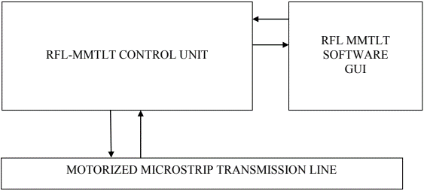

**Theory:**

**Microstrip Transmission Lines:**

Microstrip is a type of electrical transmission line. It can be fabricated using printed circuit board technology and is used to convey microwave-frequency signals. It consists of a conducting strip separated from a ground plane by a dielectric layer known as the substrate. Microwave components such as antennas, couplers, filters, power dividers, etc. can be formed from microstrip, with the entire device existing as the pattern of metallization on the substrate. Microstrip is thus much less expensive than traditional waveguide technology, as well as being far lighter and more compact. Microstrip lines are also used in high-speed digital PCB designs, where signals need to be routed from one part of the assembly to another with minimal distortion and avoiding high cross-talk and radiation.

**Transmission line Terminated with LOAD (ZL):**

For maximum transfer of energy into a transmission line from a source or from a transmission line to a load (the next stage of an amplifier, an antenna, etc.), the impedance of the source and load should match the characteristic impedance of the transmission line. In general, then, ZL is the target for input and output impedances of devices and networks.

**Standing Wave:**

Standing waves is a phenomenon that is the result of interference of 2 waves. It is also known as a **stationary wave**, is a **wave** that oscillates in time but whose peak amplitude profile does not move in space. The distance between 2 maxima or 2 minima of a standing wave is lambda / 2, where lambda is the wavelength of one wave. So, we can measure the distance between two waves to calculate the wavelength.

**Setup and Procedure:**

**Load Category:**

1. Connect the “9 Pin D Type Male to 5 pin Din Male Cable” in between 9 Pin D Type Female connector from “stepper motor” Section located on Control Unit and 5 pin Din Female Terminal Located on transmission line Jig.
2. Connect the “9 Pin D Type Male to Female Cable” in between Limit Switch 9 Pin D type female Connector on back side of the control panel unit and 9 Pin D Type Male Connector on Transmission Line Jig.
3. Connect the RF output of the Motorized Microstrip Transmission Line Trainer (RF OUT) to the port 1 of the transmission line module (i.e., signal generated by RFL - MMTLT RF Signal Generator is applied as input to the transmission line.
4. Connect the RF Sensing port of the transmission line Control Unit (RF IN) to the RFL - MMTL port 2 (i.e., Movable probe from the Transmission line assembly is applied to the input of RF Detector of RFL - MMTLT)
5. Connect LOAD at Port 3 of transmission line assembly.
6. Turn on the RFL - MMTLT System, Apply Power using Power Cable and switch ON the Trainer Kit using Power ON switch present backside the trainer kit. Display will show following messages.

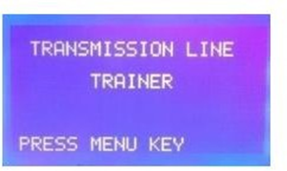

1. Press **MENU** button on Front Control unit.
2. Select Control Mode. Press MENU key for PC control mode.
3. Make sure that Software is running and press **ENTER**.
4. A continuous Window will be appeared throughout. 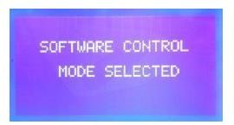
5. Connect USB cable in between PC and RFL-MMTLT System. **Double click the RFL- MMTLT icon to Run the Software in PC.**
6. Select the **COM PORT**: Click refresh button to update the COM port.
7. Select transmission line parameter.
8. Select resolution and frequency 1 mm & 900 MHz respectively.

# Click on RUN button to start experiment.

When we press RUN button motor starts running and signal sensing probe at port2 starts moving from 0 cm of transmission line towards 59 cm (Total 600 mm). After completion of this distance moving probe returns back to 0 cm position.

# Note: During the start of the experiment, if the moving probe position is not at 0 cm, you can still RUN the experiment. It automatically comes to 0 cm i.e., home position and then starts the experiment.

The sensor probe takes some minutes to complete its full rotation from generator to load The graph will display on screen. Save the graph on computer.

Go to **Settings > Plot settings** to initiate the markers.

Now on graph you can move the markers to find the Distance and Magnitude of particular Minima and maxima.

Keep Markers on two successive minima’s and press set.

# Put Z0 parameter is 27 (Note: This is impedance (Z0 = 27) of transmission line with LOAD termination which is measured on VNA at 900 MHz frequency).

Press Summery to get all the transmission Line Parameters for your selected Load Condition.

# Outputs:

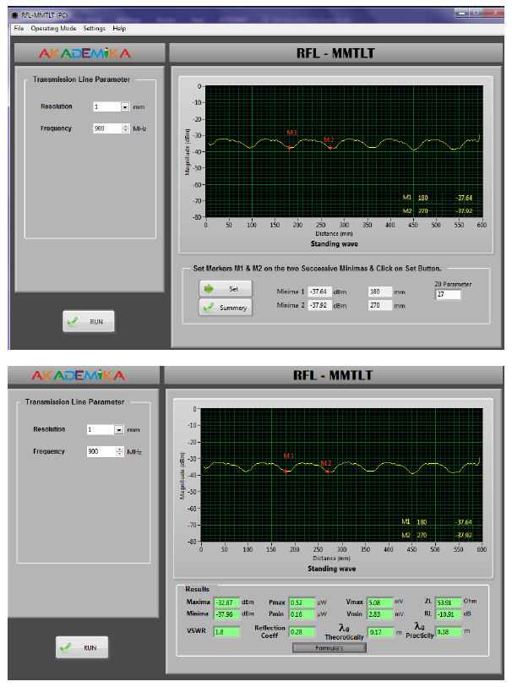

This is the standing wave when the frequency is 900 MHz and the transmission line is terminated by a load not equal to 0 or infinite. We have selected 2 points on the graph, M1 and M2. These are the two minima of the output.

The distance between them is (270 - 180) = 90 mm. They have almost the same magnitude in dB. Similarly, we could even calculate the distance between 2 maxima. We could do this experiment multiple times to get a more accurate result.

# Observation Table for Load Category:

|  |  |  |  |  |  |  |
| --- | --- | --- | --- | --- | --- | --- |
| **Frequency 900 MHz** | **1st Minima** | **1st Maxima** | **2nd Minima** | **2nd Maxima** | **3rd Minima** | **3rd Maxima** |
| **Location of Movable Port (cm)** | 18 | 22.5 | 27 | 31.5 | 36 | 40.5 |

**Step 1:**

Consider any adjacent minima and maxima,

* 1. Pmax = -32.97 dBm (second maxima)
  2. Pmin = -37.96 dBm (second minima)

# Step 2:

Convert to dbm to mW conversion Pout (mW) = 1000 x 10(dBm / 10)

1. Pmax (mW) = 0.516 mW

2. Pmin (mW) = 0.159 mW

# Step 3:

1. Calculation of Vmax:

Vmax = (Pmax * Zo)1/2

Vmax = 3.732 V

1. Calculation of Vmin:

Vmin = (Pmin * Zo)1/2

Vmin = 2.072 V

1. Calculation of VSWR:

VSWR = Vmax / Vmin

VSWR = 1.801

# Short Category:

Follow the same procedure as per the Open category except step number 4. Here at Port 3 Connect the SHORT termination condition and get the results.

# For Short Category Put Z0 parameter is 19 see annex 1

**(Note: This is the impedance (Z0 = 19) of transmission line with SHORT termination which is measured on VNA at 900 MHz frequency)**

Press Summary to get all the transmission Line Parameters for your selected Load Condition.

# Outputs:

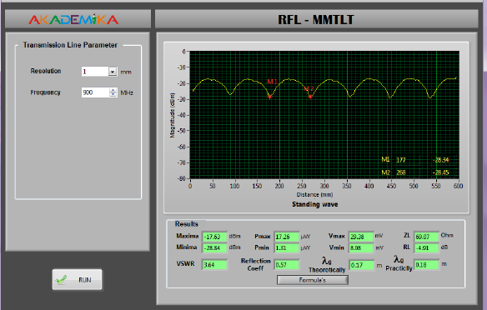

**Observation Table for Short Category:**

|  |  |  |  |  |  |  |
| --- | --- | --- | --- | --- | --- | --- |
| **Frequency 900 MHz** | **1st Minima** | **1st Maxima** | **2nd Minima** | **2nd Maxima** | **3rd Minima** | **3rd Maxima** |
| **Location of Movable Port (cm)** | 17.6 | 22.1 | 26.7 | 31.2 | 35.8 | 40.3 |

# Step 1:

Consider any adjacent minima and maxima,

* 1. Pmax = -17.63 dBm (second maxima)
  2. Pmin = -28.84 dBm (second minima)

# Step 2:

Convert to dbm to mW conversion Pout (mW) = 1000 x 10(dBm / 10)

1. Pmax (mW) = 17.258 mW

2. Pmin (mW) = 1.306 mW

# Step 3:

1. Calculation of Vmax:

Vmax = (Pmax * Zo)1/2

Vmax = 18.108 V

1. Calculation of Vmin:

Vmin = (Pmin * Zo)1/2

Vmin = 4.981 V

1. Calculation of VSWR:

VSWR = Vmax / Vmin

VSWR = 3.635

# Open Category:

Follow the same procedure as per Load category except step number 4. Here Connect Load (OPEN) to port 3 and observe the output.

# For OPEN Category Put Z0 parameter is 47 see annex 1 (Note: This is impedance (Z0 = 47 of transmission line with OPEN termination which is measured on VNA at 900 MHz frequency)

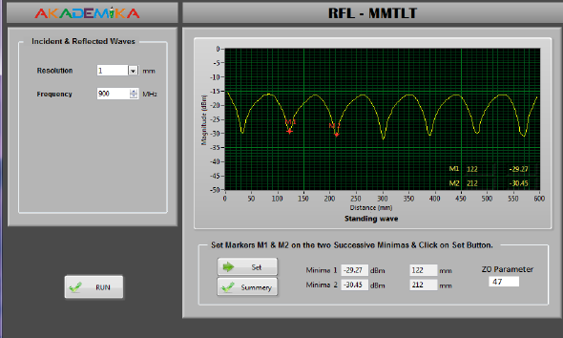**Outputs:**

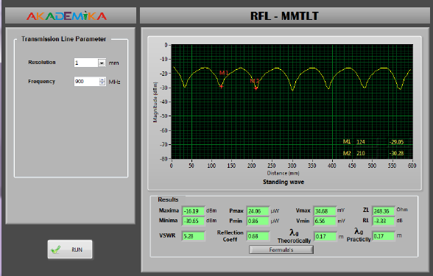

# Observation Table for Open Category:

|  |  |  |  |  |  |  |
| --- | --- | --- | --- | --- | --- | --- |
| **Frequency 900 MHz** | **1st Minima** | **1st Maxima** | **2nd Minima** | **2nd Maxima** | **3rd Minima** | **3rd Maxima** |
| **Location of Movable Port (cm)** | 12.2 | 16.7 | 21.2 | 25.7 | 30.2 | 34.7 |

**Step 1:**

Consider any adjacent minima and maxima,

* 1. Pmax = -16.19 dBm (second maxima)
  2. Pmin = -30.65 dBm (second minima)

# Step 2:

Convert to dbm to mW conversion Pout (mW) = 1000 x 10(dBm / 10)

1. Pmax (mW) = 24.044 mW

2. Pmin (mW) = 0.861 mW

# Step 3:

1. Calculation of Vmax:

Vmax = (Pmax * Zo)1/2

Vmax = 33.616 V

1. Calculation of Vmin:

Vmin = (Pmin * Zo)1/2

Vmin = 6.361 V

1. Calculation of VSWR:

VSWR = Vmax / Vmin

VSWR = 5.284

# Observation Table:

|  |  |  |  |
| --- | --- | --- | --- |
| **LOAD / TERMINATION** | **OPEN** | **SHORT** | **LOAD** |
| **Vmin** | 6.56 | 8.08 | 2.83 |
| **Vmax** | 34.68 | 29.38 | 5.08 |
| **VSWR** | 5.28 | 3.64 | 1.8 |
| **Load Impedance**  **(ZL)** | 248.36 | 69.07 | 53.91 |