**Module 7) WD - JQuery Basic, Effects & Advanced**

1. **What is JQuery?**

**ANS.** JQuery is a fast, small, and feature-rich JavaScript library. It makes things like HTML document traversal and manipulation, event handling, animation, and Ajax much simpler with an easy-to-use API that works across a multitude of browsers. With a combination of versatility and extensibility, JQuery has changed the way that millions of people write JavaScript. The main purpose of jQuery is to provide an easy way to use JavaScript on your website to make it more interactive and attractive. It is also used to add animation.

* jQuery is a small, fast and lightweight JavaScript library.
* jQuery is platform-independent.
* jQuery means "write less do more".
* jQuery simplifies AJAX call and DOM manipulation.

**The jQuery library contains the following features:**

* HTML/DOM manipulation
* CSS manipulation
* HTML event methods
* Effects and animations
* AJAX
* Utilities

1. **How to Apply CSS Using JQuery, How to Add Class and Remove Class in JQuery, JQuery Animation?**

**ANS.** To apply CSS properties using jQuery, use the css() method. It’s easy to apply any CSS property using jQuery method css( PropertyName, PropertyValue ).

Here is the syntax for the method −

selector.css( PropertyName, PropertyValue );

Example:-

<!DOCTYPE html>

<html>

<head>

<script src="https://ajax.googleapis.com/ajax/libs/jquery/3.6.1/jquery.min.js"></script>

<script>

$(document).ready(function(){

$("button").click(function(){

$("p").css("background-color", "yellow");

});

});

</script>

</head>

<body>

<h2>This is a heading</h2>

<p style="background-color:#ff0000">This is a paragraph.</p>

<p style="background-color:#00ff00">This is a paragraph.</p>

<p style="background-color:#0000ff">This is a paragraph.</p>

<p>This is a paragraph.</p>

<button>Set background-color of p</button>

</body>

</html>

**OUTPUT.**

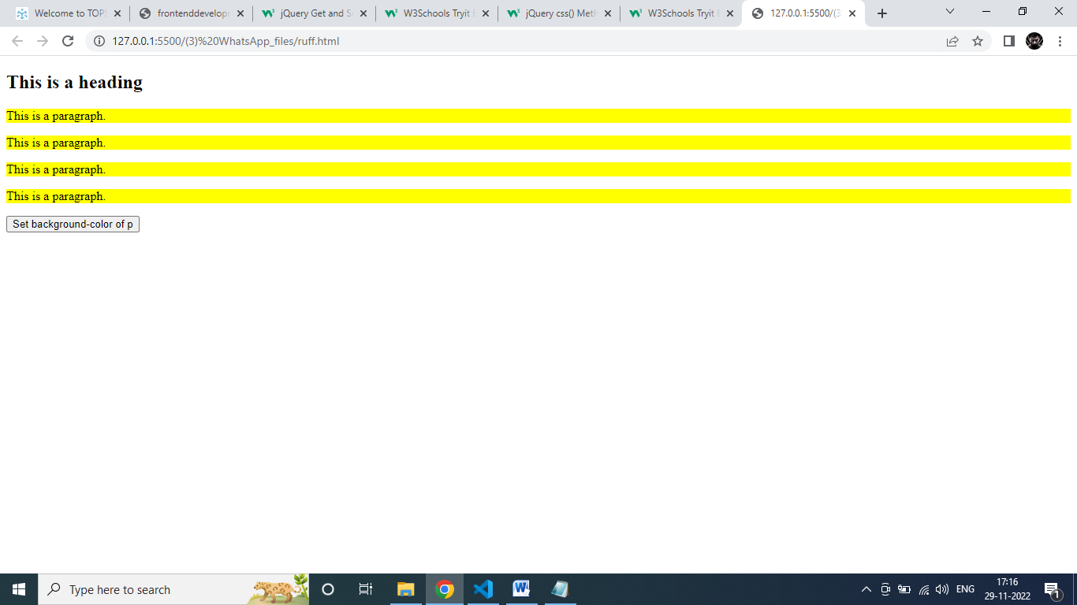

## jQuery addClass() Method

Example:-

<!DOCTYPE html>

<html>

<head>

<script src="https://ajax.googleapis.com/ajax/libs/jquery/3.6.1/jquery.min.js"></script>

<script>

$(document).ready(function(){

$("button").click(function(){

$("#div1").addClass("important blue");

});

});

</script>

<style>

.important {

font-weight: bold;

font-size: xx-large;

}

.blue {

color: blue;

}

</style>

</head>

<body>

<div id="div1">This is some text.</div>

<div id="div2">This is some text.</div>

<br>

<button>Add classes to first div element</button>

</body>

</html>

**OUTPUT:-**

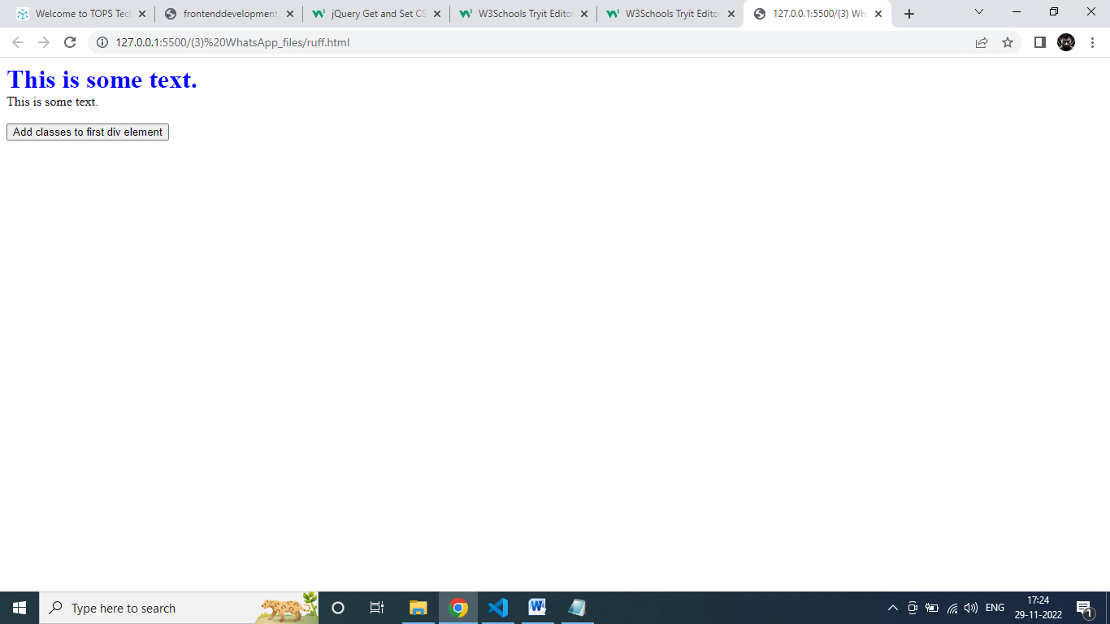

## jQuery removeClass() Method

### Example

## <!DOCTYPE html>

## <html>

## <head>

## <script src="https://ajax.googleapis.com/ajax/libs/jquery/3.6.1/jquery.min.js"></script>

## <script>

## $(document).ready(function(){

## $("button").click(function(){

## $("h1, h2, p").removeClass("blue");

## });

## });

## </script>

## <style>

## .blue {

## color: blue;

## }

## </style>

## </head>

## <body>

## <h1 class="blue">Heading 1</h1>

## <h2 class="blue">Heading 2</h2>

## <p class="blue">This is a paragraph.</p>

## <p>This is another paragraph.</p>

## <button>Remove class from elements</button>

## </body>

## </html>

OUTPUT:-

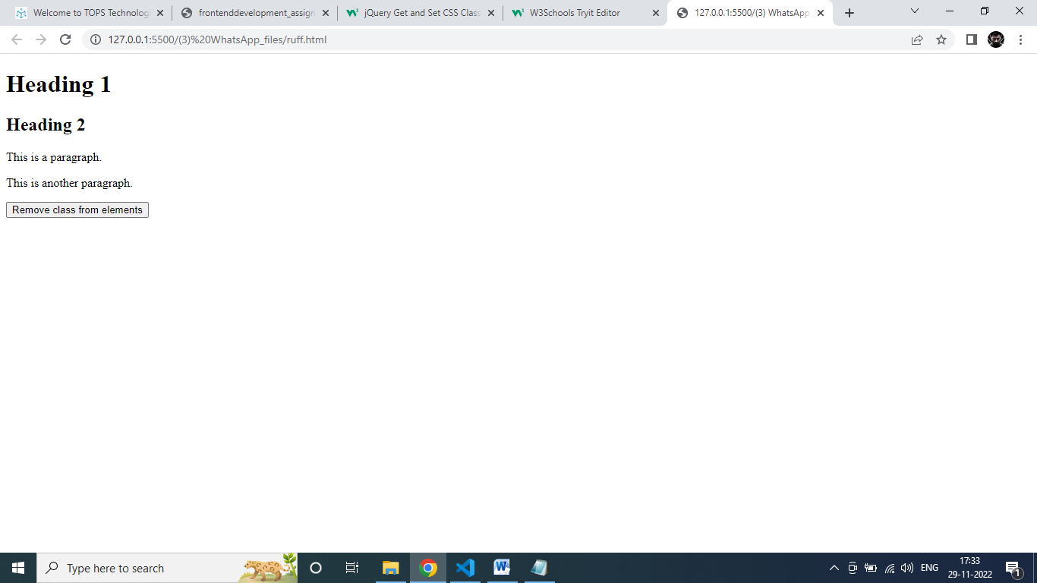

1. **How to create slider with animation?**

## ANS.

## jQuery Sliding Methods

With jQuery you can create a sliding effect on elements.

jQuery has the following slide methods:

slideDown()

slideUp()

slideToggle()

## jQuery slideDown() Method

The jQuery slideDown() method is used to slide down an element.

**Syntax:**

$(*selector*).slideDown(*speed,callback*);

The optional speed parameter specifies the duration of the effect. It can take the following values: "slow", "fast", or milliseconds.

The optional callback parameter is a function to be executed after the sliding completes.

The following example demonstrates the slideDown() method:

### Example

<!DOCTYPE html>

<html>

<head>

<script src="https://ajax.googleapis.com/ajax/libs/jquery/3.6.1/jquery.min.js"></script>

<script>

$(document).ready(function(){

$("#flip").click(function(){

$("#panel").slideDown("slow");

});

});

</script>

<style>

#panel, #flip {

padding: 5px;

text-align: center;

background-color: #e5eecc;

border: solid 1px #c3c3c3;

}

#panel {

padding: 50px;

display: none;

}

</style>

</head>

<body>

<div id="flip">Click to slide down panel</div>

<div id="panel">Hello world!</div>

</body>

</html>

OUTPUT:-

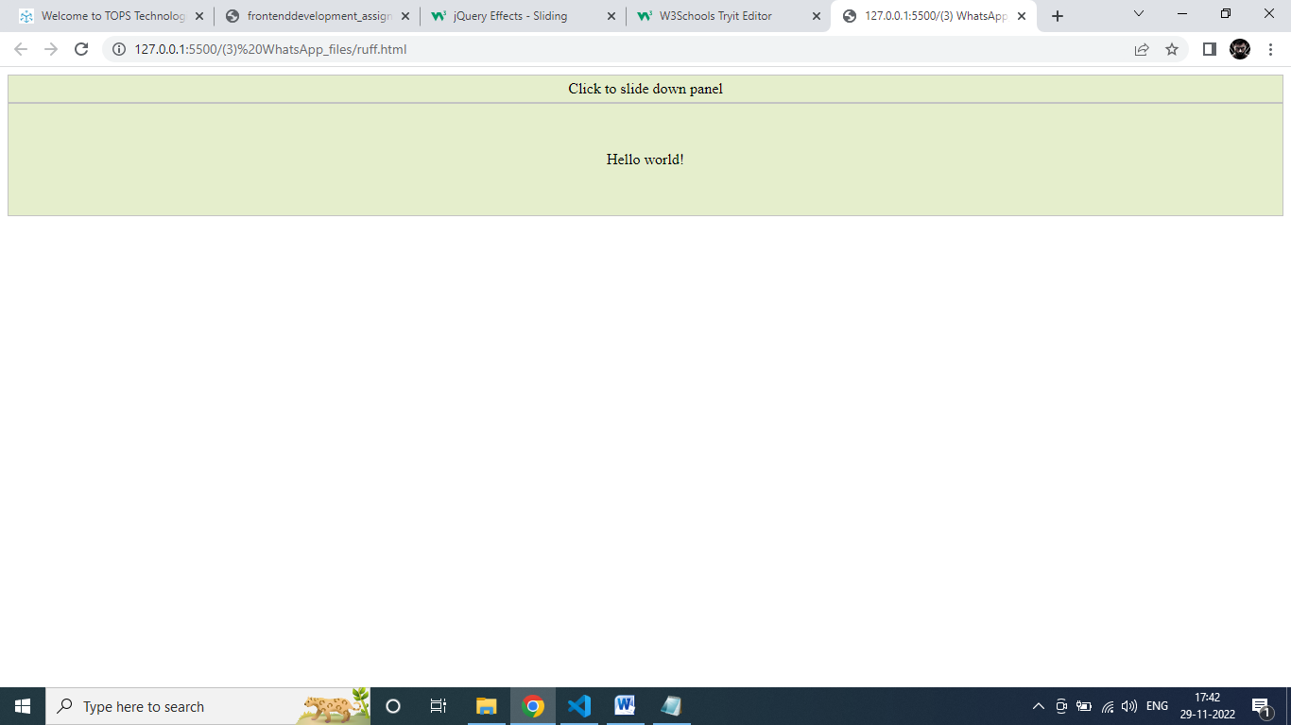

## jQuery slideUp() Method

The jQuery slideUp() method is used to slide up an element.

**Syntax:**

$(*selector*).slideUp(*speed,callback*);

The optional speed parameter specifies the duration of the effect. It can take the following values: "slow", "fast", or milliseconds.

The optional callback parameter is a function to be executed after the sliding completes.

The following example demonstrates the slideUp() method:

### Example

<!DOCTYPE html>

<html>

<head>

<script src="https://ajax.googleapis.com/ajax/libs/jquery/3.6.1/jquery.min.js"></script>

<script>

$(document).ready(function(){

$("#flip").click(function(){

$("#panel").slideUp("slow");

});

});

</script>

<style>

#panel, #flip {

padding: 5px;

text-align: center;

background-color: #e5eecc;

border: solid 1px #c3c3c3;

}

#panel {

padding: 50px;

}

</style>

</head>

<body>

<div id="flip">Click to slide up panel</div>

<div id="panel">Hello world!</div>

</body>

</html>

OUTPUT:-

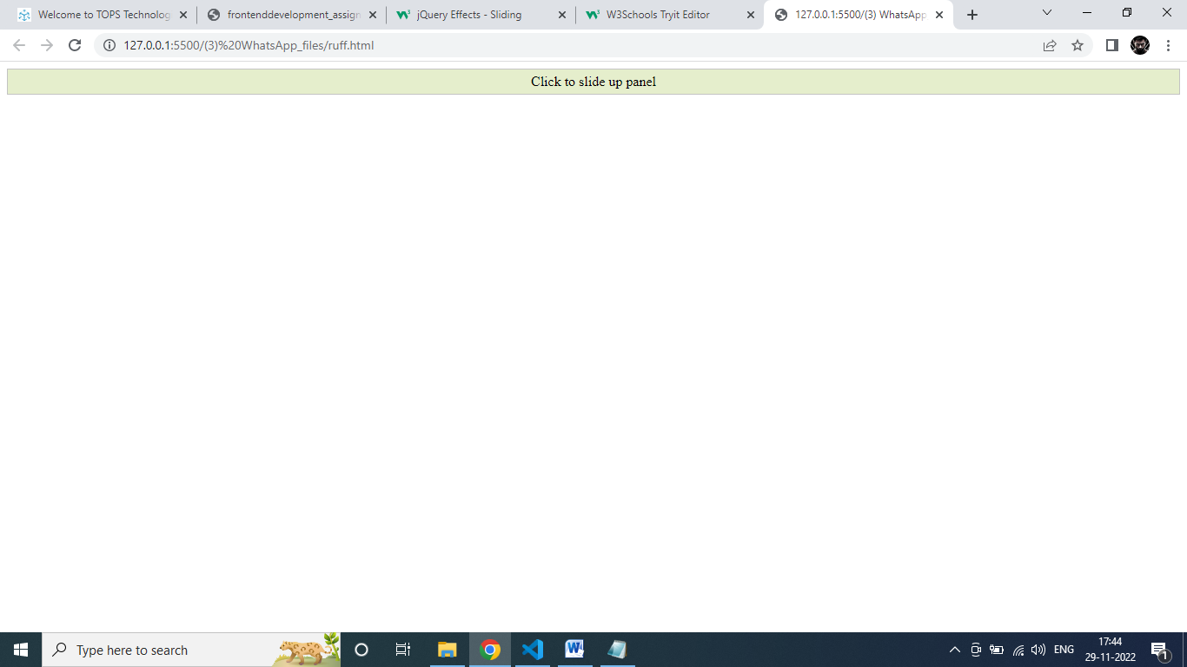

**jQuery slideToggle() Method**

The jQuery slideToggle() method toggles between the slideDown() and slideUp() methods.

If the elements have been slid down, slideToggle() will slide them up.

If the elements have been slid up, slideToggle() will slide them down.

$(*selector*).slideToggle(*speed,callback*);

The optional speed parameter can take the following values: "slow", "fast", milliseconds.

The optional callback parameter is a function to be executed after the sliding completes.

The following example demonstrates the slideToggle() method:

### Example

<!DOCTYPE html>

<html>

<head>

<script src="https://ajax.googleapis.com/ajax/libs/jquery/3.6.1/jquery.min.js"></script>

<script>

$(document).ready(function(){

$("#flip").click(function(){

$("#panel").slideToggle("slow");

});

});

</script>

<style>

#panel, #flip {

padding: 5px;

text-align: center;

background-color: #e5eecc;

border: solid 1px #c3c3c3;

}

#panel {

padding: 50px;

display: none;

}

</style>

</head>

<body>

<div id="flip">Click to slide the panel down or up</div>

<div id="panel">Hello world!</div>

</body>

</html>

OUTPUT:-

