**International Institute of Information Technology, Naya Raipur**

**Object Oriented Programming & Methodology (OOM)**

**Lab Assignment-08**

**TA: Mr. Nachiket Tapas**

**Date of assignment: 04/11/2016 Faculty: Prof. O. P. Vyas**

**Note:**

1. **All Assignments should be done independently.**
2. **Try to develop Object Oriented Thinking for the problem given.**
3. **Be Ready for line-by-line explanation of your code running on your system.**
4. Write a temperature conversion program that converts from Fahrenheit to Celsius. The Fahrenheit temperature should be entered from the keyboard (via a JTextField). A JLabel should be used to display the converted temperature. Use the following formula for the conversion:

$$Celsius=\frac{5}{9} ( Fahrenheit-32 )$$

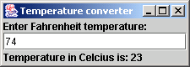

1. Enhance the temperature conversion program of previous exercise by adding the Kelvin temperature scale. The program should also allow the user to make conversions between any two scales. Use the following formula for the conversion between Kelvin and Celsius

$$Celsius=\frac{5}{9} ( Fahrenheit-32 )$$

$$Kelvin= Celsius+273.15$$

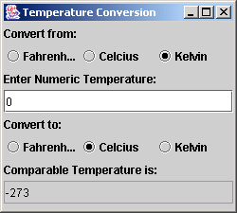

1. Write an application that allows the user to draw a rectangle by dragging the mouse on the application window. The upper left coordinate should be the location where the user presses the mouse button, and the lower right coordinate should be the location where the user releases the mouse button. Also display the area of the rectangle in a JLabel in the SOUTH region of a BorderLayout. Use the following formula for the area:

$$area=width ×height$$

