**Problem 1**

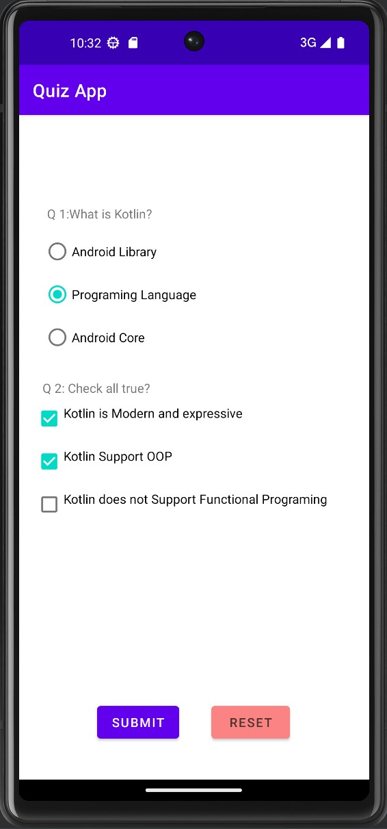

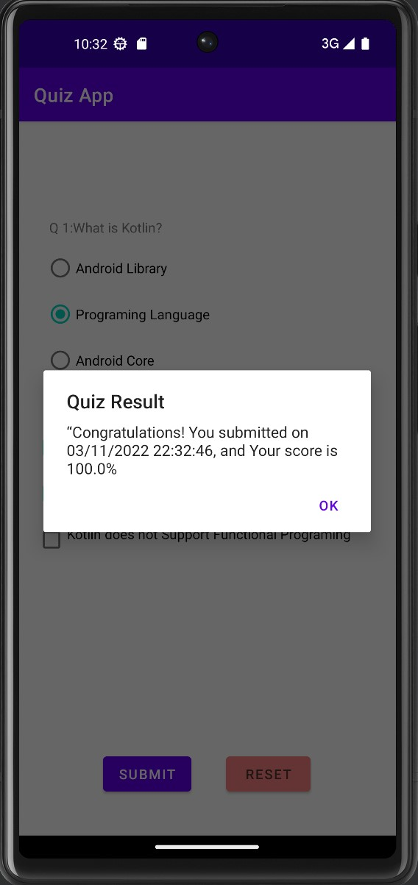

**Problem 2**

