Prog6221-Imaad Kajee

St10050486-Group2

Imaad Kajee

[Company name]  [Company address]

**Prog6221**

**Description**

**Prog6221 is a command-line application designed to help users manage and scale recipes. With this application, you can easily input the details of your recipe, view the full recipe with ingredients and steps, scale the recipe by a factor of your choice, reset quantities to their original values, and more.**

**Functionality**

**Gather Recipe Details: Enter the name of the recipe, the number of ingredients, details for each ingredient (name, quantity, unit), the number of steps, and details for each step.**

**Display Recipe: View the full recipe, including ingredients and steps, in a neat format.**

**Scale Recipe: Scale the recipe by a factor of 0.5 (half), 2 (double), or 3 (triple). All ingredient quantities will be adjusted accordingly.**

**Reset Quantities: Reset ingredient quantities to their original values after scaling.**

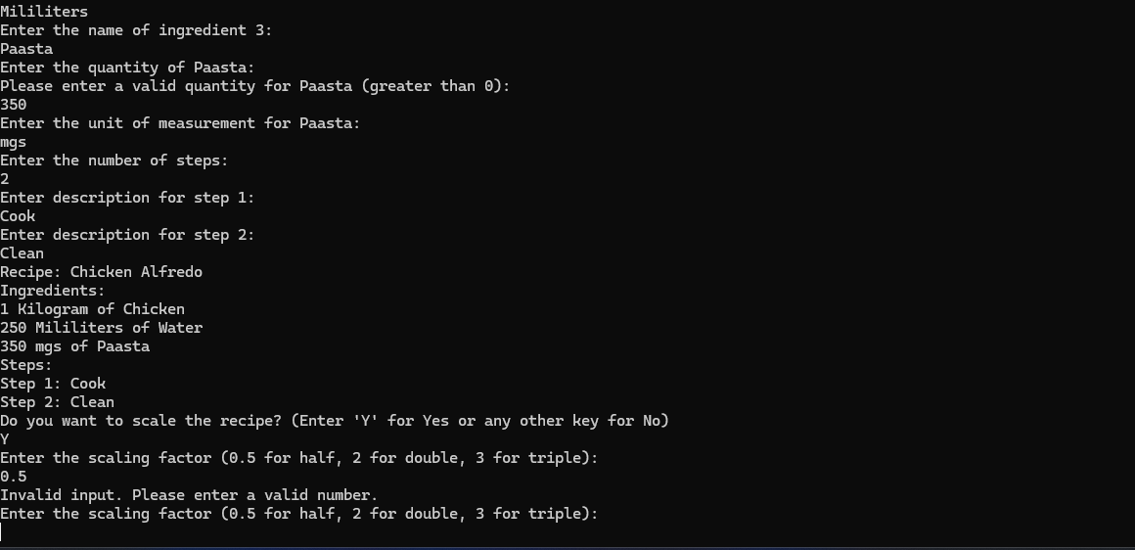**Clear Data: Clear all entered data to start inputting a new recipe.**

<https://github.com/imaadkajee/prog6221imadkajee.git>