STANDARD OPERATING PROCEDURE
AI-Powered SOC Automation Workflow
Wazuh SIEM • n8n • Google Gemini AI • VirusTotal • Jira Cloud • PostgreSQL
Prepared by
Muhammad Imaad Ul Haq
Security Operations Center (SOC) Automation Project

1. Document Control
Document Title | AI-Powered SOC Automation Workflow — Standard Operating Procedure
Author | Muhammad Imaad Ul Haq
Role | SOC Analyst / Security Automation Engineer
Project Type | Personal / Portfolio Cybersecurity Project
Environment | Ubuntu WSL, Docker, Wazuh Single-Node Deployment

2. Purpose
This document describes the design, architecture, and operational procedure of an end-to-end Security Operations Center (SOC) automation workflow built to reduce manual analyst workload and accelerate incident response. In simple terms, the project takes a security alert that would normally require a human analyst to manually read, research, and document, and instead has a machine do most of that groundwork automatically, in seconds, before handing the analyst a ready-to-work case.
The workflow ingests security alerts from Wazuh SIEM (Security Information and Event Management), enriches them with threat intelligence and AI-generated analysis, and automatically creates a structured, ready-to-investigate case in Jira with supporting records stored in PostgreSQL and a notification sent to the responsible analyst by email.
The objective is to demonstrate, in a realistic and reproducible way, how SIEM platforms, workflow automation tools, large language models (LLMs), and case-management systems can be combined to streamline triage while keeping human analysts focused on higher-value investigative decisions rather than repetitive data-gathering tasks.

3. Background and Problem Statement
In a typical SOC, every alert generated by a SIEM has to be triaged by a human analyst before any action is taken. Triage usually involves the same repetitive set of tasks: reading the raw alert, pulling out the relevant indicators (hostnames, IP addresses, file paths, process names), checking those indicators against threat intelligence sources, writing up a summary of what happened and how risky it is, opening a ticket in a case-management tool, and notifying the right people. When alert volumes are high, this manual process becomes a bottleneck — analysts spend more time on data collection and formatting than on actual decision-making, and lower-priority alerts can sit unreviewed for longer than they should.
This project was built to address that bottleneck directly. Rather than replacing the analyst, the automation acts as a force multiplier: it performs the repetitive triage work (parsing, enrichment, summarization, documentation) automatically and consistently, every time, so that by the time a human analyst opens the ticket, the investigation has already been started for them.

4. Scope
This SOP covers the complete lifecycle of a security alert from the moment it is generated by Wazuh through to ticket creation, AI-assisted investigation notes, database logging, and analyst notification. It applies to alerts that meet the configured severity threshold and are routed into the automation pipeline.

5. Technology Stack
The table below lists every tool used in the project, along with a plain-language explanation of what it does and why it was chosen, alongside the technical role it plays in the pipeline.
Wazuh SIEM | The detection engine. In simple terms, it watches activity on endpoints and raises an alarm when something looks suspicious. Technically, it ingests logs, evaluates them against a rule set, and assigns each match a severity level.
n8n | The “glue” that connects every other tool together. It is a visual, node-based workflow automation engine — think of it as an assembly line where each station (node) performs one task and passes its output to the next.
Google Gemini AI | The “brain” of the workflow. A large language model that reads the raw alert and enrichment data and writes a human-readable investigation summary, much like a junior analyst drafting notes before handing the case to a senior analyst.
VirusTotal API | A threat-intelligence lookup service. It checks whether an indicator (such as an IP address) has a known bad reputation, similar to checking a phone number against a spam-call database.
Jira Cloud | The case-management system where the actual investigation ticket lives, gets assigned, and is tracked through to closure.
PostgreSQL | The system of record — a relational database that keeps a permanent, independently queryable log of every incident, separate from Jira or email, for audit and reporting purposes.
Gmail API | The notification channel used to alert the on-call analyst by email as soon as a case is ready.
Windows Sysmon | An endpoint-level logging tool that records detailed system activity (process creation, file events, network connections) far beyond what Windows logs by default — this is the raw data Wazuh analyzes.
PowerShell | The scripting environment used on the test endpoint to simulate the suspicious activity that triggered the detection rule.
Docker | Used to run Wazuh and PostgreSQL as isolated, reproducible containers rather than installing them directly on the host.
Ubuntu WSL | The Linux environment (Windows Subsystem for Linux) used to host Docker and run the Wazuh single-node deployment.

6. High-Level Architecture
The pipeline is implemented as a linear, event-driven n8n workflow triggered by a Wazuh webhook. In plain terms, nothing happens until Wazuh actually detects something suspicious; the moment it does, that single event automatically sets off a chain reaction of nine connected steps, each one adding more context to the case before passing it forward. There is no manual intervention required between detection and the analyst receiving a ready-to-work case in their inbox and ticketing system.
Technically, this is a webhook-driven, stateless automation: each execution of the workflow is independent, carries its own data payload from node to node, and does not depend on any previous run. This makes the pipeline predictable and easy to troubleshoot — if one alert fails to process correctly, it has no effect on alerts processed before or after it.
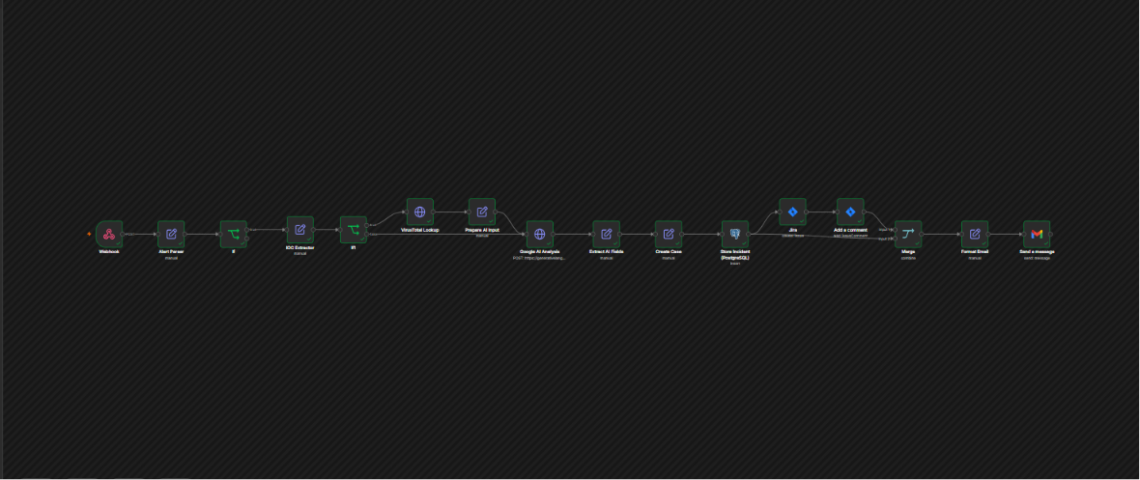
Figure 1: End-to-end n8n automation workflow overview.
Workflow sequence:
- Wazuh SIEM generates a security alert and triggers a webhook.
- n8n receives the webhook and parses the raw alert payload.
- Indicators of Compromise (IOCs) are extracted from the alert data.
- Extracted IP addresses are checked against VirusTotal for reputation data.
- The enriched alert and VirusTotal results are passed to Google Gemini AI for analysis.
- Gemini AI returns a structured investigation summary, risk rating, and recommended actions.
- A case record is created and an incident entry is stored in PostgreSQL.
- A Jira ticket is created for the case, and the AI investigation summary is added as a comment.
- A formatted notification email is sent to the on-call SOC analyst.

7. Detailed Process Workflow

7.1 Alert Detection (Wazuh SIEM)
Wazuh continuously monitors endpoint telemetry collected via Sysmon and Windows Event Logs. In simple terms, every action that happens on the monitored computer — a new process starting, a file being created, a registry key changing — is recorded and sent to Wazuh for inspection. When a monitored host exhibits suspicious behavior, Wazuh's rule engine evaluates the event against its detection rule set (a large library of known attack patterns and behaviors) and generates an alert if a rule is matched.
Each Wazuh alert carries a severity score from 0 to 15, where higher numbers indicate greater risk, along with a rule description and, where applicable, a mapping to the MITRE ATT&CK framework — an industry-standard catalogue of attacker tactics and techniques. This mapping is what allows the AI and the analyst to immediately understand not just “what happened” but “what category of attack technique this resembles.”
In the validation scenario used to test this workflow, rule ID 92213 (“Executable file dropped in folder commonly used by malware”) was triggered at the maximum severity level of 15 on host LAPTOP-EGEQKF5L, mapped to MITRE ATT&CK technique T1105 (Ingress Tool Transfer) under the Command and Control tactic. In plain language: a script file was created in a location attackers commonly use to stage malicious tools, which is exactly the kind of activity this rule exists to catch.
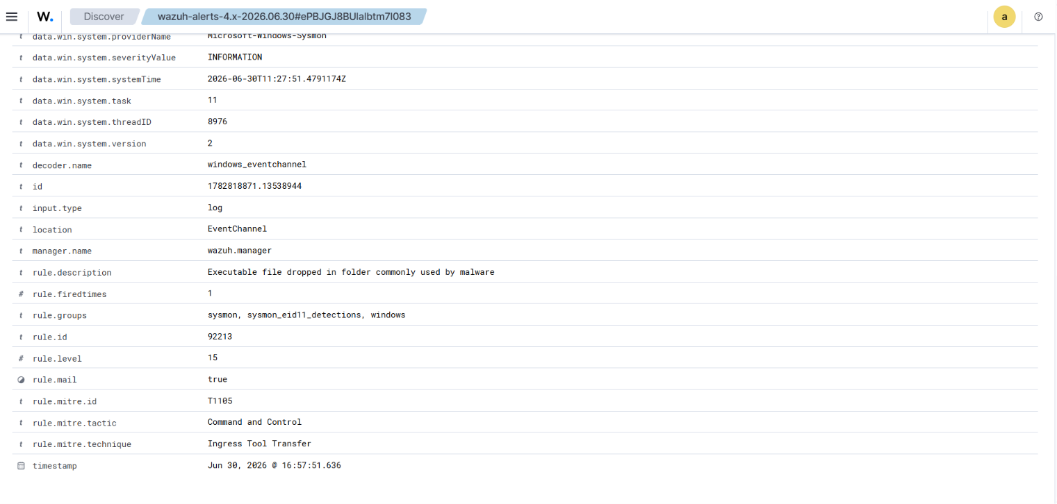
Figure 2: Raw Wazuh alert detail as viewed in Discover, showing rule metadata and MITRE ATT&CK mapping.

7.2 Alert Ingestion and Parsing (n8n)
A Wazuh-configured webhook forwards qualifying alerts to an n8n workflow endpoint as soon as they fire — essentially, Wazuh “taps n8n on the shoulder” the instant it detects something. The “Alert Parser” node then normalizes the raw JSON payload into a consistent structure that the rest of the workflow can work with, regardless of which specific Wazuh rule triggered it.
A filter (“IF”) node then checks the alert against severity thresholds before allowing it to continue through the pipeline. This is an important cost and noise control: it ensures the AI analysis, ticketing, and notification stages only run for alerts that genuinely warrant analyst attention. Alerts that do not meet the threshold are discarded at this stage and never reach a human inbox, preventing alert fatigue.

7.3 IOC Extraction
The “IOC Extractor” node parses the normalized alert to pull out Indicators of Compromise (IOCs) relevant to investigation — the specific, concrete facts an analyst needs rather than the full raw log. This includes the hostname, username, source IP, process path, dropped file path, rule ID, event ID, and the associated MITRE ATT&CK technique ID. Structuring these fields up front means every later stage (VirusTotal, the AI, Jira, the database) can reference exactly the same, clean data.

7.4 Threat Intelligence Enrichment (VirusTotal)
Extracted IP addresses are submitted to the VirusTotal API for a reputation lookup. VirusTotal aggregates results from dozens of antivirus engines and threat-intelligence feeds and returns a detection ratio (for example, 0 out of 91 engines flagging it) along with a reputation score. This step answers a simple question for the analyst: “Is this IP address already known to be bad?”
For internal/private IP ranges — such as 172.22.32.1 in the validation test — VirusTotal has limited or no reputation data, since private addresses are not publicly routable and therefore are not something external threat feeds would have visibility into. The workflow does not treat this as a failed lookup; instead, the AI analysis stage notes the limitation explicitly so the analyst is not misled into thinking a clean VirusTotal result means the activity itself is safe.

7.5 AI-Driven Analysis (Google Gemini)
The enriched alert, including IOC data and VirusTotal results, is formatted into a structured prompt and sent to Google Gemini AI. This is the step that turns raw technical data into something readable: rather than handing the analyst a wall of field names and values, Gemini writes the equivalent of a junior analyst's case notes.
Gemini returns a multi-part analysis consisting of an executive summary in plain English, a risk assessment (Risk, Priority, and the specific reason the rule fired), an analyst confidence rating, detailed investigation findings describing exactly what the evidence shows and what remains unverified, a list of recommended actions, and a step-by-step investigation playbook tailored to the specific alert — effectively a checklist telling the human analyst exactly which logs to pull next and in what order.
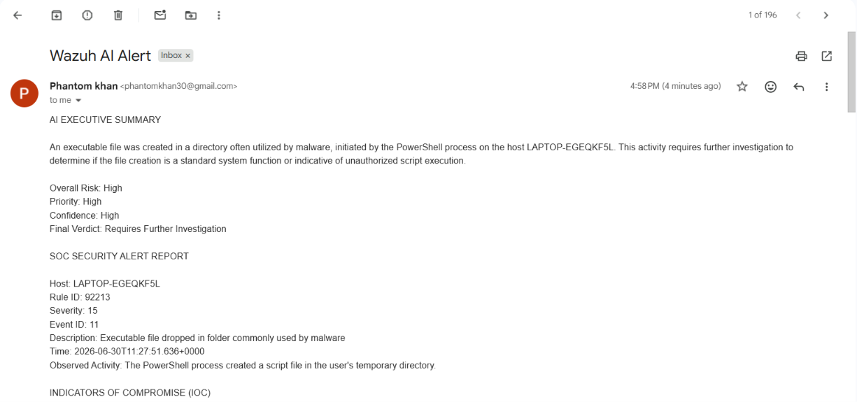
Figure 3: AI-generated executive summary and SOC alert report delivered by email.
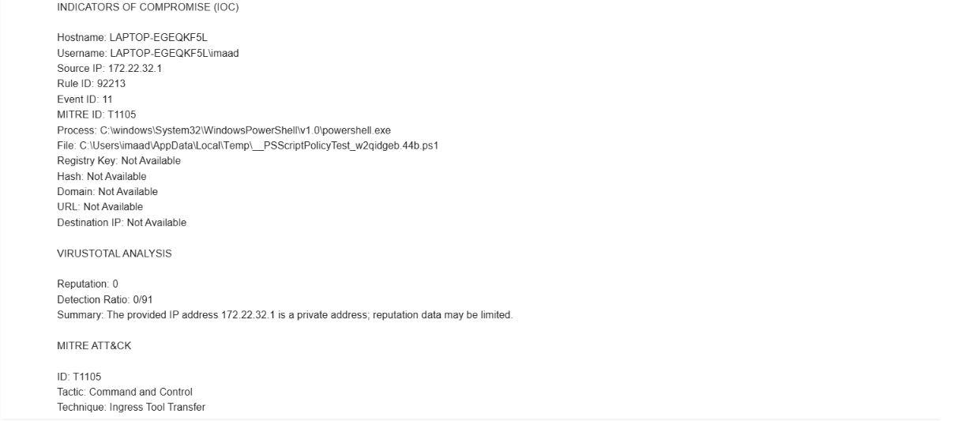
Figure 4: AI-compiled IOC listing, VirusTotal analysis, and MITRE ATT&CK mapping.
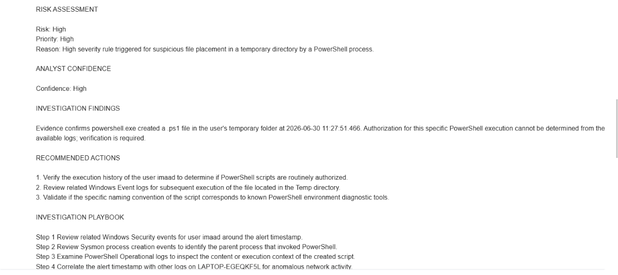
Figure 5: AI risk assessment, investigation findings, recommended actions, and investigation playbook.

7.6 Case Creation and Incident Logging (PostgreSQL)
A unique case ID is generated using a timestamp-based format (SOC-YYYYMMDD-HHMMSS, e.g. SOC-20260630-072811) and a record is written to the soc_incidents table in PostgreSQL, capturing the case ID, description, severity, priority, status, and creation timestamp.
This step exists independently of Jira and email for a specific reason: tickets can be deleted, edited, or closed, and inboxes can be cleaned out, but the database entry remains untouched as a permanent system of record. This gives the SOC a reliable source of truth for later reporting — for example, calculating how many high-severity incidents occurred in a given week — that does not depend on the state of any single ticket or mailbox.
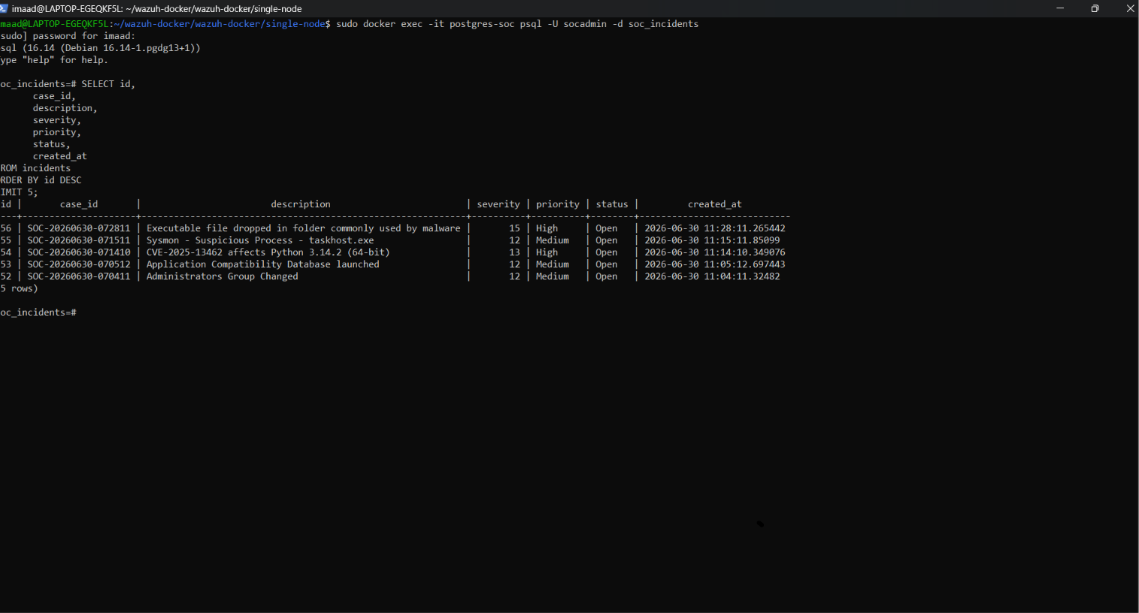
Figure 6: Incident records stored in the PostgreSQL soc_incidents table, queried via psql.

7.7 Jira Ticket Creation
A Jira ticket is automatically created in the operations project, pre-populated with the executive summary, host, severity, risk rating, priority, MITRE technique, and verdict — all of the context an analyst would otherwise have had to type in manually. The ticket is labeled for searchability (e.g., ai, mitre-t1105, severity-high, soc, wazuh, windows) so that, over time, the SOC can filter and report on incidents by technique, severity, or source, and is assigned to the Tier-1 SOC analyst queue with a default priority for triage.
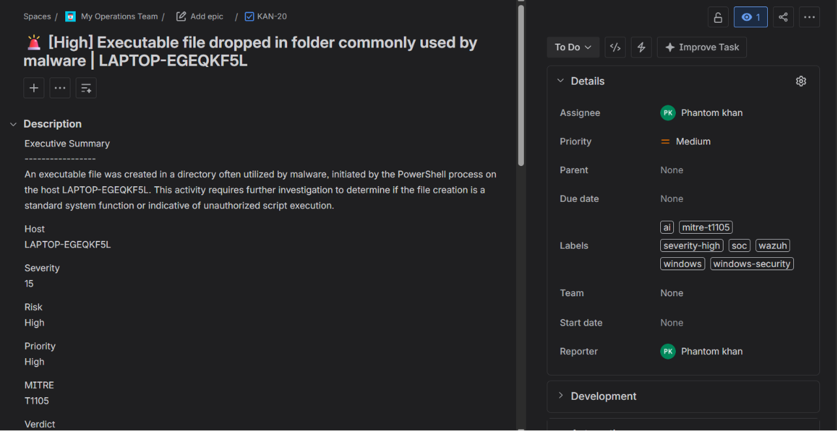
Figure 7: Auto-generated Jira ticket (KAN-20) with case details and labels.

7.8 AI Investigation Comment in Jira
Immediately after ticket creation, the full AI investigation summary generated in step 7.5 is posted as a comment on the Jira ticket. This means the analyst never has to leave their normal ticketing tool to find the AI's findings — there is no need to cross-reference the email or query the database manually, since everything they need to start working the case is already attached to the ticket itself.
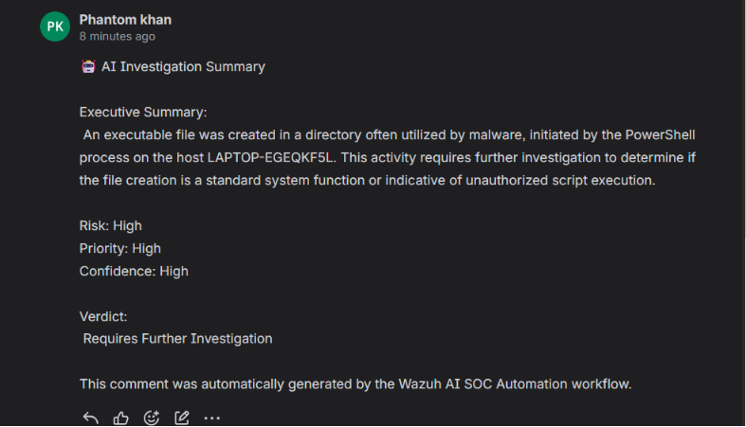
Figure 8: AI investigation summary automatically posted as a Jira comment.

7.9 Case Management Summary and Analyst Notification
A final formatted email is sent to the SOC analyst summarizing case management details (case ID, status, assignee, priority, creation time, source) and a direct link to the corresponding Jira ticket, along with an automated incident timeline showing the time taken for each pipeline stage (alert received, IOC extracted, VirusTotal lookup completed, and so on). This timeline doubles as a built-in performance metric: because every timestamp is logged automatically, the SOC can later measure exactly how fast the pipeline reacts to an incoming alert, end to end, without needing separate monitoring tooling.
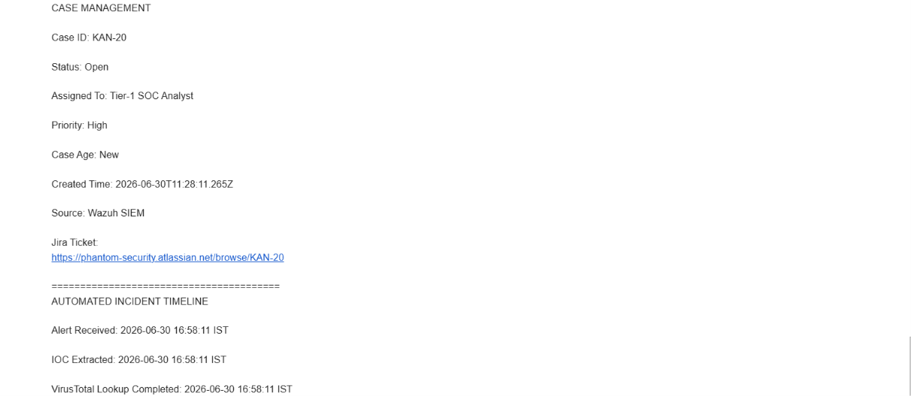
Figure 9: Case management summary and automated incident timeline included in the analyst notification email.

8. Validation Test Case
The workflow was validated end-to-end using a controlled high-severity scenario: a PowerShell process creating an executable/script file inside a directory commonly associated with malware staging (the user's Temp folder) on host LAPTOP-EGEQKF5L.
Host | LAPTOP-EGEQKF5L
User | imaad
Rule ID / Severity | 92213 / Level 15
MITRE ATT&CK | T1105 — Ingress Tool Transfer (Command and Control)
Dropped File | C:\Users\imaad\AppData\Local\Temp\__PSScriptPolicyTest_w2qidgeb.44b.ps1
AI Verdict | Requires Further Investigation (Risk: High, Confidence: High)
Jira Ticket | KAN-20
PostgreSQL Case ID | SOC-20260630-072811
All nine pipeline stages, from Wazuh alert detection through to email notification, completed successfully and were confirmed against the Wazuh Discover view, n8n execution log, Gmail inbox, Jira ticket, and a direct PostgreSQL query, as documented in Figures 1 through 9.

9. Key Features
- Automated Wazuh alert ingestion via webhook
- Indicator of Compromise (IOC) extraction from raw security events
- VirusTotal enrichment for threat intelligence context
- AI-generated executive investigation summaries using Google Gemini
- Automatic Jira ticket creation with structured metadata and labels
- AI investigation notes posted directly as Jira comments
- Persistent incident logging in PostgreSQL for audit and reporting
- Automated, formatted email notifications to SOC analysts

10. Skills Demonstrated
- SOC Analysis and SIEM Operations
- Security Automation and Workflow Orchestration
- Threat Investigation and Incident Response
- Threat Intelligence Integration
- AI-Assisted SOC Workflows
- IOC Analysis and MITRE ATT&CK Mapping
- Jira Integration and Case Management
- Database Management (PostgreSQL)

11. Roles and Responsibilities
Workflow Owner | Muhammad Imaad Ul Haq — designs, builds, and maintains the n8n automation pipeline
Tier-1 SOC Analyst | Reviews auto-generated Jira tickets, validates AI findings, executes the investigation playbook
System Administrator | Maintains Wazuh, Docker, PostgreSQL, and n8n infrastructure availability

12. Future Enhancements
The workflow is under continuous improvement. Planned enhancements include:
- Additional threat intelligence enrichment sources beyond VirusTotal
- Analyst decision nodes for human-in-the-loop approval before automated actions
- Automated response capabilities (e.g., host isolation, account disablement)
- Expanded detection coverage across additional Sysmon and Windows Event rule sets

13. Glossary of Terms
A short reference for non-technical readers of this document.
SIEM | Security Information and Event Management — a system that collects logs from many sources and flags suspicious activity.
Alert / Rule | A notification that the SIEM has matched activity against a known pattern of concern, weighted with a severity score.
IOC | Indicator of Compromise — a specific, concrete artifact (IP address, file path, hash, etc.) that may be evidence of malicious activity.
MITRE ATT&CK | An industry-standard, publicly maintained knowledge base that catalogues known attacker tactics and techniques (e.g., T1105 = Ingress Tool Transfer).
Webhook | An automated message one system sends to another the moment something happens, without anyone needing to check manually.
LLM / Generative AI | A large language model — an AI system trained to read and generate human-like text, used here to write investigation summaries.
Triage | The initial review of an alert to decide how serious it is and what should happen next.
Enrichment | Adding extra context (such as a reputation score) to raw alert data to make it more useful for decision-making.

14. Conclusion
This project demonstrates a practical, working implementation of an AI-augmented SOC automation pipeline that integrates SIEM detection, threat intelligence, generative AI analysis, case management, and persistent incident logging into a single automated flow. In simple terms, it takes the slow, repetitive part of an analyst's job and hands it to a machine, while keeping the analyst firmly in charge of the final decision.
By automating triage, enrichment, and documentation, the workflow reduces analyst response time and allows SOC personnel to focus on validation and response decisions rather than manual data gathering. The successful end-to-end validation test confirms that the pipeline behaves reliably under a realistic, high-severity scenario, and the modular n8n design means new enrichment sources, decision points, or response actions can be added in future without redesigning the workflow from scratch.
Prepared and documented by Muhammad Imaad Ul Haq.

