## Criterion D: Product design—Overall structure

Relationships

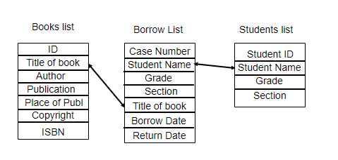

Login Page

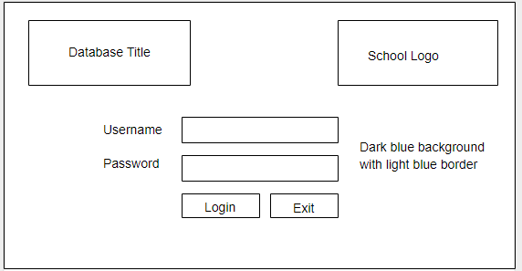

User Input

Navigation Buttons

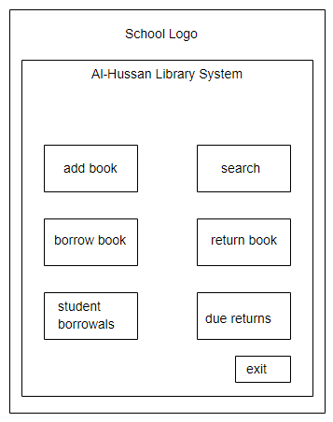

Main Menu:

Macros

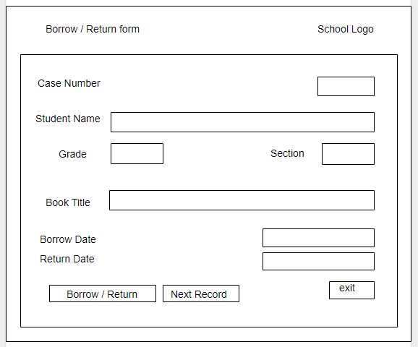

Borrow and Returning forms

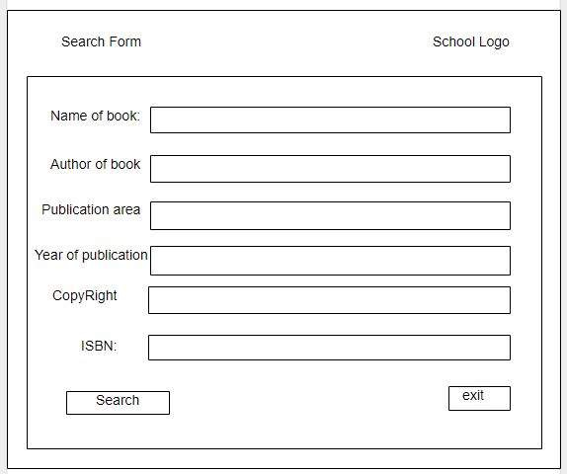

Search books Form:

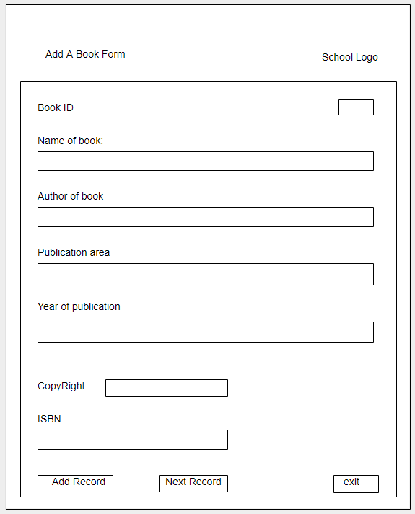

Add book form:

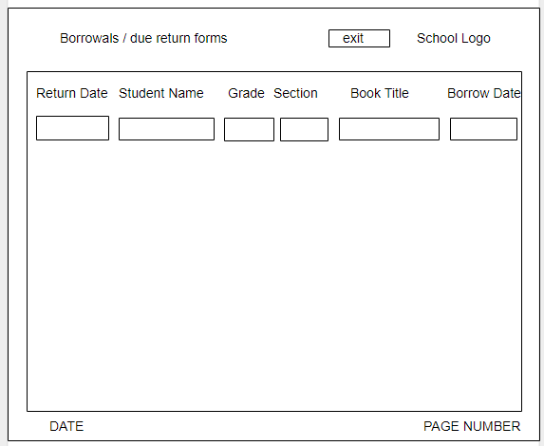

Reports

Tables:

Book Table:

|  |  |  |
| --- | --- | --- |
| Field | Data Type | Validation |
| Book ID | AutoNumber | Presence Check |
| Title of book | Text | Presence Check, Format Check |
| Author | Text | Presence Check, Format Check |
| Publication | Text | Presence Check, Format Check |
| Place of Publ | Text | Presence Check, Format Check |
| Copyright | Number | Presence Check, Format Check, Length Check |
| ISBN | Text | Presence Check, Format Check |

Students Table:

|  |  |  |
| --- | --- | --- |
| Field | Data Type | Validation |
| Student ID | Number | Presence Check, Length Check, Format Check |
| Student Name | Text | Presence Check, Format Check |
| Grade | Number | Presence Check, Format Check |
| Section | Text | Presence Check, Format Check |

Borrow Table:

|  |  |  |
| --- | --- | --- |
| Field | Data Type | Validation |
| Case Number | AutoNumber | Presence Check |
| Student Name | Text | Presence Check, Format Check |
| Grade | Text | Presence Check, Format Check |
| Section | Text | Presence Check, Format Check, Length Check |
| Title of book | Text | Presence Check, Format Check |
| Borrow Date | Date/Time | Presence Check, Format Check |
| Return Date | Date/Time | Presence Check, Format Check |

## Internal structure

### List of resources and techniques

|  |  |
| --- | --- |
| **Resources** | **Details** |
| **Students List** | **The name of every student in the school with their school ID, grade and section.** |
| **Books List** | **The name of available books with their authors, and if it’s available or not** |

|  |  |
| --- | --- |
| **Techniques** | **Details** |
| **Validation Checks** | **To make sure data is correct** |
| **Calculations** | **To calculate upcoming due dates and deadlines** |
| **Queries** | **To filter and find specific needed data, as well as searching methods to find specific items** |
| **Forms and reports** | **Usage of easy to read and use forms and reports for needed data** |
| **Relationships** | **Reduce and prevent redundancy** |
| **Adept design** | **Design does not confuse the user and is easy to read and go through** |
| **Navigation buttons and menu** | **To make UI more friendly to the user** |

## Test plan

|  |  |  |  |  |  |  |
| --- | --- | --- | --- | --- | --- | --- |
| Test item | Test data | Part of system tested | Expected outcome | Actual outcome | Comments | Ref in product |
| **Cover page testing – REQUIRED ELEMENT FOR CRITERION G** | | | | | | |
| **Web pages load from the cover page in three different locations** | **File naming to ensure home page is called Index.htm** | **Links on cover page are relative** | **Loads as required from 3 different locations** |  |  |  |
| **Product testing** | | | | | | |
| **Queries** | **Correct fields presented** | **Queries** | **Working order** | **Working** |  |  |
| **Forms** | **Correct assignment of data** | **Forms** | **Working order** | **Working** |  |  |
| **Reports** | **Requested data is presented clearly** | **Reports** | **Working order** | **Working** |  |  |
| **Relationships** | **Connected as appropriate** | **Relationships** | **Working order** | **Working** |  |  |
| **Validation** | **Fields are in correct data type** | **Input data** | **Working order** | **Working** |  |  |
| **Navigation Buttons** | **Buttons lead to expected data** | **Input data** | **Working order** | **Working** |  |  |

## Agreement of client

**(Client)**

I confirm that the requirement specification meets my needs and the designs above are appropriate for the creation of the product.