## Criterion B: Design

Website design and layout

Home Page Layout:

Home Page

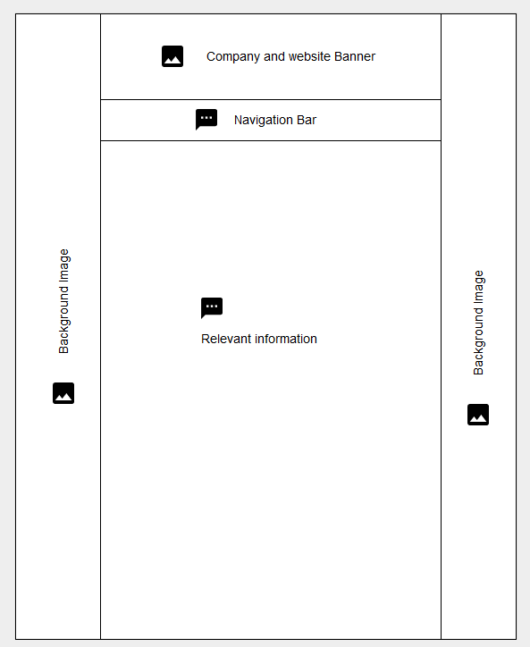

Figure

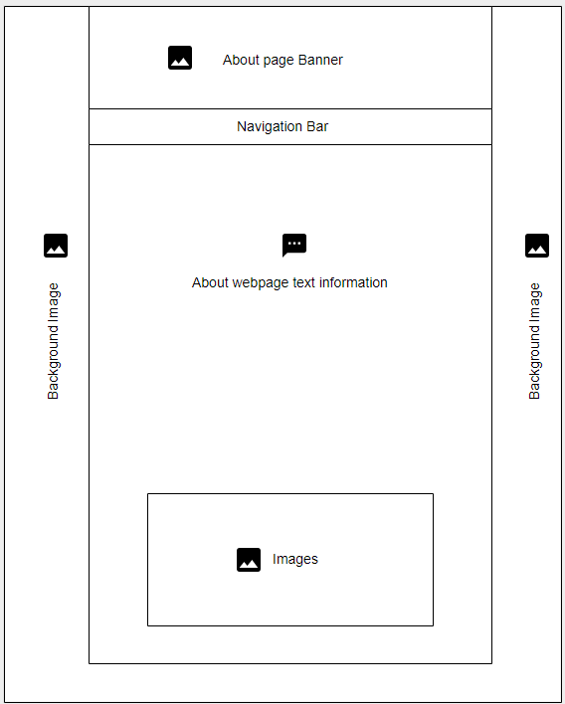

About page

Figure

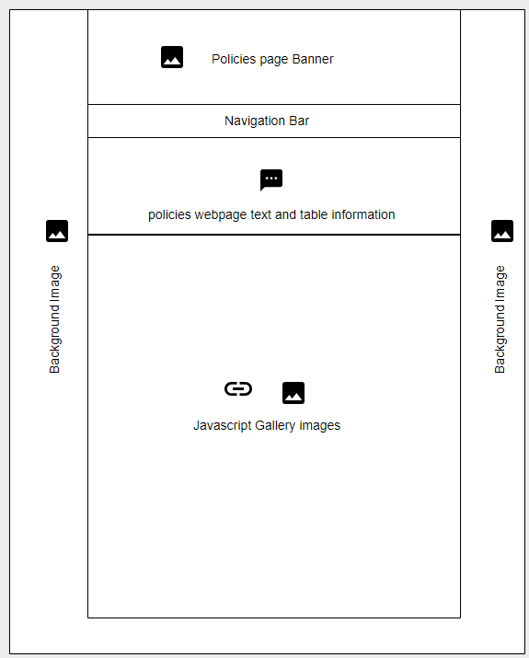

Policies page

Figure

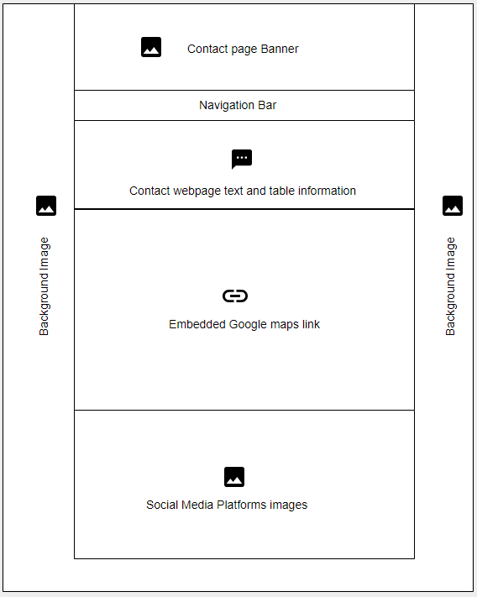

Contacts page

Figure

The home page’s objective is to provide the necessary information to give the visitor of the site an overall understanding of the company, including the company’s description, its services and its policies. The navigation bar under the banner will be the main method of traversing the webpages

Website Flow

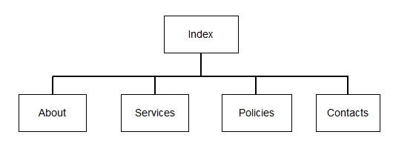

Figure

Test Plan

The website will have to be tested through multiple ways to guarantee and achieve the success criteria which overall dictates how successful the site is to the client’s needs and purposes.

|  |  |  |
| --- | --- | --- |
| Test | Test Description | Expected Outcome |
| Website is fully navigated and explored by a tester | The tester tries to navigate to the information he deems most necessary without getting lost | The tester is able to go through the website and find exactly what he needs easily |
| Tester tests out text readability (Colour, size, font) | The tester will try to look for any writing in the website that is not clear to read. | The tester finds nothing that takes a lot of effort to read |
| Accessibility across most browsers | The tester will test out the site using multiple browsers, to see if the design layout still holds | The website is perfectly compatible with most browsers |
| Content Relevancy | The tester will read out each page and try to find any irrelevant information on a subpage | All content and text information is relevant and put exactly where they should be |
| Javascript functionality | The tester will try out the javascript functions of the site, such as mousing over the navigation menu and highlighted buttons | Javascript functions on the site are working properly without any errors |
| Page flow and links connected correctly | The tester will make sure that each page is linked exactly where it should be and all the hyperlinks lead to the correct destination | Page flow is correct and as intended |
| Testing for Hyperlinks | The tester will make sure that the hyperlinks in each webpage works and functions as intended | The hyperlinks are functional and their set path is correct |