**MODUL 10**

**IMPLEMENTASI DECODER**

1. **KEGIATAN PRAKTIKUM**

**Percobaan 1. Rangkaian Clock Counter**

1. Buat Counter dibawah!

Gunakan IC 7490 (Decade Counter), 7segment(7seg-BCD-red), resistor (res)

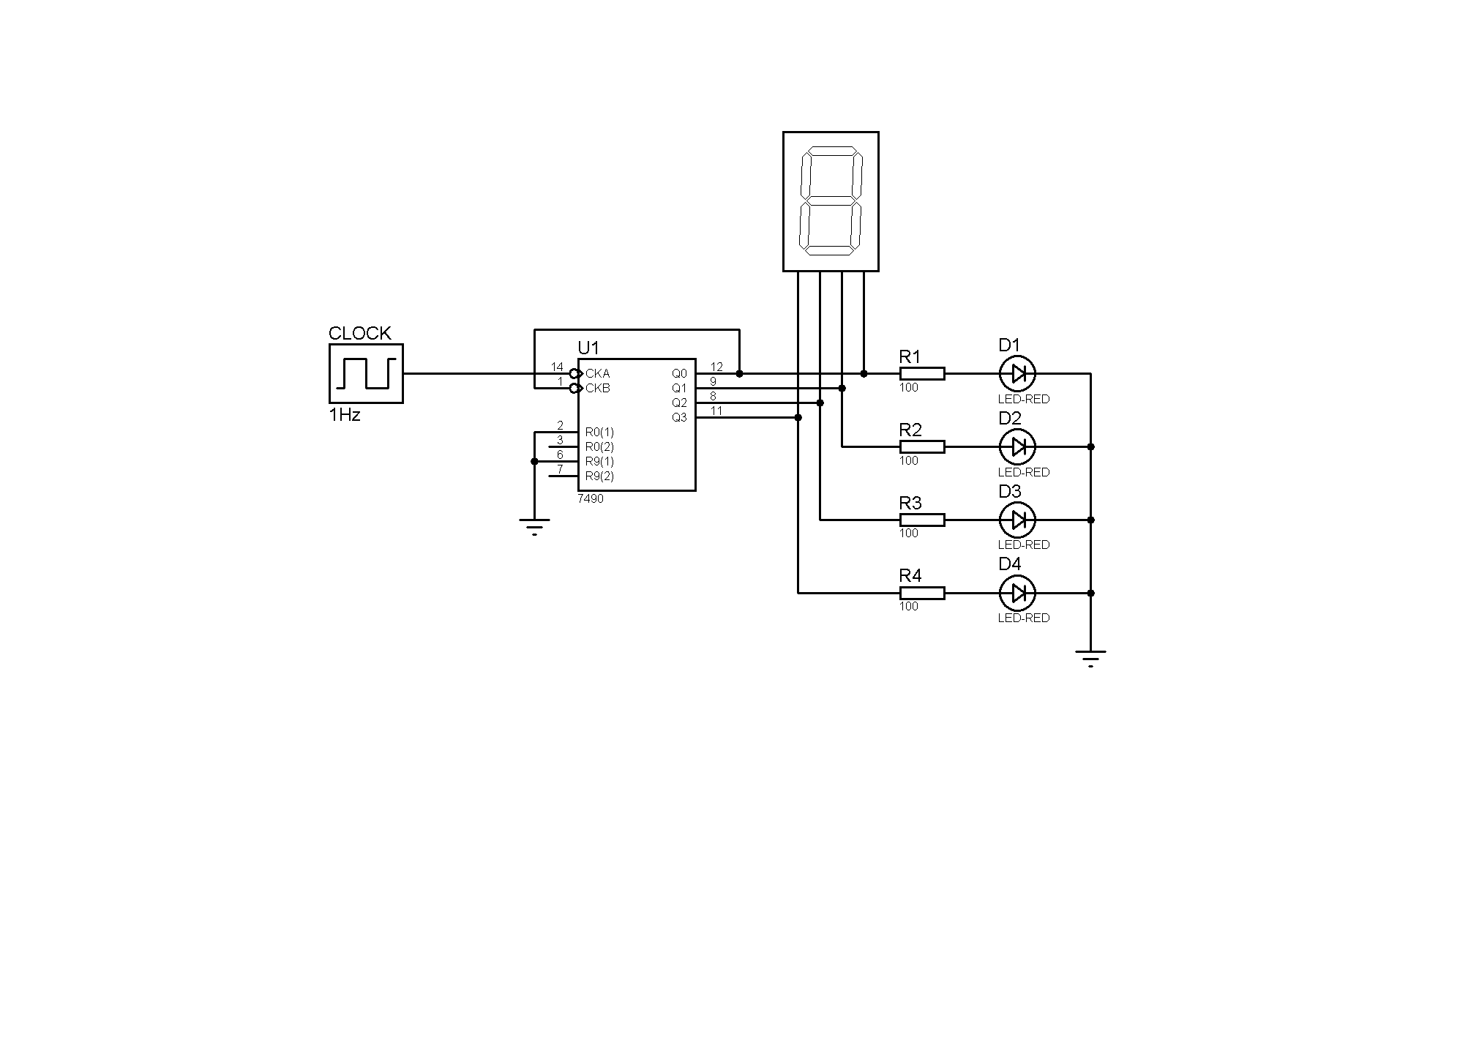

1. Isi kolom kosong pada Tabel!

|  |  |  |  |  |  |
| --- | --- | --- | --- | --- | --- |
| Input  Clock | Output LED | | | | Output Seven Segment |
| D1 | D2 | D3 | D4 |
| 1 | 0 | 0 | 0 | 0 | 0 |
| 2 | 1 | 0 | 0 | 0 | 1 |
| 3 | 0 | 1 | 0 | 0 | 2 |
| 4 | 1 | 1 | 0 | 0 | 3 |
| 5 | 0 | 0 | 1 | 0 | 4 |
| 6 | 1 | 0 | 1 | 0 | 5 |
| 7 | 0 | 1 | 1 | 0 | 6 |
| 8 | 1 | 1 | 1 | 0 | 7 |
| 9 | 0 | 0 | 0 | 1 | 8 |
| 10 | 1 | 0 | 0 | 1 | 9 |
| 11 | 0 | 0 | 0 | 0 | 0 |
| 12 | 1 | 0 | 0 | 0 | 1 |
| 13 | 0 | 1 | 0 | 0 | 2 |

1. mencari datasheet IC 7490 dan mendapatkan gerbang logikanya.

**Percobaan 2. Penambahan Decoder BCD-to-7segment**

1. Buat rangkaian seperti pada percobaan 1

Tambahkan rangkaian dengan IC 4511 dan 7segment common cathode!

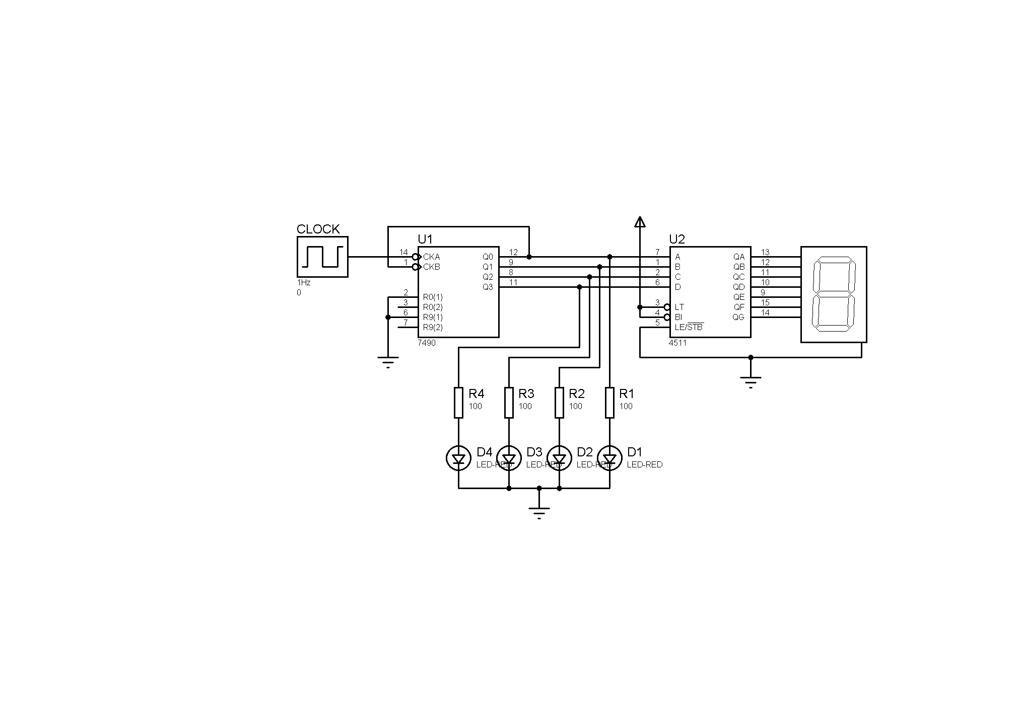

1. Isi kolom kosong pada tabel!

|  |  |  |  |  |  |
| --- | --- | --- | --- | --- | --- |
| Input  Clock | Output LED | | | | Output Seven Segment |
| D1 | D2 | D3 | D4 |
| 1 |  |  |  |  | 0 |
| 2 |  |  |  |  | 1 |
| 3 |  |  |  |  | 2 |
| 4 |  |  |  |  | 3 |
| 5 |  |  |  |  | 4 |
| 6 |  |  |  |  | 5 |
| 7 |  |  |  |  | 6 |
| 8 |  |  |  |  | 7 |
| 9 |  |  |  |  | 8 |
| 10 |  |  |  |  | 9 |
| 11 |  |  |  |  | 0 |

1. Bandingkan percobaan 1 dan percobaan 2! Dapatkan anda melihat persamaannya?

……………………………………………………………………………………………………………………………………..

1. Apakah benar bahwa 7seg-BCD sama dg BCD-to-7segment decoder? (…Yes… / …No…)

 

**=**

**Percobaan 3. Melihat di dalam BCD-to-7segment Decoder**

1. Perhatikan fungsi tabel IC 4511

|  |  |  |  |  |  |  |  |  |  |  |  |  |  |
| --- | --- | --- | --- | --- | --- | --- | --- | --- | --- | --- | --- | --- | --- |
| Decimal  Digit | *Input* | | | | | *Output* | | | | | | | Display  *Output* |
| LT | D | C | B | A | a | b | c | d | e | f | g |
| 0 | H | L | L | L | L | H | H | H | H | H | H | L | 0 |
| 1 | H | L | L | L | H | L | H | H | L | L | L | L | 1 |
| 2 | H | L | L | H | L | H | H | L | H | H | L | H | 2 |
| 3 | H | L | L | H | H | H | H | H | H | L | L | H | 3 |
| 4 | H | L | H | L | L | L | H | H | L | L | H | H | 4 |
| 5 | H | L | H | L | H | H | L | H | H | L | H | H | 5 |
| 6 | H | L | H | H | L | L | L | H | H | H | H | H | 6 |
| 7 | H | L | H | H | H | H | H | H | L | L | L | L | 7 |
| 8 | H | H | L | L | L | H | H | H | H | H | H | H | 8 |
| 9 | H | H | L | L | H | H | H | H | L | L | H | H | 9 |
| LT | L | X | X | X | X | H | H | H | H | H | H | H | 8 |

1. Output “a” (highlight) pada tabel, menunjukan kerjanya LED di seven segment Common cathode dibawah.

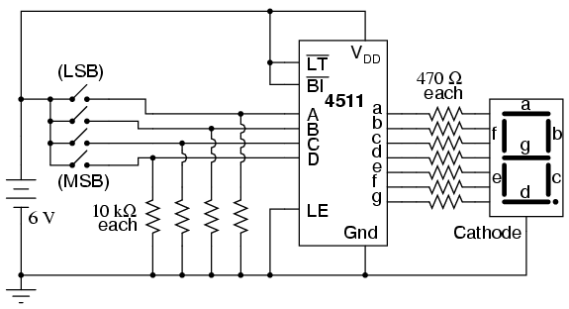 

**“a” output**

**output “a”** pada teori **output** **“a”** pada percobaan anda

1. Tiap output menunjukan keadaan LED dari seven segment berbagai kondisi

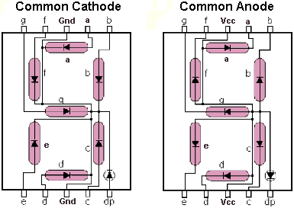

1. Masing-masing LED dikendalikan oleh kombinasi gerbang logika.

Diagram logic lengkap dari decoder BCD-to-7segment ditunjukan pada gambar beriku ini.

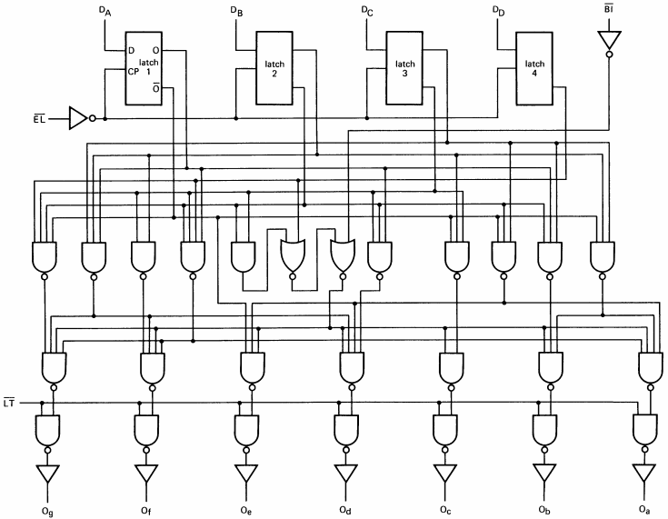

1. **TUGAS**

Coba buat rangkaian decoder BCD-to-7 Segmen di atas, dan bandingkan dengan tabel kebenaran pada point no 1!