***How to set break points and "walk-through" a JavaScript application.***

Load the page in Firefox.

Right click and choose Inspect element.

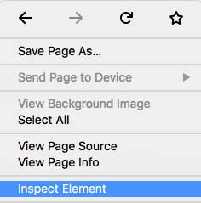

Click on the Debugger tab

In the Source list pane, drill down till you find the file that contains the file containing the JavaScript to be tested.

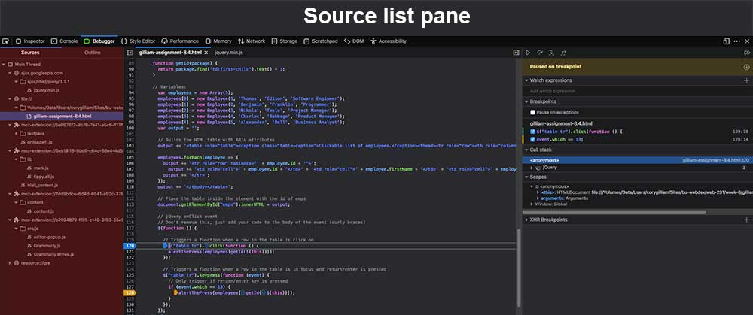

To set a Standard breakpoint:

In the Source pane, right click on the line number, select Add breakpoint.

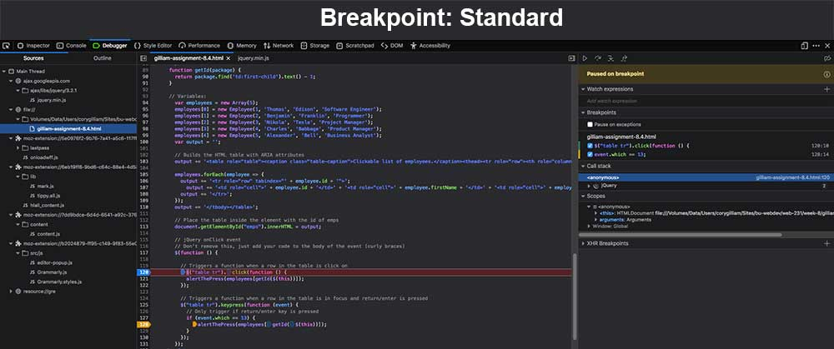

To set a Conditional breakpoint:

In the Source pane, right click on the line number, select Add condition.

Enter a conditional statement, and return.

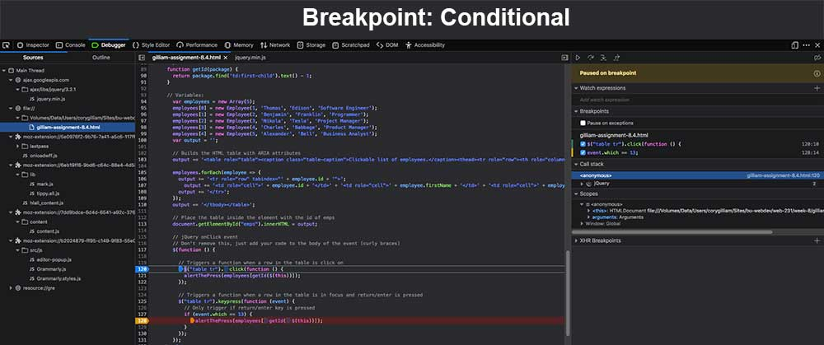

Using the tools in the Toolbar area.

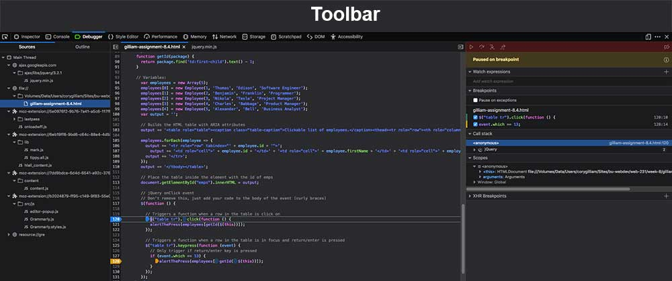

You can either continue with the execution of the program up to the next breakpoint with the play/pause control.

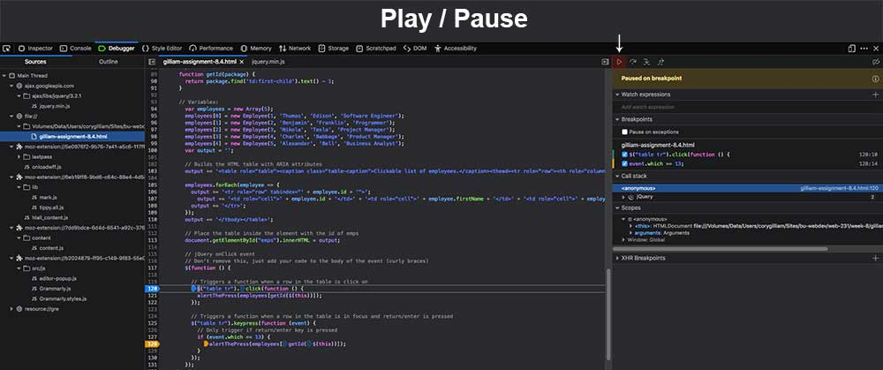

Work your way through the program line by line with the step over control.

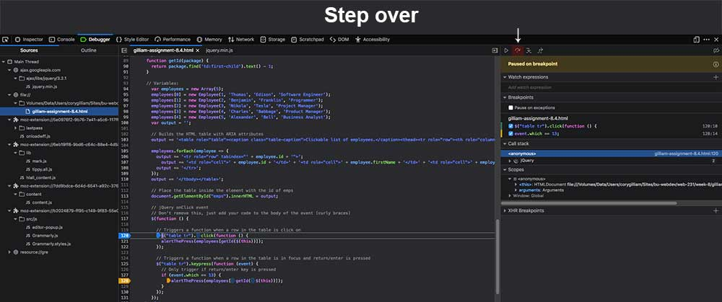

Step into the current function with the step in control.

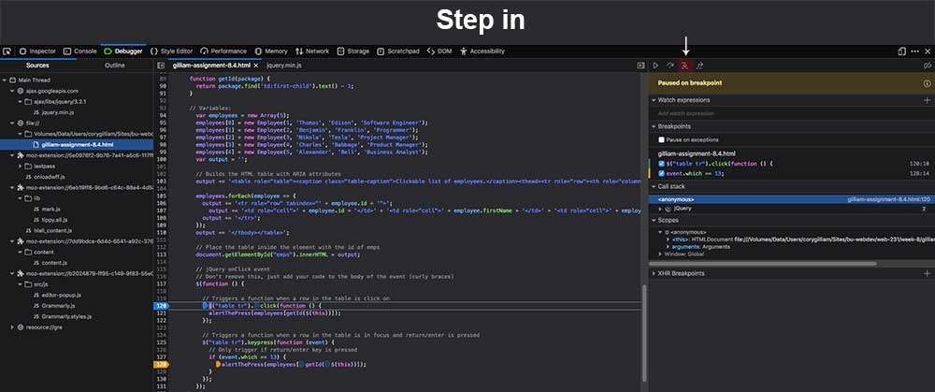

Run every step until you exit the current function with the step out control.

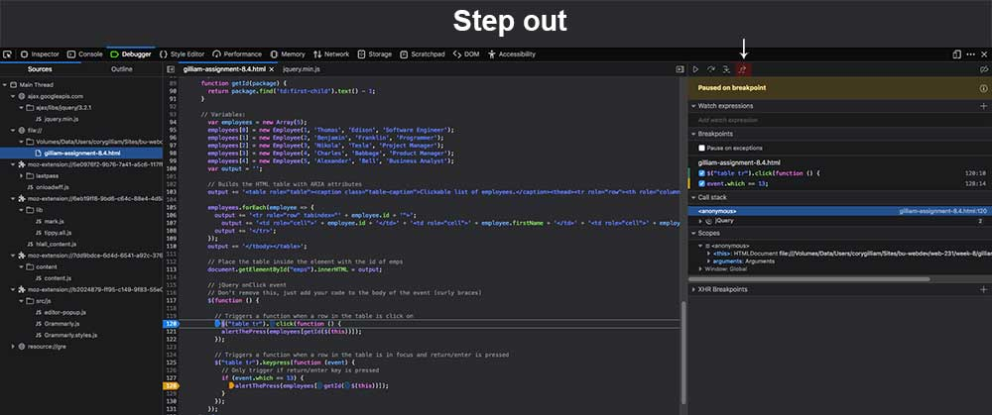

You have a list of all or your breakpoints in the breakpoint pane. You have the option of activating or deactivating the here.

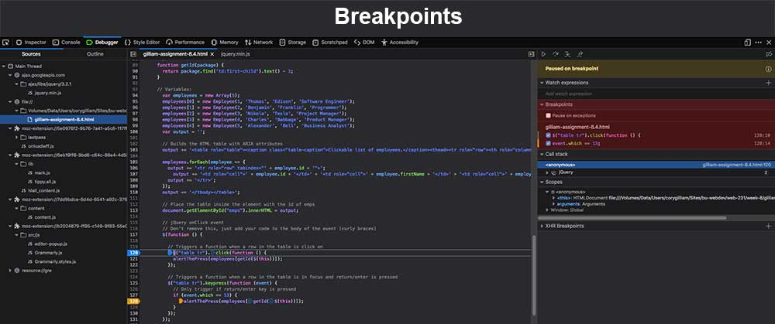

Next, you have the option to see a list of everything of concern to the program in the call stack. Each one is clickable and will take you to the corresponding line in the code.

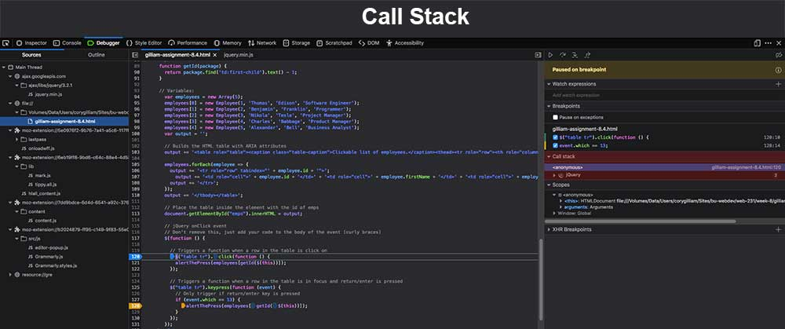

Last, there is the scope pane. Here you can see everything that is with in the current scope of the application.

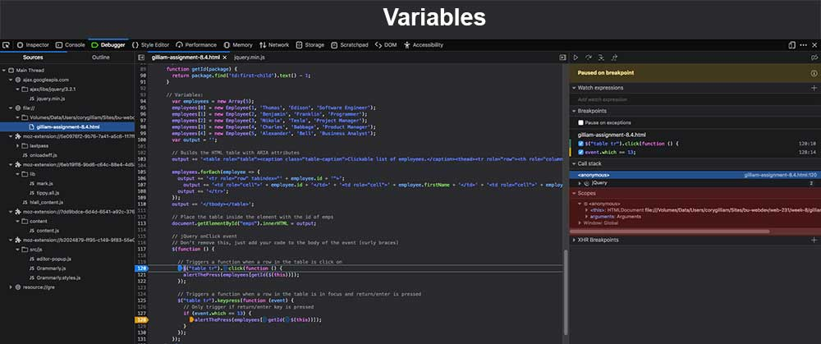

***How to do you log and read messages from the JavaScript console window?***

In your code add the line console.log().

Inside the parentheses, enter the information you want displayed in the browser’s console. This can be a string, number, or a variable name. Load the page in Firefox.

Right click and choose Inspect element.



Click on the Console tab

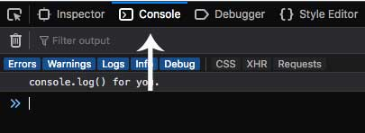

Your log message will be displayed just below the filter selection buttons

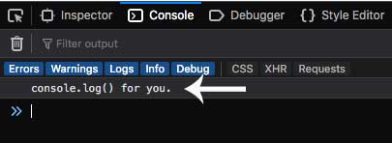

***How do you select HTML elements in the JavaScript console window?***

Inside the parentheses, enter the information you want displayed in the browser’s console. This can be a string, number, or a variable name. Load the page in Firefox.

Right click and choose Inspect element.



Click on the Console tab



Enter: console.log(document.getElementById("{#}")); Inside the double quotes should be the #id of the HTML element you wish to select.

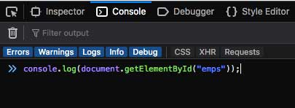

Press Enter/Return

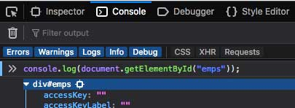

***How to simulate CSS states (hover, focus) on live HTML elements?***

Load the page in Firefox.

Right click and choose Inspect element.



Click on the Inspector tab (Default tab when you first open)

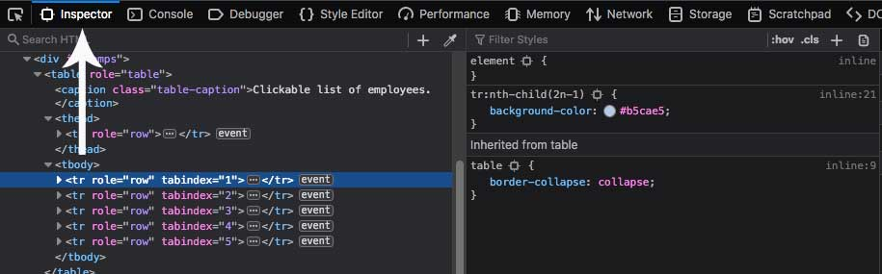

Select the line of HTML you want to see the CSS for

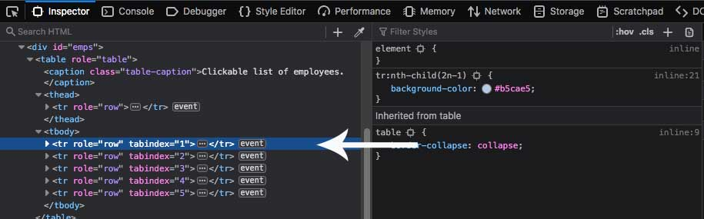

In the top-right of the center pane, click the .hov toggle

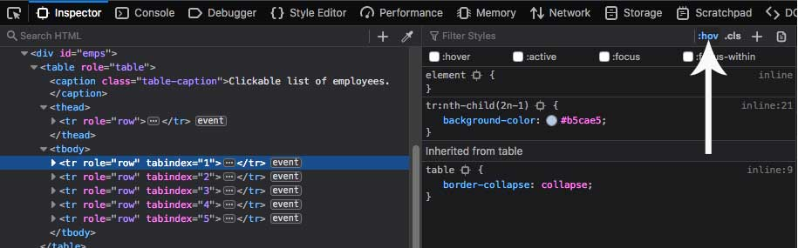

Check the boxes for the CSS states you would like to see the CSS for

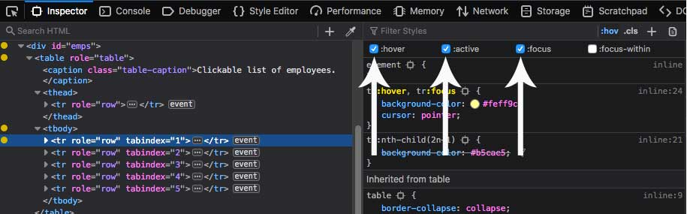

The states you select will be visible in the browser window, and you can test CSS changes here

