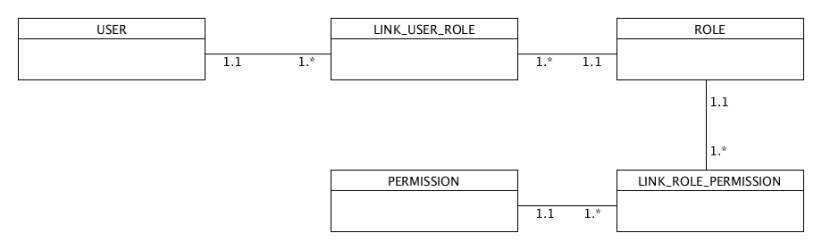

Business Rules:

1. A User can have many Roles

2. A Role can have many Permissions

